**Assignment 7(a) Program To find maximum among numbers entered in an array of size 10**

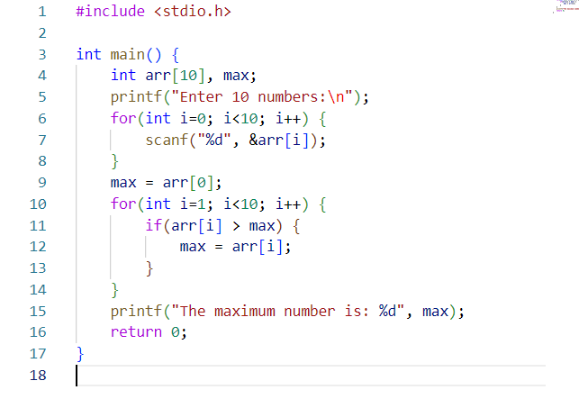

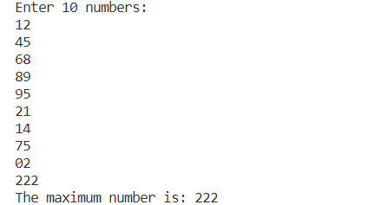

**Assignment 7(a) Output**

**Assignment 7(b) Program To add, multiply and find transpose of two matrix of order 3x3**

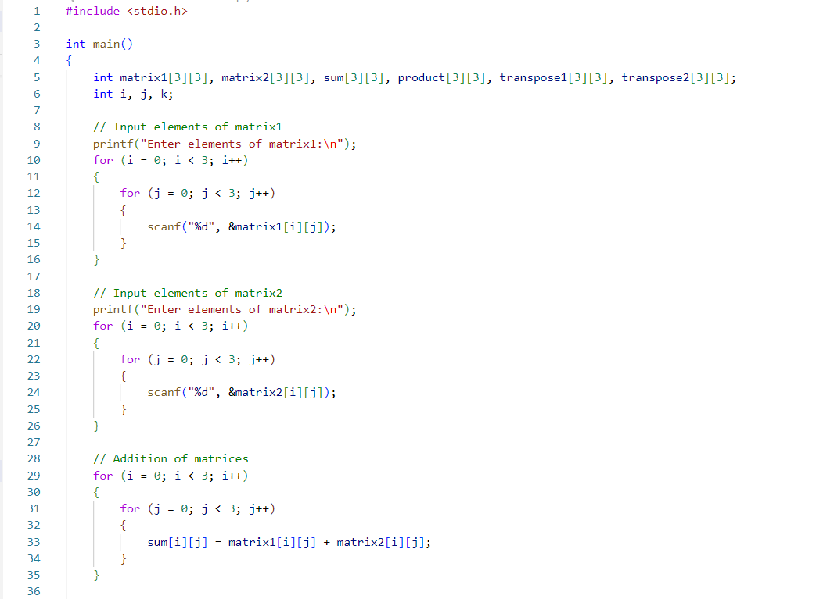

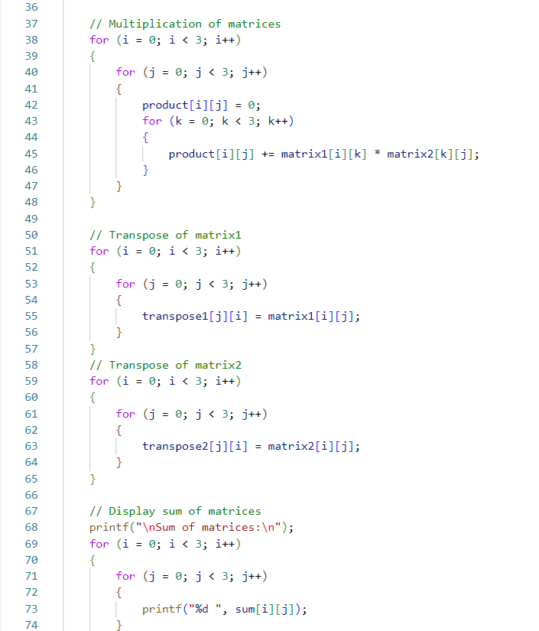

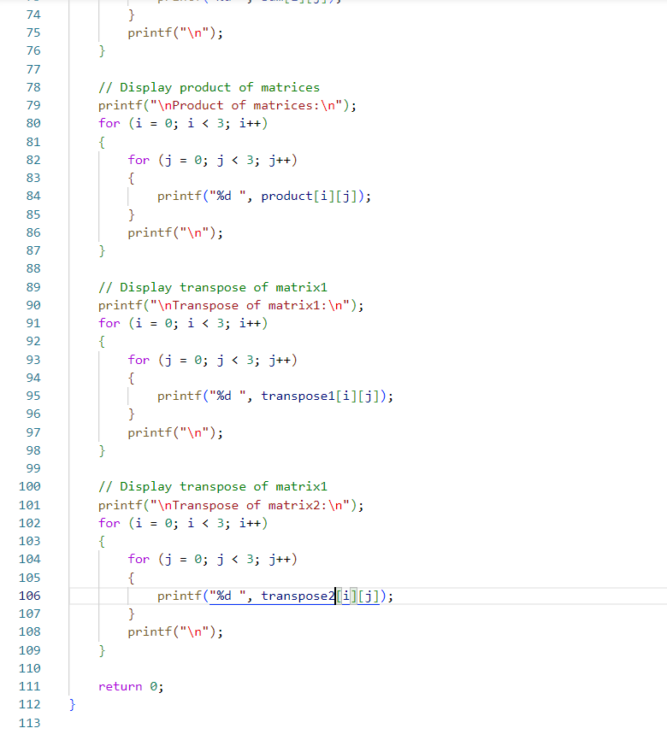

**Assignment 7(b) Output**

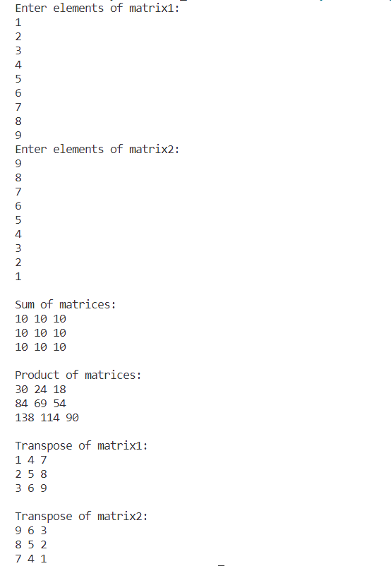

**Assignment 7(c) Program To create 3d matrix from given 3x4 2d matrix**

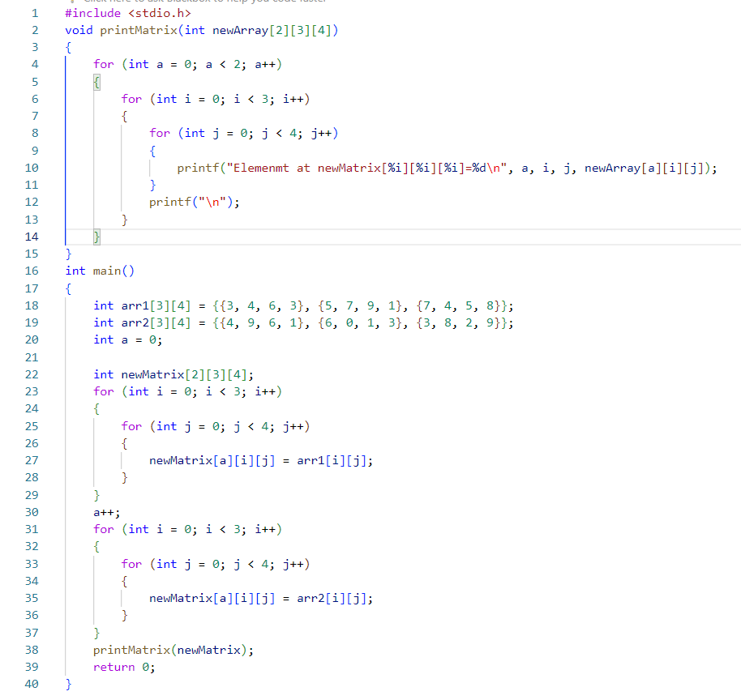

**Assignment 7(c) Output**

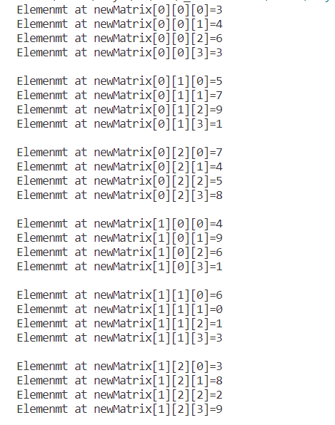

**Assignment 7(d) Program To Concatenate 2 string without any predefined function**



**Assignment 7(d) Output**

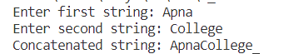

**Assignment 7(e) Program To Check whether a string is palindrome or not**

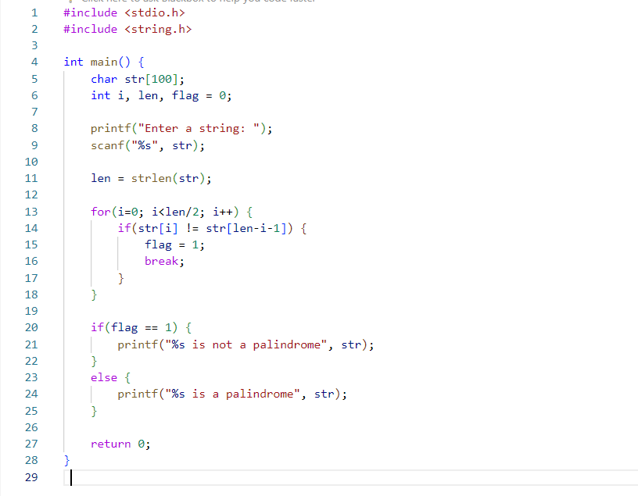

**Assignment 7(e) Output**

