Lab 1  
CST8912_011  
Satyam Panseriya  
pans0012@algonquinlive.com  
January 13, 2025  
Submitted to :   
Prof. Tanishq Bansal

# 

# **Lab Report Format**

**Title**

**Configuring and Monitoring Azure Virtual Machines**

**Introduction or Purpose**

This lab report explains how to configure and monitor a Linux virtual machine (VM) in Azure cloud. For this hands-on lab, beginners will be familiarized with the creation, management, and monitoring of virtual machines through cloud services. The tasks go hand in hand with concepts of cloud architecture (reliability, resiliency, and scalability) to ensure the incorporation of core cloud computing features in the curriculum. This lab focuses on deploying a VM in the Canada Central region, configuring it with essential services, and utilizing Azure's monitoring tools to track its performance and health.

**Steps covered in the lab**

1. 1.Create a new instance of the resource (Azure virtual Machine) and select Ubuntu Server 18.04 LTS image from the marketplace
2. Configuring and launching a VM for region Canada central and with sku size standard_B1s- 1vcpu, 1 GiB memory and use SSH public key as authentication type
3. Configure disk type Premium SSD
4. Configure networking to create a virtual network and keep the default settings.
5. Keep default options on management tab, advanced and tags respectively
6. Perform basic VM controls (start, stop, restart, delete)
7. Create log analytics workspace and configure it with the same region as the existing resources.
8. Connect your virtual machine to log analytics to monitor virtual machine’s health.
9. a. Create a data collection rule and select the VM created in scope  
   b. In collect and deliver tab, select “Linux syslog” as data source

c. Go to “insights” and see monitoring information from the VM selected

d. Switch to health/agents tabs to get more details on the VM monitored

**Results**

1. 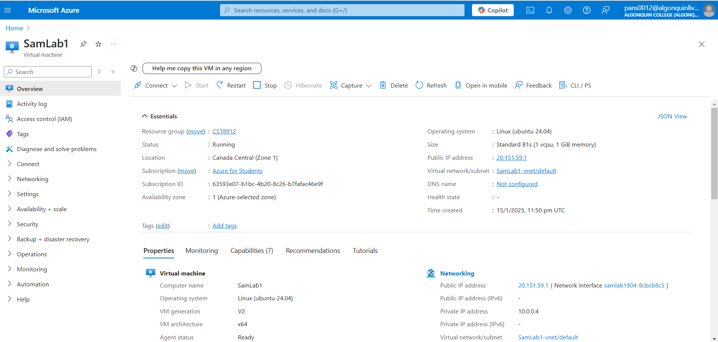

2.

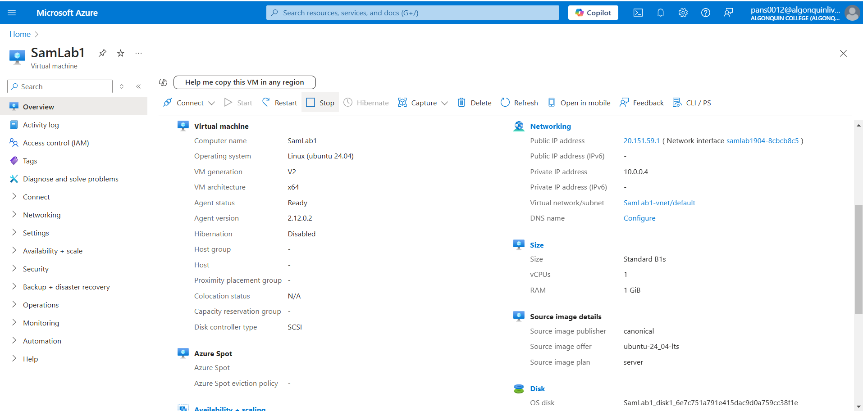

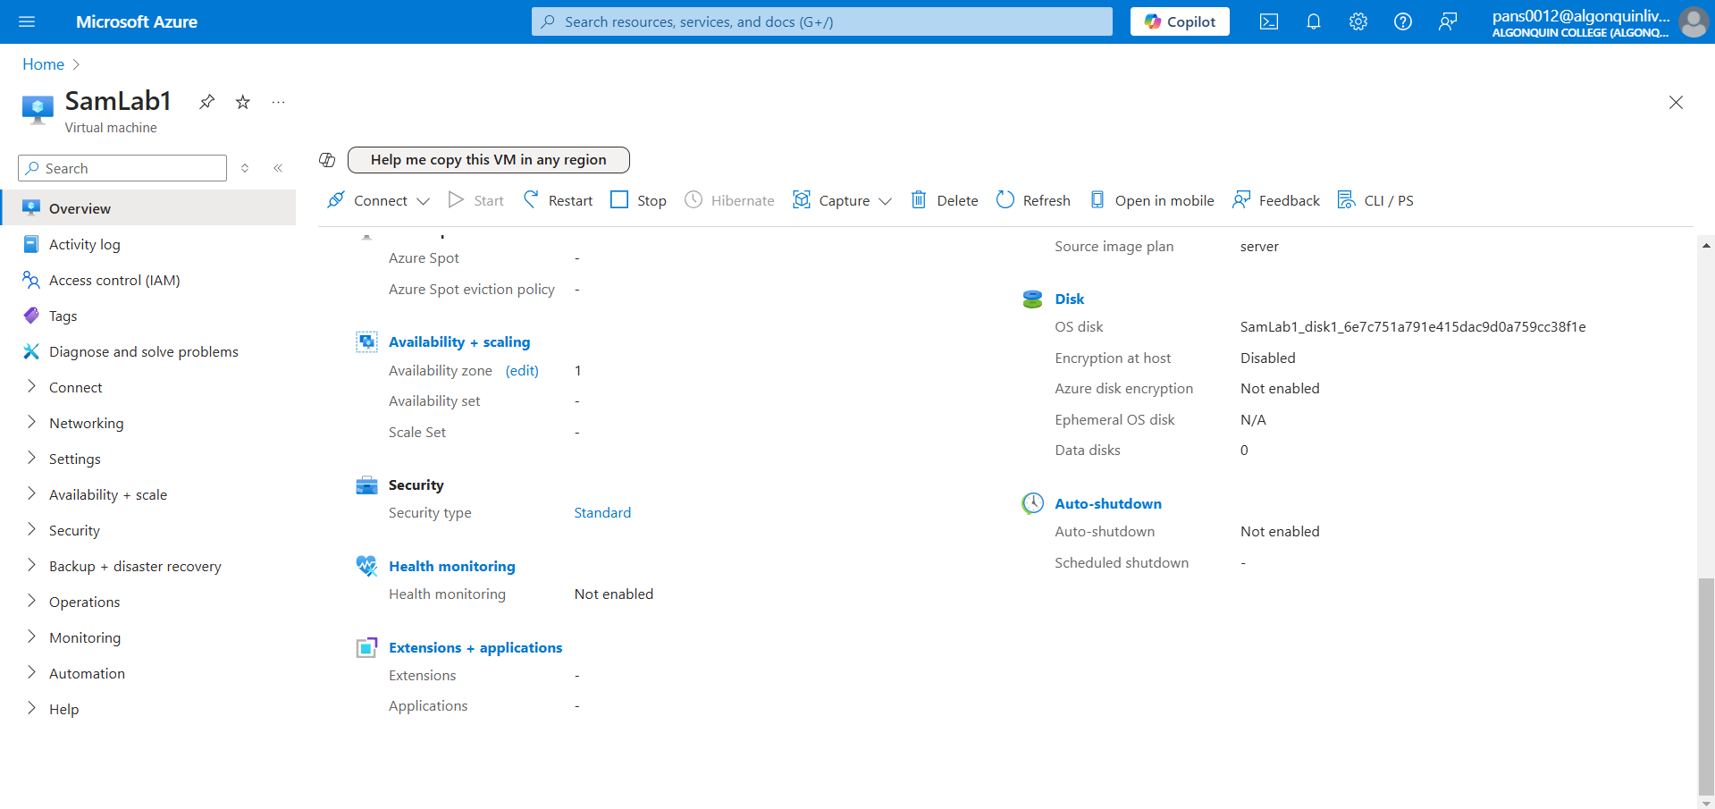

4.

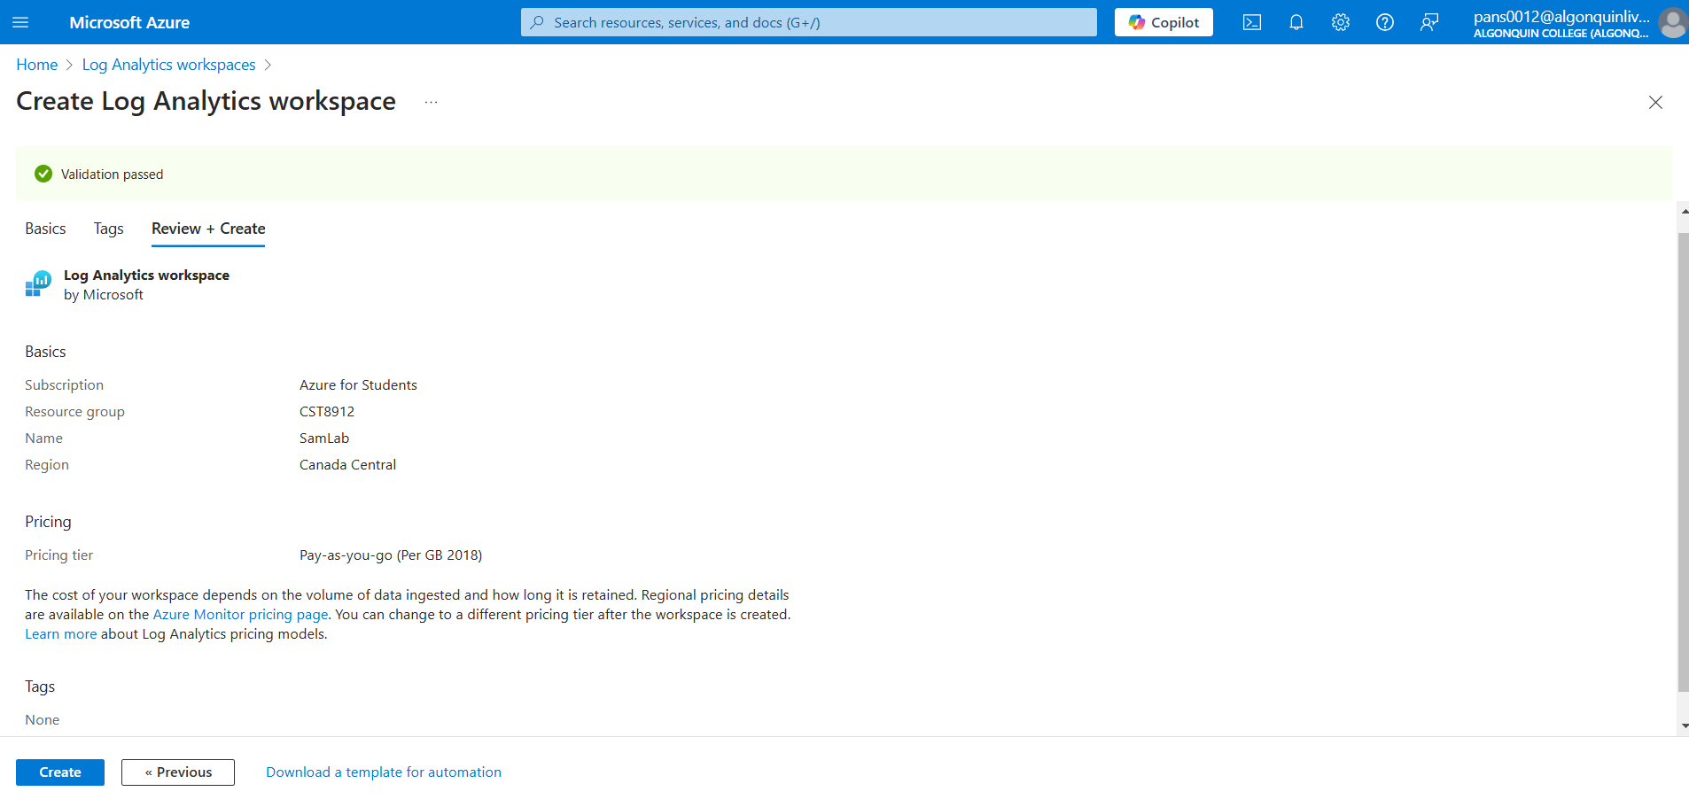

5.

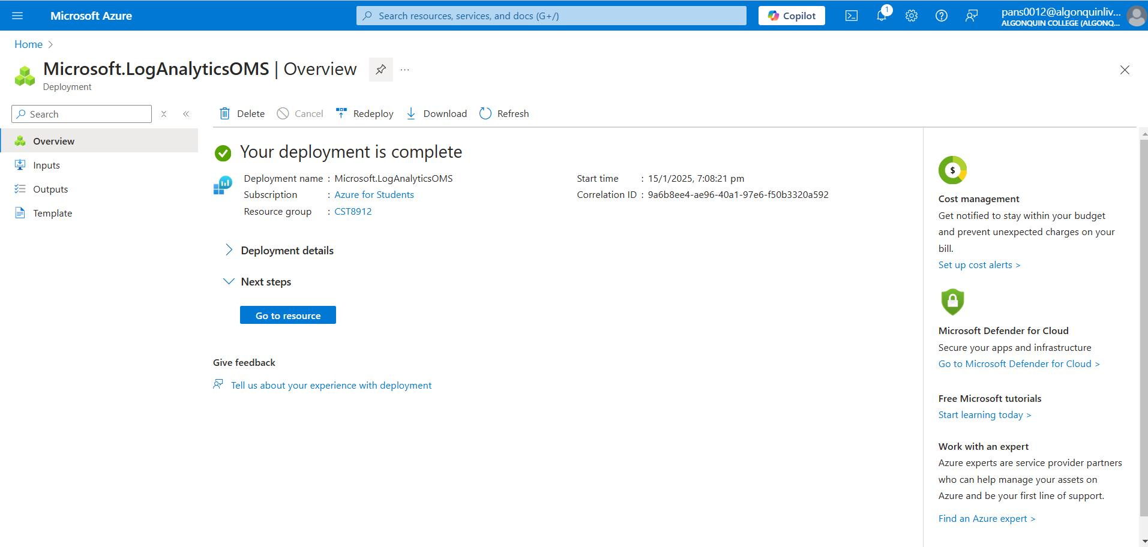

6.

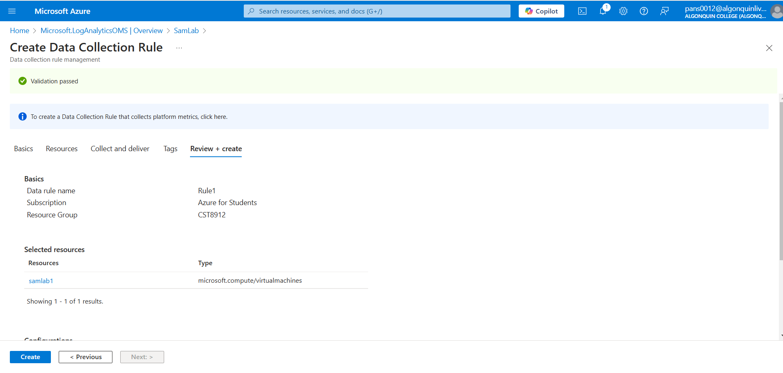

7.

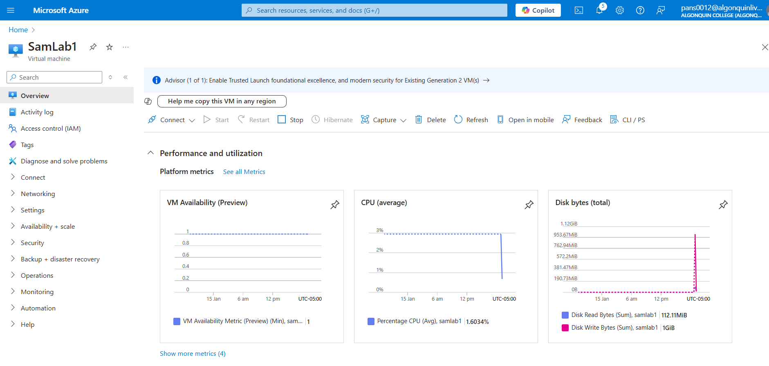

8.

