Lab2

CST8912_011

Satyam Panseriya

ID :- 41128392

January 22, 2025

Submitted to : Prof. Tanishq Bansal

**Title :-** In this lab, I Learned how to explored Virtual Network Peering and Virtual Machine Connectivity Across Azure Regions.

**Introduction :-** I deployed virtual machines (VMs) in various locations, set up VNet peering between them, and constructed and configured many virtual networks (VNets) in Azure. The objective was to use private IP addresses over port 3389 (RDP) to verify connection between these virtual machines. This lab gave me hands-on experience setting up VNet peering across several Azure regions and showcasing how to use private IP addresses to provide safe communication between virtual machines. It made it easier for me to comprehend how to set up VNets, create peering connections, and check connectivity to make sure network communication runs well.

Steps covered in the lab :-

1. Create a Resource Group - CST8912-demo in Canada Central Region

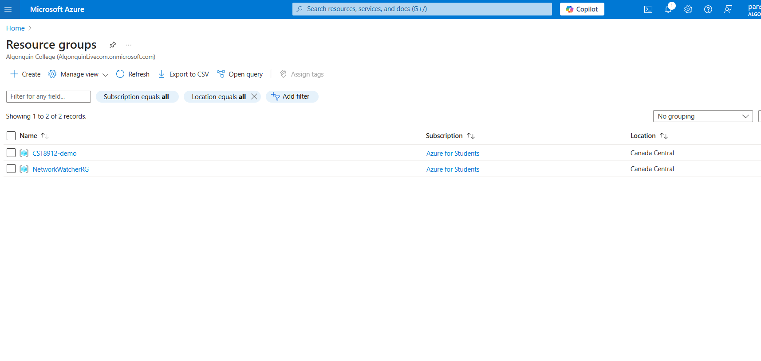

2. In the Azure portal, search for and select Virtual networks. Create one Virtual Network (cst8912_vnet0) for Canada central region and two Virtual networks (cst8912_vnet1 and cst8912_vnet2) in EAST US region.

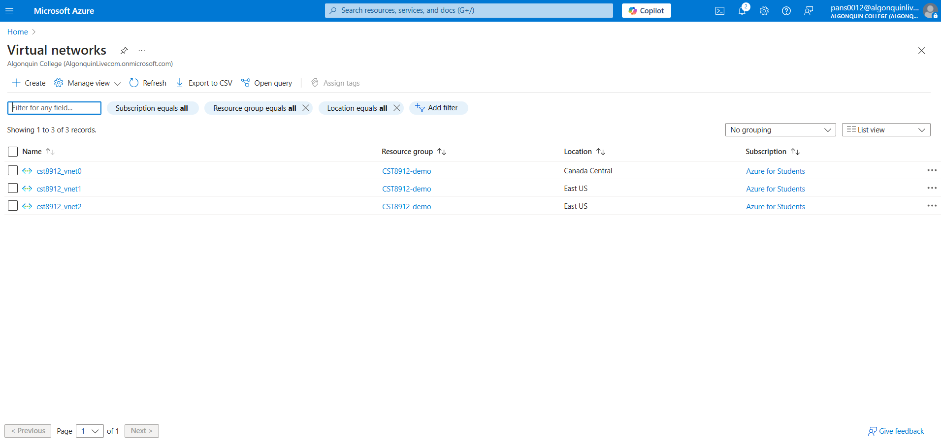

**3. Reviewing Virtual Network Configuration**

I)VM0 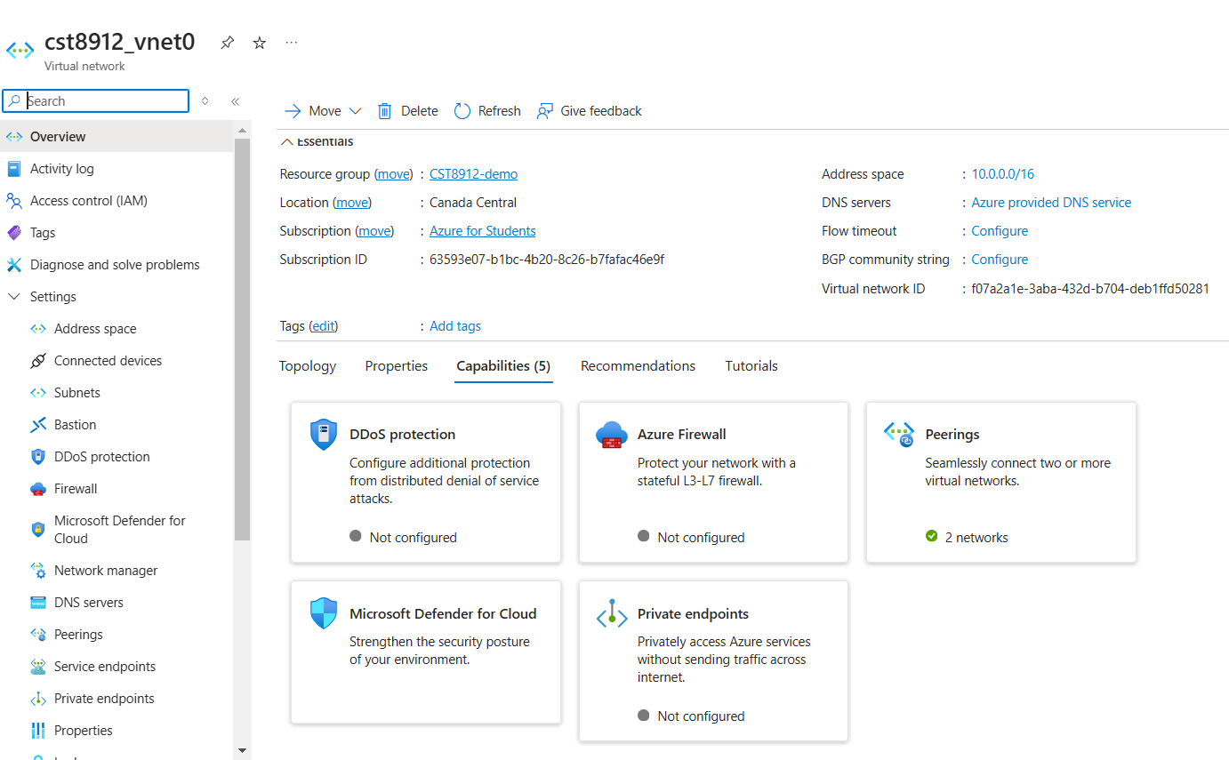

II)VM1

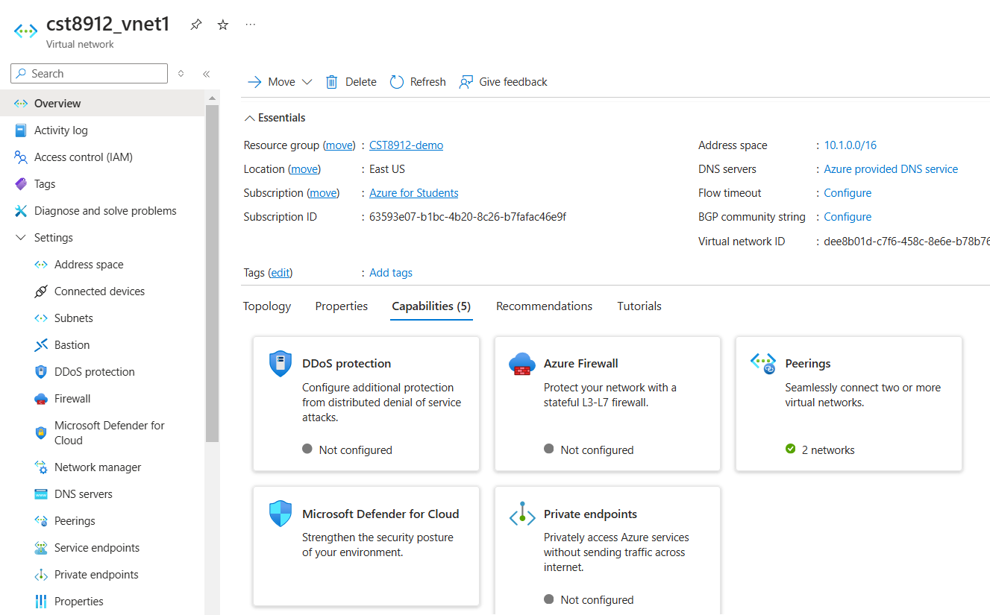

III) VM2

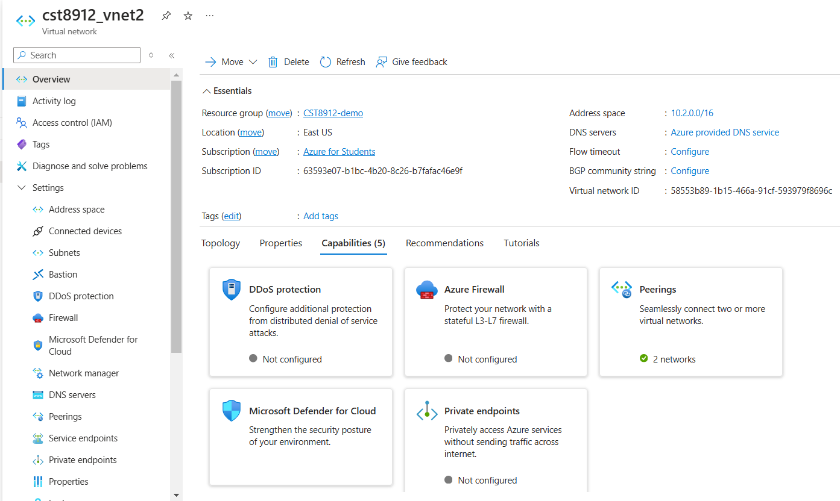

Q :- 4 & 5 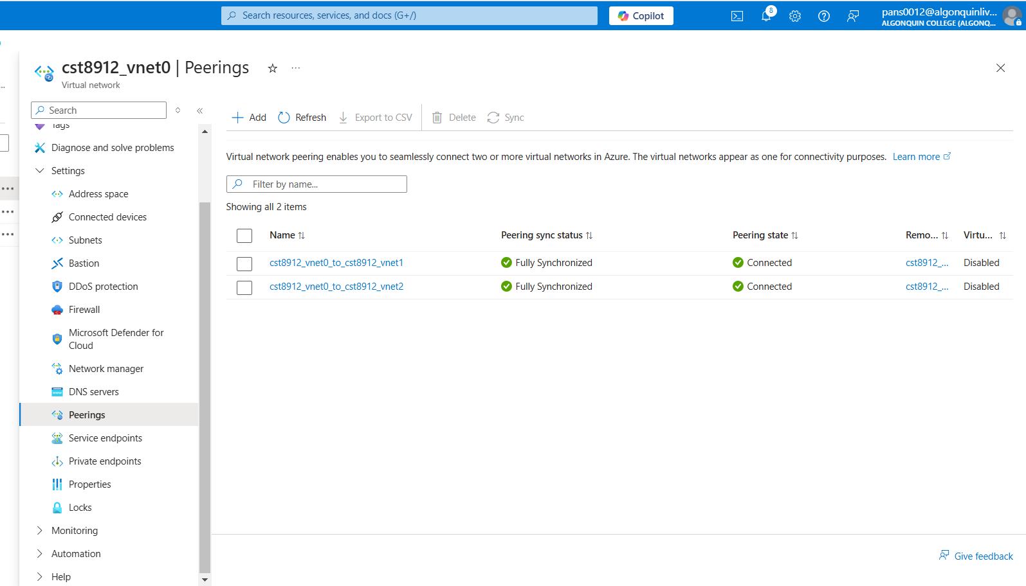

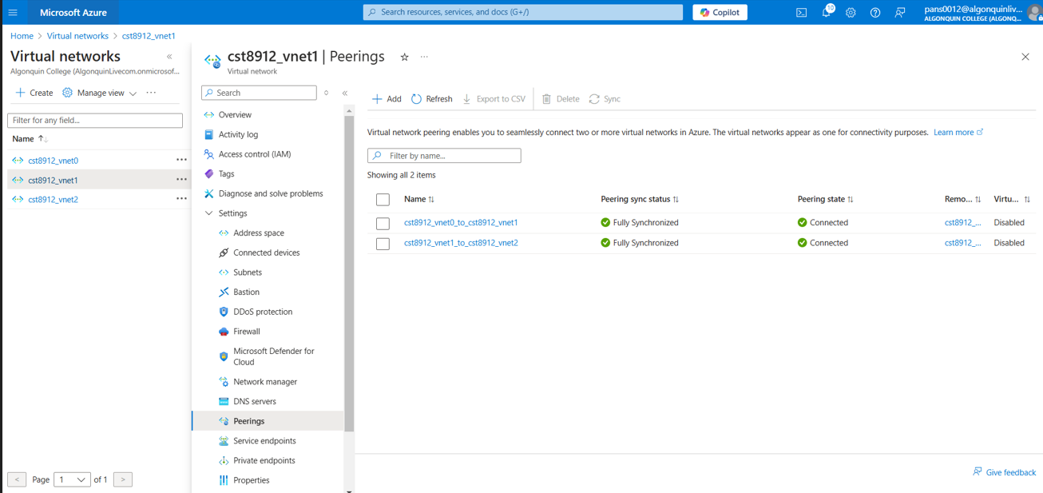

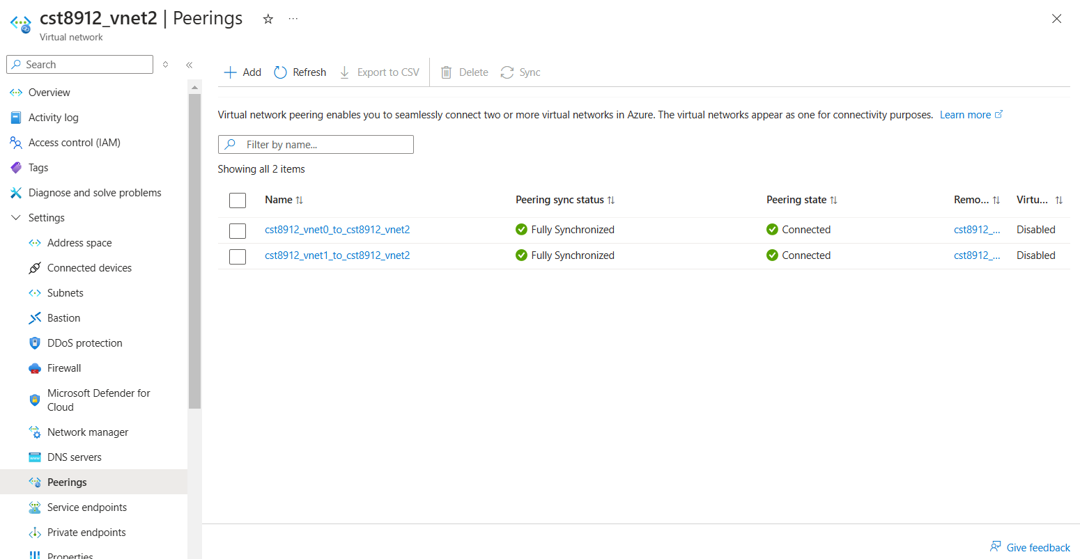

7. In the Azure portal, search for and select Virtual machines. In the list of virtual machines, create VM0 in Canada Central on Vnet 0 and VM1 and VM2 in East US (use Windows Server 2022 Datacenter) image on Vnet1 and Vnet 2 respectively

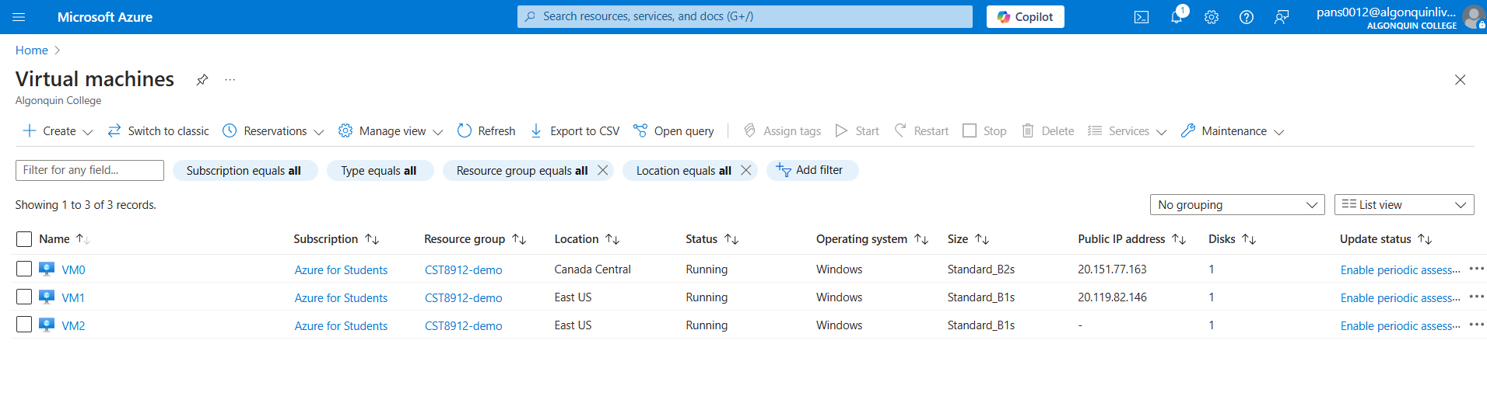

8. Select VM0 and connect using RDP signing in with username and password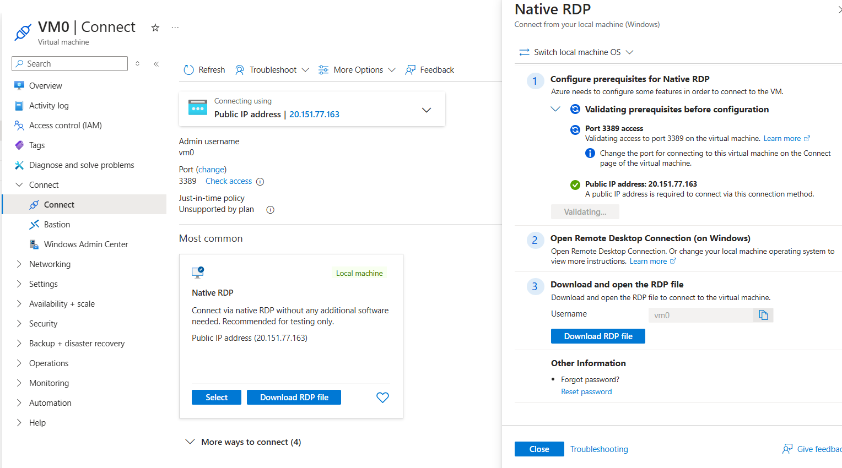

9. Within RDP ,in the Windows PowerShell console window, run the following to test connectivity to vm1 (use private ip) over TCP port 3389: Test-NetConnection -ComputerName “ip” -Port 3389 -InformationLevel 'Detailed'

**Vm0 to VM1 connection:**

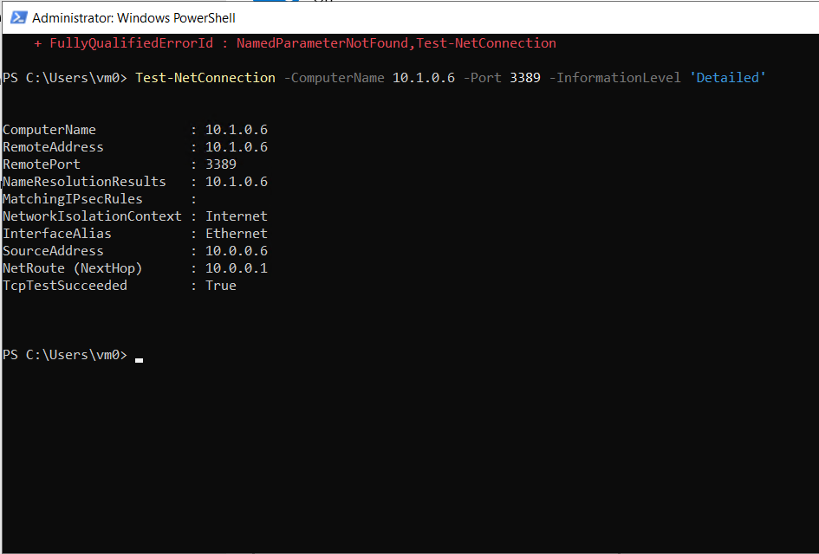

11. Repeat the same step to connect Vm0 to Vm2 and Vm1 to Vm2 and test the connection

**VM0 to VM2 Connection:**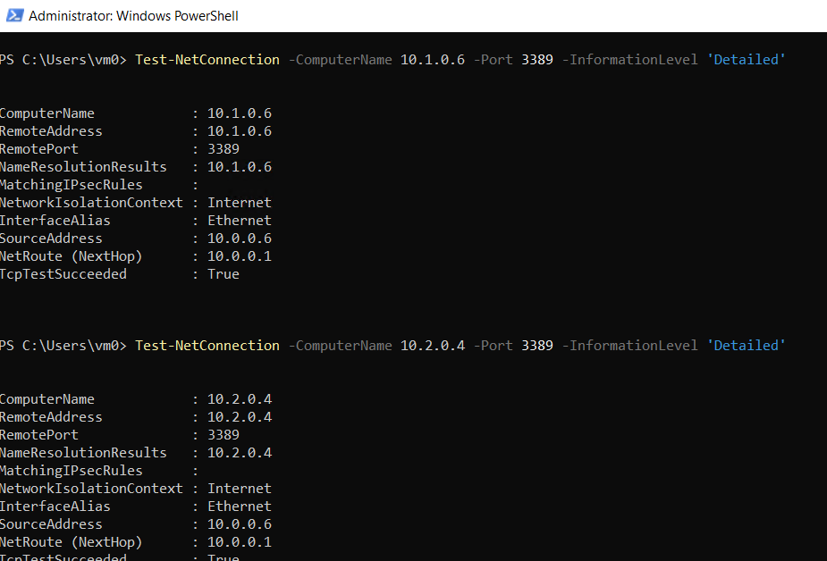

VM1 to VM2 Connection:

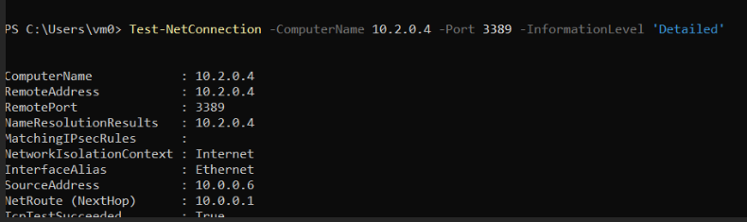

12. After demo delete all the resources created during this lab and create a lab report documenting all the steps with screenshots

