Lab4

CST8912_011

Satyam Panseriya

ID :- 41128392

Submitted to : Prof. Tanishq Bansal

**Introduction :-**

Cloud databases are modern kinds of databases that can be adjusted to any level and they are based on the cloud infrastructure. This lab was oriented on creating an Azure SQL Database with the help of the test data, and then running SQL queries on that data, configuring an Azure Storage Account, and using Azure Data Factory to transfer data from these two to a Blob Storage. Furthermore, the lab underlined the main cloud service models (IaaS, PaaS, SaaS) and it was shown how these elements work together in order to make sure that there is a high availability, resiliency, and scalability.

Que :- 1 & 2.

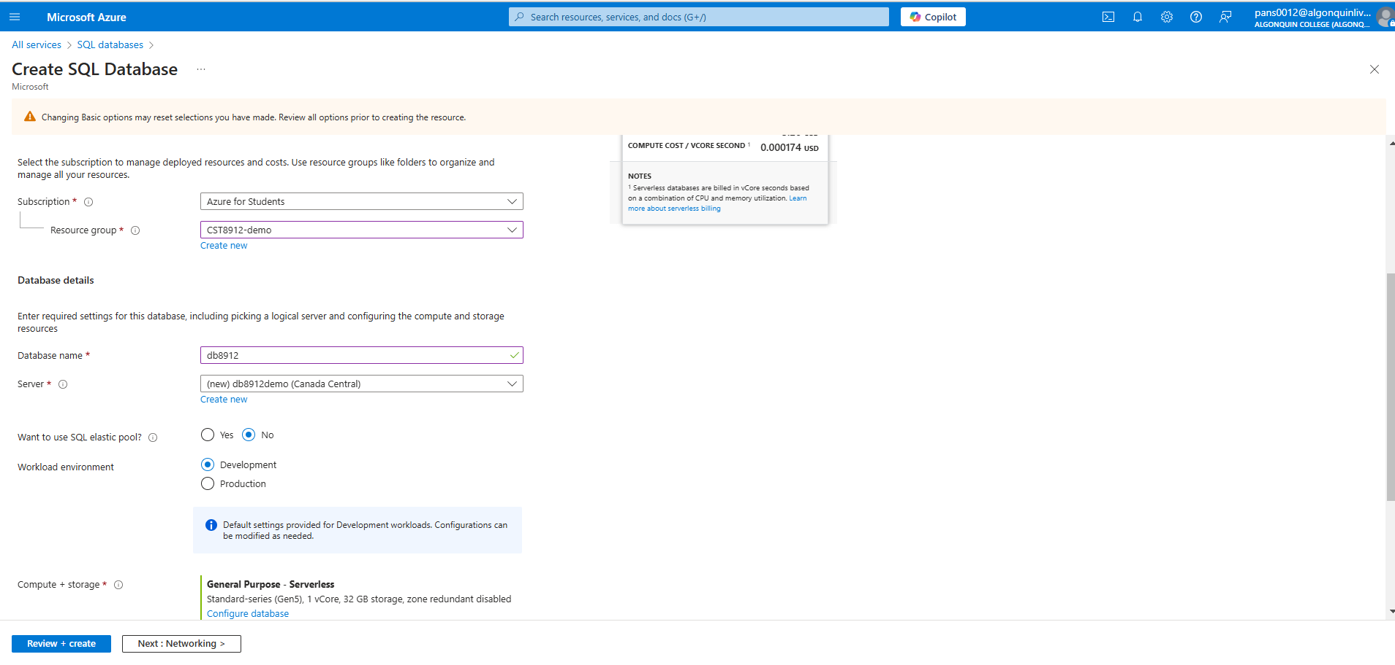

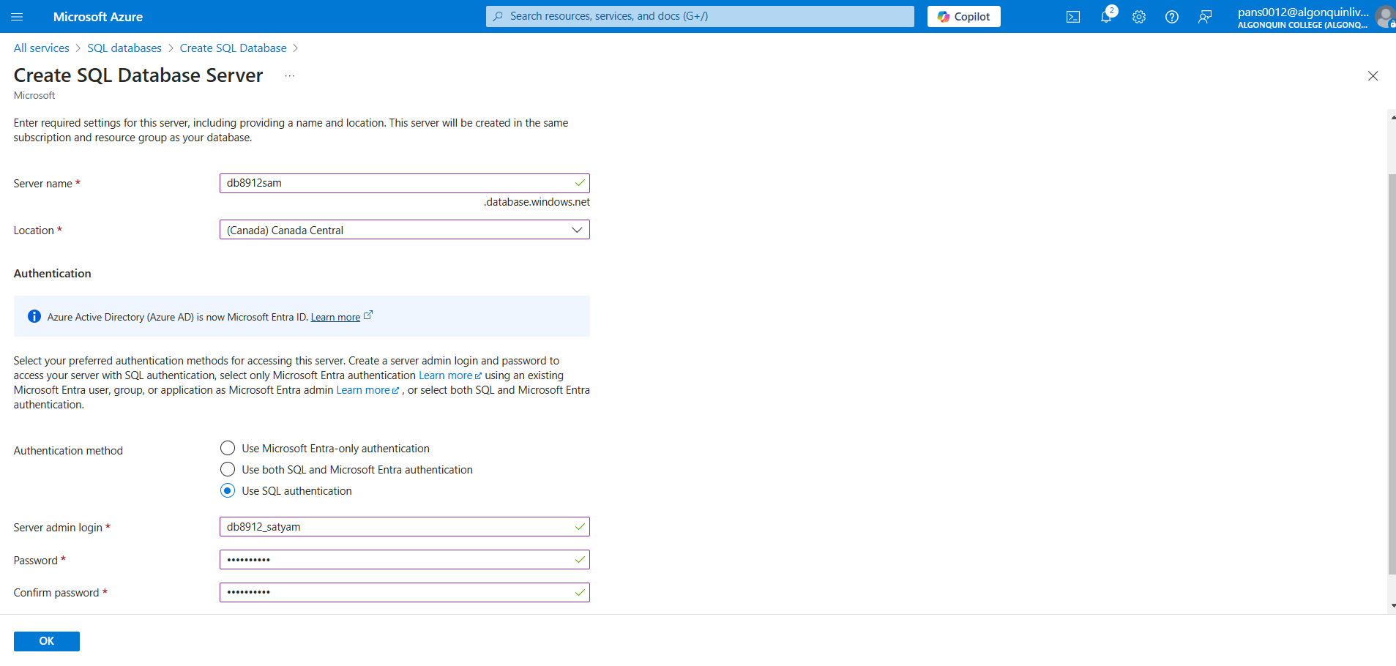

Que :- 7

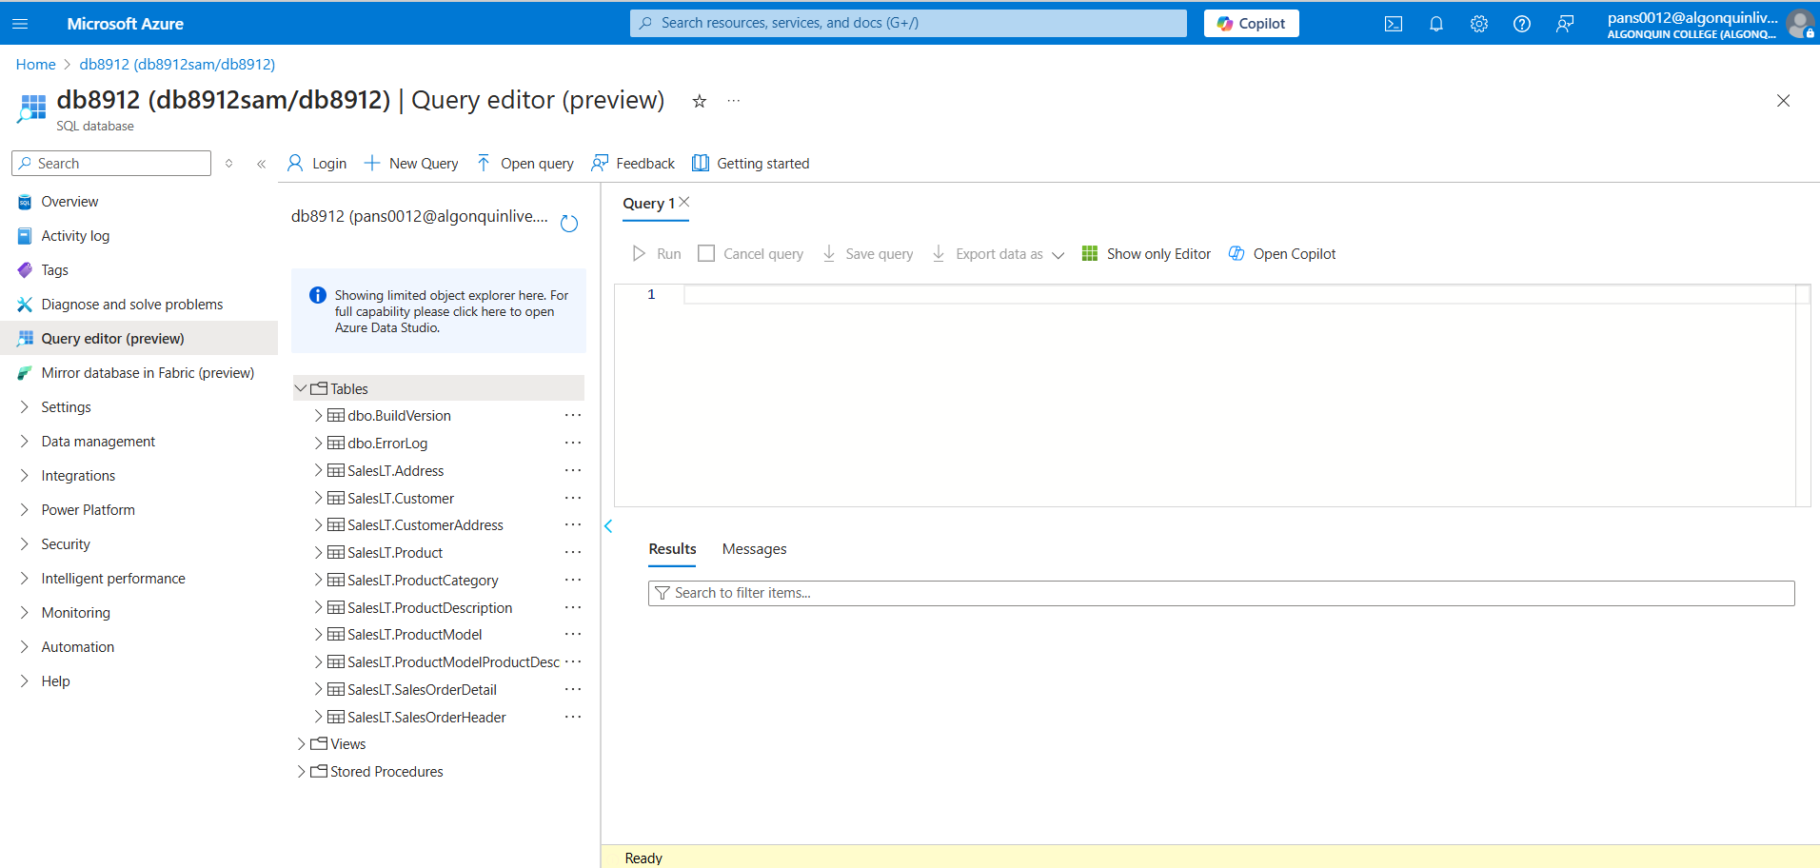

Que :- 9

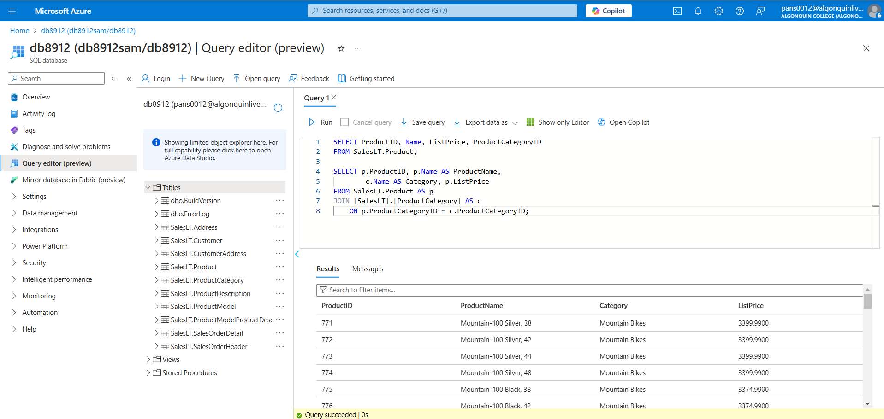

Que - 10.

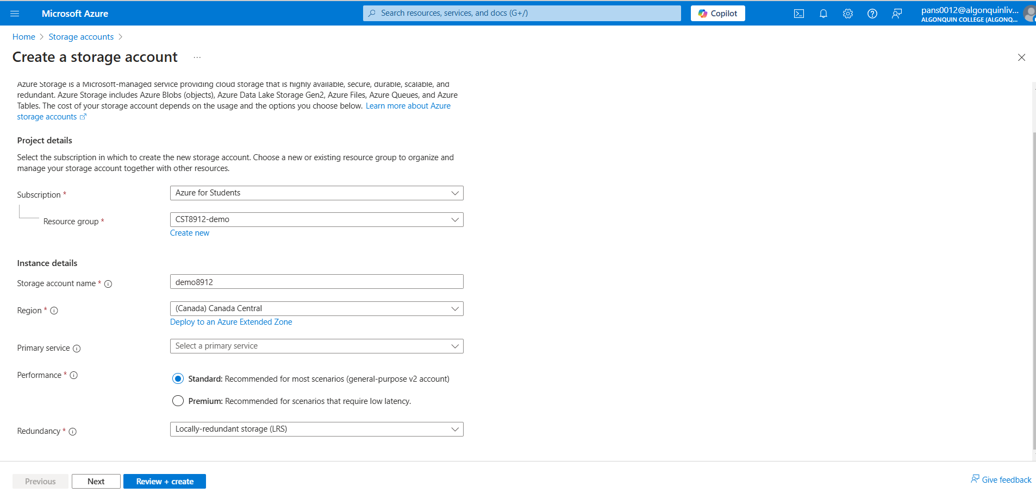

Que -12 .

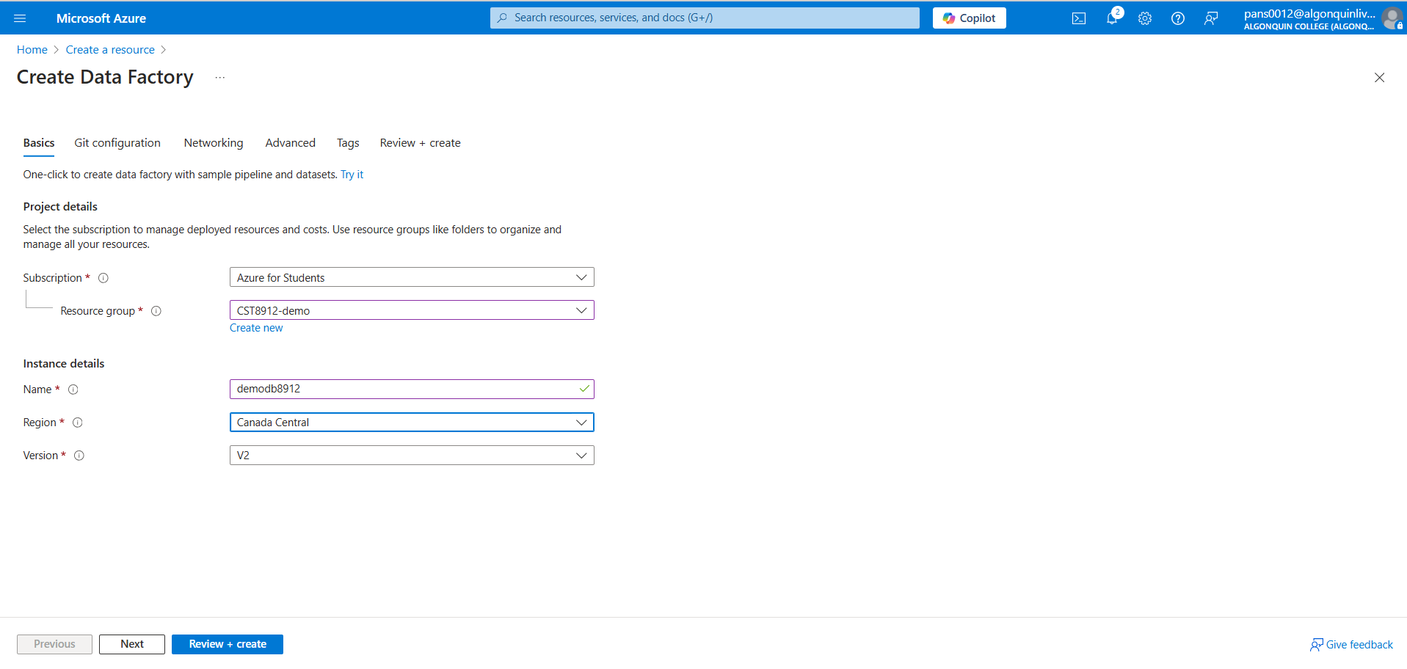

Que - 16

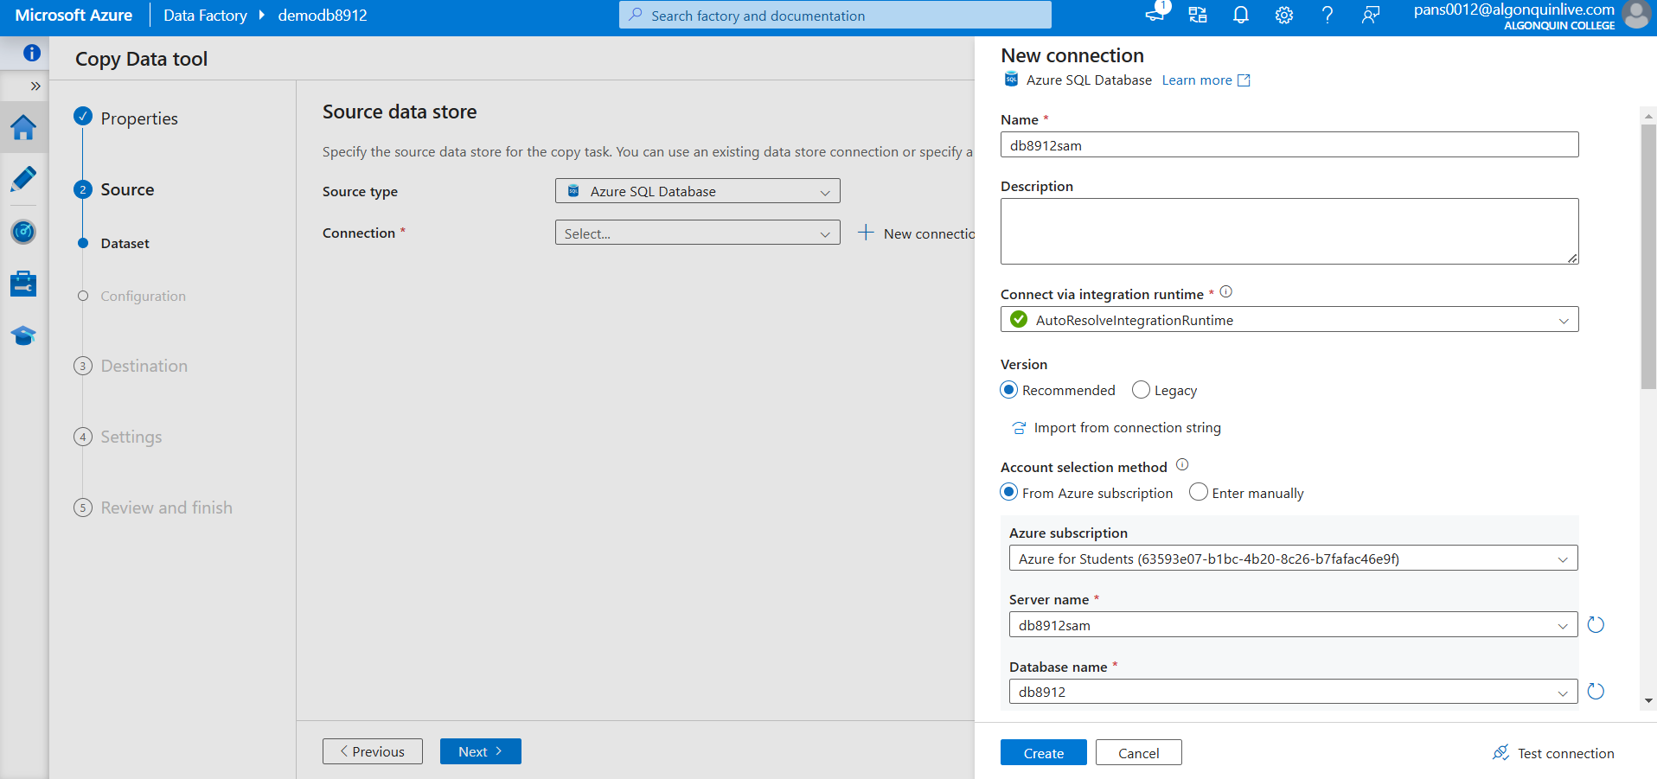

Que - 17

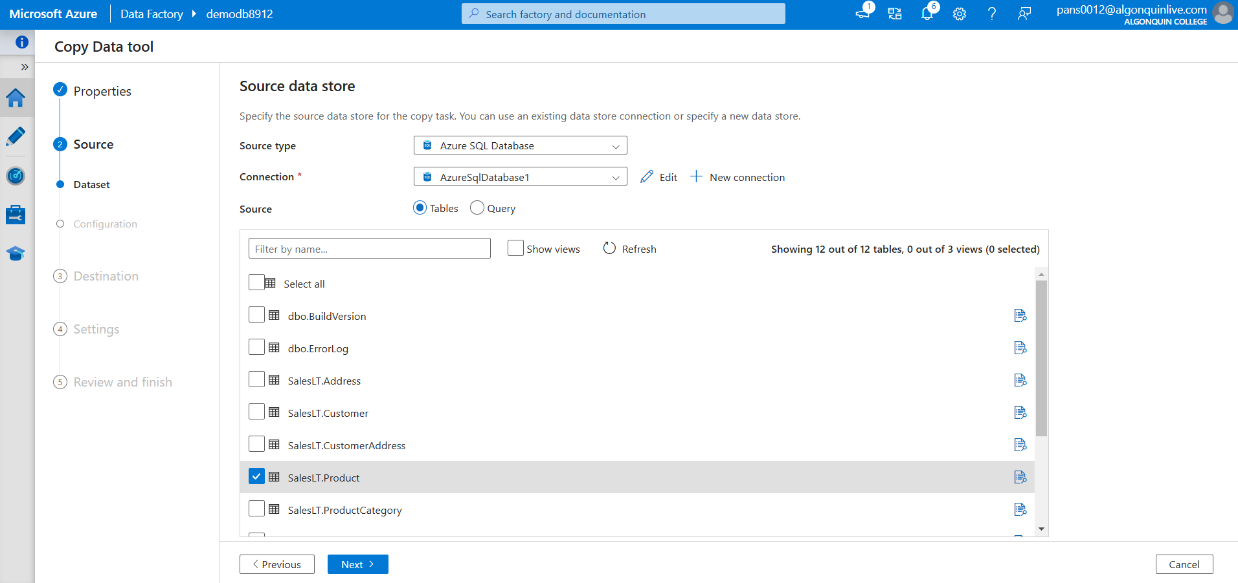

Que :- 19

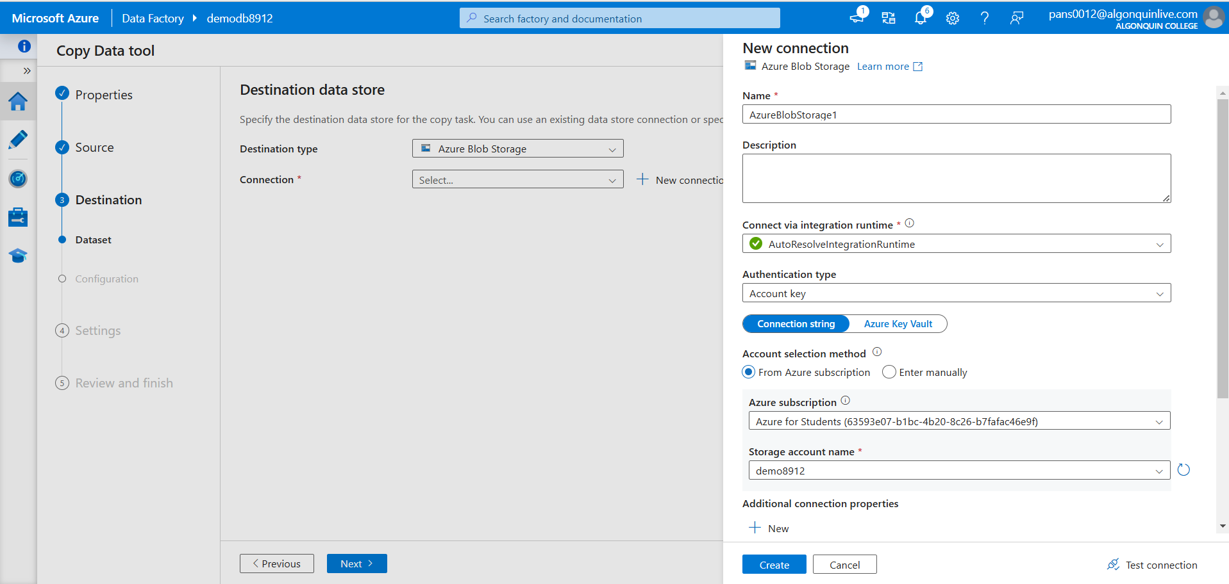

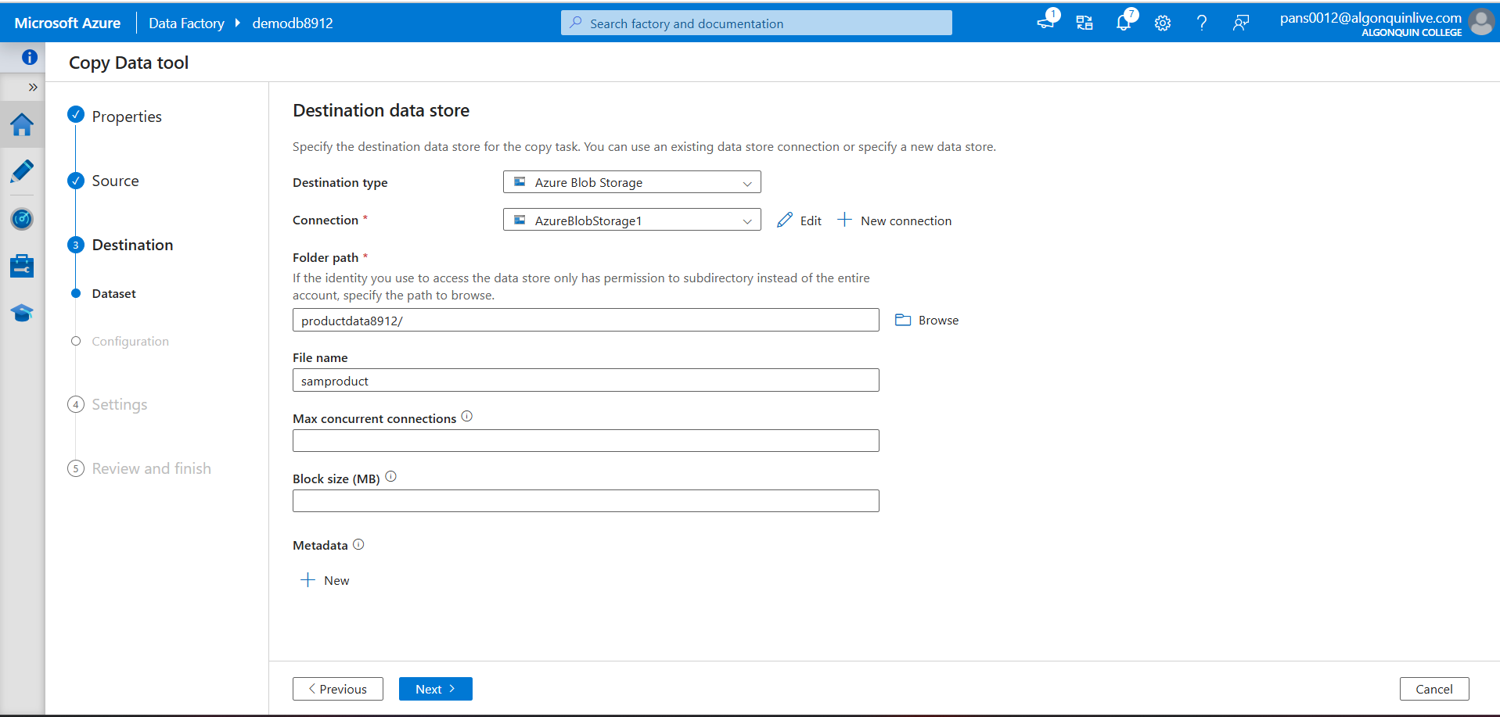

Que - 20

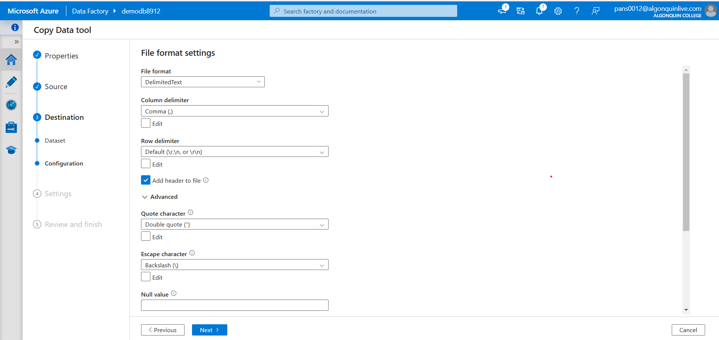

Que :- 21

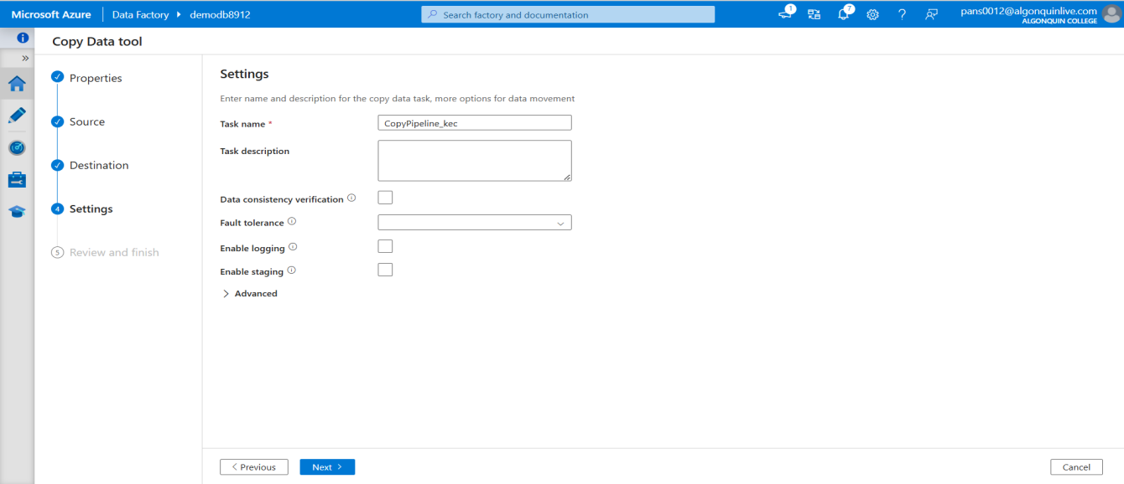

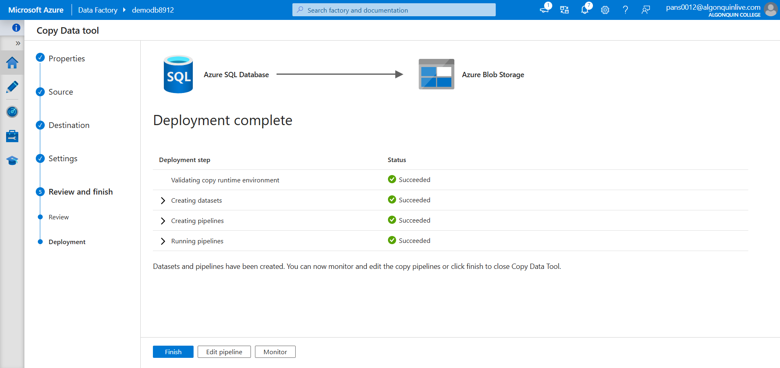

Que - 22

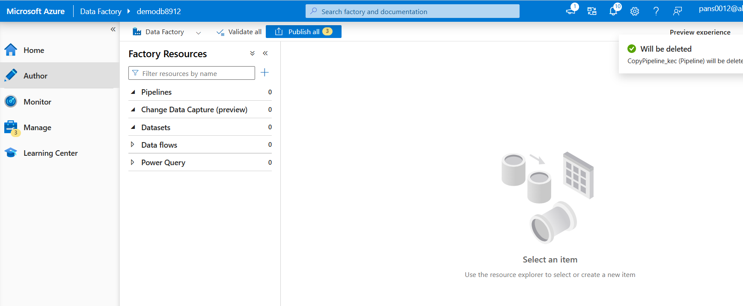

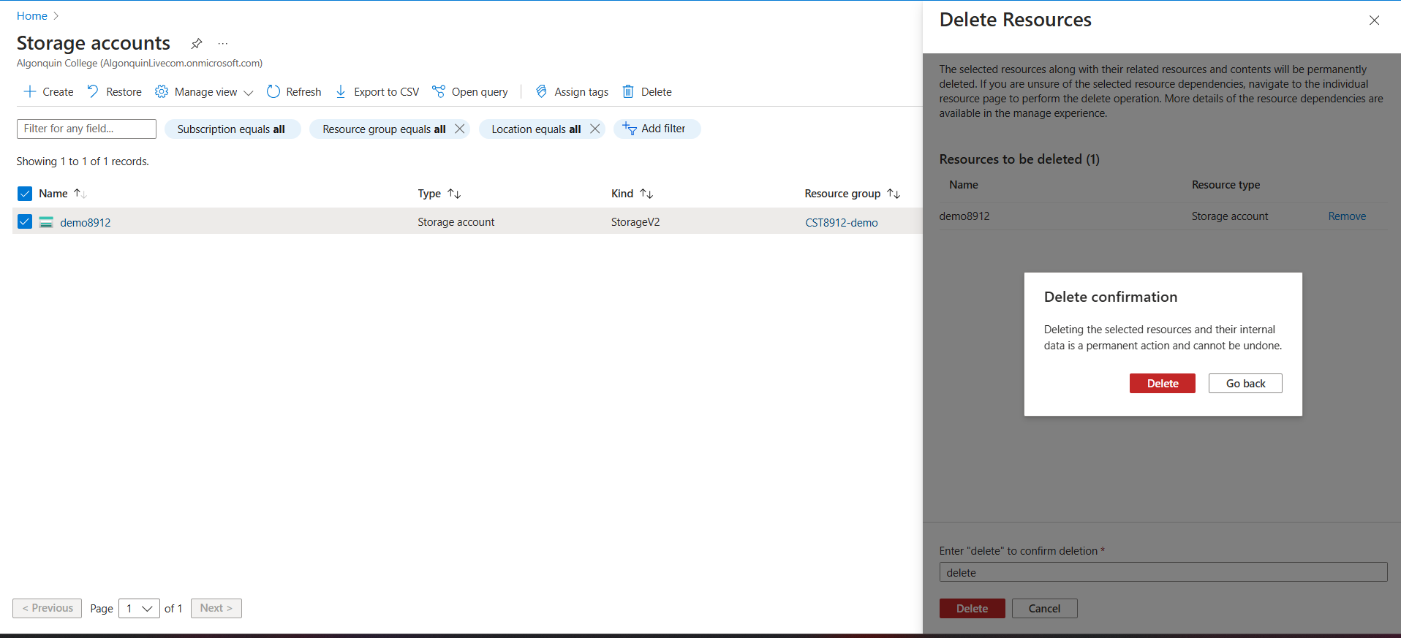

**Findings and Analysis :**

**Integration Success**: By the lab, it was successfully shown how all the different Azure services can be integrated in order to tackle the issue of a smooth data ingestion process. The usage of a public endpoint and proper firewall rules ensured the secure access to the SQL Database service.

**Data Verification:** The running of SQL queries confirmed that the files were not corrupted and that they were available. The reports ultimately proved with no doubts that the sample data was loaded correctly and was indeed retrievable.

**Process Efficiency:** The use of Azure Data Factory for the copy task managed to move data from one service to another in the fastest and easiest way. The successful run of the pipeline was the best proof that the plumbing was established and the configuration between Azure SQL Database and Azure Blob Storage was done correctly.

**Resiliency and Scalability:** The lab has shown the very important parts of cloud architecture, i.e. resiliency through backup and security measures as well as scalability based on the use of managed cloud services.

## Conclusion

The practical experience in building and provisioning a cloud solution with Azure services was the main contribution of this lab activity. The theoretical concepts like the cloud service models, and resiliency were enhanced by the hands-on exercise which showed the important role of the integration of the main cloud components. The efficiency of using Azure for data management, which involves deployment, querying and data ingestion, is evident.