**Title of Project**

AI Gesture-Controlled LED System Using Arduino and Mediapipe

**Abstract**

This project integrates AI-based hand gesture recognition using Mediapipe with Arduino to control LEDs. The system detects the number of fingers raised and correspondingly turns on LEDs, providing a novel interaction method between humans and electronic devices.

**Introduction**

Gesture-controlled systems are increasingly popular due to their intuitive interface and potential applications in various fields, including home automation and assistive technology. This project aims to create a simple yet effective gesture-controlled LED system using Arduino and Mediapipe for hand gesture detection.

**Problem Discussion**

Conventional methods of controlling electronic devices often require physical interaction, which can be cumbersome or inaccessible for some users. Gesture-controlled systems offer a solution by allowing users to interact with devices using natural gestures, enhancing usability and accessibility.

**List of Components and Specifications**

1. **Arduino Uno**: Microcontroller board for controlling LEDs.
2. **LEDs (5 units)**: Indicators for gesture recognition output.
3. **Resistors (330 ohms, 5 units)**: Current limiting for LEDs.
4. **Jumper Wires**: For connecting components on the breadboard.
5. **Breadboard**: For prototyping the circuit.
6. **USB Cable**: For programming Arduino.
7. **Computer with Python**: For running Mediapipe hand tracking software.
8. **Mediapipe and OpenCV Libraries**: For hand gesture recognition.

**Methodology Used**

1. **Hand Gesture Detection**: Use Mediapipe to recognize hand gestures and count the number of fingers raised.
2. **Communication with Arduino**: Send the count of fingers via serial communication to Arduino.
3. **LED Control**: Use Arduino to turn on LEDs based on the received data.

**Code of Project:**

Ardunio code (In C++):

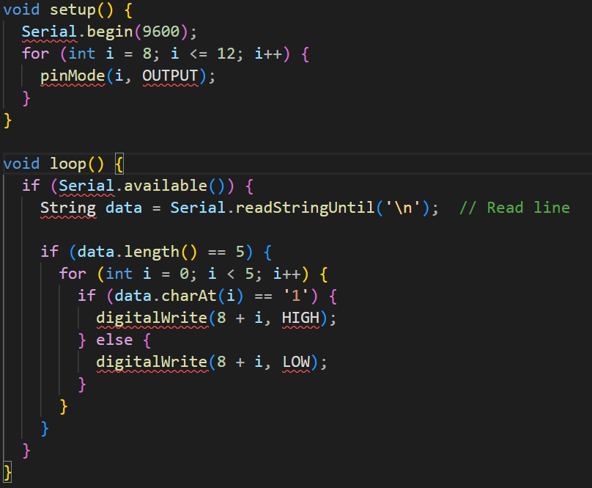

Python code:

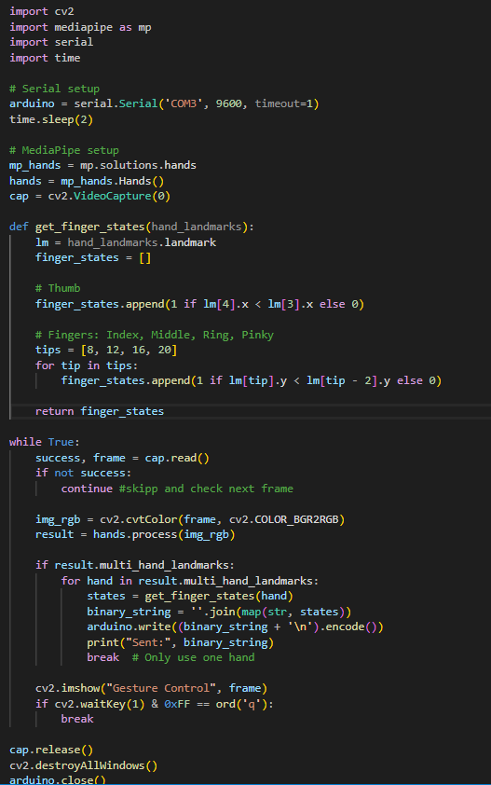

Block Diagram:

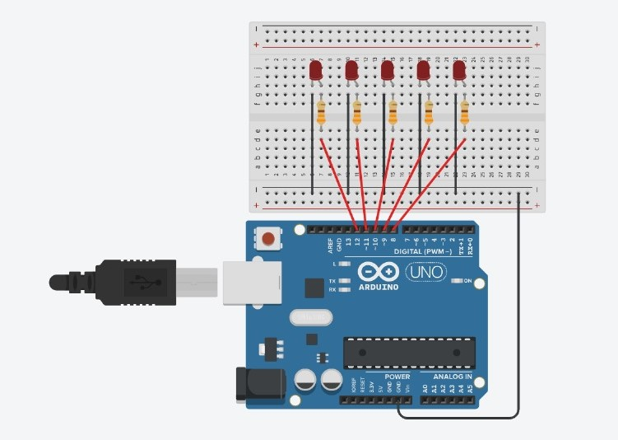

Snapshots of Output:

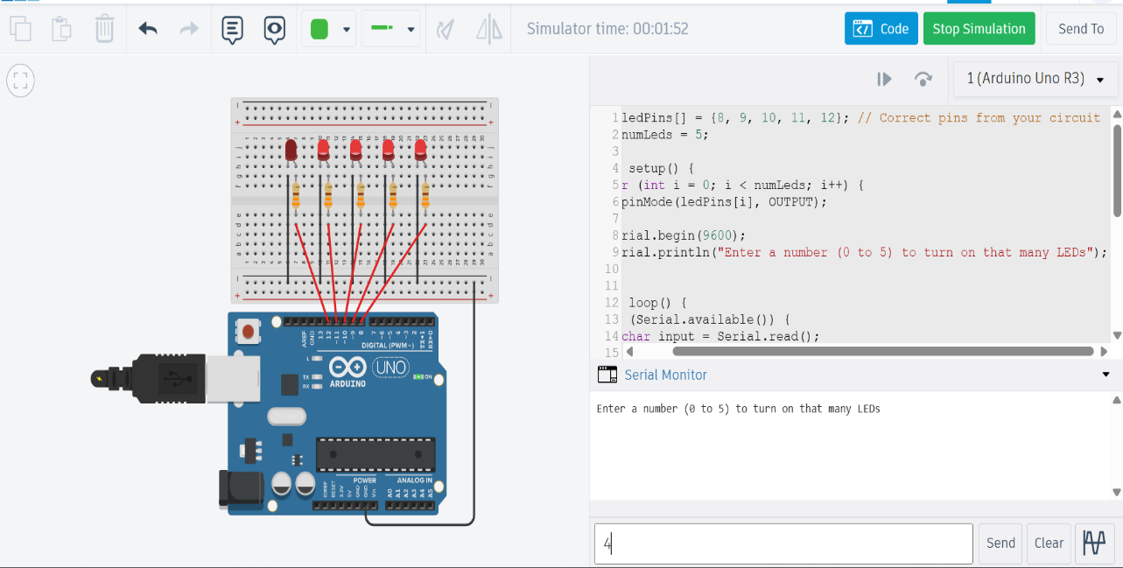

CREDITS:

|  |  |  |
| --- | --- | --- |
| SATYAM KUMAR (LEADER) | Roll: 23, PRN: 1262240634 | RESEARCH ON IDEA + CODE + WORKING PROTOTYPE |
| RUPESH KUMAR GARG | Roll: 27, PRN: 1262240690 | SIMULATION ON TINKERCAD + WORKING PROTOTYPE + CODE |
| SATYAM KUMAR JHA | Roll: 31, PRN: 1262240703 | WORKING PROTOTYPE |
| MOHAMMED AZAD | Roll: 26, PRN: 1262240680 | REPORT PREPARATION |
| ABHIJEET PATIL | Roll: 14, PRN: 1262240532 | REPORT PREPARATION |