Database Mirroring.

Before `breaking mirror the Data Bases are show as above (like **3M(Principal, Synchronized)** on Primary server.

Before ` breaking mirror the Data Bases are show as above (like **3M(Mirror, Synchronized/Restoring) on** DR server.

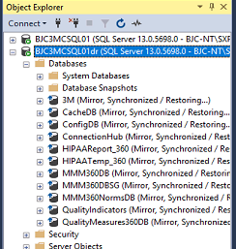

After Break mirriong.

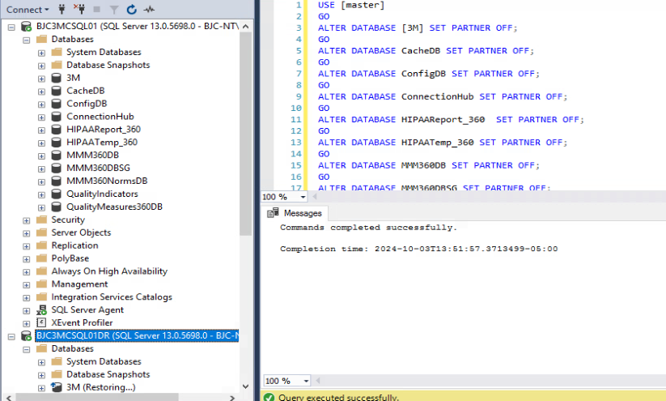

**Break Morroring by using below query if AlwasOn High availability Group is not configured.**

USE [master]

GO

ALTER DATABASE 3M SET PARTNER OFF;

GO

ALTER DATABASE CacheDB SET PARTNER OFF;

GO

ALTER DATABASE ConfigDB SET PARTNER OFF;

GO

ALTER DATABASE ConnectionHub SET PARTNER OFF;

GO

ALTER DATABASE HIPAAReport_360 SET PARTNER OFF;

GO

ALTER DATABASE HIPAATemp_360 SET PARTNER OFF;

GO

ALTER DATABASE MMM360DB SET PARTNER OFF;

GO

ALTER DATABASE MMM360DBSG SET PARTNER OFF;

GO

ALTER DATABASE MMM360NormsDB SET PARTNER OFF;

GO

ALTER DATABASE QualityIndicators SET PARTNER OFF;

GO

ALTER DATABASE QualityMeasures360DB SET PARTNER OFF;

GO

>> Take a T-Log backup in Commvault.

>>Take differential (If differential not works take full backup) and T-Log backups and restore.

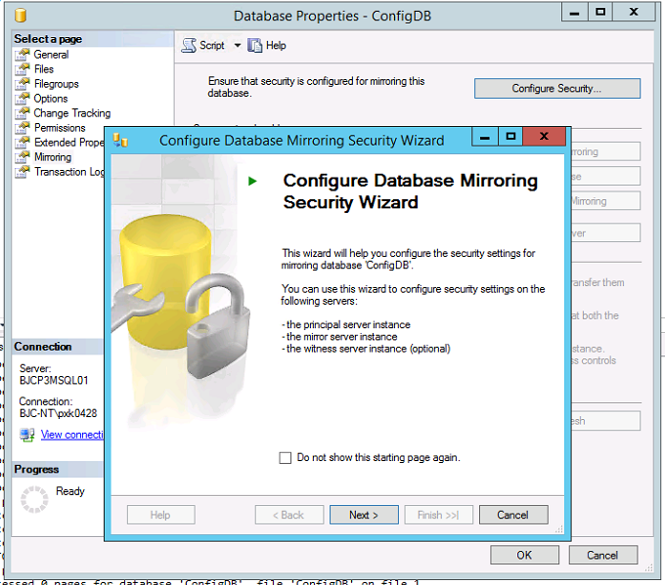

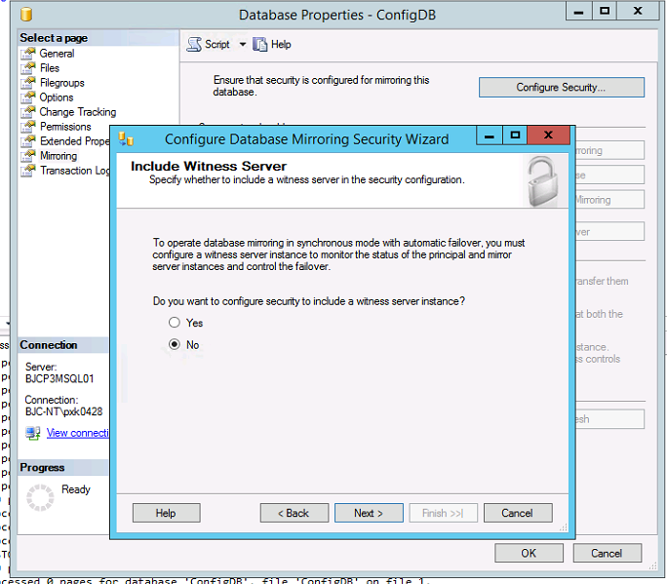

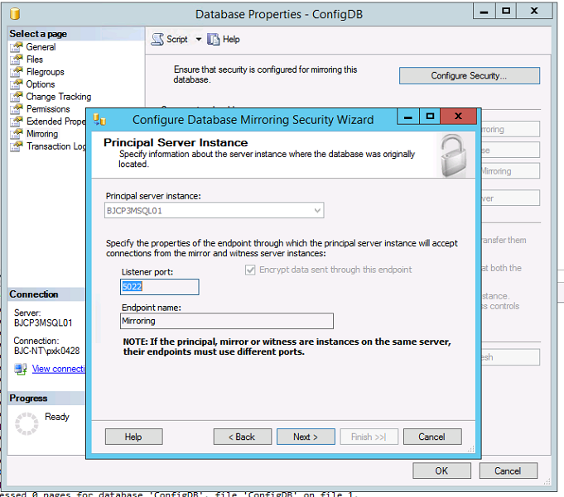

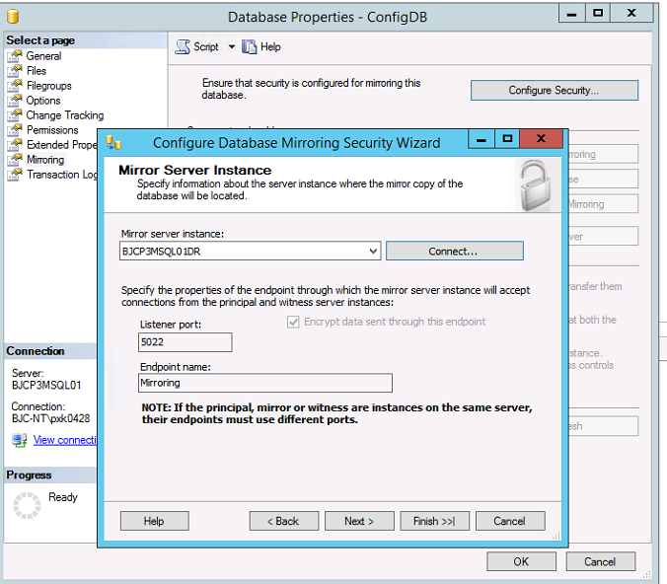

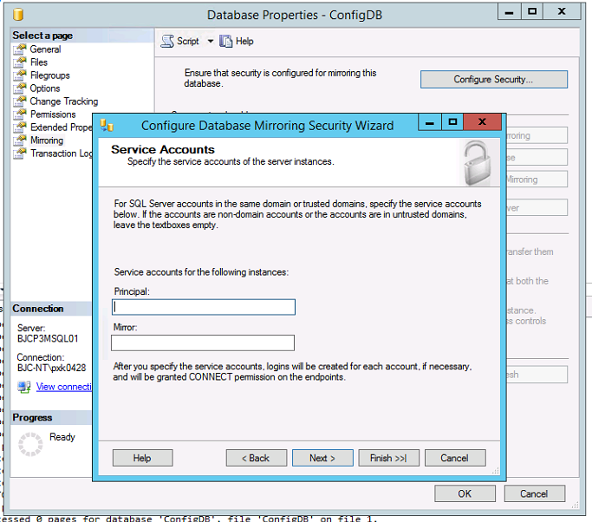

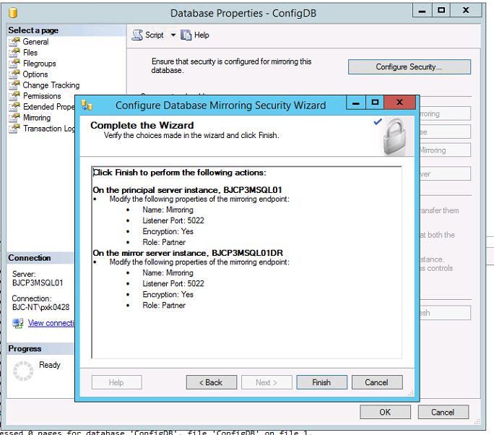

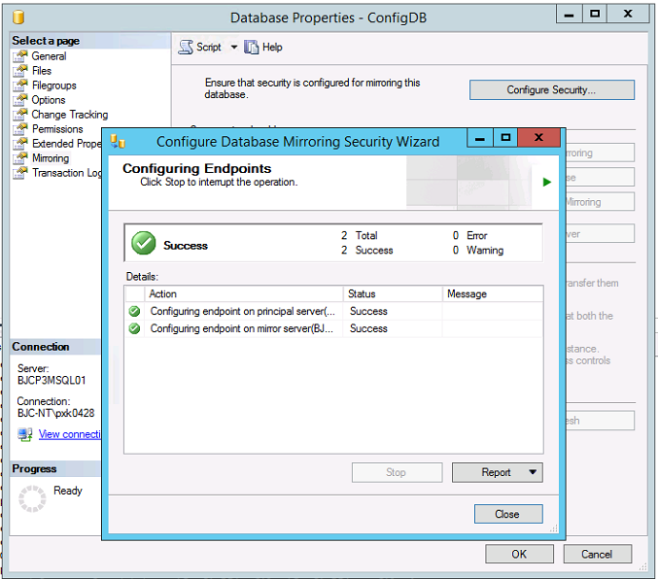

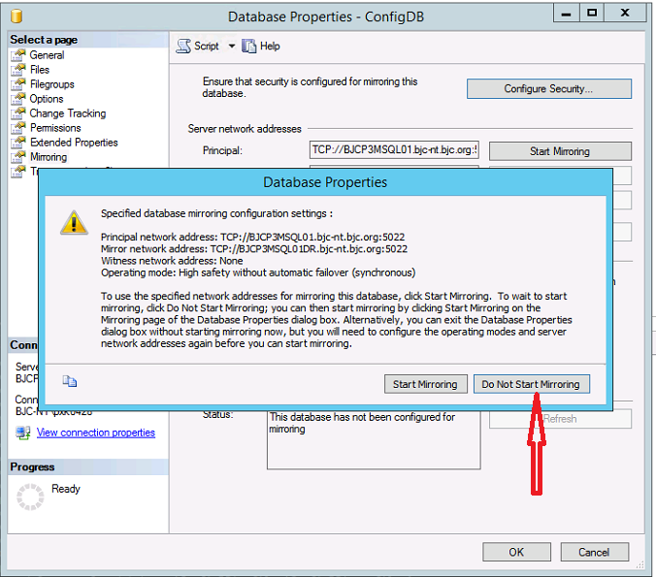

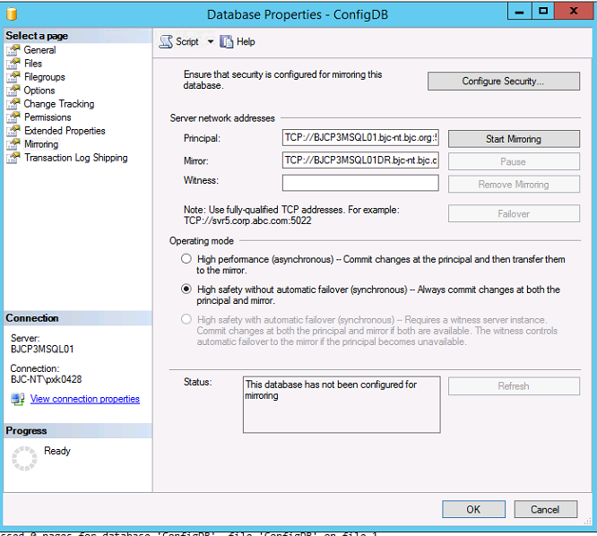

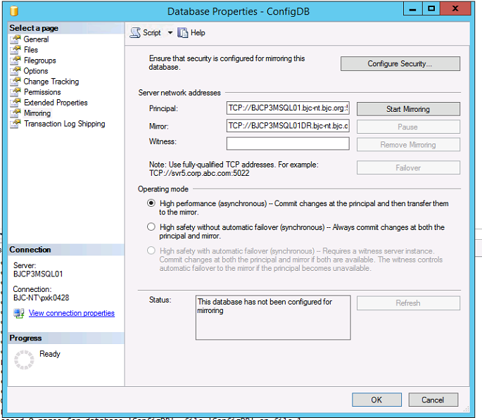

Change the Operating mode then start mirroring

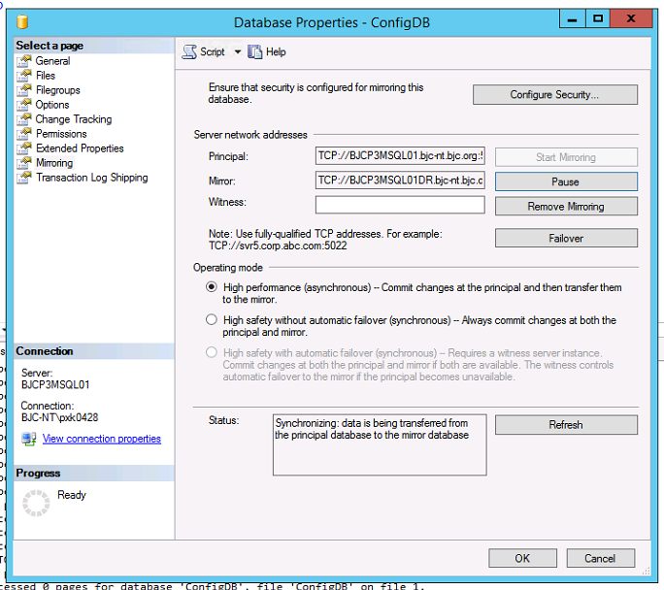

Click on OK