Job Skill Extraction Using NLP
Day-Wise Project Report
Prepared by: Satyam Singh
Role: Data Analyst Intern
Project Duration Covered: Day 1 – Day 19

Project Overview
This report documents the work completed across Days 1 through 7 of the Job Skill Extraction using NLP project, assigned as part of the internship task plan. The project's goal is to automatically identify and extract skills from unstructured job description text, moving from raw data collection through cleaning, taxonomy design, preprocessing, and a first rule-based extraction engine.
Project Title | Job Skill Extraction Using NLP
Days Covered | Day 1 – Day 7
Core Stack | Python, Pandas, NumPy, NLTK, spaCy, Scikit-learn, Jupyter Notebook, Google Colab
Primary Data Field | job_description
Pipeline Stage Reached | Rule-based dictionary skill extractor (baseline)
DAY 1 — Understanding the Problem

Objective
To build a clear conceptual foundation for the project by understanding what a job description and a skill are, why automated skill extraction is valuable, and how the project's input/output pipeline is defined.

Work Completed
- Studied the definitions of a job description and a skill in the context of NLP-based extraction.
- Reviewed why automatic skill extraction is useful (faster resume screening, skill-gap analysis, market trend tracking).
- Compared four NLP techniques relevant to the project: keyword extraction, entity extraction (NER), text classification, and information extraction, and identified how each applies here.
- Defined the project's input (raw job description text) and output (structured role + skill list) using a sample JSON schema.
- Prepared a formal Project Requirement Document covering Problem Statement, Business Objective, Technical Objective, Input, Expected Output, Technologies, and Success Criteria.

Sample Input/Output Definition
Input: "We require a Data Scientist with Python, Pandas, NumPy, Scikit-learn, SQL and AWS experience."
Output:
{
"role": "Data Scientist",
"skills": ["Python", "Pandas", "NumPy", "Scikit-learn", "SQL", "AWS"]
}

Tools & Technologies Used
Python, Jupyter Notebook, Pandas, NumPy, NLTK, spaCy, Scikit-learn, Transformers, Matplotlib, Seaborn, Power BI/Tableau, Flask/FastAPI

Outcome
A documented understanding of the problem space and a formal scope document that anchors every later stage of the project to a shared definition of success.

Deliverable
Project_Requirement_Document.pdf
DAY 2 — Dataset Collection

Objective
To source a public dataset of job descriptions suitable for skill extraction and perform an initial inspection of its structure and quality.

Work Completed
- Identified a suitable public dataset of job postings and downloaded it in CSV/JSON format.
- Loaded the dataset with pandas and inspected shape, column names, and sample rows.
- Checked for missing values across all fields, with particular attention to the job_description column.
- Identified duplicate job postings.
- Reviewed job_description text length distribution to understand typical posting size.
- Confirmed the recommended field set (job_id, job_title, company, location, job_description, experience, education, salary, job_type) and flagged job_description as the primary column for extraction.

Initial Inspection Code
import pandas as pd
df = pd.read_csv("jobs.csv")
print(df.shape)
print(df.columns)
print(df.head())
print(df.isnull().sum())

Tools & Technologies Used
Python, Pandas, Jupyter Notebook

Outcome
A clean, inspected raw dataset with documented shape, missing-value counts, and duplicate counts, ready for exploratory analysis in Day 3.

Deliverable and Screensorts
raw_jobs.csv and dataset_analysis.ipynb
- MISSING VALUES
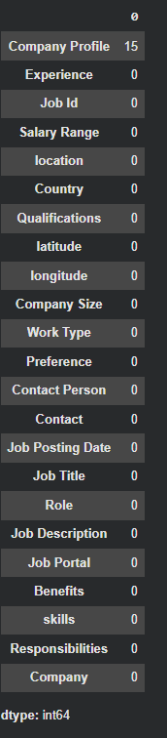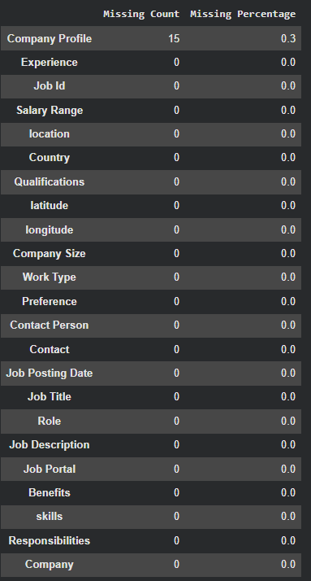
DAY 3 — Exploratory Data Analysis

Objective
To analyze the collected job dataset statistically and visually before cleaning, to understand its composition and surface data-quality issues.

Work Completed
- Calculated total number of jobs and number of unique job titles.
- Identified the most common job roles and job counts by location.
- Computed average, minimum, and maximum job_description length.
- Quantified missing values and duplicate records across the dataset.
- Built visualizations: top job titles, jobs by location, description-length distribution, missing-value summary, and top companies.

Description Length Analysis
df["description_length"] = df["job_description"].str.len()
df["description_length"].describe()

Tools & Technologies Used
Python, Pandas, Matplotlib, Seaborn, Jupyter Notebook

Outcome
A statistical and visual profile of the dataset that informed the cleaning rules applied in Day 4 (e.g. handling outlier-length descriptions, duplicates, and missing text).

Deliverable
EDA_Report.ipynb
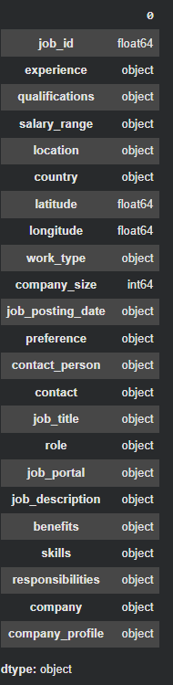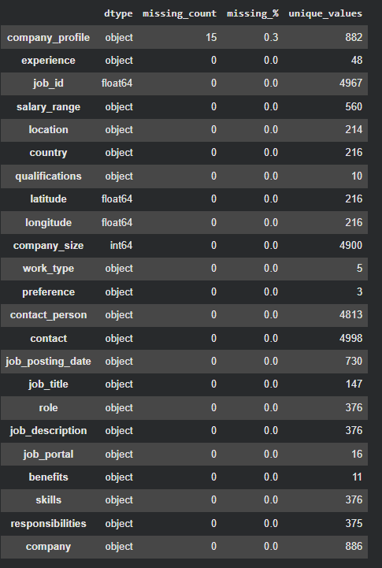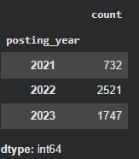

MISSING VALUE VISUALIZATION
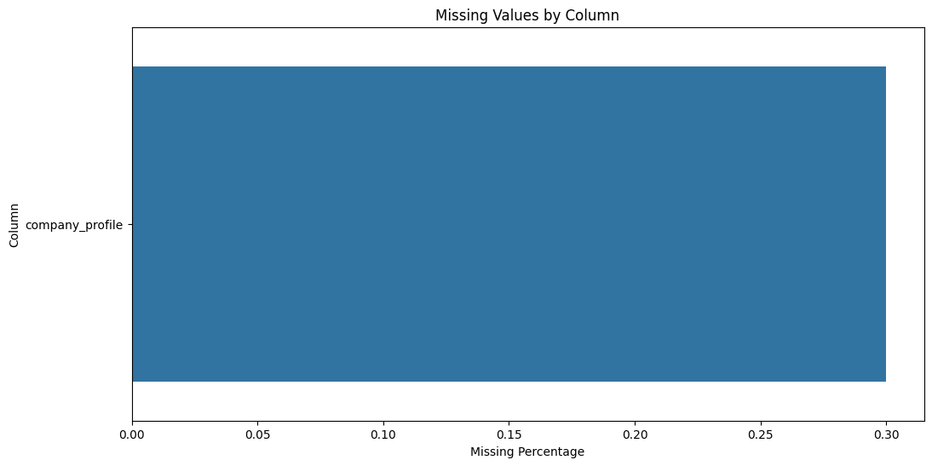
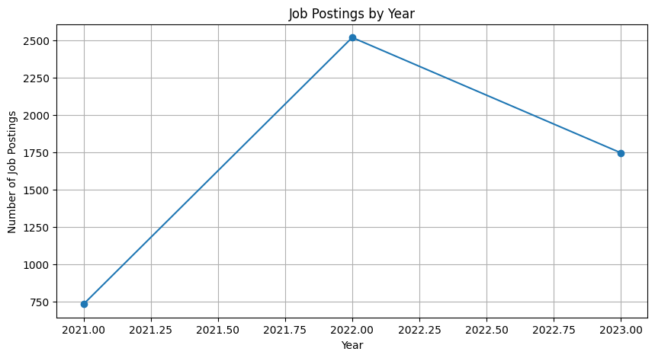

JOB VS COUNT TOP JOB TITLES
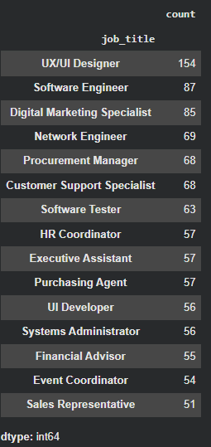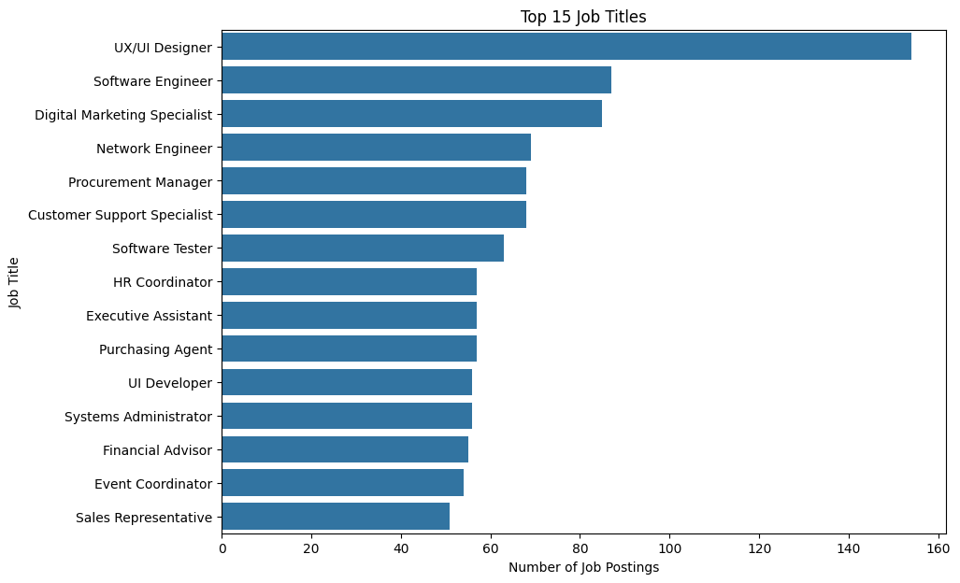

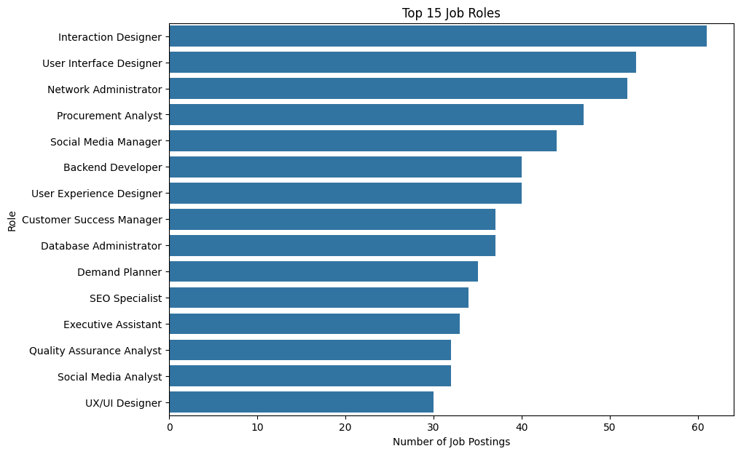

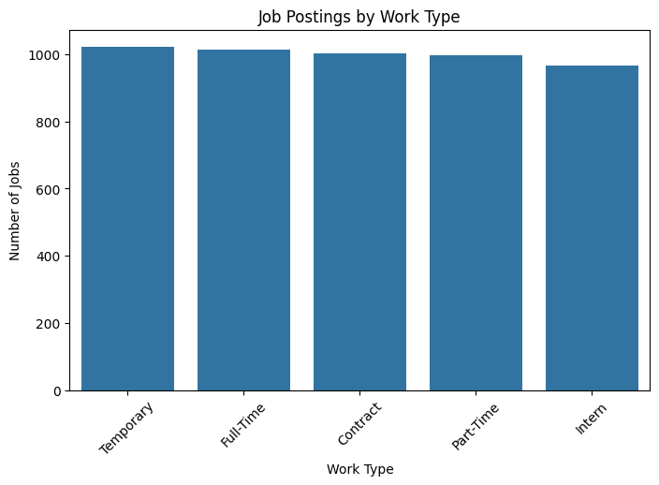
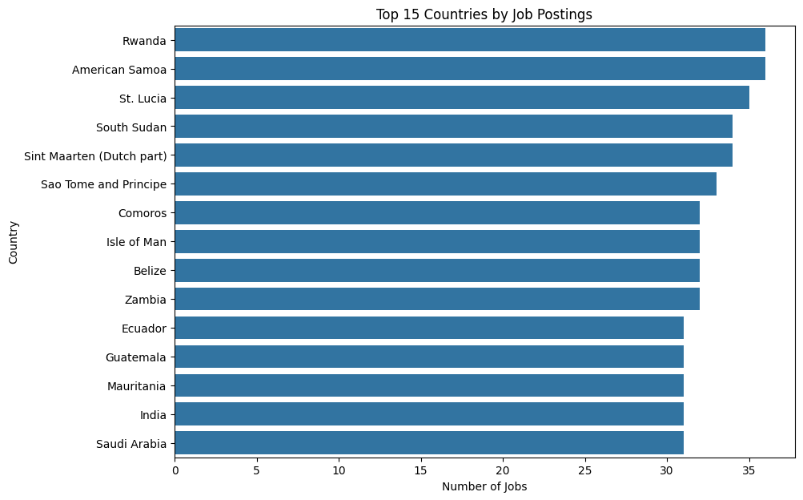

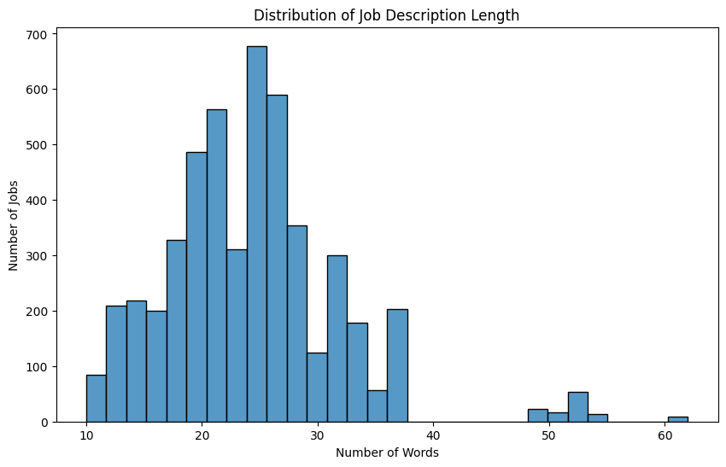
DAY 4 — Data Cleaning

Objective
To clean raw job description text so it is suitable for downstream NLP processing — a foundational step for any text-based extraction pipeline.

Work Completed
- Removed HTML tags from job description text.
- Stripped URLs and email addresses.
- Removed phone numbers and unnecessary special characters/symbols.
- Normalized whitespace (collapsed extra spaces) and removed duplicate text fragments.
- Lower-cased and trimmed the cleaned text.
- Applied the cleaning function across the full dataset to produce a new clean_description column.

Cleaning Function
import re
def clean_text(text):
text = str(text)
text = re.sub(r"http\S+", "", text)
text = re.sub(r"<.*?>", "", text)
text = re.sub(r"\S+@\S+", "", text)
text = re.sub(r"[^a-zA-Z0-9\s]", " ", text)
text = re.sub(r"\s+", " ", text)
return text.strip().lower()
df["clean_description"] = df["job_description"].apply(clean_text)

Tools & Technologies Used
Python, Pandas, re (regex)

Outcome
A normalized clean_description column, free of HTML, links, emails, phone numbers, and noisy symbols, forming the basis for tokenization and skill extraction.

Deliverable
clean_jobs.csv
DAY 5 — Skill Taxonomy Creation

Objective
To build a master, categorized dictionary of skills — the single most important reference artifact for the extraction logic used in later stages.

Work Completed
- Compiled a master list of skills spanning programming, databases, analytics tools, machine learning, and cloud platforms (e.g. Python, SQL, Java, C++, Power BI, Tableau, Excel, AWS, Azure, GCP, TensorFlow, PyTorch, Pandas, NumPy, Scikit-learn, Spark, Hadoop, Docker, Kubernetes, Git).
- Grouped skills into categories: Programming, Database, Data Analytics, Machine Learning, Cloud, and others as needed.
- Defined alias/synonym mappings so variant spellings resolve to one canonical skill name (e.g. python3 -> Python, ms excel -> Excel, postgres/postgresql -> PostgreSQL, powerbi -> Power BI, scikit learn -> Scikit-learn).
- Structured the taxonomy as a table with skill, category, and aliases columns for direct use by the extractor.

Taxonomy Structure
skill category aliases
Python Programming python3
SQL Database sql
Power BI BI powerbi, power-bi
PostgreSQL Database postgres, postgresql

Tools & Technologies Used
Python, Pandas, CSV

Outcome
A reusable master skill dictionary with categories and alias mappings, enabling consistent, normalized skill matching regardless of how a skill is phrased in a job posting.
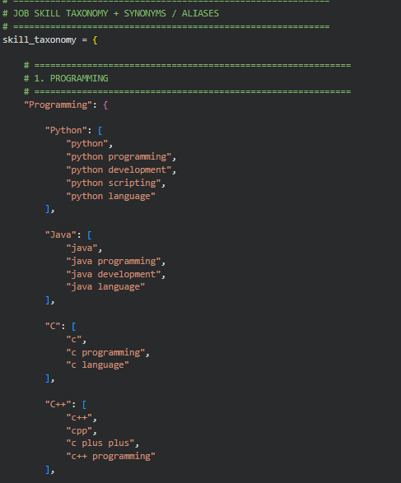

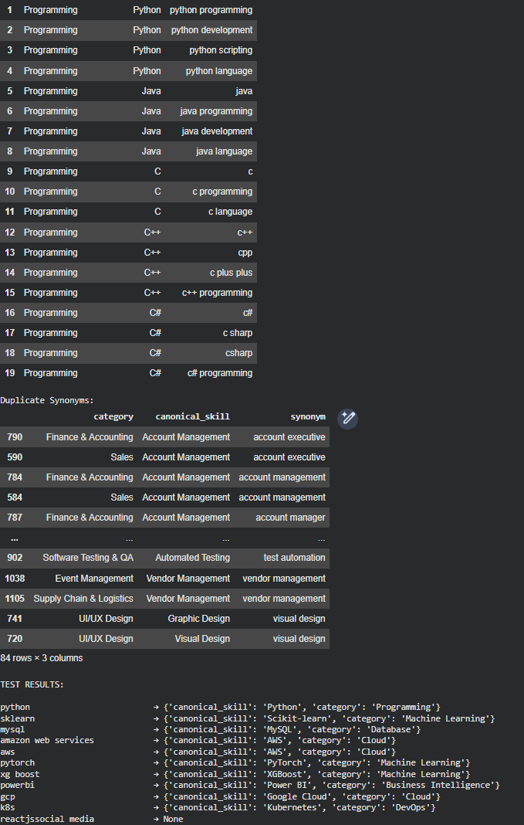

Deliverable
skill_taxonomy.csv
DAY 6 — NLP Text Preprocessing

Objective
To convert cleaned job description text into a linguistically normalized form suitable for reliable skill matching.

Work Completed
- Performed sentence segmentation and word tokenization on the cleaned text.
- Lower-cased all tokens for case-insensitive matching.
- Removed stopwords (e.g. we, are, for, with) to retain only meaningful terms.
- Applied lemmatization to reduce words to their dictionary base form.
- Ran a stemming comparison alongside lemmatization to evaluate which normalization method preserves skill-name integrity better (important since stemming can distort technical terms).

Example Transformation
Original:
We are looking for candidates with strong experience in Python and SQL.
Tokenized:
we | are | looking | for | candidates | with | strong | experience | in | python | and | sql
After stopword removal:
looking | candidates | strong | experience | python | sql

Tools & Technologies Used
Python, NLTK, spaCy, Jupyter Notebook

Outcome
A preprocessed, tokenized version of every job description, with stopwords removed and terms normalized, ready for dictionary-based skill matching.
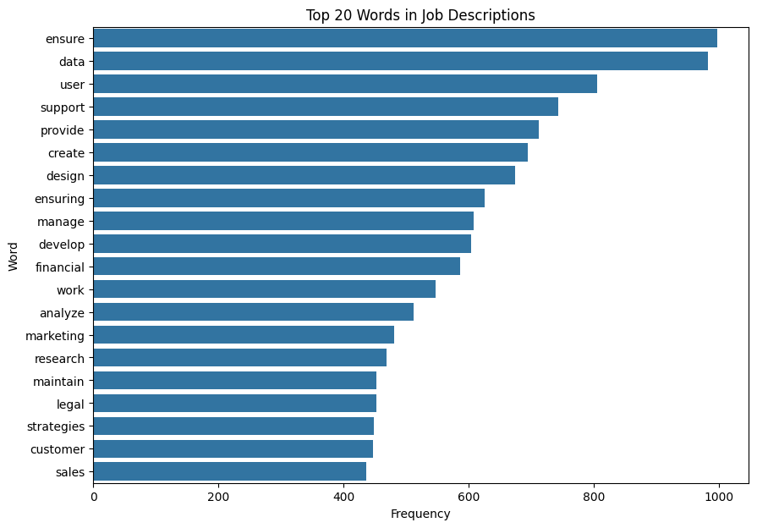

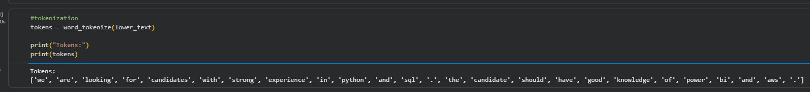

AFTER STOPWORD REMOVAL

Deliverable
NLP_Preprocessing.ipynb

WORD CLOUD VISUALIZATION

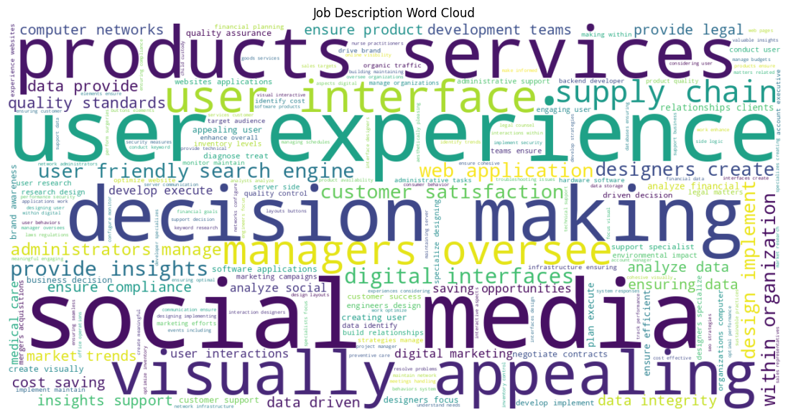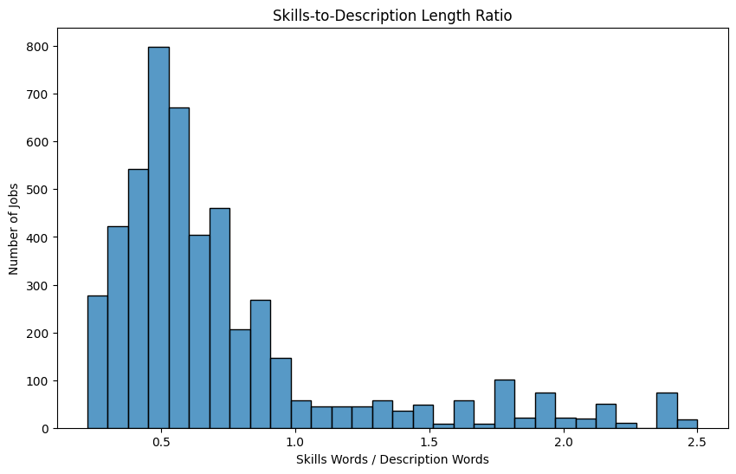

DAY 7 — Rule-Based Skill Extractor

Objective
To build the first working version of the skill extraction engine using direct dictionary lookups against the Day 5 taxonomy.

Work Completed
- Implemented a dictionary-based matching function that scans each cleaned job description for every skill in the master skill list.
- For each job description, searched for occurrences of each known skill (e.g. Python, SQL, Power BI, Tableau, Excel, AWS) using case-insensitive substring matching.
- Collected all matched skills per job description into a result list.
- Validated the extractor against sample descriptions to confirm expected skills were correctly identified.

Extraction Function
skills = ["python", "sql", "power bi", "tableau", "excel", "aws"]
def extract_skills(text):
found = []
for skill in skills:
if skill in text.lower():
found.append(skill)
return found
# Sample output: Python, SQL, Power BI, AWS

Tools & Technologies Used
Python, Pandas

Outcome
A functioning rule-based skill extractor that reliably tags known skills from job descriptions, serving as the baseline before more advanced (NER/ML-based) extraction methods.

Deliverable
rule_based_extractor.py

Summary & Next Steps
Across Days 1–7, the project moved from problem definition and dataset collection through exploratory analysis, text cleaning, taxonomy design, NLP preprocessing, and a first working rule-based skill extractor. The pipeline currently extracts skills via exact/substring dictionary matching against the Day 5 taxonomy.

DAY 8 — Improve Skill Extraction Using Regex & Phrase Matching
1. Objective
The objective of Day 8 was to improve the rule-based skill extraction system developed on Day 7.
The basic dictionary-based approach can have problems with variations of the same skill. For example:

- Python
- Python 3
- Python3
- Python programming
All of these should ideally be mapped to the same canonical skill: Python
Therefore, regular expressions and phrase matching were introduced to improve skill recognition.

2. Problem With Basic Dictionary Matching
The initial extractor searched for skills directly in the job description.
For example:
skills = [
"python",
"sql",
"power bi",
"tableau",
"excel",
"aws"
]
A simple implementation was:
def extract_skills(text):
found = []

for skill in skills:
if skill in text.lower():
found.append(skill)

return found
Although this works for straightforward cases, it has limitations.
Example
A job description may contain: Python 3 programming experience
A simple search for "python" can identify Python, but different variations such as:
Python3
Python programming
Python 3
need to be handled consistently.
There can also be problems with:
- word boundaries
- different spellings
- multi-word skills
- abbreviations
- skill aliases
- duplicate matches

3. Regular Expression Matching
Regular expressions were introduced to identify skill variations more reliably.
Example: import re
pattern = r"\bpython(?:\s*3)?\b"
This pattern can recognize variations such as:
Python
Python 3
Python3
Explanation
\b represents a word boundary. Python matches the word Python.
(?:\s*3)? optionally matches:
- 3
- 3
- nothing
Therefore:
Python
Python 3
Python3
can all be recognized as Python.
4. Why Phrase Matching Was Needed
Job descriptions frequently contain multi-word skills.
Examples from the taxonomy include:
machine learning
deep learning
natural language processing
power bi
data science
social media
account management
data visualization
Searching for individual words is not sufficient.
For example:
machine learning
should be recognized as one skill, rather than treating:
machine
learning
as separate skills.
Therefore, phrase matching was implemented.

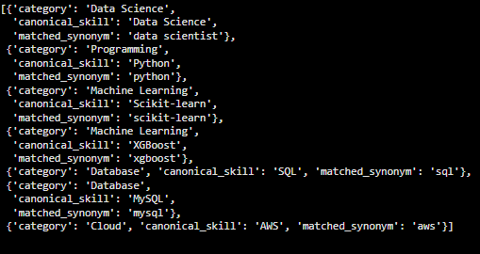
JSON FORMAT JOB TITLE VS SKILLS EXTRACTED
[{"index":0,"job_title":"Digital Marketing Specialist","extracted_skills":"{'category': 'Digital Marketing', 'canonical_skill': 'Social Media', 'matched_synonym': 'social media'},{'category': 'Digital Marketing', 'canonical_skill': 'Brand Marketing', 'matched_synonym': 'brand awareness'}"},{"index":1,"job_title":"Web Developer","extracted_skills":"{'category': 'Web Development', 'canonical_skill': 'Web Development', 'matched_synonym': 'web developers'}"},{"index":2,"job_title":"Operations Manager","extracted_skills":"{'category': 'Software Testing & QA', 'canonical_skill': 'Quality Control', 'matched_synonym': 'quality control'},{'category': 'Operations', 'canonical_skill': 'Quality Control', 'matched_synonym': 'quality control'}"},{"index":3,"job_title":"Network Engineer","extracted_skills":"{'category': 'Networking', 'canonical_skill': 'Wireless Networking', 'matched_synonym': 'wireless network'}"},{"index":4,"job_title":"Event Manager","extracted_skills":"{'category': 'Event Management', 'canonical_skill': 'Logistics', 'matched_synonym': 'logistics'},{'category': 'Finance & Accounting', 'canonical_skill': 'Budgeting', 'matched_synonym': 'budgeting'}"},{"index":5,"job_title":"Software Tester","extracted_skills":"{'category': 'Software Testing & QA', 'canonical_skill': 'Quality Assurance', 'matched_synonym': 'quality assurance'},{'category': 'Operations', 'canonical_skill': 'Quality Control', 'matched_synonym': 'quality assurance'}"},{"index":6,"job_title":"Teacher","extracted_skills":"{'category': 'Education & Teaching', 'canonical_skill': 'Teaching', 'matched_synonym': 'teacher'},{'category': 'Education & Teaching', 'canonical_skill': 'Lesson Planning', 'matched_synonym': 'lesson plans'}"},{"index":7,"job_title":"UX/UI Designer","extracted_skills":"{'category': 'UI/UX Design', 'canonical_skill': 'UI Design', 'matched_synonym': 'user interface designers'}"},{"index":8,"job_title":"UX/UI Designer","extracted_skills":"{'category': 'UI/UX Design', 'canonical_skill': 'UX Design', 'matched_synonym': 'interaction designers'},{'category': 'UI/UX Design', 'canonical_skill': 'UI Design', 'matched_synonym': 'digital interfaces'}"},{"index":9,"job_title":"Wedding Planner","extracted_skills":"{'category': 'Event Management', 'canonical_skill': 'Budget Management', 'matched_synonym': 'budget management'},{'category': 'Finance & Accounting', 'canonical_skill': 'Budgeting', 'matched_synonym': 'budget management'}"}]

CSV FORMAT OF IMPROVED PARSE AND SKILL MATCHING
index,job_index,job_id,job_title,category,canonical_skill,matched_synonym
0,0,1089840000000000.0,Digital Marketing Specialist,Digital Marketing,Social Media,social media
1,0,1089840000000000.0,Digital Marketing Specialist,Digital Marketing,Brand Marketing,brand awareness
2,1,398454000000000.0,Web Developer,Web Development,Web Development,web developers
3,2,481640000000000.0,Operations Manager,Software Testing & QA,Quality Control,quality control
4,2,481640000000000.0,Operations Manager,Operations,Quality Control,quality control
5,3,688193000000000.0,Network Engineer,Networking,Wireless Networking,wireless network
6,4,117058000000000.0,Event Manager,Event Management,Logistics,logistics
7,4,117058000000000.0,Event Manager,Finance & Accounting,Budgeting,budgeting
8,5,116831000000000.0,Software Tester,Software Testing & QA,Quality Assurance,quality assurance
9,5,116831000000000.0,Software Tester,Operations,Quality Control,quality assurance
10,6,1292170000000000.0,Teacher,Education & Teaching,Teaching,teacher
11,6,1292170000000000.0,Teacher,Education & Teaching,Lesson Planning,lesson plans
12,7,1498780000000000.0,UX/UI Designer,UI/UX Design,UI Design,user interface designers
13,8,1680290000000000.0,UX/UI Designer,UI/UX Design,UX Design,interaction designers
14,8,1680290000000000.0,UX/UI Designer,UI/UX Design,UI Design,digital interfaces
15,9,255628000000000.0,Wedding Planner,Event Management,Budget Management,budget management
16,9,255628000000000.0,Wedding Planner,Finance & Accounting,Budgeting,budget management
17,10,2696960000000000.0,QA Analyst,Software Testing & QA,Performance Testing,performance testing
18,11,1446190000000000.0,Litigation Attorney,Legal,Family Law,family law
19,12,1914120000000000.0,Mechanical Engineer,Engineering,Mechanical Engineering,mechanical design

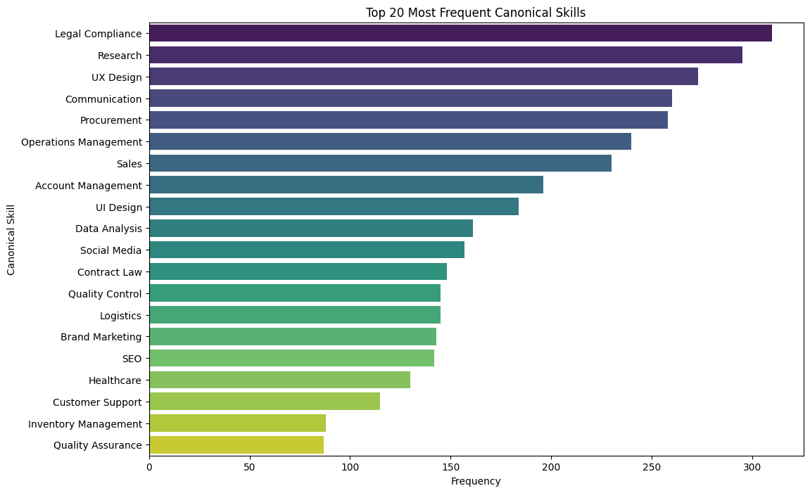

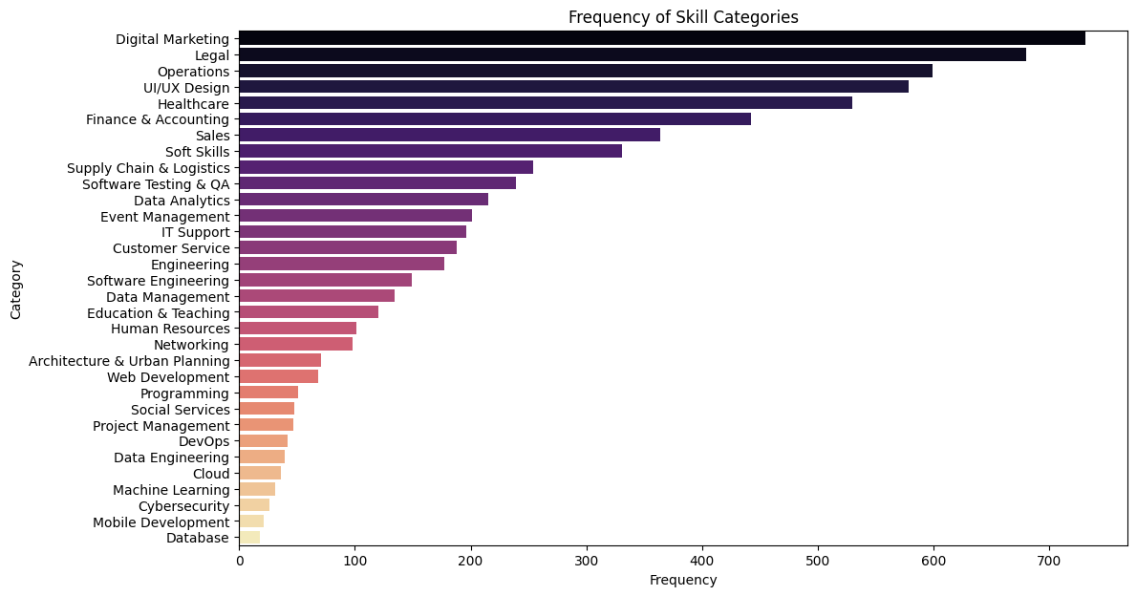

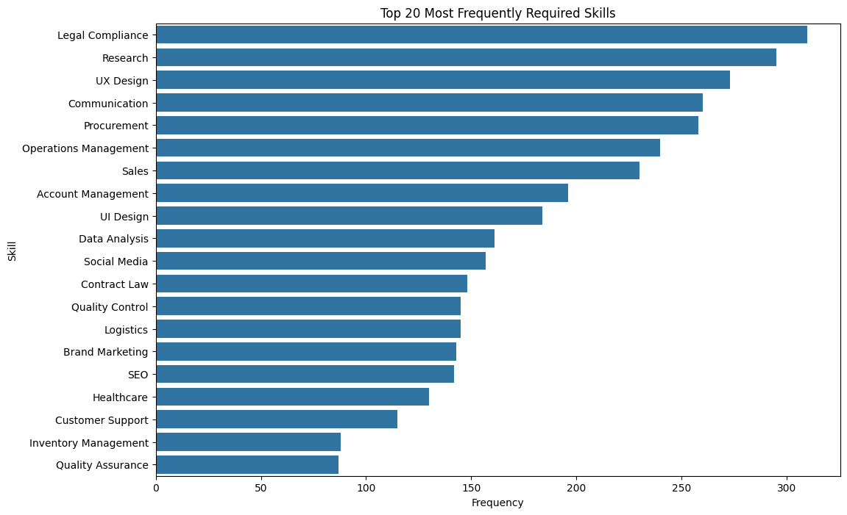
5. spaCy PhraseMatcher
The project uses spaCy PhraseMatcher to identify skill phrases inside job descriptions.
The general process is:

Job Description
↓
spaCy NLP Processing
↓
PhraseMatcher
↓
Skill Phrase Detection
↓
Synonym Mapping
↓
Canonical Skill
↓
Skill Category
6. Taxonomy-Based Phrase Matching
Instead of maintaining only a small list of skills, the project uses the larger skill taxonomy developed during the previous stages.
The taxonomy contains:
Category
↓
Canonical Skill
↓
Synonyms / Aliases

For example:
Programming
Python
python
python programming
python development
python scripting

This allows different expressions to map to the same canonical skill.

7. Synonym-to-Skill Mapping
A mapping was created so that detected synonyms can be converted into their canonical skills.
Example:
synonym_to_skill["python"] maps to:
canonical_skill → Python
category → Programming
Similarly:
Sklearn maps to:
Scikit-learn
Machine Learning
and:
powerbi maps to:
Power BI
Business Intelligence
This is important because the final output should contain standardized skills instead of every variation found in the text.
8. PhraseMatcher Implementation
The taxonomy synonyms were converted into spaCy patterns.
Conceptually:
matcher = PhraseMatcher(nlp.vocab, attr="LOWER")
Using:
attr="LOWER"
allows matching without depending on capitalization.
For example:
- Python
- python
- PYTHON
can be treated consistently.
Patterns are then created from the synonyms:
patterns = []

for synonym in synonym_to_skill.keys():
patterns.append(nlp.make_doc(synonym))
The patterns are added to the matcher:
matcher.add("SKILLS", patterns)

9. Skill Extraction Function
A spaCy-based extraction function was developed to process each job description.
The function performs the following operations:
Input Job Description
↓
Convert text into spaCy Doc
↓
Run PhraseMatcher
↓
Find matching skill phrases
↓
Look up synonym in taxonomy
↓
Get canonical skill
↓
Get category
↓
Remove duplicate canonical skills
↓

Return structured result
The resulting information contains fields such as:
category
canonical_skill
matched_synonym
Example:
Python → Programming → matched synonym: python

10. Duplicate Skill Handling
One important improvement was duplicate removal.
For example, a job description might contain:
- Python
- Python programming
- Python
The extractor should not produce:
- Python
- Python
- Python programming
Instead, all of these should map to: Python
Therefore, the final extraction uses the canonical skill rather than simply returning every phrase match.

11. Testing the Extractor
A test job description was used containing several skills:
- Python
- Python programming
- SQL
- Power BI
- machine learning
- natural language processing
The raw PhraseMatcher output initially showed the individual matched phrases.
After applying canonical mapping and duplicate removal, the output became:
- Python
- SQL
- Power BI
- Machine Learning
- Natural Language Processing
This demonstrates that different mentions can be normalized into unique canonical skills.

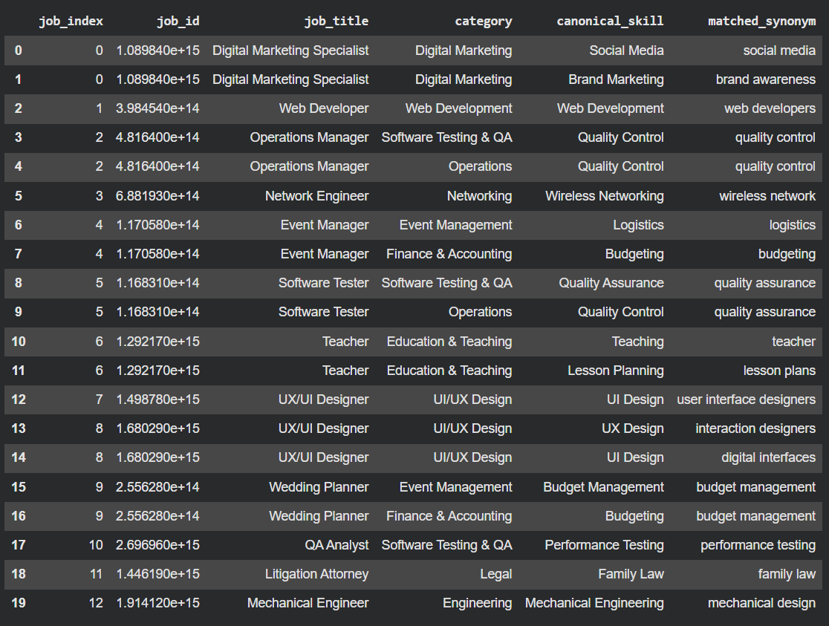
13. Applying the Extractor to the 5K Dataset
After testing the extractor, it was applied to the 5,000-job dataset.
The extraction was performed on:
df["job_description_matching"]
and the results were stored in:
df["extracted_skills_spacy"]
This created a structured skill-extraction result for each job description.

14. Initial Results
After applying the improved extraction approach to the 5K dataset, approximately:
- Total Jobs: 5,000
- Jobs with detected skills: ~3,650
- Jobs without detected skills: ~1,350
- Skill coverage: ~72%

After Improvement :

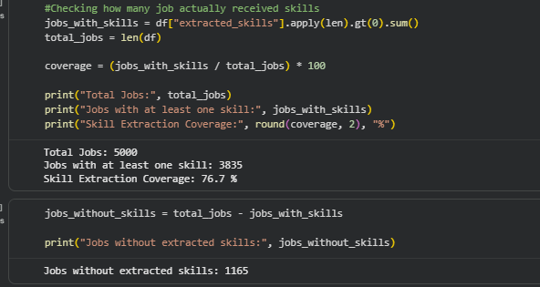

15. Analysis of Zero-Skill Jobs
The zero-skill jobs were then inspected to understand whether the issue was with the extractor or the taxonomy.
Examples included:
- Key Account Manager
strategic account managers nurture relationships with key clients...
Potential missing concepts:
Account Management
Account Strategy
Client Relationship Management
- Data Engineer
a data architect designs and manages data infrastructure...
Potential missing concepts:
Data Architecture
Data Infrastructure
- Technical Writer
documentation specialists create and manage documents...
Potential missing concepts:
Technical Writing
Documentation
This analysis showed that some zero-skill results were caused by missing taxonomy synonyms, rather than a failure of PhraseMatcher.

16. Important Finding
Not every zero-skill job represents an extraction failure.
Some jobs belong to domains that are currently outside the project's taxonomy.
Examples observed include:
- Nurse Practitioner
- Wedding Planner
- Urban Planner
- Structural Engineer
- Investment Analyst
Therefore, forcing these jobs into the existing technology/data/business taxonomy could create false-positive skill extraction.
The objective is therefore not simply:
Zero skills = 0
Instead, the goal is:
Maximize meaningful skill extraction while minimizing false positives.

17. Day 8 Outcome
By the end of Day 8, the skill extraction system was improved from simple dictionary matching to a more robust approach using:
- Regular expressions
- spaCy NLP
- spaCy PhraseMatcher
- Multi-word phrase matching
- Case-insensitive matching
- Skill synonyms and aliases
- Canonical skill mapping
- Duplicate canonical-skill removal
- Taxonomy-based categorization
- Zero-skill analysis

Final pipeline
5K Job Dataset
↓
Job Description
↓
Text Preprocessing
↓
Regex / Phrase Matching
↓
spaCy PhraseMatcher
↓
Synonym Detection
↓
Canonical Skill Mapping
↓
Category Mapping
↓
Duplicate Removal
↓
Structured Extracted Skills
↓
Skill Analysis

18. Deliverable
Deliverable: NLP_Skill_Extraction_Day8.ipynb
The notebook contains:
- Regex-based skill matching
- spaCy setup
- PhraseMatcher implementation
- Taxonomy integration
- Synonym mapping
- Canonical skill normalization
- Duplicate removal
- Test cases
- Extraction on the 5K dataset
- Skill coverage analysis
- Zero Skills Jobs analysis

Day 9 — spaCy Phrase Matching & Skill Extraction Documentation
Objective
Improve the rule-based skill extraction system by using spaCy PhraseMatcher to identify skills and their variations from job descriptions.
Work Performed
- Loaded the en_core_web_sm spaCy model.
- Created a PhraseMatcher using case-insensitive matching.
- Used the existing skill taxonomy and synonyms/aliases to create matching patterns.
- Matched skills against the job_description_matching column.
- Mapped matched phrases to their canonical skill and category.
- Removed duplicate skill matches.
- Stored the extracted results in a new column:
extracted_skills_spacy
Example
Job Description:
Candidates should have experience with Python programming, SQL and Power BI.
Extracted Skills:
- Python
- SQL
- Power BI
Output Structure
Each extracted skill contains:
category
canonical_skill
matched_text
Example:
Data Analytics → Data Analysis → data analysis
Programming → Python → python programming
Business Intelligence → Power BI → power bi

Result
The spaCy PhraseMatcher provided a more flexible approach to matching multi-word phrases and skill synonyms compared with simple string matching. It was applied to the 5,000-record job dataset and stored separately for further comparison and analysis.

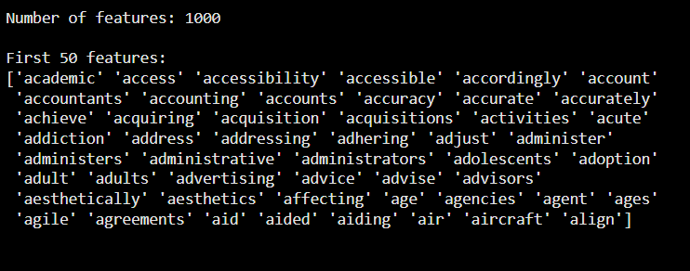

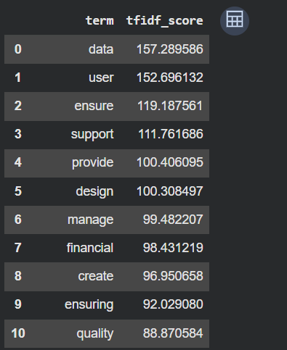
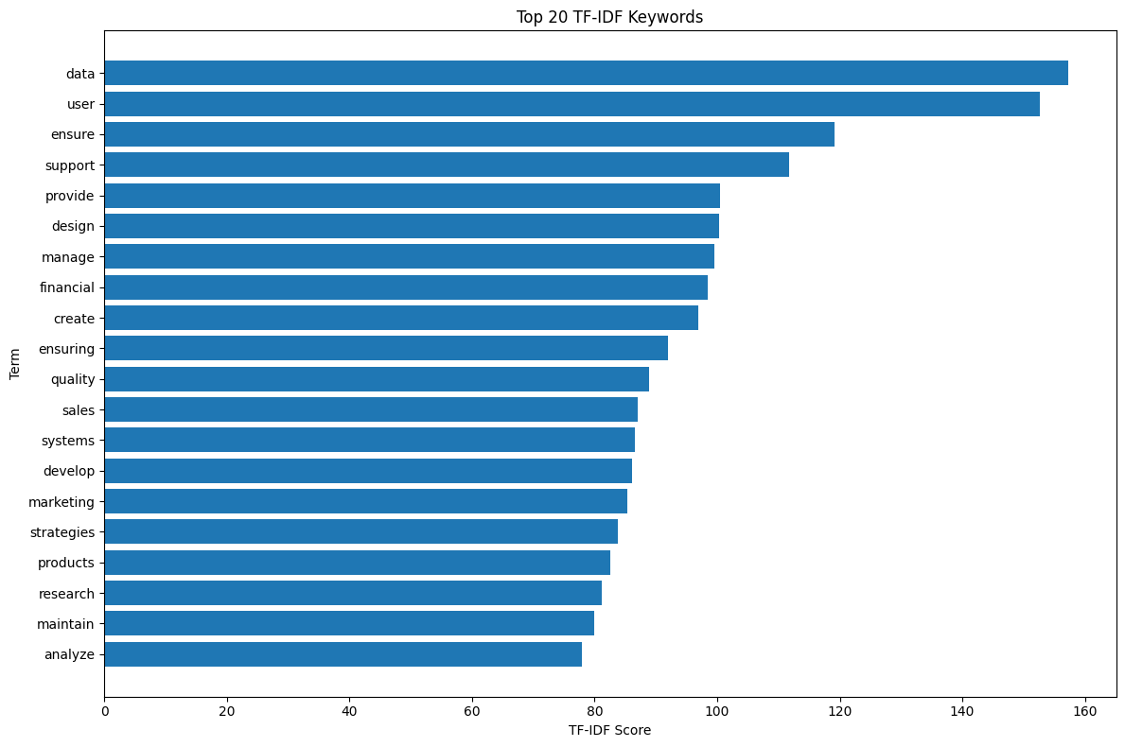

Tools Used
- Python
- Pandas
- spaCy
- PhraseMatcher
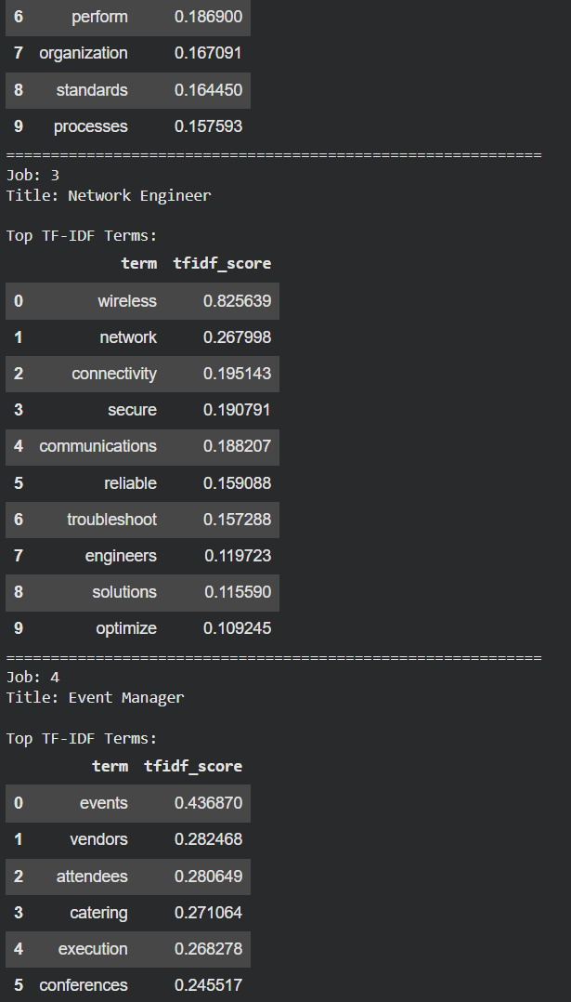

DAY 10 — N-Gram Analysis
1. Objective
The objective of Day 10 was to identify single-word and multi-word terms from job descriptions using N-Gram analysis.
Many technical and professional skills consist of multiple words, such as:
- Machine Learning
- Deep Learning
- Power BI
- Natural Language Processing
- Data Analysis
- Computer Vision
- Cloud Computing
A simple single-word tokenizer may not capture these skill phrases effectively. Therefore, unigrams, bigrams, and trigrams were generated from the 5,000 job descriptions.
2. Dataset Used
- Dataset: 5,000 job records
- Text column: job_description_matching
- Task: Extract important unigrams, bigrams, and trigrams from job descriptions.
3. Tools & Libraries
- Python
- Pandas
- NumPy
- Scikit-learn
- Matplotlib
- TfidfVectorizer

4. Methodology
The TfidfVectorizer was configured with:
TfidfVectorizer(
ngram_range=(1, 3),
stop_words="english"
)
The configuration generates:
N-Gram | Meaning | Example
Unigram | One word | Python
Bigram | Two words | Machine Learning
Trigram | Three words | Natural Language Processing

5. Implementation Steps
Step 1 — Prepare Job Descriptions
Missing descriptions were replaced with empty strings and the text was converted to string format.
Step 2 — Generate N-Grams
TF-IDF was applied with:
ngram_range = (1,3)
This generated unigrams, bigrams, and trigrams simultaneously.
Step 3 — Calculate TF-IDF Scores
The average TF-IDF score was calculated for each generated term to identify important terms across the dataset.
Step 4 — Separate N-Grams
The generated terms were divided into:
- Unigrams
- Bigrams
- Trigrams
Step 5 — Compare With Skill Taxonomy
The discovered multi-word terms were compared against the existing skill taxonomy and synonyms.
This helped identify terms that may already exist in the taxonomy and potential terms that are not currently included.
6. Key Outputs
The following outputs were generated:
A. Top Unigrams
A table containing:
ngram | tfidf_score
showing the highest-scoring single-word terms.
B. Top Bigrams
Important two-word phrases were identified, such as potential skill phrases like:
machine learning
data analysis
social media
business development
C. Top Trigrams
Important three-word phrases were identified, including potential technical skill phrases such as:
natural language processing
D. Multi-Word Skill Candidates
Bigrams and trigrams were compared with the existing taxonomy to identify potential missing multi-word skills.

7. Visualization
Bar charts were created for:
- Top 15 Bigrams
- Top 15 Trigrams
These visualizations show which multi-word terms received the highest average TF-IDF scores.
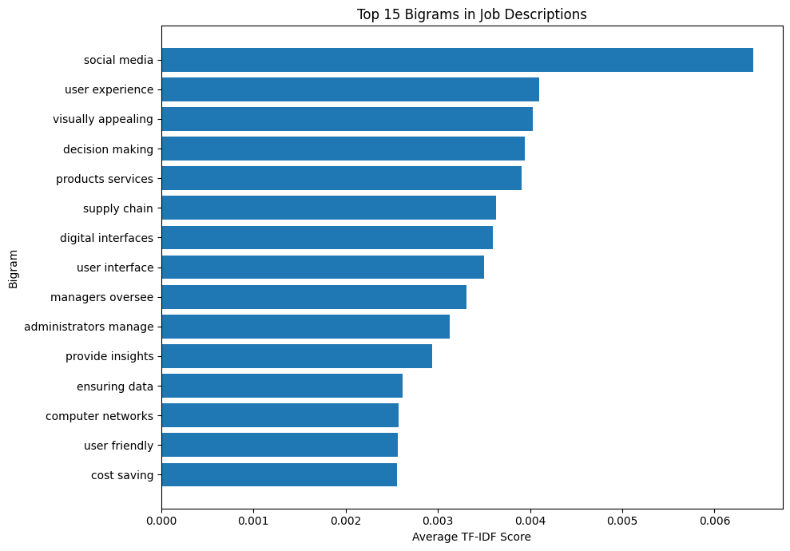
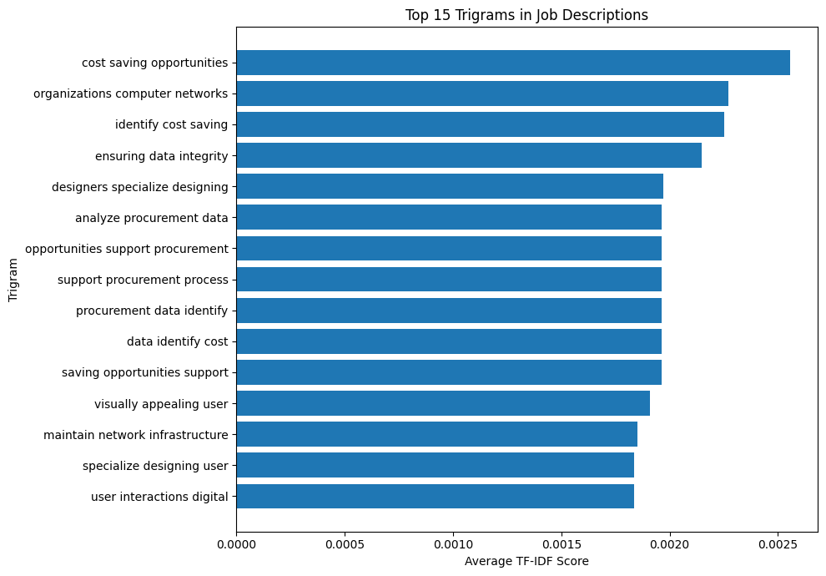

8. Deliverables
The following files/results were produced:
NLP_NGram_Analysis.ipynb
ngram_analysis_results.csv
unigrams.csv
bigrams.csv
trigrams.csv

9. Outcome
Successfully implemented N-Gram analysis on the 5,000 job descriptions using TF-IDF. Unigrams, bigrams, and trigrams were generated to identify important single-word and multi-word terms. The extracted multi-word terms were compared with the existing skill taxonomy to identify potential missing skill phrases and improve the overall skill extraction system.

10. Learning
Through this task, I learned:
- What N-Grams are and why they are useful in NLP.
- Difference between unigrams, bigrams, and trigrams.
- How to generate N-Grams using TfidfVectorizer.
- How TF-IDF can help identify important terms.
- How multi-word phrases can improve skill discovery.
- How N-Gram analysis can support skill taxonomy improvement.

DAY 11 — Word Embeddings and Semantic Similarity

1. Objective
The objective of Day 11 was to improve the job-skill extraction system by introducing semantic similarity.
The earlier rule-based/taxonomy approach primarily depended on exact words and predefined synonyms. This can fail when two expressions have the same meaning but different wording.
For example:
- ML
- Machine Learning
Both refer to the same concept, but simple keyword matching may not always recognize them as equivalent.
Therefore, Day 11 introduced the concept of word/sentence embeddings and semantic similarity.

2. Problem with Exact Matching
The taxonomy-based extractor searches for predefined skills and their synonyms.
For example:
Machine Learning
ML
machine-learning
are explicitly included in the taxonomy.
However, job descriptions may contain variations that are not present in the dictionary.
Examples:
machine learning techniques
ML models
predictive modeling
language processing
A simple dictionary-based approach may fail to identify some semantically related expressions.
3. Approach Used
The Day 11 workflow was:
Job Description
↓
Candidate Phrase Generation
↓
Generate Unigrams / Bigrams / Trigrams
↓
Skill Dictionary
↓
Create Embeddings
↓
Calculate Semantic Similarity
↓
Identify Possible Skills
Candidate phrases were generated using CountVectorizer.
Example:
- machine learning
- power bi
- data science
- natural language processing

4. Candidate Phrase Generation
The following approach was used to generate candidate phrases:
from sklearn.feature_extraction.text import CountVectorizer

def generate_phrases(text):

if pd.isna(text):
return []

text = str(text).lower()

vectorizer = CountVectorizer(
ngram_range=(1, 3),
stop_words="english"
)

vectorizer.fit([text])

phrases = vectorizer.get_feature_names_out()

return list(phrases)
The function generates:
- Unigrams
- Bigrams
- Trigrams
from the job description.
5. Sample Test
The function was tested on a job description using:
phrases = generate_phrases(
df.iloc[0]["job_description_matching"]
)

print(phrases[:50])
Output
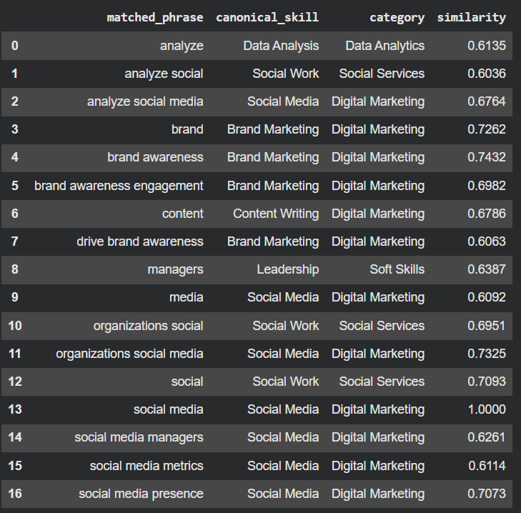
For example, the output contains candidate words/phrases extracted from the job description.

6. Semantic Similarity Concept
The next step of Day 11 was to compare the meaning of job-description phrases with skills from the taxonomy.
Conceptually:
"ML"
↓
Embedding
↓
Vector
↓
Cosine Similarity
↓
"Machine Learning"
↓
High similarity
The higher the similarity score, the more semantically related the two phrases are.
7. Expected Semantic Similarity Example
For documentation, you can show the concept as:
Phrase 1 | Phrase 2 | Expected Relationship
ML | Machine Learning | High
NLP | Natural Language Processing | High
Power BI | Business Intelligence | Related
AWS | Amazon Web Services | High
PyTorch | PyTorch | Very High

8. Day 11 Outcome
The Day 11 experiment demonstrated that semantic approaches can help overcome some limitations of exact dictionary matching.
The major learning was:
Exact matching looks for the presence of predefined terms, whereas embeddings attempt to capture semantic relationships between words and phrases.
This provides a foundation for improving the skill extractor beyond simple keyword matching.
9. Day 11 Key Learnings
- Understood the limitations of exact skill matching.
- Learned the concept of embeddings.
- Learned how candidate phrases can be generated using n-grams.
- Understood semantic similarity.
- Learned how cosine similarity can be used to compare embeddings.
- Understood how semantic matching can potentially identify variations of technical skills.

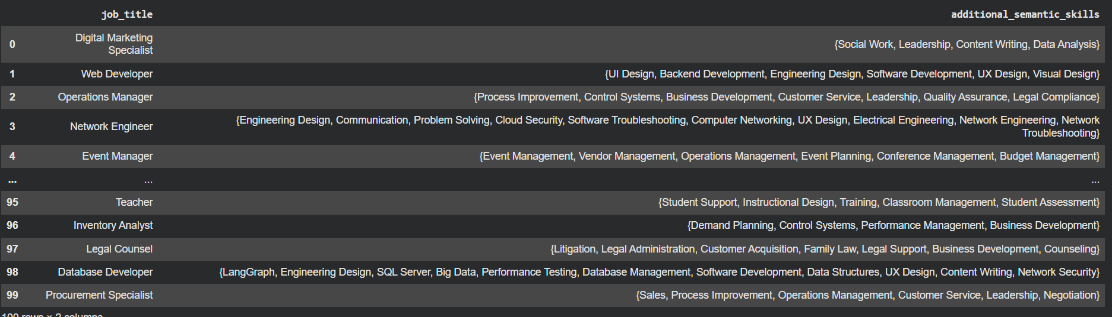

DAY 12 — Named Entity Recognition
1. Objective
The objective of Day 12 was to understand Named Entity Recognition (NER) and investigate whether a standard NLP NER model can identify technical skills from job descriptions.
The experiment was then extended using custom entities designed specifically for the job-skill extraction project.
2. Standard NER
Named Entity Recognition is an NLP technique used to identify important entities in text.
Typical entities include:
- PERSON
- ORG
- GPE
- DATE
- LOCATION
However, technical skills do not always belong to these standard categories.
For example:
- Python
- SQL
- AWS
- PostgreSQL
- TensorFlow
- Power BI
are important entities for a job-description analysis system, but a general-purpose NER model may not recognize them as technical skills.
3. Why Standard NER Can Fail
The experiment demonstrated an important real-world NLP problem.
General-purpose NER models are usually trained to identify common entities such as:
People
Organizations
Locations
Dates
Countries
They are not specifically trained to identify:
- Programming languages
- Databases
- Cloud platforms
- BI tools
- Machine-learning frameworks
Therefore, domain-specific/custom NER is required for a technical skill extraction system.
4. Custom Entity Categories
Custom entity categories were created based on the project's skill taxonomy.
Skill/Technology | Custom Entity
Python | SKILL
SQL | DATABASE
PostgreSQL | DATABASE
AWS | CLOUD_PLATFORM
TensorFlow | TECHNOLOGY
Power BI | TOOL
The exact mapping depends on the custom taxonomy used in the project.
5. Custom NER Using EntityRuler
A spaCy EntityRuler was used to create custom patterns from the existing skill taxonomy.
The workflow was:
Skill Taxonomy
↓
Synonyms / Aliases
↓
Custom NER Patterns
↓
spaCy EntityRuler
↓
Job Description
↓
Detected Entities

6. Initial Custom NER Output
The initial experiment produced output such as:
We → CLOUD_PLATFORM
looking for a Data Analyst → SKILL
Python, SQL, → TECHNOLOGY
PostgreSQL and AWS experience → SKILL
Machine → TECHNOLOGY
TensorFlow → SKILL
Interpretation
This output was useful because it showed that the NER system was detecting text spans, but some spans were assigned incorrect entity labels.
For example:
We → CLOUD_PLATFORM
is clearly incorrect.
Similarly:
PostgreSQL and AWS experience → SKILL
contains multiple concepts that should ideally be separated.
7. Improved Custom NER
The custom EntityRuler was then constructed using the skill taxonomy and category-to-entity mapping.
The objective was to produce results closer to:
Python → SKILL
SQL → DATABASE
PostgreSQL → DATABASE
AWS → CLOUD_PLATFORM
TensorFlow → TECHNOLOGY
Power BI → TOOL
while avoiding incorrect entities such as:
We → CLOUD_PLATFORM
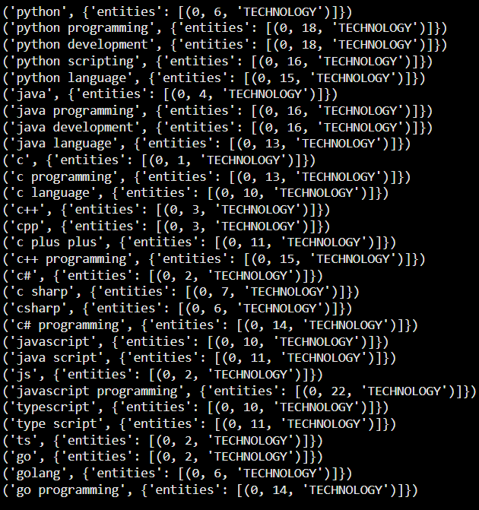
8. Custom NER Applied to Dataset
The custom NER pipeline was applied to the job-description column:
df["custom_ner_entities"] = (
df["job_description_matching"]
.apply(extract_custom_entities)
)
The resulting column stores the entities detected from each job description.
Example structure:
[
{
"entity": "Python",
"label": "SKILL"
},
{
"entity": "AWS",
"label": "CLOUD_PLATFORM"
}
]

9. Readable NER Output
The entities were converted into a readable format:
Python → SKILL | SQL → DATABASE | AWS → CLOUD_PLATFORM
Output

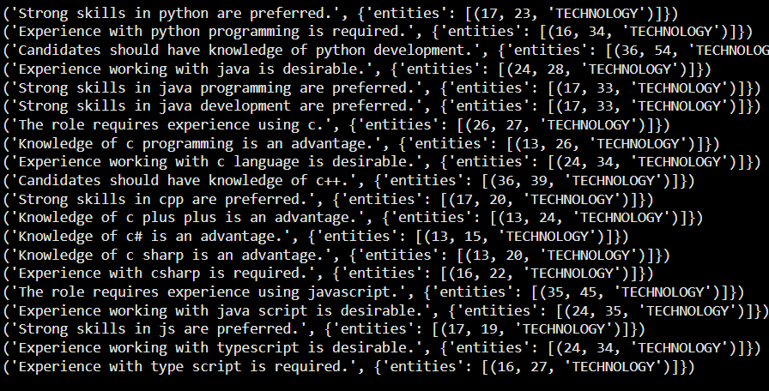
This is one of the best outputs to include in the Day 12 report because it clearly demonstrates the working of custom NER.

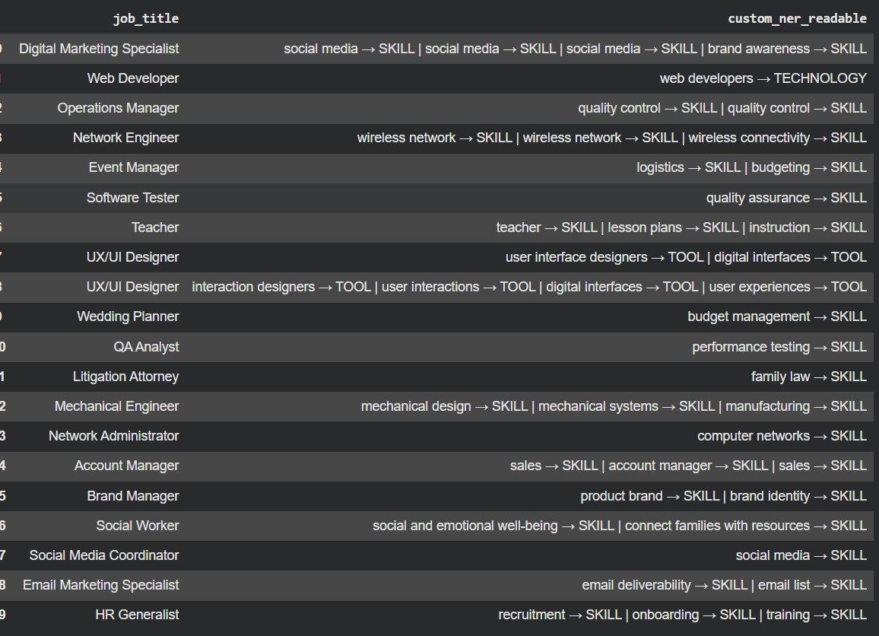

10. Entity Frequency Analysis
Entity types were counted to understand which types appeared most frequently in the dataset.
The output was generated using:
display(entity_frequency)
Output
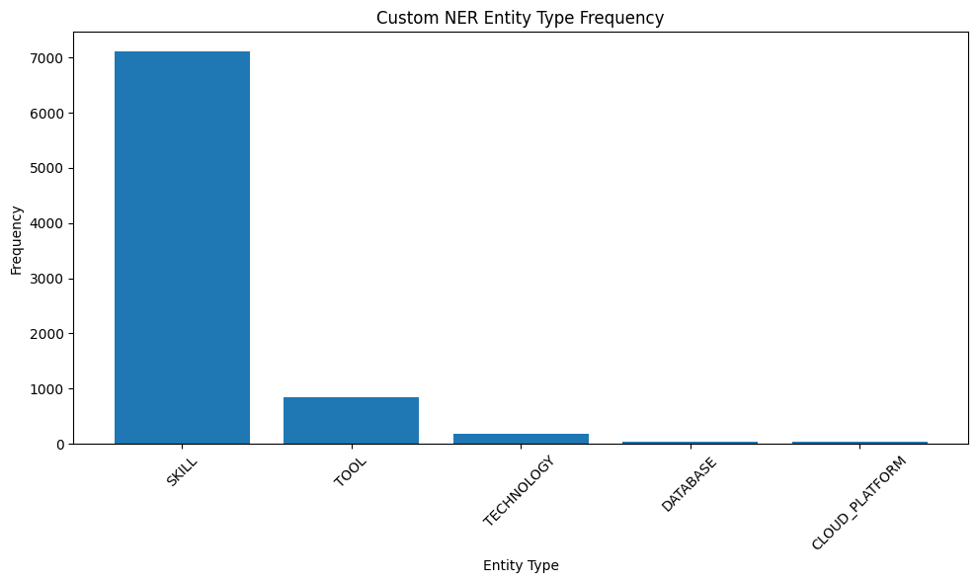

11. Jobs Without Custom NER Entities
The project also checked job descriptions where no custom entities were detected.
The code calculated:
print(
"Jobs with no custom NER entities:",
len(no_entity_jobs)
)
and:
print(
"Percentage:",
round(
len(no_entity_jobs) / len(df) * 100,
2
),
"%"
)

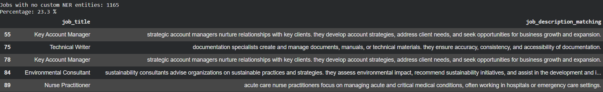
Percentage: 23%
This is important because it helps evaluate the coverage of the custom NER approach.
12. Comparison With Previous Skill Extraction
The Day 12 experiment can also be compared with the previous taxonomy-based extractor.
display(
df[
[
"job_title",
"extracted_skills",
"custom_ner_entities"
]
].head(20)
)
Output
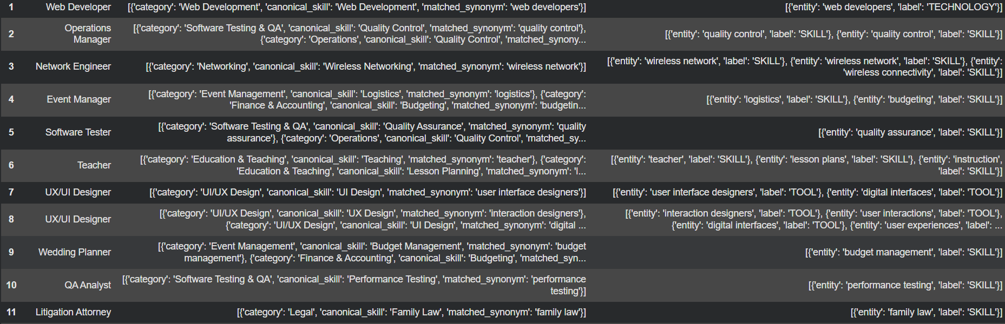This demonstrates how the project is evolving:
Dictionary Matching
↓
Regex / Phrase Matching
↓
N-Gram Analysis
↓
Semantic Similarity
↓
Custom NER

13. Day 12 Outcome
The Day 12 experiment demonstrated that standard NER is not sufficient for technical skill extraction because general NER models are not specifically trained on technology-related entities.
A custom NER approach was therefore implemented using spaCy's EntityRuler and the project's skill taxonomy.
The experiment also showed that entity detection and correct entity classification are two different problems. Initial results contained incorrect labels, demonstrating the importance of carefully designed domain-specific patterns.

14. Day 12 Key Learnings
- Understood Named Entity Recognition.
- Tested standard NER on job descriptions.
- Identified limitations of general-purpose NER.
- Created domain-specific entity categories.
- Used the existing skill taxonomy to generate custom patterns.
- Implemented custom NER using spaCy EntityRuler.
- Applied custom NER to job descriptions.
- Analyzed entity frequencies.
- Identified job descriptions with no detected entities.
- Compared custom NER results with previous skill extraction.

DAY 13 — ML Skill Classifier
Objective
Build a supervised ML model to classify job descriptions into skill categories using TF-IDF + Logistic Regression.
Steps Performed
- Prepared labeled job-description data from the existing skill taxonomy.
- Removed records without skill categories.
- Split data into 80% training / 20% testing.
- Converted text into numerical features using TF-IDF with unigrams, bigrams, and trigrams.
- Trained a Logistic Regression classifier.
- Predicted skill categories for test and new job descriptions.
- Evaluated the model using:
  - Accuracy
  - Precision
  - Recall
  - F1-score
  - Confusion Matrix
- Checked prediction confidence.
- Saved the trained model.
Key Output
TF-IDF → Logistic Regression → Skill Category
Model file:
skill_classifier.pkl
Outcome
Successfully added a Machine Learning-based classification layer to the job-skill extraction pipeline, moving beyond simple rule-based matching.
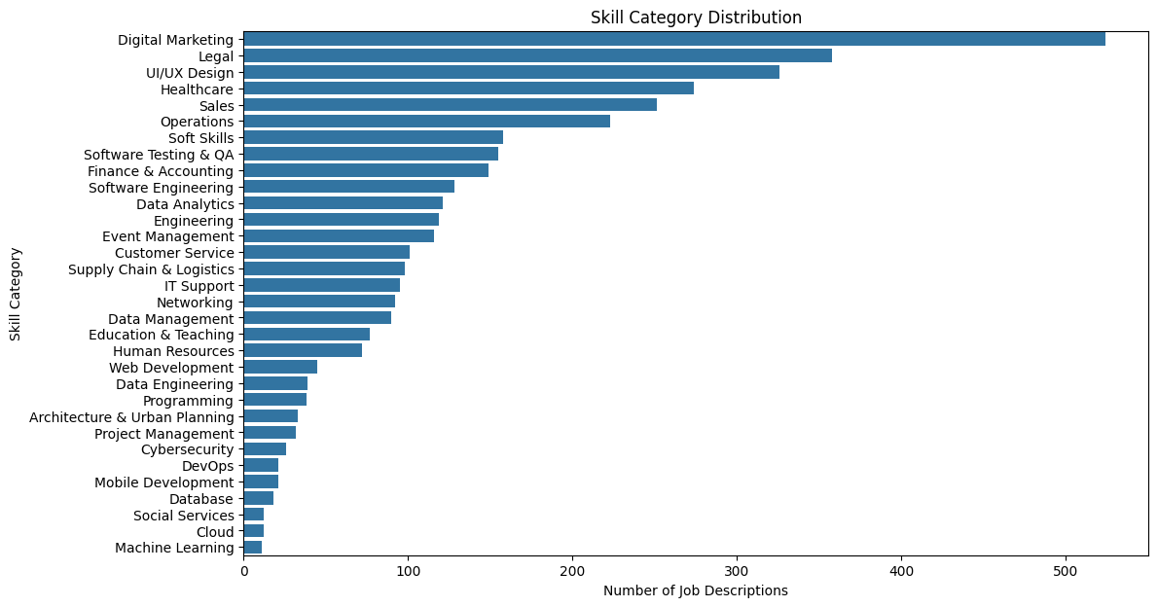

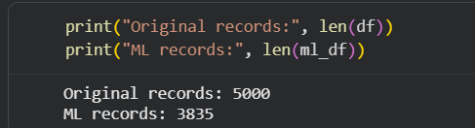
Figure: Original Record vs ML Records

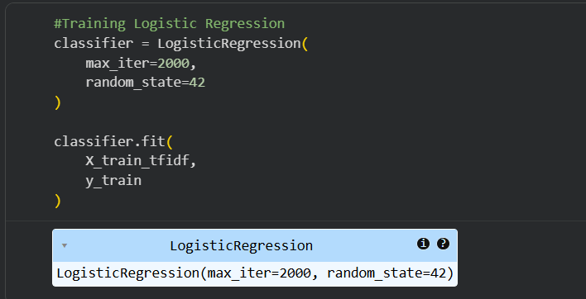
Figure: Logistic Regression Training
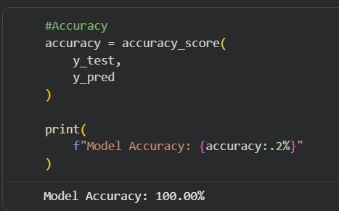
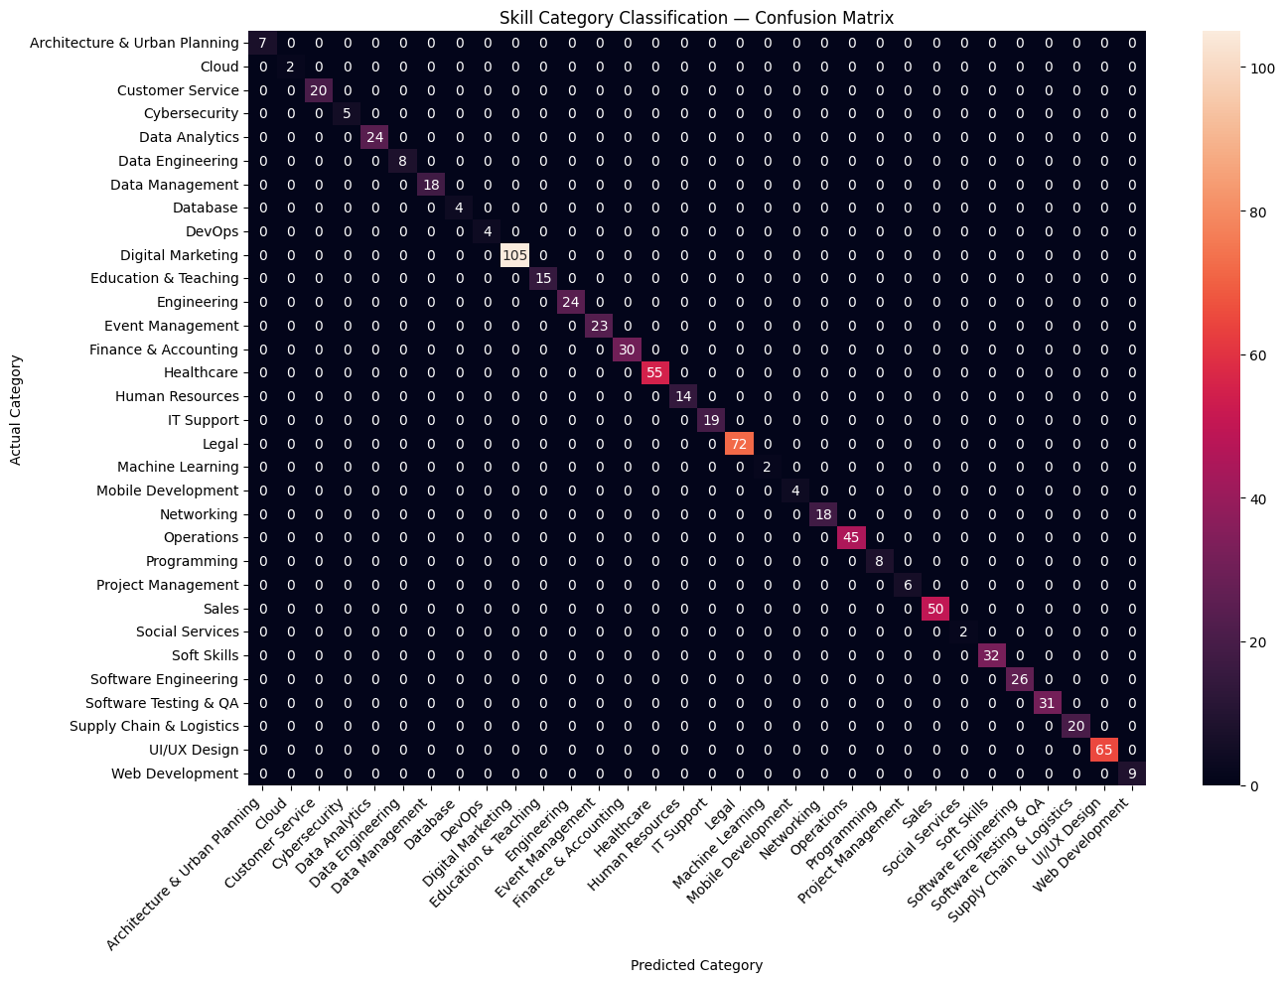

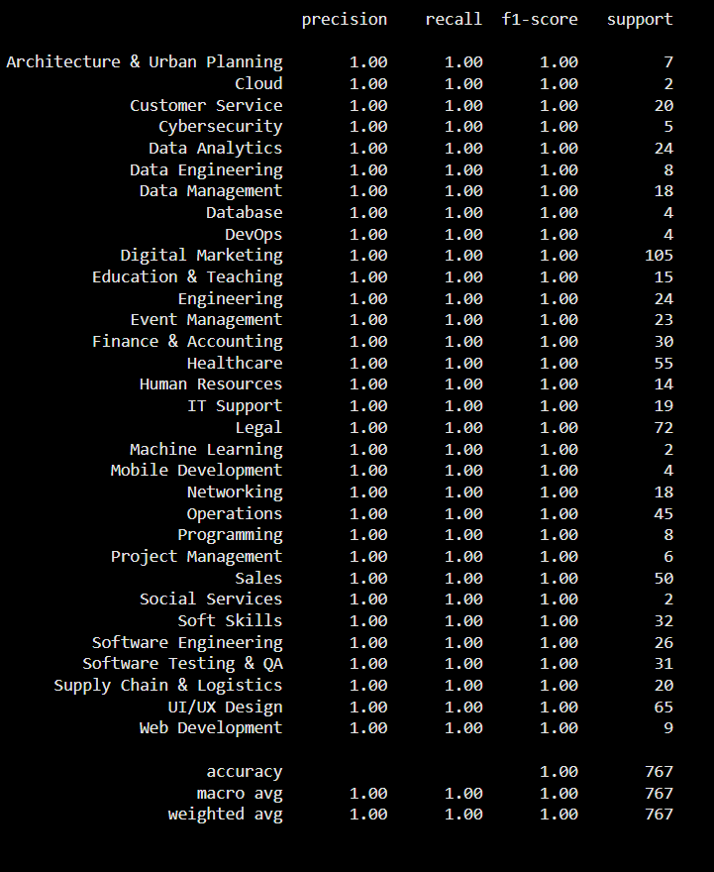

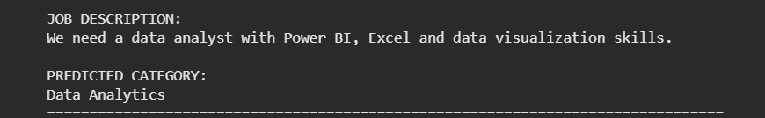

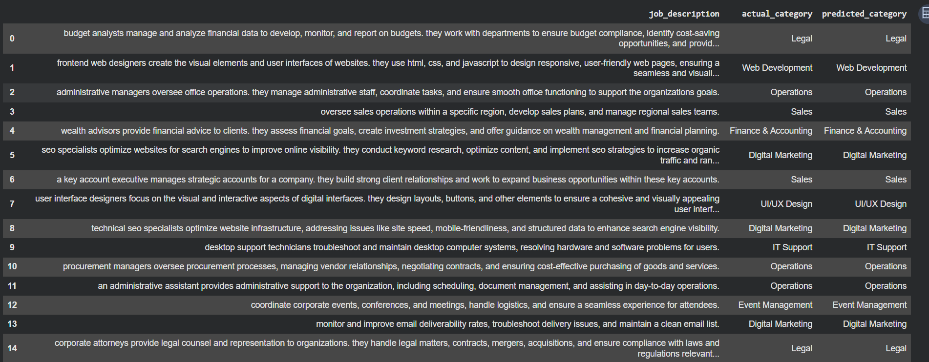
Figure: Actual Category vs predicted category

DAY 13 Summary
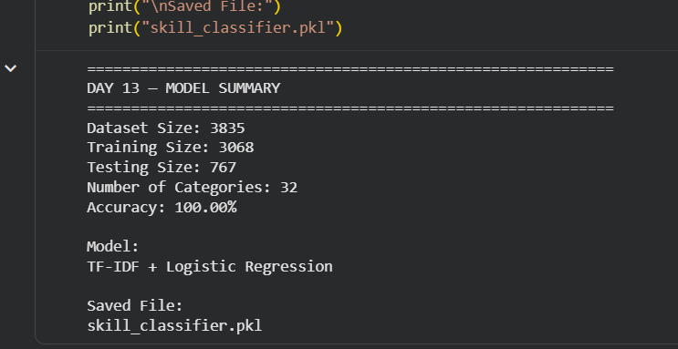

DAY 14 - Skill Extraction Evaluation & Error Analysis
Objective:
Evaluate the Day 13 job-title classification model on unseen test data and identify classification errors.
Tasks completed:
- Test-set evaluation
- Accuracy calculation
- Precision, recall and F1-score
- Confusion matrix
- Error analysis
- Incorrect prediction analysis
- Class distribution analysis
- New job-description testing
- Prediction confidence analysis
- Top-3 prediction analysis

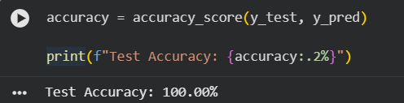

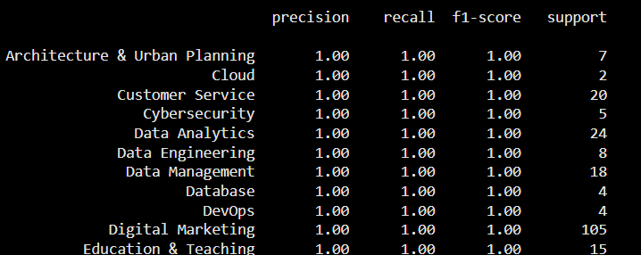

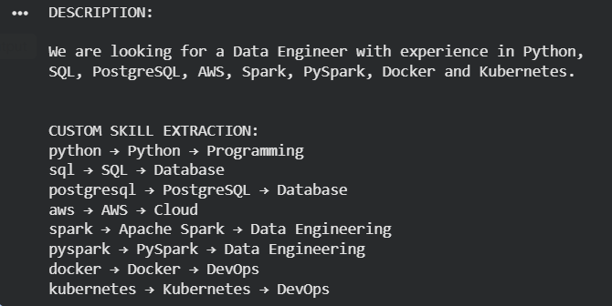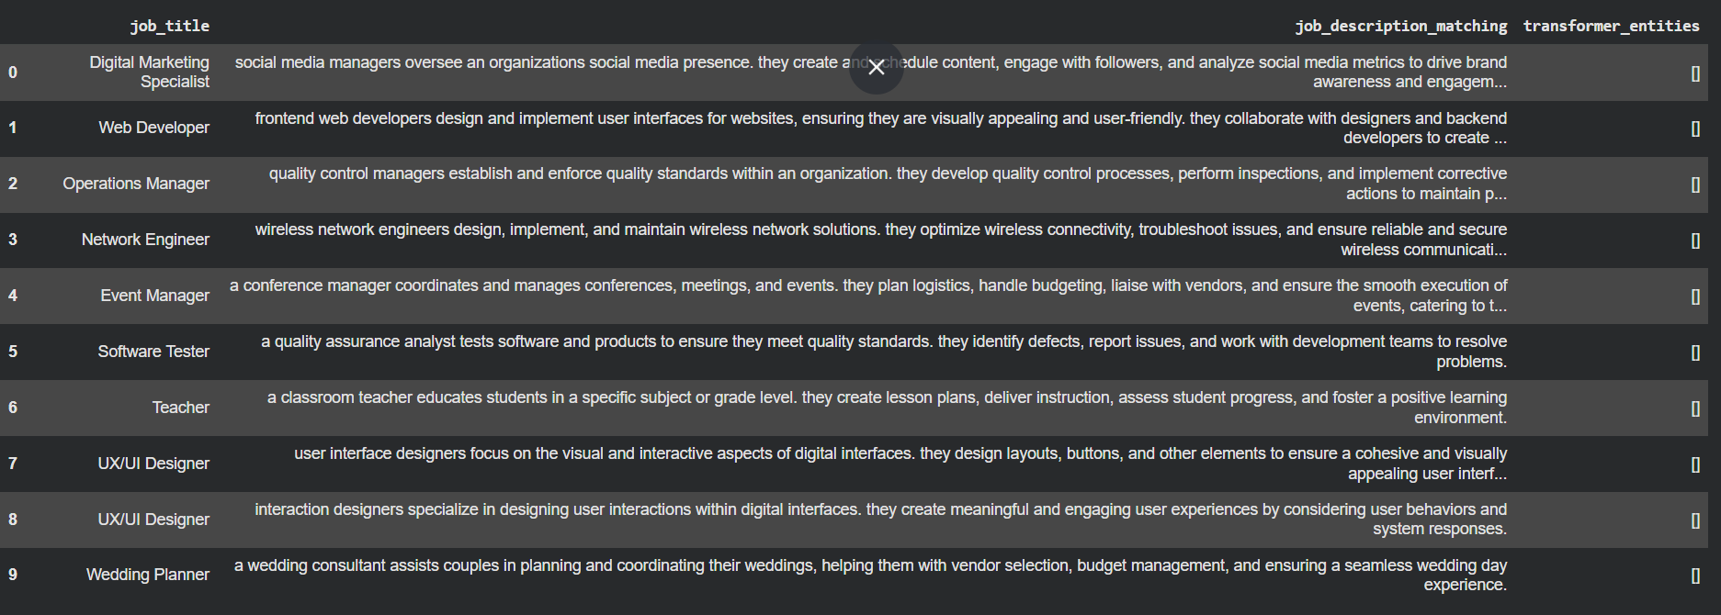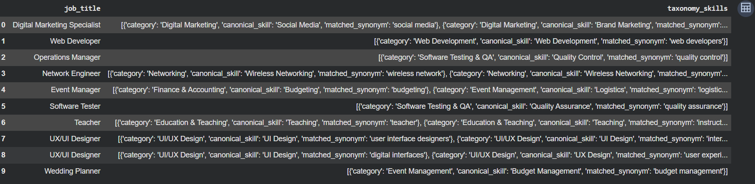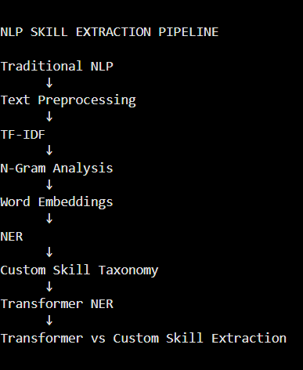

Key learning
Day 14 demonstrated that overall accuracy alone is not sufficient for evaluating an NLP classification model. Error analysis, confusion matrices, class distribution, and prediction confidence provide deeper insight into model performance and help identify cases where job descriptions are semantically similar or insufficiently distinctive.

DAY 15 — Model Evaluation
Objective
Evaluate the custom taxonomy-based skill extraction system against manually labelled skills and measure its performance.
Approach
The 100 manually labelled job descriptions were compared with the skills extracted by the custom taxonomy. The following metrics were calculated:
- True Positive (TP): Correctly extracted skills
- False Positive (FP): Incorrectly extracted skills
- False Negative (FN): Actual skills that were missed
- Precision: Measures how many predicted skills were correct.
- Recall: Measures how many actual skills were successfully extracted.
- F1 Score: Harmonic mean of Precision and Recall.
- Exact-Match Accuracy: Percentage of job descriptions where the complete actual and predicted skill sets matched exactly.
- Confusion Matrix: Skill-level TP, FP, FN and TN analysis.
Actual Results
Metric | Result
Total Records | 110
True Positives | 33
False Positives | 143
False Negatives | 85
Precision | 18.75%
Recall | 27.97%
F1 Score | 22.45%
Exact Accuracy | 1.82%

After Fine Tuning the transformer on 4 Epocs.
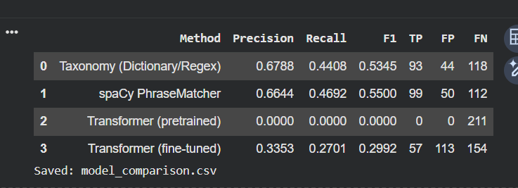
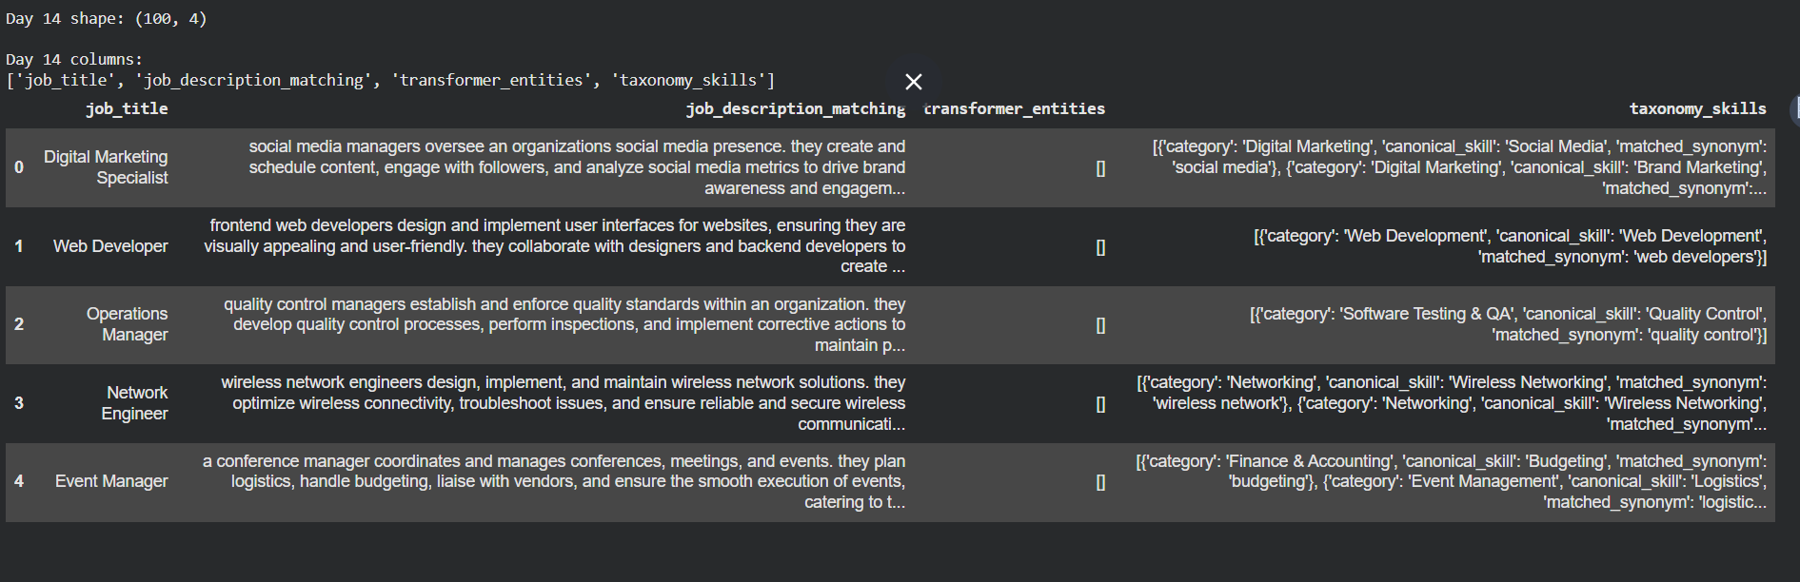
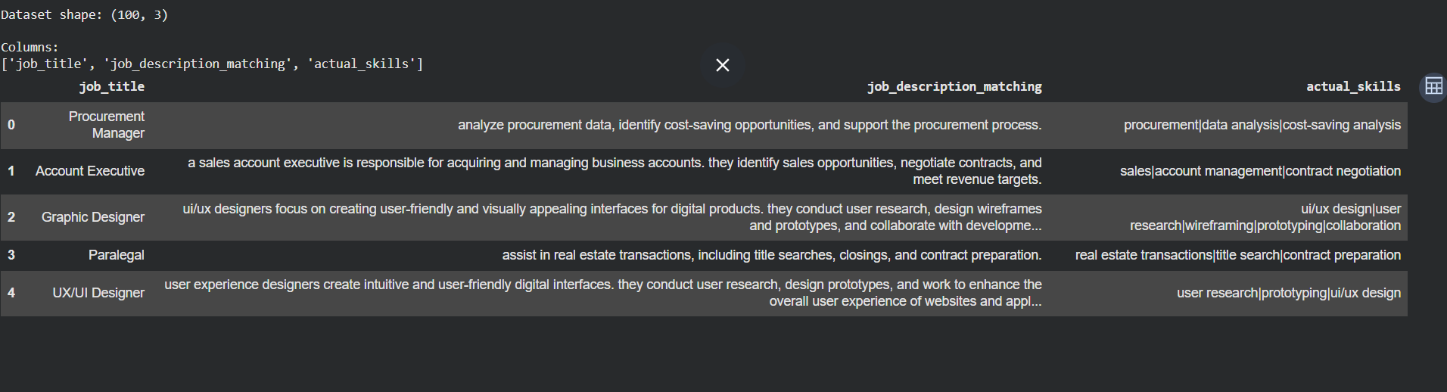

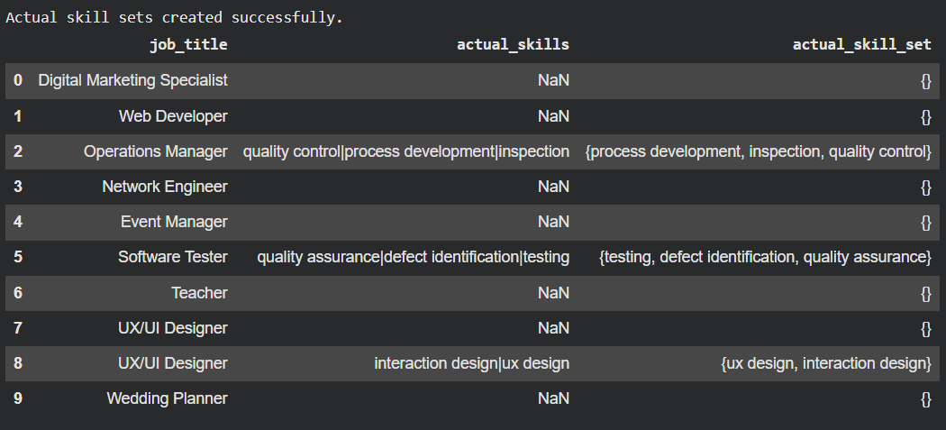

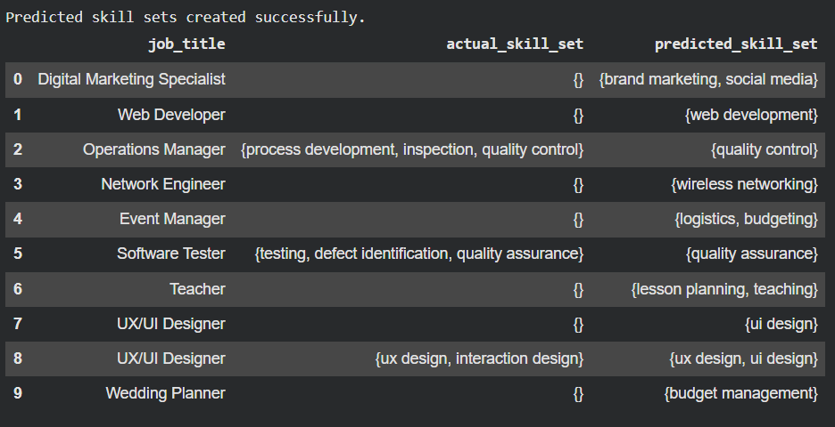

Outcome
The evaluation showed that the current taxonomy has low precision and recall, with a relatively high number of false positives and false negatives. This indicates that the skill extraction system requires further improvement in synonym handling, skill normalization, taxonomy coverage, and entity matching.
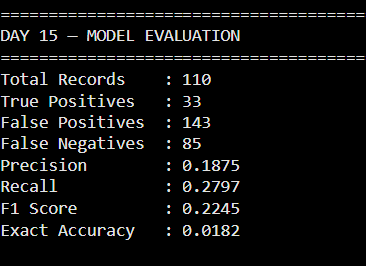
The results were saved in:
model_comparison.csv
Day 15 Deliverable: Model evaluation and performance comparison completed.
DAY 16 — Error Analysis

Objective
Identify and analyze the errors made by the skill extraction system after the Day 15 evaluation.
Approach
The predicted skills were compared with the manually labelled actual skills to identify different types of extraction errors.
Error Categories
- False Positive: Skill predicted but not present in the actual skills.
- False Negative: Actual skill present but not extracted.
- Partial Entity: Only part of a multi-word skill was extracted.
- Duplicate Skill: Same skill extracted multiple times through different synonyms.
- Synonym Problem: Different terms representing the same skill were not correctly mapped.
- Unknown Skill: A skill was present but missing from the current taxonomy.
- Spelling Problem: Skill was missed because of spelling or textual variation.
Analysis Performed
The project generated:
- Individual FP and FN records
- Most frequent false-positive skills
- Most frequent false-negative skills
- Duplicate skill analysis
- Possible synonym/partial-match cases
- Overall error-category summary
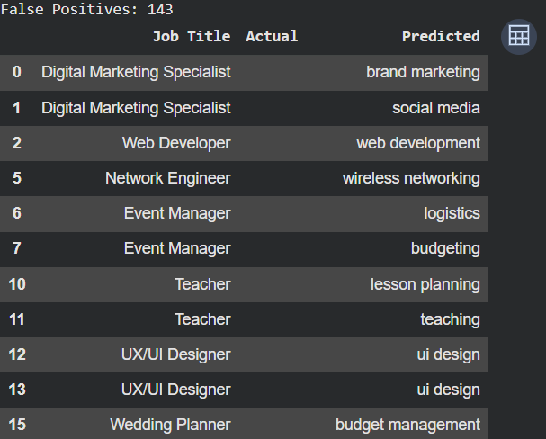
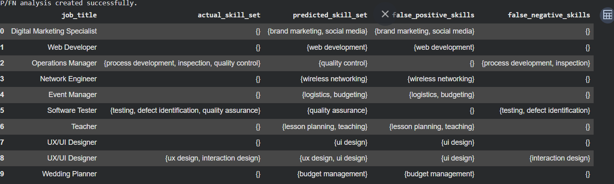

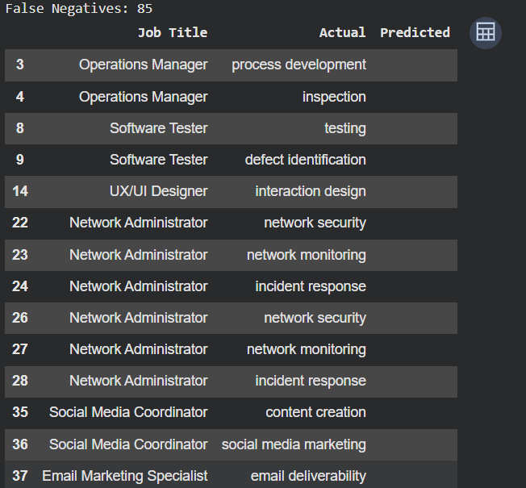

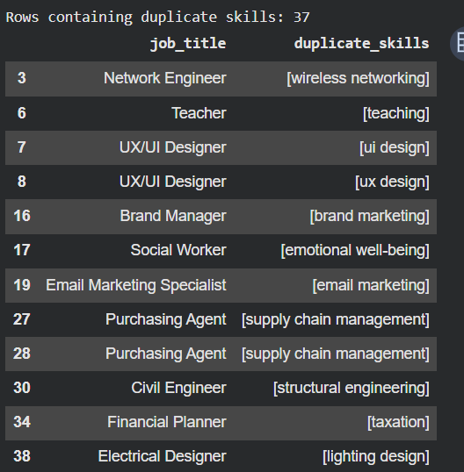

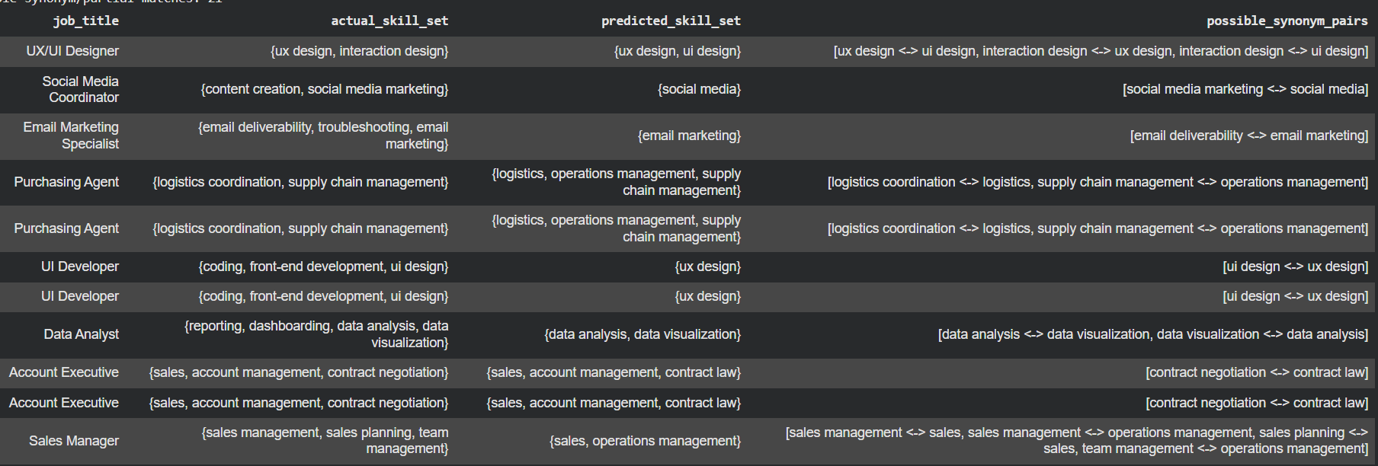
Possible Synonyms Problem
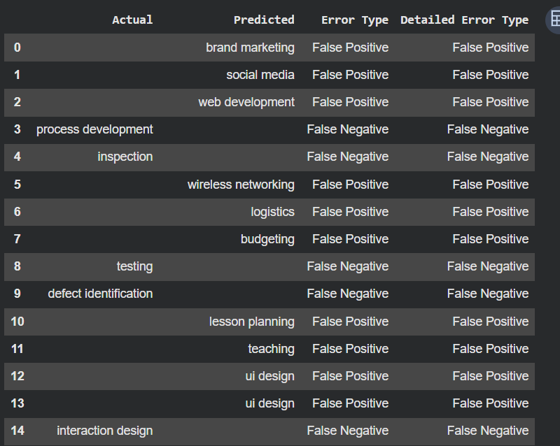

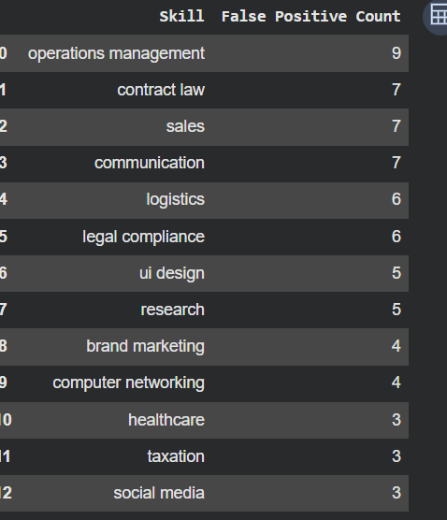 Most Common False Positive Skills
That tells you your taxonomy contains generic terms that are too broad.
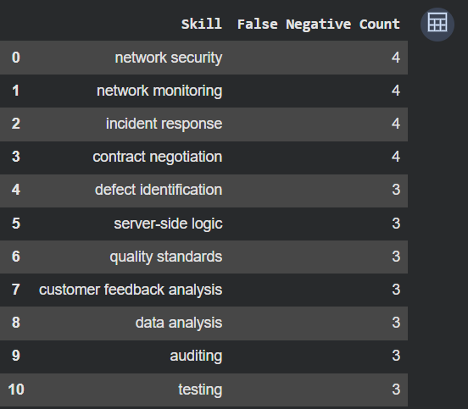
This tells you which skills your taxonomy is missing.
Outcome
Error analysis revealed the main weaknesses of the current taxonomy-based extraction system, particularly false positives, missed skills, generic terms, and incomplete synonym mapping. These findings can be used to improve the taxonomy and matching rules in the next stage.

DAY 17 — Skill Normalization
Objective
Normalize extracted skills so that different representations of the same skill are treated as one skill.
Process
Raw Skill
↓
Lowercase
↓
Remove spaces / special characters
↓
Alias Matching
↓
Canonical Skill
Examples
Raw Skill | Normalized Skill
Python | Python
python3 | Python
Python 3 | Python
Python programming | Python
PowerBI | Power BI
Power BI | Power BI
Power-BI | Power BI
postgres | PostgreSQL
PostgreSQL | PostgreSQL

Implementation
A normalization dictionary/engine was created to map skill aliases to their canonical names.
Example:
skill_aliases = {
"python3": "Python",
"python 3": "Python",
"python programming": "Python",
"powerbi": "Power BI",
"power-bi": "Power BI",
"postgres": "PostgreSQL"
}
The normalization process ensures that multiple variants do not get counted as separate skills.
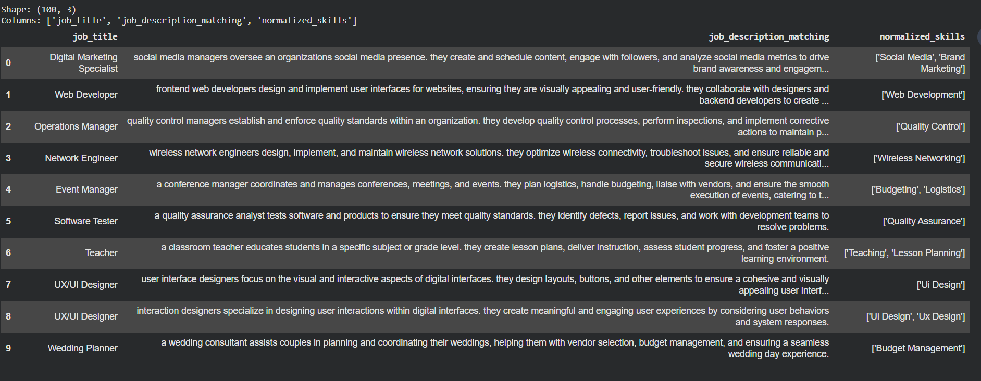
Outcome
The system can now standardize extracted skills into consistent canonical skill names, improving:
- Skill counting
- Skill comparison
- Duplicate removal
- Taxonomy matching
- Model evaluation
- Downstream job-skill analysis
Deliverable
normalized_skills.csv
Day 17 Status: ✅ Skill normalization engine implemented.

DAY 18 — Business Dashboard Documentation
Objective
Convert the NLP skill-extraction results into a business analytics dashboard using Power BI. Power BI is designed to connect, model, visualize, and analyze data through interactive reports and dashboards.
Data Preparation
The normalized skill output from Day 17 was transformed into a dashboard-ready dataset containing:
- Job Title
- Job Description
- Skill
- Skill Category
The skill data was flattened so that each skill could be analyzed individually.
Dashboard KPIs
The dashboard was designed to track:
- Total Jobs
- Unique Skills
- Top Skill
- Top Job Role
- Most Required Technology
- Top Skill Category
Visualizations
The following visuals were created/planned:
- Top 20 Skills — identifies the most frequently required skills.
- Skill Demand by Job Role — shows which skills are associated with different job roles.
- Skill Category Distribution — compares categories such as Programming, Database, Cloud, Machine Learning, and Analytics.
- Job Role Analysis — compares skill requirements across different roles.
- Interactive Filters/Slicers — allow analysis by job role, skill, and skill category.
Power BI reports support interactive visuals, filters and slicers for exploring the underlying data.
Outcome
The NLP pipeline was extended from skill extraction and normalization to business-level analytics. The resulting dashboard provides a visual view of skill demand and relationships between job roles, technologies, and skill categories.

Job Title | Skill | Skill Category
Data Analyst | Python | Programming
Data Analyst | SQL | Database
Data Analyst | Power BI | Business Intelligence
Data Engineer | AWS | Cloud
Data Engineer | SQL | Database

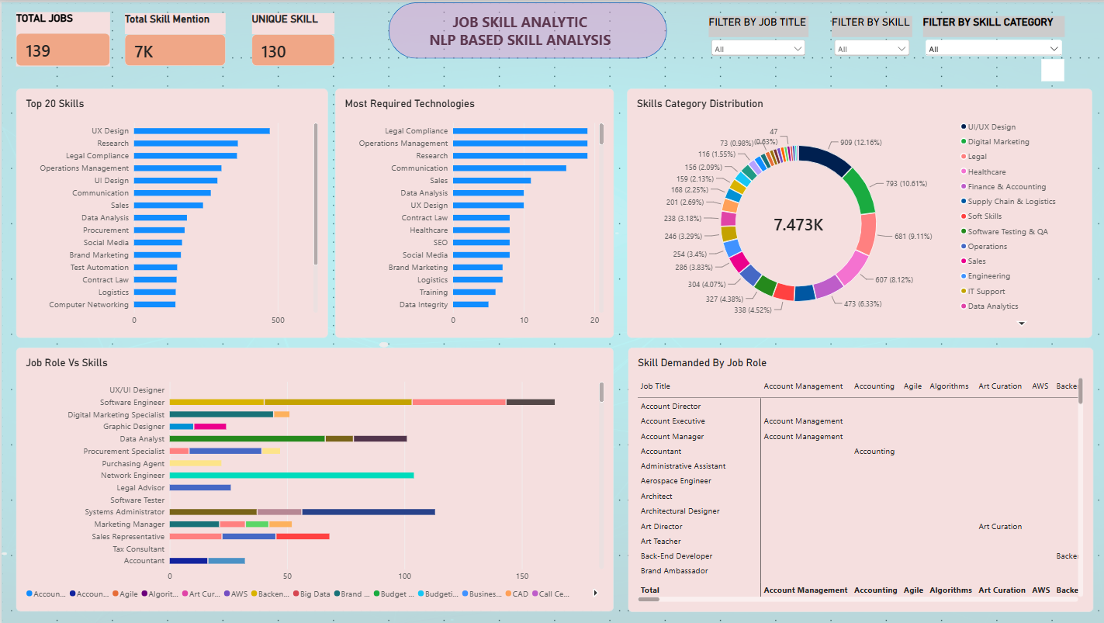

DAY 19 — Build an Application/API Documentation
Objective
The objective of Day 19 was to convert the NLP-based skill extraction pipeline into a usable application. The system accepts a job description from the user, detects relevant skills, normalizes them, maps them to skill categories, and displays the final results.

Application Workflow
User enters Job Description
↓
Preprocessing
↓
Skill Extraction
↓
Skill Normalization
↓
Category Mapping
↓
Final Results
Input
Example:
Looking for Data Analyst with SQL, Python, Power BI and Excel experience.
Output
The application identifies the skills:
Python
SQL
Power BI
Excel
and categorizes them:
Programming → Python
Database → SQL
Business Intelligence → Power BI
Analytics → Excel

Technology Used
For the application layer, FastAPI is used to expose the NLP pipeline as a REST API. Uvicorn is used as the ASGI server to run the FastAPI application, while spaCy handles the NLP preprocessing and skill extraction.
For this project, a FastAPI-based application is suitable because it allows the existing Python NLP pipeline to be integrated into a usable API where users can submit a job description and receive the extracted, normalized, and categorized skills as a structured response.
Application Components
The project structure was designed as:
project/
│
├── app.py
│
├── model/
│ └── skill extraction components
│
├── data/
│ └── skill taxonomy / aliases
│
├── utils/
│ └── preprocessing and normalization
│
├── requirements.txt
│
└── README.md
Key Features
- Job description input
- Automatic skill extraction
- Skill normalization
- Synonym/alias handling
- Skill category mapping
- Display of detected skills
- Easy-to-use web interface
Outcome
The project was transformed from an experimental NLP pipeline into a usable skill-extraction application. This provides a practical interface through which users can enter job descriptions and obtain structured skills and their corresponding categories.
Deliverable
app.py
model/
data/
utils/
requirements.txt
README.md
Day 19 Status: ✅ NLP skill extraction pipeline converted into an application-ready system.

