Angular JS

Introduction

Angular JS is client side JavaScript framework to build the rich client side applications with MVC architecture and two day binding.

Angular JS is best suitable for Single Page applications.

Angular JS is an open source project and we can use it freely with our applications. This is best suitable to develop complex applications at client side where JavaScript DOM manipulation is almost impossible.

As the applications grows bigger and bigger and more complex logics at the client side, for this we should require client side frameworks. There are many client side frameworks available React JS , Ember , Backbone , Vue JS , Ext JS etc., but still Angular JS is more popular than any other frameworks.

Overall, AngularJS is a framework to build large scale and high performance web application while keeping them as easy-to-maintain

Features of Angular JS

Following are most important core features of AngularJS −

**Data-binding** − It is the automatic synchronization of data between model and view components.

**Scope** − These are objects that refer to the model. They act as a glue between controller and view.

**Controller** − These are JavaScript functions that are bound to a particular scope.

**Services** − AngularJS come with several built-in services for example $https: to make a XMLHttpRequests. These are singleton objects which are instantiated only once in app.

**Filters** − These select a subset of items from an array and returns a new array.

**Directives** − Directives are markers on DOM elements (such as elements, attributes, css, and more). These can be used to create custom HTML tags that serve as new, custom widgets. AngularJS has built-in directives (ngBind, ngModel...)

**Templates** − These are the rendered view with information from the controller and model. These can be a single file (like index.html) or multiple views in one page using "partials".

**Routing** − It is concept of switching views.

Model View Whatever − MVC is a design pattern for dividing an application into different parts (called Model, View and Controller), each with distinct responsibilities. AngularJS does not implement MVC in the traditional sense, but rather something closer to MVVM (Model-View-ViewModel). The Angular JS team refers it humorously as Model View Whatever.

**Deep** **Linking** − Deep linking allows you to encode the state of application in the URL so that it can be bookmarked. The application can then be restored from the URL to the same state.

**Dependency** **Injection** − AngularJS has a built-in dependency injection subsystem that helps the developer by making the application easier to develop, understand, and test.

Advantages of Angular JS

AngularJS provides capability to create Single Page Application in a very clean and maintainable way.

AngularJS provides data binding capability to HTML thus giving user a rich and responsive experience

AngularJS code is unit testable.

AngularJS uses dependency injection and make use of separation of concerns.

AngularJS provides reusable components.

With AngularJS, developer write less code and get more functionality.

In AngularJS, views are pure html pages, and controllers written in JavaScript do the business processing.

Angular JS way of MVC

If any application logic is becoming more and more complex we have to divide the application into various parts in high level and we should lighten the dependency between them by achieving loose coupling.

In a high level, in order to develop and website we should require the following things, such as

1. Application Design (View)
2. Data for the application (Modal)
3. Logic to change the data. (Controller)

These three parts are club together and called as MVC architecture.

This is one of the successful design pattern for server side, we can also use this client side application if the client side application become more complex.

Model View Controller or MVC as it is popularly called, is a software design pattern for developing web applications. A Model View Controller pattern is made up of the following three parts −

Model − It is the lowest level of the pattern responsible for maintaining data.

View − It is responsible for displaying all or a portion of the data to the user.

Controller − It is a software Code that controls the interactions between the Model and View.

Angular JS Architecture

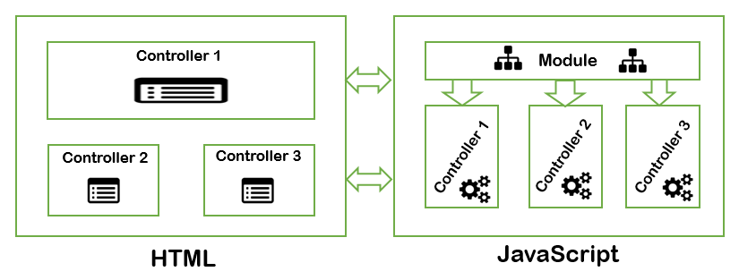

In Angular JS we can design the angular JS application as mentioned above.

In Angular JS we will define a main module for the application and some of other dependent modules, and each module is having various controllers.

Each controller is having its own defined variables and scope objects with their own processing logic. We can connect the angular Module with the HTML using ‘ng-app’ and we can connect with the Controllers using ‘ng-controller’ directive.

The ‘ng-app’ directive is used to starts the angular JS application. Once we define any module with this directive then along with the defined module, all the other dependent modules are also be loaded.

‘ng-controller’ directive is used to connect the specific controller with parts of HTML Application.

The ng-controller directive attaches a controller class to the view. This is a key aspect of how angular supports the principles behind the Model-View-Controller design pattern.