AI Powered Personal Fitness Coach using Deep Learning
In propose project you ask to generate exercise plan and posture correction based on user input such as age and weight but we will not get such exact dataset to predict all the above details so we trained YOLO11 CNN algorithm to recognized 36 different exercise activities and then based on detected activity application will recommend exercise plan according to age and then explain user about how to perform correct exercise for detected activity.
To implement this project we have designed following modules
- User Login: using this module user can login to system using username and password as ‘admin and admin’.
- Train Deep Learning Model: using this module user can train and load Activity recognition deep learning module
- Training Graph: this module will plot CNN training precision and loss graph
- Activity Recognition & Plan Recommendation: using this module user can upload test image and then CNN deep learning algorithm will recognized activity and then recommend plan to the user.
SCREEN SHOTS
To run project double click on ‘runServer.bat’ file to get below page
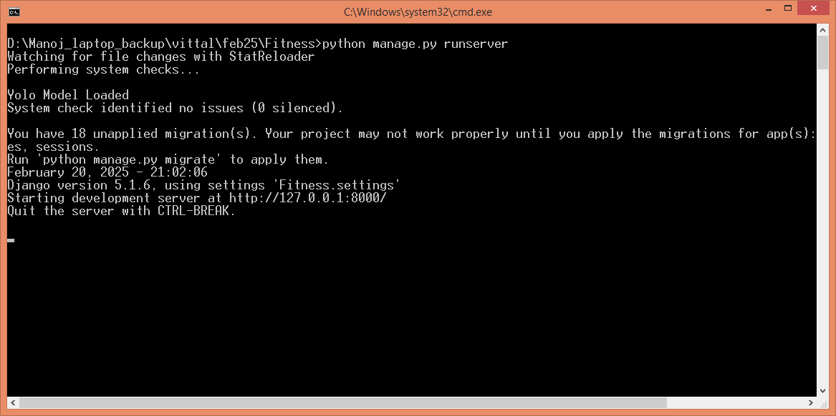
In above screen python server started and now open browser and enter URL as http://127.0.0.1:8000/index.html and then press enter key to get below page
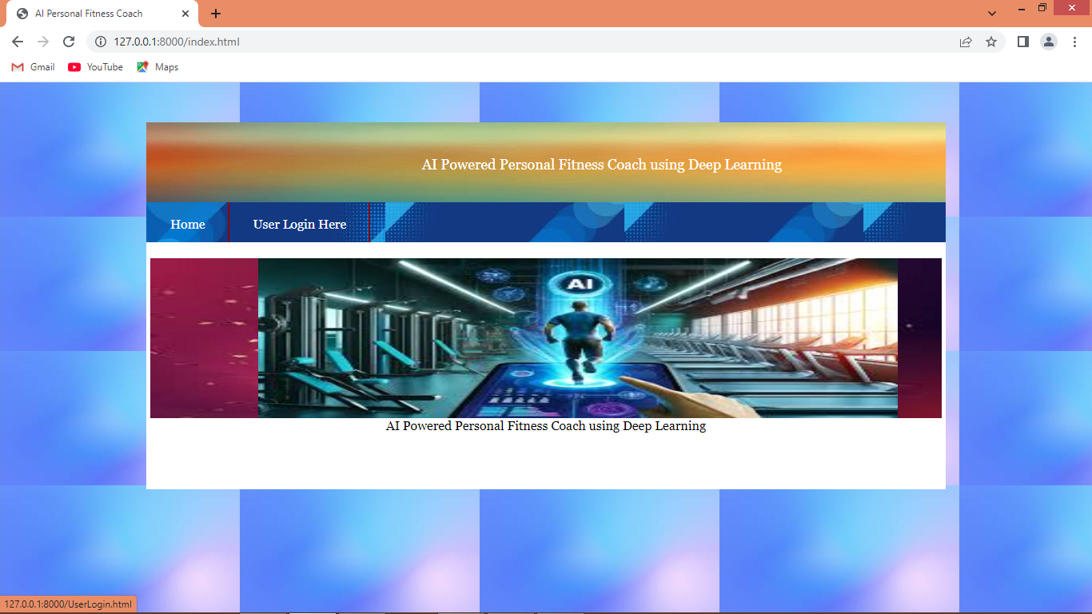
In above screen click on ‘User Login’ link to get below page
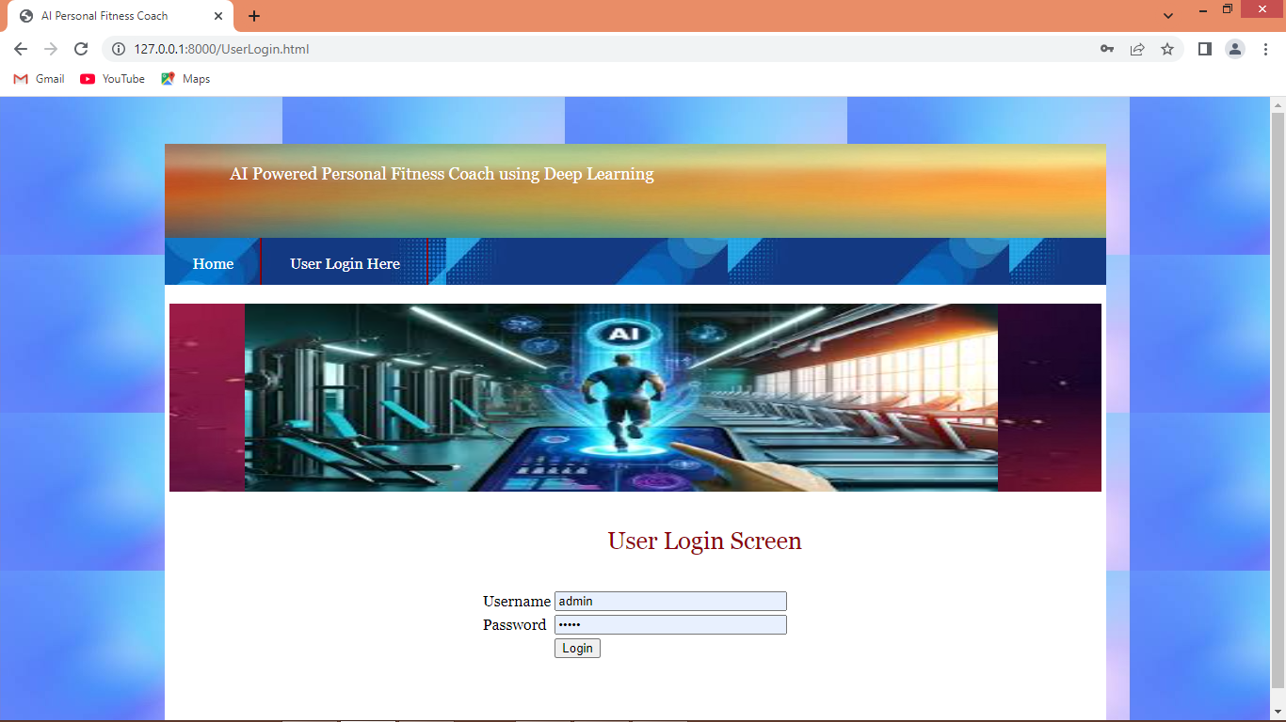
In above screen enter username and password as ‘admin and admin’ and then press button to get below page
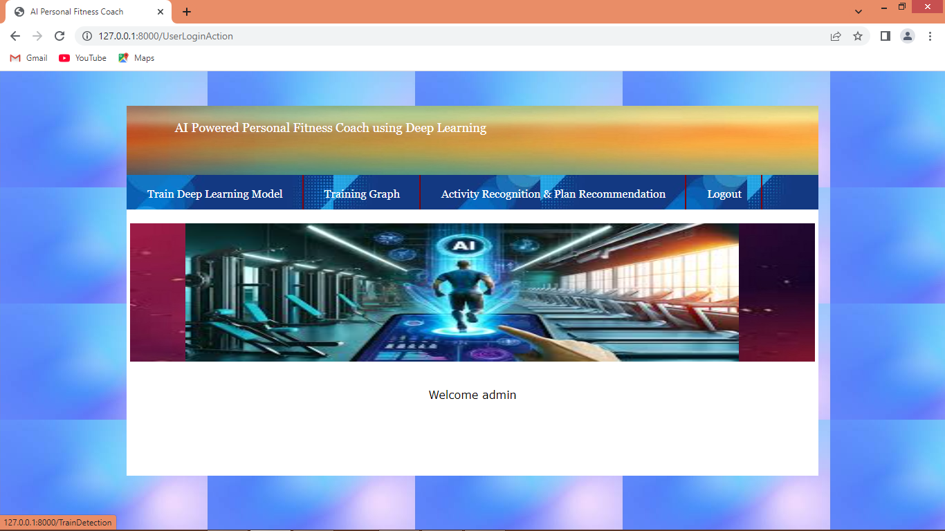
In above screen click on ‘Train Deep Learning Model’ link to train model and then will get below page
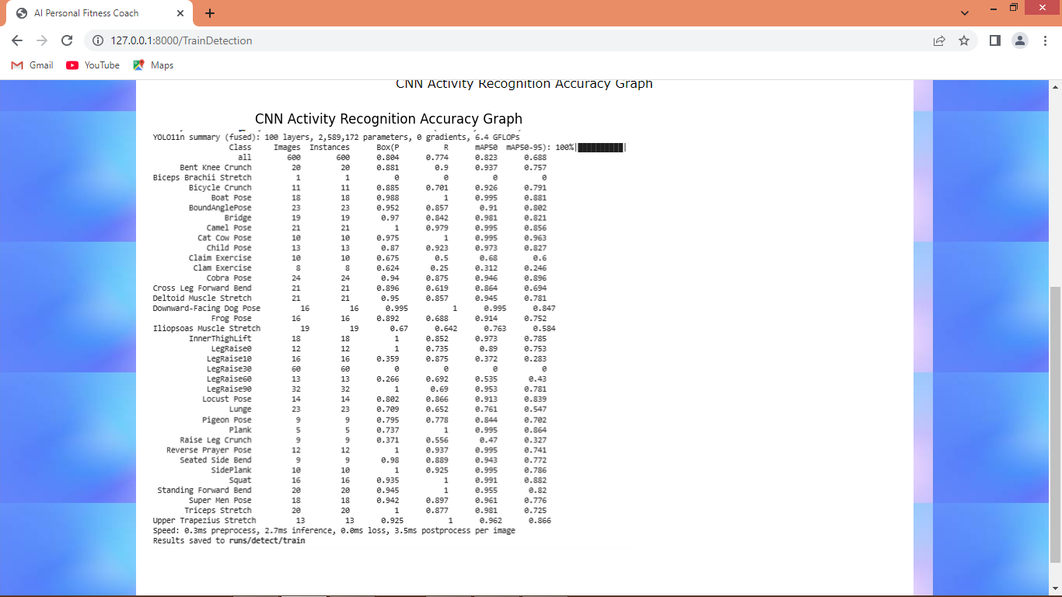
In above screen displaying each exercise classification accuracy of CNN model and now click on ‘Training Graph’ link to get below page
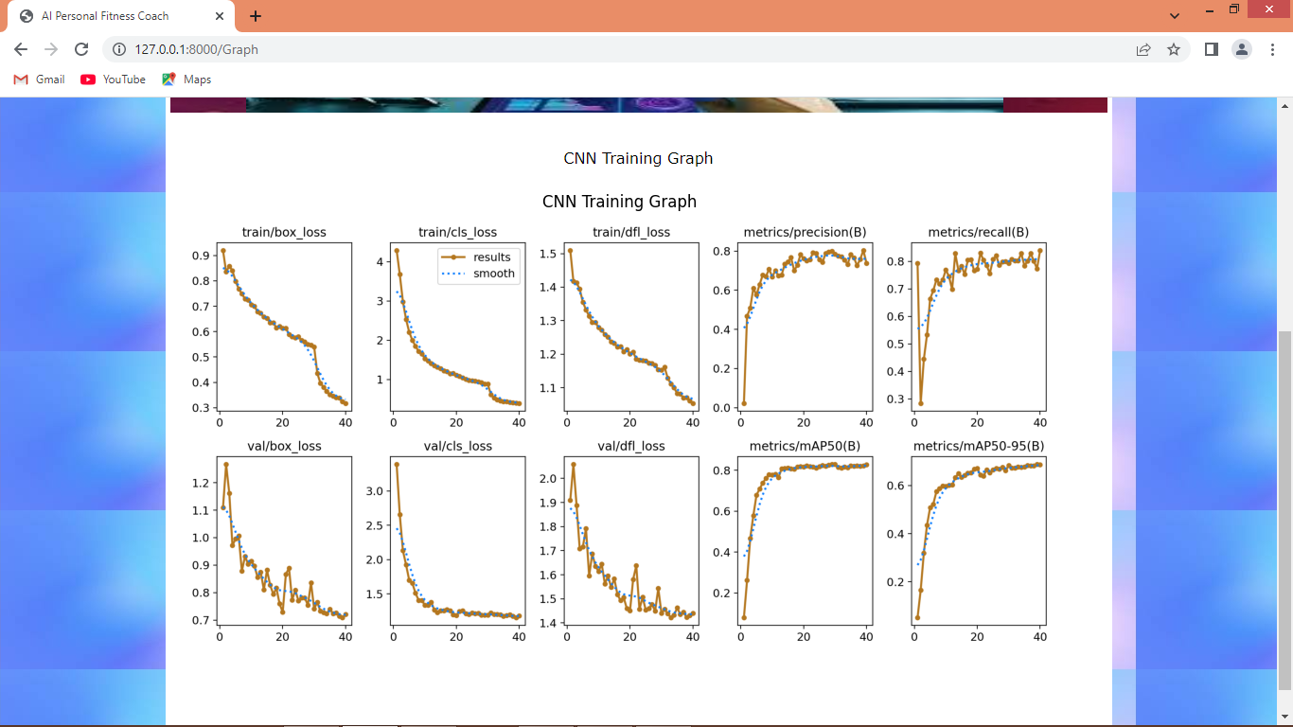
In above screen displaying loss and precision graph for detection and classification where x-axis represents number of epochs and y-axis represents loss/precision and can see with each increasing epoch precision got increased and loss got decreased. Now click on ‘Activity Recognition & Plan Recommendation’ link to get below page
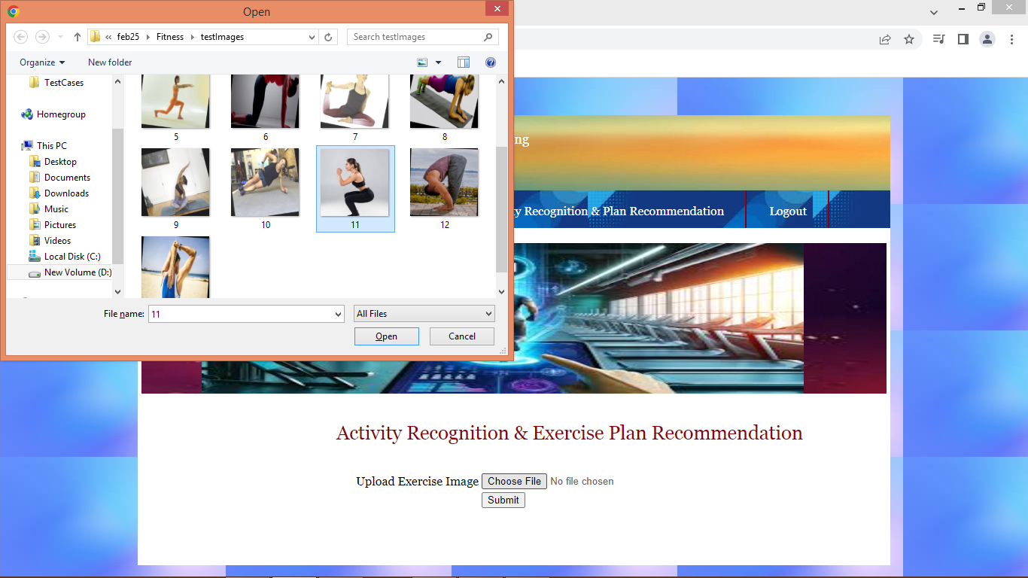
In above screen select and upload image and then press button to get below activity recognition and plan recommendation
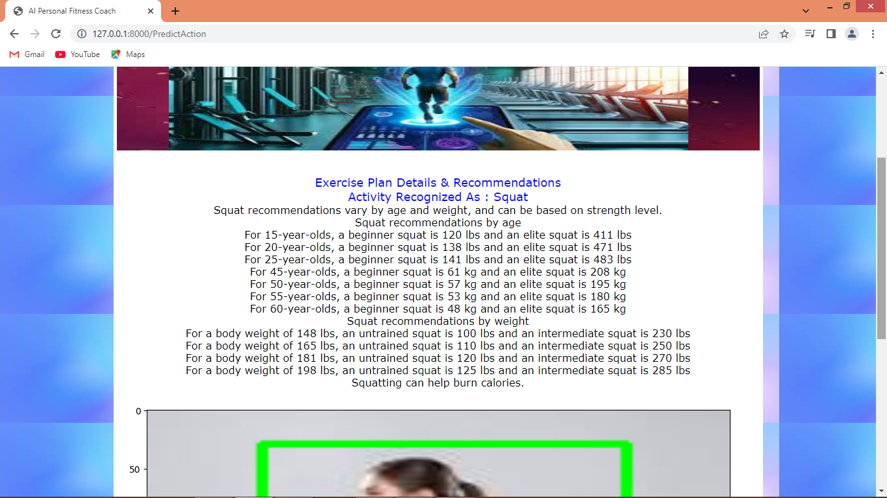
In above screen can see activity recognized as ‘Squat’ and then can see entire plan recommendation based on detected activity and scroll down above output to see image
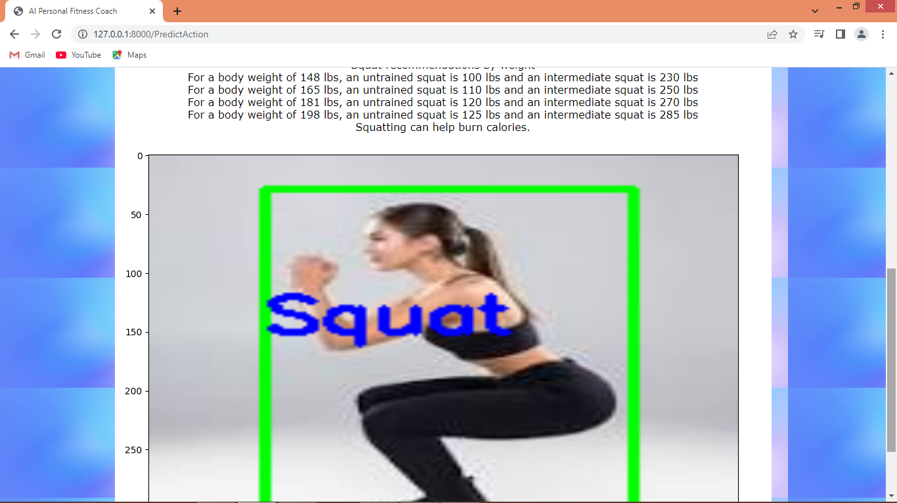
In image also can see detected activity and similarly upload image and detect activity type,. Below is another example
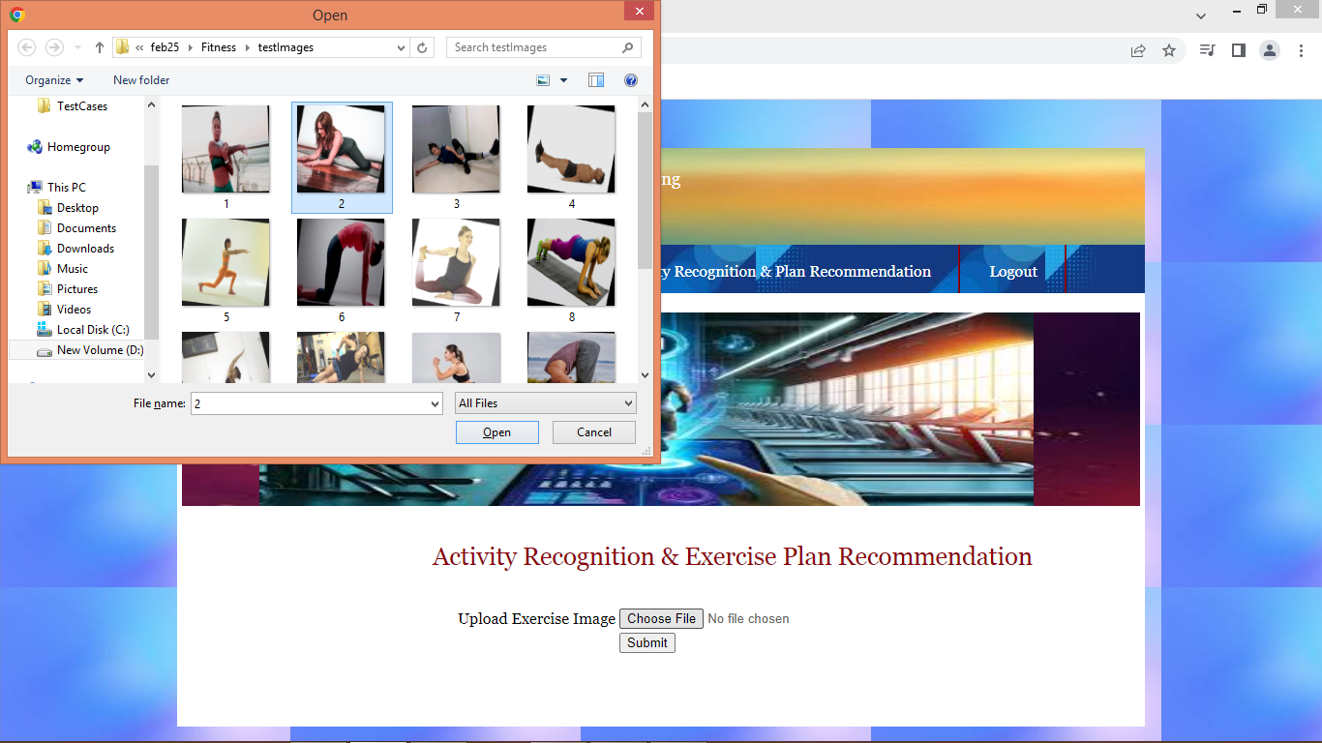
In above screen uploading another image and below is the output
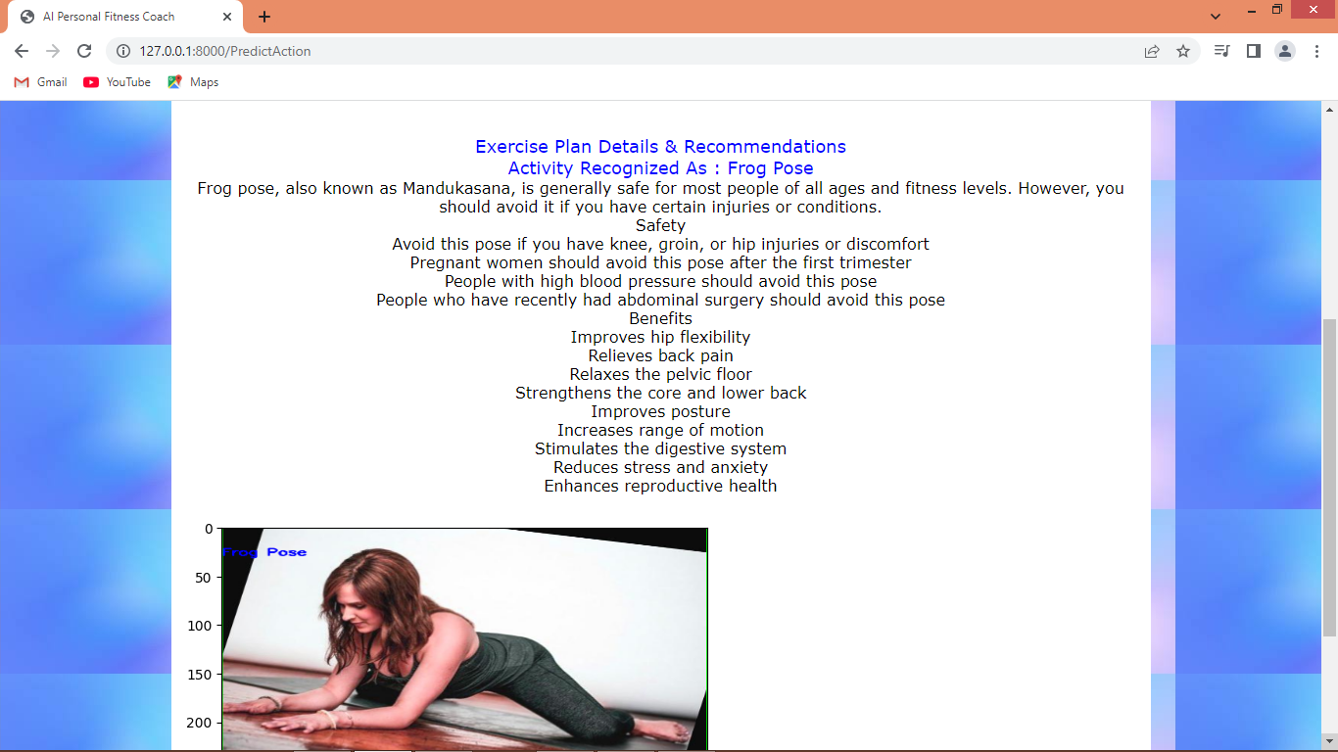
In above screen activity detected as ‘Frog Pose’ and then can see all recommended plan details
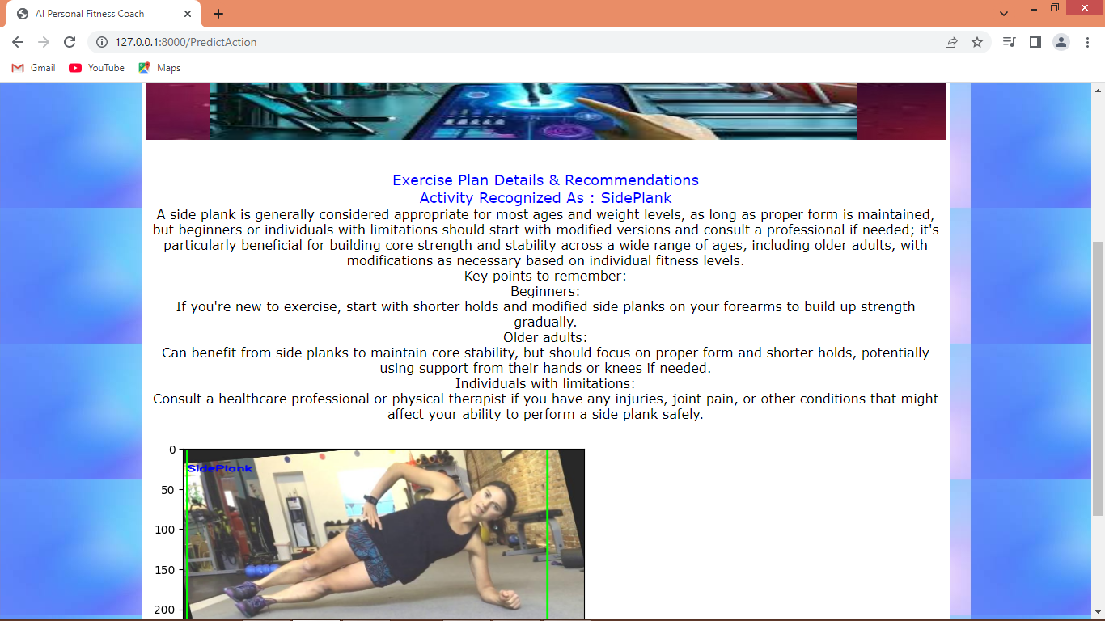
In above screen can see other activity recognition
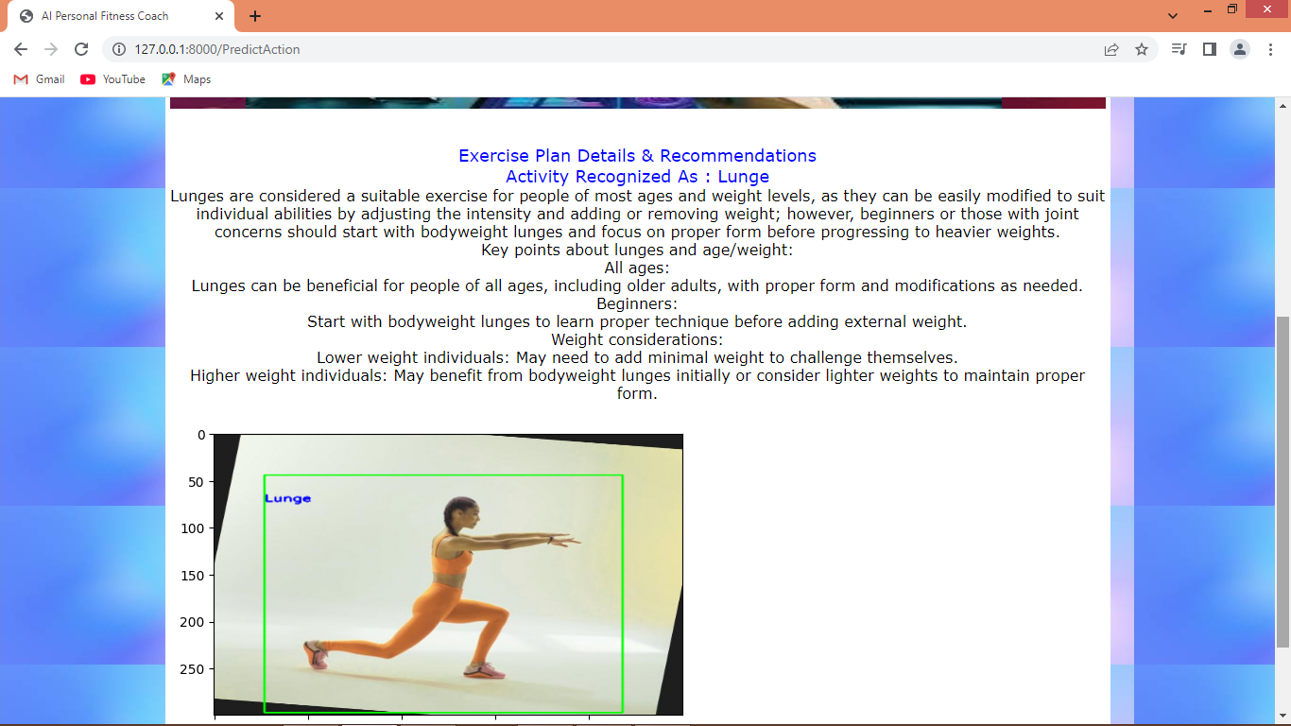
Above activity recognized as plunge.
Similarly you can test any other activity

