### 🔹 1. Project Title:

**Laptop Request Catalog Item using ServiceNow**

### 🔹 2. Project Description:

The *Laptop Request Catalog Item* project streamlines the process of requesting laptops within the organization by utilizing ServiceNow's Service Catalog capabilities. A dynamic and user-friendly catalog item was created to simplify the request process, reduce manual errors, and improve overall efficiency. The project demonstrates how ServiceNow can replace traditional, error-prone workflows with automated, employee-centric solutions — boosting service delivery and satisfaction.

### 🔹 3. Milestones & Activities:

* Gathered requirements
* Designed the catalog item form
* Added dynamic behavior (variables, conditions)
* Configured workflows and approvals
* Performed testing
* Uploaded project to GitHub
* Prepared final documentation

### 🔹 4. Tools & Technologies Used:

* **Platform:** ServiceNow
* **Documentation:** MS Word / Doc Writer
* **Version Control:** GitHub

🔹 5. Screenshots:

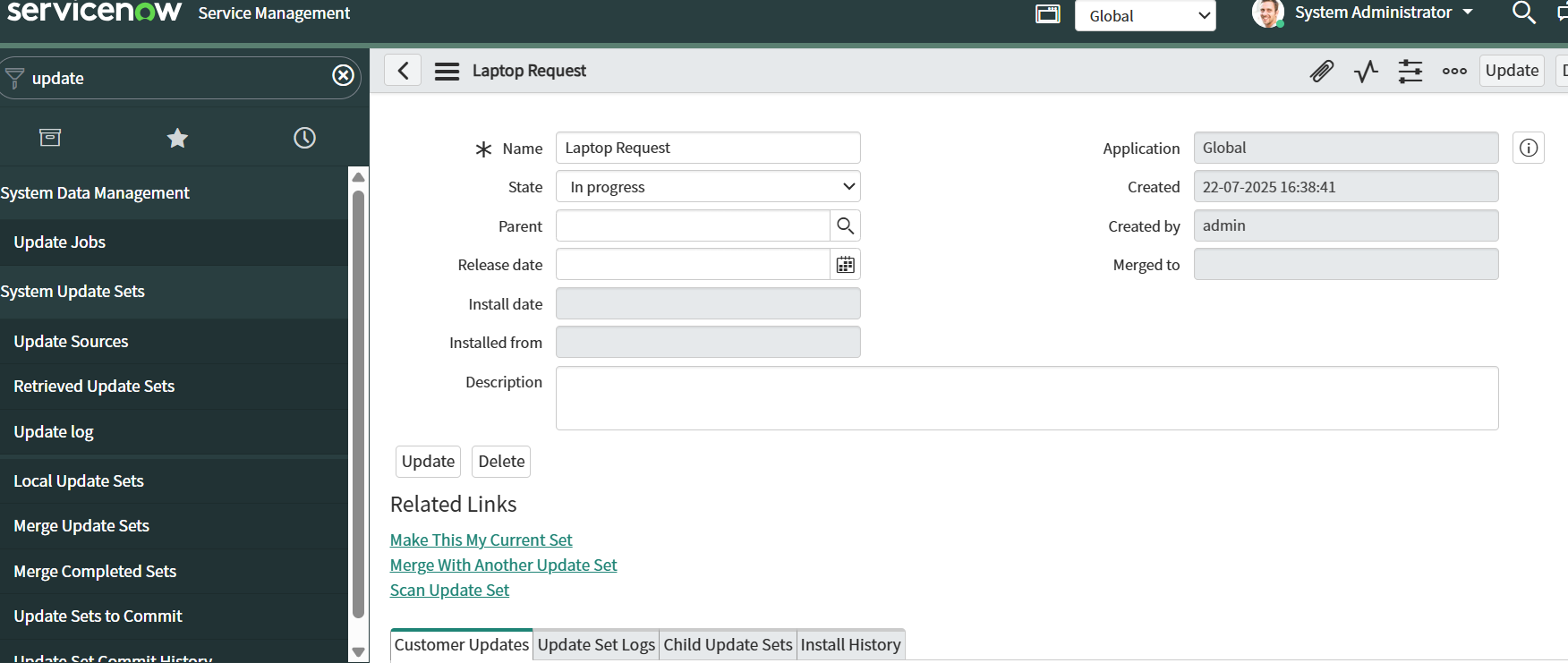

* **Laptop Request Form Interface**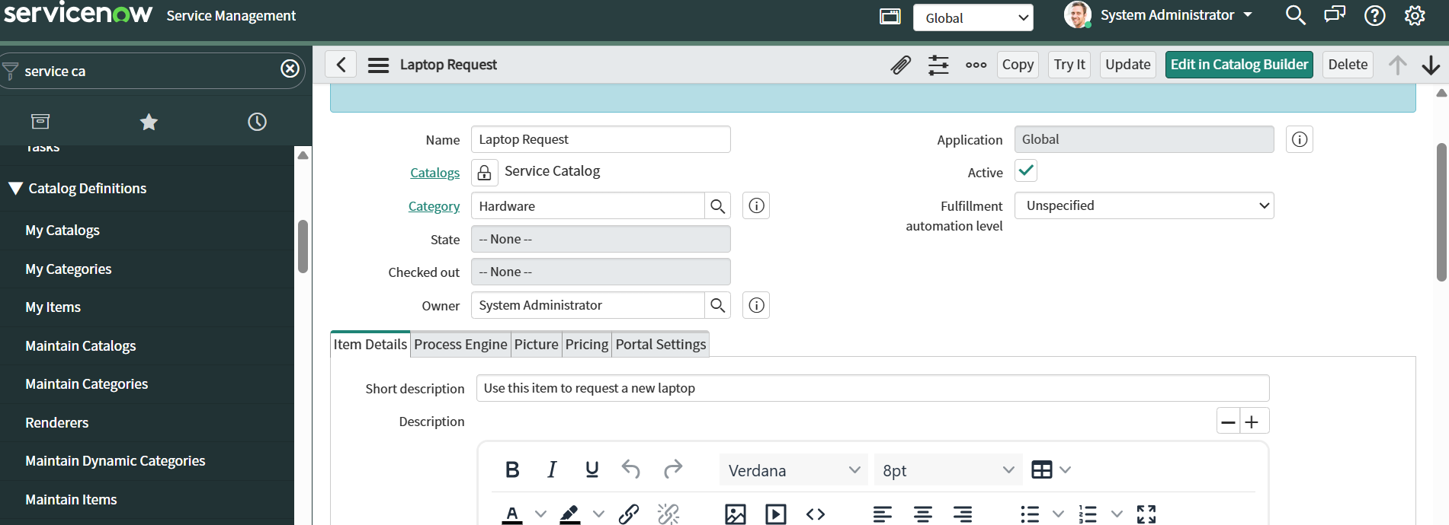

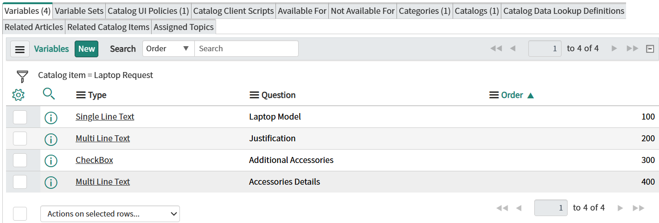

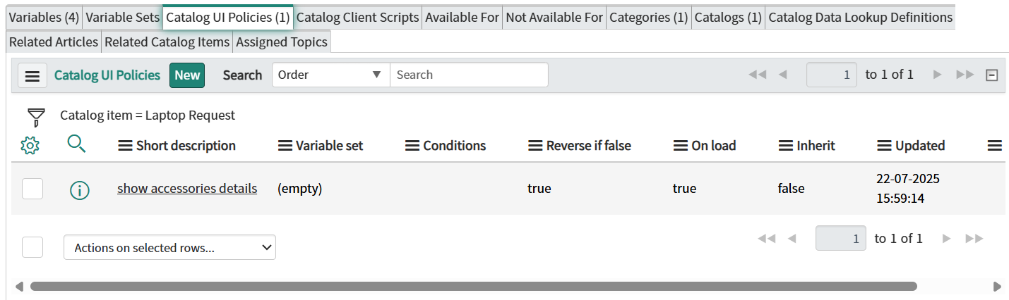

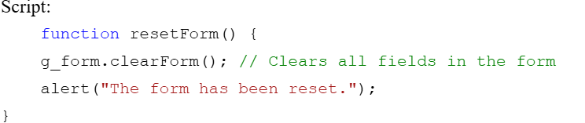

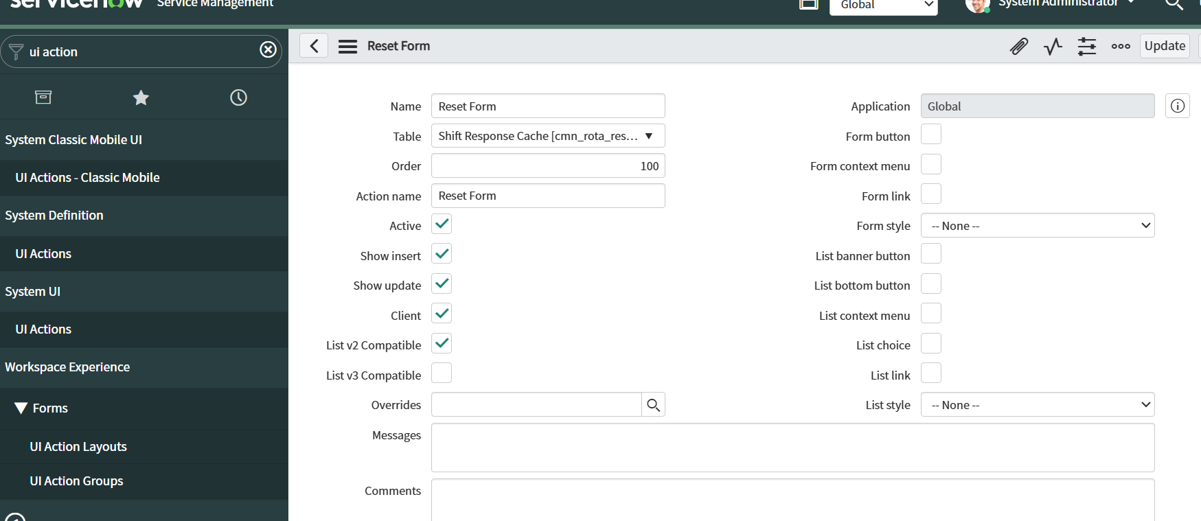

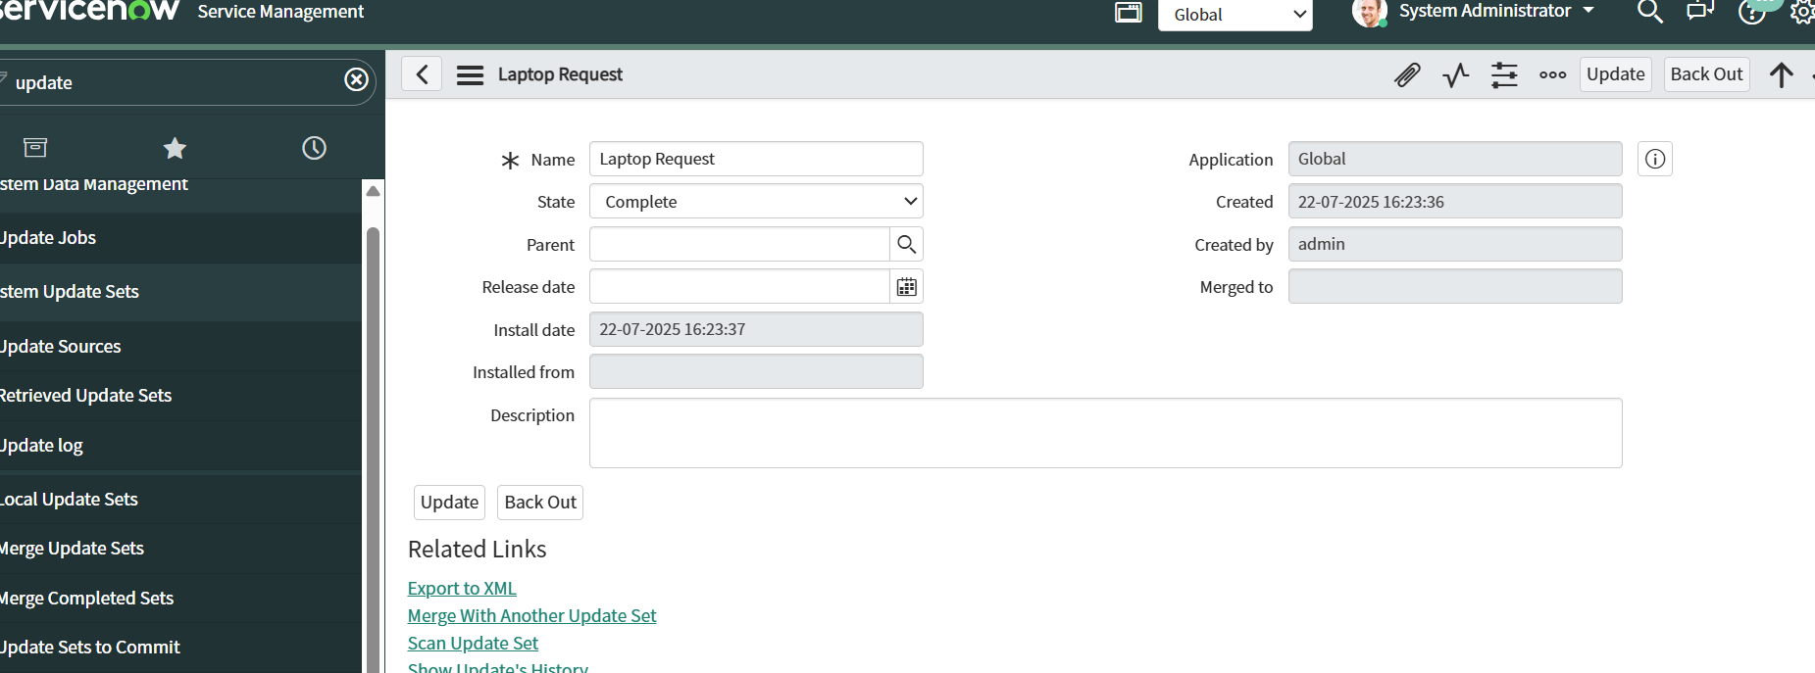

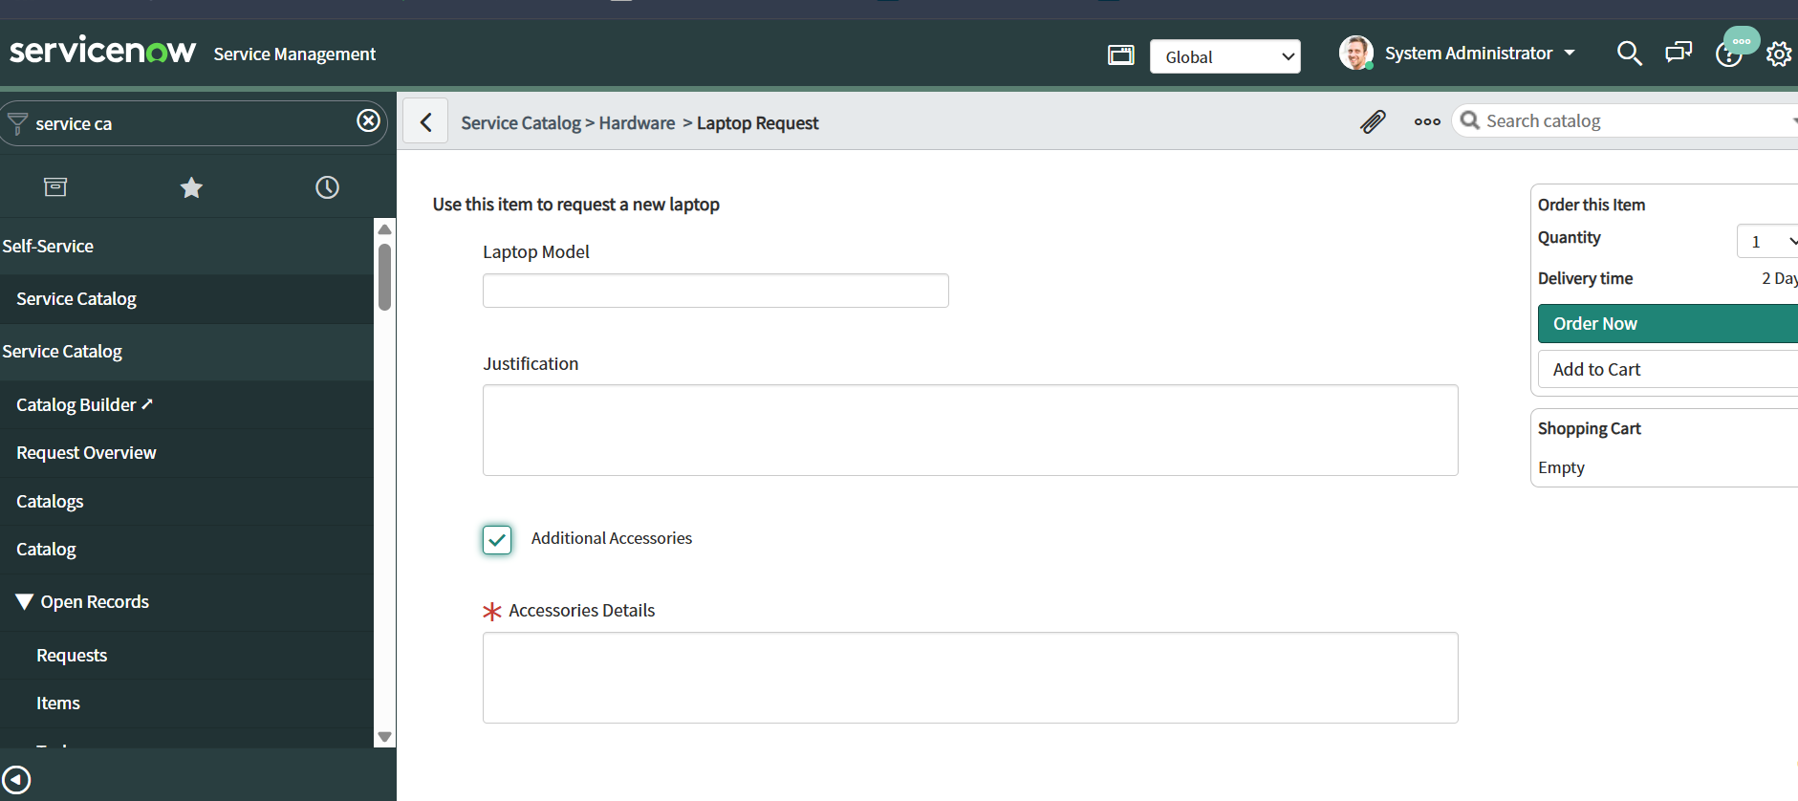



* **Approval Workflow in ServiceNow**

🔹 **6. GitHub Repository Link:**

[Git repo Link](https://github.com/Satyavathi12/Nasscom-Project)

### 🔹 7. Application Link (If Hosted):

N/A

# 🔹 9. Conclusion:

The *Laptop Request Catalog Item* project effectively showcases how ServiceNow can transform a manual, time-consuming laptop request process into a streamlined, automated workflow. By offering a dynamic and user-friendly interface, the project not only reduces errors but also enhances the employee experience. The implementation highlights the platform's ability to support efficient IT service management while aligning with modern digital workplace needs. This solution sets the foundation for scaling similar catalog items for other organizational needs in the future.