**A PROJECT REPORT ON**

**Android Application**

**Submitted in the partial fulfillment for the award of degree in**

**BACHELOR OF TECHNOLOGY TO RAJ KUMAR GOEL INSTITUTE OF TECHNOLOGY GHAZIABAD**

**Submitted by**

Satyender Kumar Yadav

**Under the guidance of**

**NETCAMP SOLUTIONS PRIVATE LIMITED,**

**Kolkata**

**“BASIC ANDROID APPLICATION”**

**Summer Project Report**

**Submitted in partial fulfillment of the degree of B.Tech**

**(Computer Science Engineering)**

**By**

**Satyender kumar Yadav(1403310186)**

**Under the supervision of**

**Mr. Santu Purkait**



**Final Year Student of**

**“BACHELOR OF TECHNOLOGY IN COMPUTER SCIENCE ENGINEERING”**

**RAJ KUMAR GOEL INSTITUTE OF TECHNOLOGY**

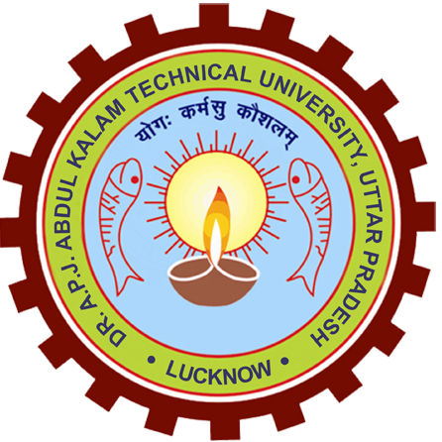

**To Whomsoever It May Concern**

**This is to certify that Satyender Kumar Yadav, a student of B.Tech, 7th semester, Raj Kumar Goel Institute of Technology, AKTU, Ghaziabad, has under gone project training for the period of one month (i.e. 5th of July to 28nd of July) in our organization. He carried out his work as a trainee in Android App Development. He has worked on the project titled “One for All Android App” under the guidance of Santu Purkait.**

**We wish his success in all his future endeavors.**

**Santosh Kumar**

**(CEO/Project Head)**

**(NETCAMP SOLUTIONS PRIVATE LIMITED, Kolkata)**