**Project Environment**

This project will be developed in NetBeans IDE, using Apache Tomcat as web server and MySQL as database management system. NetBeans IDE is a free, open source which helps in developing web applications quickly and easy. Apache Tomcat is an open source web server and servlet container. MySQL is an open source relational database management system. It is mostly used for its quick processing, proven reliability, ease and flexibility of use.

**Project Requirement**

In our project we would like to implement a **car rental system**, through which **customers** can rent **cars** online. Customers can be registered or non-registered. Registered members have to obtain a **membership ID** and must provide **credit card details** and **license** as a form of **security**. We want our customers to select pickup date, time and location to browse through cars **available** then. Once they select the date/time, they will choose the type of car they want like sedan, economy, hatchback, SUV etc. After selecting the type of car, they will be prompted to a vehicle details page. On this page, they will be given estimated **amount** they have to pay depending the time and car they rent. Along with the rent, all the taxes, coupons (if any) will be added and the estimate will be shown. The **registered customers** are entitled to **membership discounts** depending upon the criteria. If they have used our service for 5 times or more, then they are entitled to have a 10% discount. Then, the customer confirms his request by paying through his valid credit card. Once he confirms his order, an invoice will be emailed to him, confirming his pickup date, location, time. When the customer walks in to pick up his car, he then have to provide his driver's license as additional form of security along with card details.

The customers who are not yet members, can sign up and have their membership ID to enjoy the membership discounts and **coupons**. In this case, when they click the sign up option, they will be directed to registration page, where they have to provide all the details about them like name, email address, mailing address and credit card details. There they can set up their username and password for future use.

The **admin** of this system will be having access to all the car rental database and the customer details. He is responsible for revising the car rental prices, adding or removing any car, coupons and discounts to be given. He will generate monthly reports, finalize the orders and review them. He maintains contact with customers through emails. When a customer checks out a car he requested, the admin will update his **order page** by adding the **license plate** of the car given to him and his license number. This page will be updated finally when the car is returned. This page is not accessible to the customers but admin.

The customer, registered or non-registered can access only the available cars according to the given date/ time and location. They can even cancel their orders if they want to and it should be at least 24 hours prior to the pickup time. If the customer fails to do that he will be charged for that particular day. If the customer fails to return the car on decided return date, they will be charged **overdue rent** of 35$ per day.

**Conceptual Design**

**A: Noun-Verb Identification**

**List of Nouns**

customer

admin

car

membership id

price

type

availability

membership discounts

registered customers

amount

credit card details

license

overdue rent

security

license plate

coupons

order page

**List of Verbs**

implement

rent

fails

charged

update

responsible

checks out

returned

access

sign up

confirm

browse

provide

obtain

select

pay

**B: Entities, Relationships and Attributes**

Strong Entity **Customer** (Generalization) with non-composite single-valued attributes

**Entity: Customer**

email_id

first_name

middle_name

last_name

phone_number

registration_time

Strong Entity **RegisteredCustomer** (Specialization) with non-composite single-valued attributes

**Entity: RegisteredCustomer**

email_id

membership_id

password

**Foreign Key:** email_id (From Customer)

Derived attribute of the strong entity **RegisteredCustomer** - num_rentals

Strong Entity **CarCategory** with non-composite single-valued attributes

**Entity: CarCategory**

category_id

category_name

renting_price

Derived attribute of the strong entity **CarCategory** - availability

Strong Entity **Reservation** with non-composite single-valued attributes, Binary Relationship (one-to-many) between the strong entities **Customer** and **Reservation** (Customer **Makes** Reservation) and Binary Relationship (one-to-one) between the strong entities **Reservation** and **CarCategory** (Reservation **For** CarCategory)

**Entity: Reservation**

reservation_id

email_id

category_id

pick_up_date

return_date

Derived attributes of the strong entity **Reservation** - discount_amount, transaction_amount

**Foreign Key Approach:** email_id (Primary Key of **Customer**), category_id (Primary Key of **CarCategory**) are included in the strong entity **Reservation** as Foreign Keys

Weak entity **Driver** with non-composite single-valued attributes (Strong entity: **Reservation**) and Weak Binary Relationship (one-to-one) between the strong entity **Reservation** and the weak entity **Driver** (Reservation **UsedBy** Driver)

**Entity: Driver**

reservation_id

license_id

first_name

middle_name

last_name

**Foreign Key Approach:** reservation_id (Primary Key of **Reservation**) is included in the weak entity **Driver** as a Foreign Key

Strong entity **Car** with non-composite single-valued attributes, Binary Relationship (one-to-many) between the strong entities **CarCategory** and **Car** (CarCategory **Has** Car)

**Entity: Car**

VIN

category_id

license_plate

availability

**Foreign Key Approach:** category_id (Primary Key of **CarCategory**) is included in the strong entity **Car** as a Foreign Key

Weak Binary Relationship (one-to-one) between the weak entity **Driver** and the strong entity **Car**

Driver **PicksUp/Returns** a Car

**PicksUpReturns**

reservation_id

license_id

VIN

pick_up_time

return_time

cc_name

cc_number

cc_cvv

cc_expiry_date_year

cc_expiry_date_month

Derived attributes of the relationship **PicksUpReturns** - over_due_amount, amount_to_pay

**Foreign Keys:** reservation_id, license_id (From Driver), VIN (From Car)

**C: Entity-Relationship Diagram**

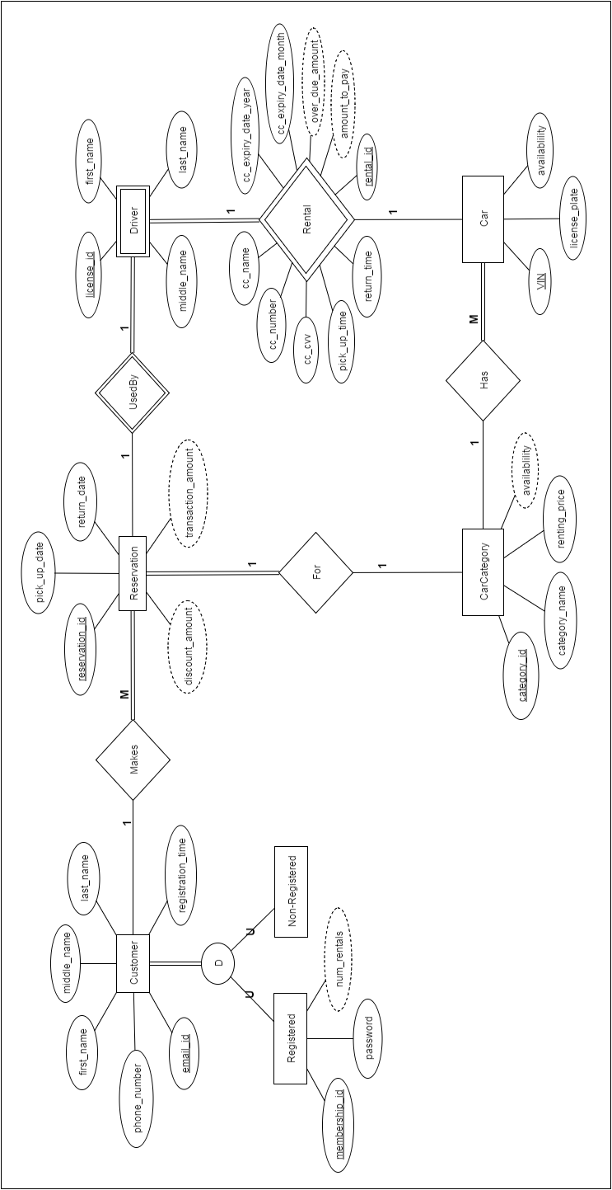

**D: Logical Design**

**Functional Dependencies**

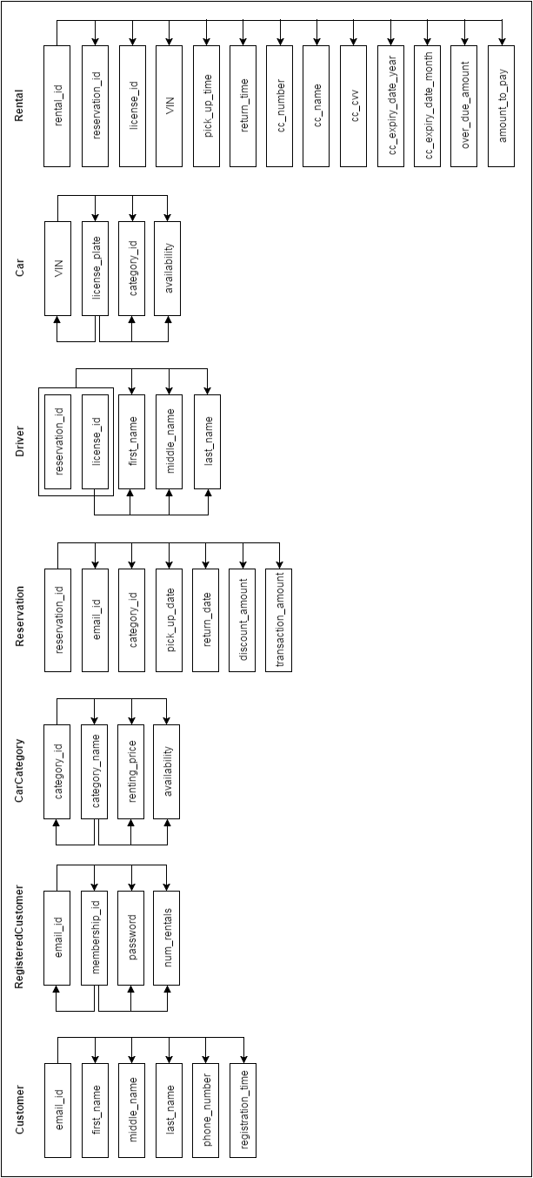

**Table: Customer**

email_id VARCHAR(30)

first_name VARCHAR(40) NOT NULL

middle_name VARCHAR(20)

last_name VARCHAR(20) NOT NULL

phone_number CHAR(10) NOT NULL

registration_time TIMESTAMP

**Primary Key:** email_id

**Highest Normal Form:** BCNF

**Justification:** We are not checking for 4NF

**Table: RegisteredCustomer**

email_id VARCHAR(30)

membership_id INT(4) NOT NULL

password VARCHAR(20) NOT NULL

num_rentals INT DEFAULT 0

**Primary Key:** email_id

**Foreign Key:** email_id REFERENCES Customer (email_id)

**Highest Normal Form:** BCNF

**Justification:** We are not checking for 4NF

**Table: CarCategory**

category_id INT(4)

category_name VARCHAR(20) NOT NULL

renting_price DOUBLE NOT NULL

availability BOOLEAN DEFAULT 0

**Primary Key:** category_id

**Highest Normal Form:** BCNF

**Justification:** We are not checking for 4NF

**Table: Reservation**

reservation_id INT(4)

email_id VARCHAR(30)

category_id INT(4)

pick_up_date DATE NOT NULL

return_date DATE NOT NULL

discount_amount DOUBLE DEFAULT 0.00

transaction_amount DOUBLE DEFAULT 0.00

**Primary Key:** reservation_id

**Foreign Key:** email_id REFERENCES Customer (email_id)

**Foreign Key:** category_id REFERENCES CarCategory (category_id)

**Highest Normal Form:** BCNF

**Justification:** We are not checking for 4NF

**Table: Driver**

reservation_id INT(4)

license_id VARCHAR(15)

first_name VARCHAR(40) NOT NULL

middle_name VARCHAR(20)

last_name VARCHAR(20) NOT NULL

**Primary Key:** reservation_id, license_id

**Foreign Key:** reservation_id REFERENCES Reservation (reservation_id)

**Highest Normal Form:** 1NF

**Justification:** reservation and license id together form candidate key. first_name, last_name and middle_name do not fully depend on candidate key, violating 2NF.

**Table: Car**

VIN VARCHAR(18)

category_id INT(4)

license_plate CHAR(8) NOT NULL

availability BOOLEAN DEFAULT 0

**Primary Key:** VIN

**Foreign Key:** category_id REFERENCES CarCategory (category_id)

**Highest Normal Form:** BCNF

**Justification:** We are not checking for 4NF

**Table: Rental**

rental_id INT(4)

reservation_id INT(4)

license_id VARCHAR(15)

VIN VARCHAR(18)

pick_up_time TIMESTAMP NOT NULL

return_time TIMESTAMP

cc_name VARCHAR(30) NOT NULL

cc_number CHAR(16) NOT NULL

cc_cvv CHAR(3) NOT NULL

cc_expiry_date_year CHAR(4) NOT NULL

cc_expiry_date_month CHAR(2) NOT NULL

over_due_amount DOUBLE DEFAULT 0.00

amount_to_pay DOUBLE DEFAULT 0.00

**Primary Key:** rental_id

**Foreign Key:** reservation_id, license_id REFERENCES Driver (reservation_id, license_id)

**Foreign Key:** VIN REFERENCES Car (VIN)

**Highest Normal Form:** 1NF

**Justification:** reservation_id, license_id, VIN, check_out_date form candidate key and non-key

attributes do not fully depend on candidate key, violating 2NF.

**E: Creation of Database and Tables (SQL Dump)**

CREATE DATABASE CarRentalSystem;

USE CarRentalSystem;

CREATE TABLE Customer

(

email_id VARCHAR(30),

first_name VARCHAR(40) NOT NULL,

middle_name VARCHAR(20),

last_name VARCHAR(20) NOT NULL,

phone_number CHAR(10) NOT NULL,

registration_time TIMESTAMP NOT NULL DEFAULT CURRENT_TIMESTAMP,

PRIMARY KEY (email_id),

INDEX index_customer_email (email_id),

INDEX index_customer_phone (phone_number),

INDEX index_customer_name (last_name, first_name)

);

CREATE TABLE RegisteredCustomer

(

membership_id INT(4) UNSIGNED AUTO_INCREMENT,

email_id VARCHAR(30) UNIQUE NOT NULL,

password VARCHAR(20) NOT NULL,

num_rentals INT DEFAULT 0,

PRIMARY KEY (membership_id),

FOREIGN KEY (email_id) REFERENCES Customer (email_id) ON DELETE CASCADE ON UPDATE CASCADE,

CONSTRAINT uc_member UNIQUE (email_id, membership_id),

CONSTRAINT uc_login UNIQUE (email_id, password),

INDEX index_registeredcustomer_membership (membership_id),

INDEX index_registeredcustomer_email (email_id)

) AUTO_INCREMENT=1000;

CREATE TABLE CarCategory

(

category_id INT(4) UNSIGNED AUTO_INCREMENT,

category_name VARCHAR(20) UNIQUE NOT NULL,

renting_price DOUBLE NOT NULL DEFAULT 0.00,

availability BOOLEAN DEFAULT 1,

PRIMARY KEY (category_id),

CONSTRAINT uc_member UNIQUE (category_name),

INDEX index_carcategory_id (category_id),

INDEX index_carcategory_name (category_name),

INDEX index_carcategory_price (renting_price)

) AUTO_INCREMENT=6001;

CREATE TABLEReservation

(

reservation_id INT(4) UNSIGNED AUTO_INCREMENT,

email_id VARCHAR(30),

category_id INT(4) UNSIGNED,

pick_up_date DATE NOT NULL,

return_date DATE NOT NULL,

discount_amount DOUBLE DEFAULT 0.00,

transaction_amount DOUBLE DEFAULT 0.00,

PRIMARY KEY (reservation_id),

FOREIGN KEY (email_id) REFERENCES Customer (email_id) ON DELETE CASCADE ON UPDATE CASCADE,

FOREIGN KEY (category_id) REFERENCES CarCategory (category_id) ON DELETE CASCADE ON UPDATE CASCADE,

INDEX index_reservation_id (reservation_id),

INDEX index_reservation_email (email_id),

INDEX index_reservation_pickupdate (pick_up_date),

INDEX index_reservation_returndate (return_date)

) AUTO_INCREMENT=2001;

CREATE TABLE Driver

(

reservation_id INT(4) UNSIGNED,

license_id VARCHAR(15),

first_name VARCHAR(40) NOT NULL,

middle_name VARCHAR(20),

last_name VARCHAR(20) NOT NULL,

PRIMARY KEY (reservation_id, license_id),

FOREIGN KEY (reservation_id) REFERENCES Reservation (reservation_id) ON DELETE CASCADE ON UPDATE CASCADE,

INDEX index_driver_reservation (reservation_id, license_id),

INDEX index_driver_name (last_name, first_name)

);

CREATE TABLE Car

(

VIN VARCHAR(18),

category_id INT(4) UNSIGNED,

license_plate CHAR(8) NOT NULL,

availability BOOLEAN DEFAULT 1,

PRIMARY KEY (VIN),

FOREIGN KEY (category_id) REFERENCES CarCategory (category_id) ON DELETE CASCADE ON UPDATE CASCADE,

CONSTRAINT uc_licenseplate UNIQUE (license_plate),

INDEX index_car_VIN (VIN),

INDEX index_car_category (category_id),

INDEX index_car_licenseplate (license_plate)

);

CREATE TABLE Rental

(

rental_id INT(4) UNSIGNED AUTO_INCREMENT,

reservation_id INT(4) UNSIGNED,

license_id VARCHAR(15),

VIN CHAR(18),

pick_up_time TIMESTAMP NOT NULL DEFAULT CURRENT_TIMESTAMP,

return_time TIMESTAMP,

cc_name VARCHAR(30) NOT NULL,

cc_number CHAR(16) NOT NULL,

cc_cvv CHAR(3) NOT NULL,

cc_expiry_date_year CHAR(4) NOT NULL,

cc_expiry_date_month CHAR(2) NOT NULL,

over_due_amount DOUBLE,

amount_to_pay DOUBLE,

PRIMARY KEY (rental_id),

FOREIGN KEY (reservation_id, license_id) REFERENCES Driver (reservation_id, license_id) ON DELETE CASCADE ON UPDATE CASCADE,

FOREIGN KEY (VIN) REFERENCES Car (VIN) ON DELETE CASCADE ON UPDATE CASCADE,

CONSTRAINT uc_rental UNIQUE (reservation_id),

INDEX index_rental_id (rental_id),

INDEX index_rental_reservation (reservation_id),

INDEX index_rental_license (license_id),

INDEX index_rental_VIN (VIN),

INDEX index_rental_ccname (cc_name),

INDEX index_rental_ccnumber (cc_number)

) AUTO_INCREMENT=7001;

**Tables Design:**

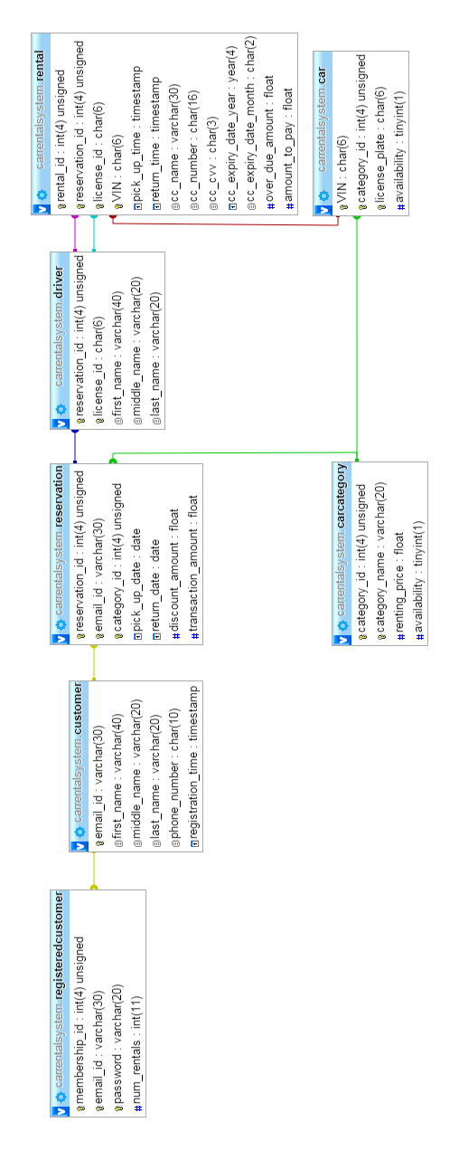

**Functions:**

CREATE FUNCTION f_validate_user (eid VARCHAR(30), pwd VARCHAR(30)) RETURNS TINYINT(1)

BEGIN

DECLARE exist BOOLEAN;

SELECT EXISTS (SELECT * FROM RegisteredCustomer WHERE email_id=eid AND password=pwd) INTO @exist;

RETURN @exist;

END

CREATE FUNCTION f_validate_new_user (eid VARCHAR(30)) RETURNS TINYINT(1)

BEGIN

DECLARE exist BOOLEAN;

SELECT EXISTS (SELECT * FROM RegisteredCustomer WHERE email_id=eid) INTO @exist;

IF @exist = 1

THEN

RETURN 0;

ELSE

RETURN 1;

END IF;

END

CREATE FUNCTION f_validate_guest (eid VARCHAR(30)) RETURNS TINYINT(1)

BEGIN

DECLARE exist BOOLEAN;

SELECT EXISTS (SELECT * FROM Customer WHERE email_id=eid) INTO @exist;

IF @exist = 1

THEN

RETURN 0;

ELSE

RETURN 1;

END IF;

END

CREATE FUNCTION f_validate_car_category (cid INT(4)) RETURNS TINYINT(1)

BEGIN

DECLARE exist BOOLEAN;

SELECT EXISTS (SELECT * FROM Carcategory WHERE category_id=cid) INTO @exist;

RETURN @exist;

END

CREATE FUNCTION f_validate_car_category_availability (cid INT(4), pdate DATE) RETURNS TINYINT(1)

BEGIN

DECLARE exist BOOLEAN;

SELECT EXISTS (SELECT * FROM v_category_available_carcount WHERE CategoryID=cid) INTO @exist;

RETURN @exist;

END

CREATE FUNCTION f_return_actual_days_count (rid INT(4)) RETURNS INT(11)

BEGIN

DECLARE dayscount INT;

SELECT DATEDIFF(DATE(return_time), DATE(pick_up_time)) INTO @dayscount FROM Rental WHERE rental_id=rid;

RETURN @dayscount;

END

CREATE FUNCTION f_return_car_category_id (rid INT(4)) RETURNS INT(4)

BEGIN

DECLARE cid INT(4);

SELECT category_id INTO @cid FROM Reservation WHERE reservation_id=rid;

RETURN @cid;

END

CREATE FUNCTION f_return_car_category_name (cid INT(4)) RETURNS VARCHAR(20)

BEGIN

DECLARE name VARCHAR(60);

SELECT category_name INTO @name FROM CarCategory WHERE category_id=cid;

RETURN @name;

END

CREATE FUNCTION f_return_cc_name (rid INT(4)) RETURNS VARCHAR(30)

BEGIN

DECLARE ccname VARCHAR(30);

SELECT cc_name INTO @ccname FROM Rental WHERE rental_id=rid;

RETURN @ccname;

END

CREATE FUNCTION f_return_cc_number (rid INT(4)) RETURNS CHAR(16)

BEGIN

DECLARE ccnumber CHAR(16);

SELECT cc_number INTO @ccnumber FROM Rental WHERE rental_id=rid;

RETURN @ccnumber;

END

CREATE FUNCTION f_return_days_count (pdate DATE, rdate DATE) RETURNS INT(11)

BEGIN

RETURN DATEDIFF(rdate, pdate);

END

CREATE FUNCTION f_return_discount (rid INT(4)) RETURNS DOUBLE

BEGIN

DECLARE discount DOUBLE;

SELECT discount_amount INTO @discount FROM Reservation WHERE reservation_id=rid;

RETURN @discount;

END

CREATE FUNCTION f_return_discount_percentage (mid INT(4)) RETURNS INT(11)

BEGIN

DECLARE discount INT;

DECLARE count INT;

SET @discount=0;

SELECT num_rentals INTO @count FROM RegisteredCustomer WHERE membership_id=mid;

IF @count<10

THEN

SET @discount=0;

ELSEIF (@count>=10 & @count<=30)

THEN

SET @discount=5;

ELSEIF (@count>30 & @count<50)

THEN

SET @discount=10;

ELSEIF (@count>50)

THEN

SET @discount=15;

END IF;

RETURN @discount;

END

CREATE FUNCTION f_return_expected_days_count (rid INT(4)) RETURNS INT(11)

BEGIN

DECLARE dayscount INT;

SELECT DATEDIFF(return_date, pick_up_date) INTO @dayscount FROM Reservation WHERE reservation_id=rid;

RETURN @dayscount;

END

CREATE FUNCTION f_return_membership_id (eid VARCHAR(30)) RETURNS INT(4)

BEGIN

DECLARE mid INT(4);

SELECT membership_id INTO @mid FROM RegisteredCustomer WHERE email_id=eid;

RETURN @mid;

END

CREATE FUNCTION f_return_name (eid VARCHAR(30)) RETURNS VARCHAR(60)

BEGIN

DECLARE name VARCHAR(60);

SELECT CONCAT(first_name, ' ', last_name) INTO @name FROM Customer WHERE email_id=eid;

RETURN @name;

END

CREATE FUNCTION f_return_pick_up_time (rid INT(4)) RETURNS TIMESTAMP

BEGIN

DECLARE ptime TIMESTAMP;

SELECT pick_up_time INTO @ptime FROM Rental WHERE rental_id=rid;

RETURN @ptime;

END

CREATE FUNCTION f_return_rental_id (rid INT(4)) RETURNS INT(4)

BEGIN

DECLARE rentalid INT(4);

SELECT rental_id INTO @rentalid FROM Rental WHERE reservation_id=rid;

RETURN @rentalid;

END

CREATE FUNCTION f_return_renting_price (cid INT(4)) RETURNS DOUBLE

BEGIN

DECLARE price DOUBLE;

SELECT renting_price INTO @price FROM CarCategory WHERE category_id=cid;

RETURN @price;

END

CREATE FUNCTION f_return_reservation_id (eid VARCHAR(30), cid INT(4), pdate DATE) RETURNS INT(4)

BEGIN

DECLARE rid INT(4);

SELECT reservation_id INTO @rid FROM Reservation WHERE email_id=eid AND category_id=cid AND pick_up_date=pdate;

RETURN @rid;

END

CREATE FUNCTION f_return_return_date (rid INT(4)) RETURNS DATE

BEGIN

DECLARE rdate INT(4);

SELECT return_date INTO @rdate FROM Reservation WHERE reservation_id=rid;

RETURN @rdate;

END

CREATE FUNCTION f_return_return_time (rid INT(4)) RETURNS TIMESTAMP

BEGIN

DECLARE rtime TIMESTAMP;

SELECT return_time INTO @rtime FROM Rental WHERE rental_id=rid;

RETURN @rtime;

END

CREATE FUNCTION f_return_vin (rid INT(4)) RETURNS VARCHAR(18)

BEGIN

DECLARE carvin VARCHAR(18);

SELECT VIN INTO @carvin FROM Rental WHERE rental_id=rid;

RETURN @carvin;

END

**Procedures:**

CREATE PROCEDURE sp_add_customer (fname VARCHAR(40), mname VARCHAR(20), lname VARCHAR(20), pnum CHAR(10), eid VARCHAR(30))

BEGIN

INSERT INTO Customer (first_name, middle_name, last_name, phone_number, email_id) VALUES (fname, mname, lname, pnum, eid);

END

CREATE PROCEDURE sp_add_registeredcustomer (eid VARCHAR(30), pwd VARCHAR(20))

BEGIN

INSERT INTO RegisteredCustomer (email_id, password) VALUES (eid, pwd);

END

CREATE PROCEDURE sp_add_rental (rid INT(4), lid VARCHAR(15), ccname VARCHAR(30), ccnum CHAR(16), year CHAR(4), month CHAR(2), cvv CHAR(3))

BEGIN

DECLARE carvin CHAR(18);

DECLARE valid BOOLEAN;

DECLARE cid INT(4);

SELECT category_id INTO @cid FROM Reservation WHERE reservation_id=rid;

SELECT VIN INTO @carvin FROM Car WHERE category_id=@cid AND availability=1 LIMIT 1;

UPDATE Car SET availability=0 WHERE VIN=@carvin;

SELECT EXISTS (SELECT CategoryID FROM v_category_available_carcount V WHERE CategoryID=@cid) INTO @valid;

IF @valid = 0

THEN

UPDATE CarCategory SET availability=0 WHERE category_id=@cid;

END IF;

INSERT INTO Rental (reservation_id, license_id, cc_name, cc_number, cc_expiry_date_year, cc_expiry_date_month, cc_cvv, pick_up_time, VIN) VALUES (rid, lid, ccname, ccnum, expyear, month, cvv, NOW(), @carvin);

END

CREATE PROCEDURE sp_add_reservation_driver (eid VARCHAR(30), cid INT(4), pdate DATE, rdate DATE, discount DOUBLE, amount DOUBLE, lid VARCHAR(15), fname VARCHAR(40), mname VARCHAR(20), lname VARCHAR(20))

BEGIN

DECLARE rid INT(4);

INSERT INTO Reservation (email_id, category_id, pick_up_date, return_date, discount_amount, transaction_amount) VALUES (eid, cid, pdate, rdate, discount, amount);

SELECT reservation_id INTO @rid FROM Reservation WHERE email_id=eid AND category_id=cid AND pick_up_date=pdate;

INSERT INTO Driver (reservation_id, license_id, first_name, middle_name, last_name) VALUES (@rid, lid, fname, mname, lname);

END

CREATE PROCEDURE sp_update_customer (fname VARCHAR(40), mname VARCHAR(20), lname VARCHAR(20), pnum CHAR(10), eid VARCHAR(30))

BEGIN

UPDATE Customer SET first_name=fname, middle_name=mname, last_name=lname, phone_number=pnum WHERE email_id=eid;

END

CREATE PROCEDURE sp_update_rental (rid INT(4), lid VARCHAR(15), carvin CHAR(18))

BEGIN

DECLARE due DOUBLE;

DECLARE pay DOUBLE;

DECLARE rentperday DOUBLE;

DECLARE discount DOUBLE;

DECLARE basic DOUBLE;

DECLARE tax DOUBLE;

DECLARE daycount INT;

DECLARE actualdaycount INT;

DECLARE eid VARCHAR(30);

DECLARE valid BOOLEAN;

UPDATE Car SET availability=1 WHERE VIN=carvin;

UPDATE CarCategory SET availability=1 WHERE category_id=(SELECT category_id FROM Car WHERE VIN=carvin);

SELECT email_id INTO @eid FROM Reservation WHERE reservation_id=rid;

SELECT DATEDIFF(return_date, pick_up_date) INTO @daycount FROM Reservation WHERE reservation_id=rid;

SELECT DATEDIFF(CURDATE(), pick_up_date) INTO @actualdaycount FROM Reservation WHERE reservation_id=rid;

SELECT CC.renting_price INTO @rentperday FROM CarCategory CC JOIN Reservation R ON CC.category_id=R.category_id AND reservation_id=rid;

IF @actualdaycount>@daycount

THEN

SET @due = ((@actualdaycount - @daycount)*@rentperday);

ELSE

SET @due=0;

END IF;

SELECT discount_amount INTO @discount FROM Reservation WHERE reservation_id=rid;

SET @basic = @actualdaycount*@rentperday;

SET @tax = (8.25*@basic)/100;

SET @pay = @basic+@tax-@discount;

UPDATE Rental SET return_time=NOW(), over_due_amount=@due, amount_to_pay=@pay WHERE reservation_id=rid;

UPDATE RegisteredCustomer SET num_rentals=(num_rentals+1) WHERE email_id=@eid;

END

**Not Used:**

CREATE PROCEDURE sp_generate_membership_id ()

BEGIN

UPDATE RegisteredCustomer SET membership_id = (SELECT FLOOR(1000.0 + RAND()*999.0) AS id FROM RegisteredCustomer WHERE membership_id = NULL AND id NOT IN (SELECT membership_id FROM RegisteredCustomer) LIMIT 1);

END

CREATE PROCEDURE sp_generate_category_id ()

BEGIN

UPDATE CarCategory SET category_id = (SELECT FLOOR(6000.0 + RAND()*999.0) AS id FROM CarCategory WHERE category_id = NULL AND id NOT IN (SELECT category_id FROM CarCategory) LIMIT 1);

END

CREATE PROCEDURE sp_generate_reservation_id ()

BEGIN

UPDATE Reservation SET reservation_id = (SELECT FLOOR(2000.0 + RAND()*999.0) AS id FROM Reservation WHERE reservation_id = NULL AND id NOT IN (SELECT reservation_id FROM Reservation) LIMIT 1);

END

CREATE PROCEDURE sp_generate_rental_id ()

BEGIN

UPDATE Rental SET rental_id = (SELECT FLOOR(7000.0 + RAND()*999.0) AS id FROM Rental WHERE rental_id = NULL AND id NOT IN (SELECT rental_id FROM Rental) LIMIT 1);

END

**Triggers:**

**Not Used:**

CREATE TRIGGER tr_membership_id AFTER INSERT ON RegisteredCustomer FOR EACH ROW

BEGIN

UPDATE RegisteredCustomer SET membership_id = (SELECT FLOOR(1000.0 + RAND()*999.0) AS id FROM RegisteredCustomer WHERE membership_id = NULL AND id NOT IN (SELECT membership_id FROM RegisteredCustomer) LIMIT 1);

END

CREATE TRIGGER tr_category_id AFTER INSERT ON CarCategory FOR EACH ROW

BEGIN

UPDATE CarCategory SET category_id = (SELECT FLOOR(6000.0 + RAND()*999.0) AS id FROM CarCategory WHERE category_id = NULL AND id NOT IN (SELECT category_id FROM CarCategory) LIMIT 1);

END

CREATE TRIGGER tr_reservation_id AFTER INSERT ON Reservation FOR EACH ROW

BEGIN

UPDATE Reservation SET reservation_id = (SELECT FLOOR(2000.0 + RAND()*999.0) AS id FROM Reservation WHERE reservation_id = NULL AND id NOT IN (SELECT reservation_id FROM Reservation) LIMIT 1);

END

CREATE TRIGGER tr_rental_id AFTER INSERT ON Rental FOR EACH ROW

BEGIN

UPDATE Rental SET rental_id = (SELECT FLOOR(7000.0 + RAND()*999.0) AS id FROM Rental WHERE rental_id = NULL AND id NOT IN (SELECT rental_id FROM Rental) LIMIT 1);

END

**Views:**

CREATE VIEW v_category_total_carcount AS

SELECT CC.category_id AS CategoryID, COUNT(C.VIN) AS TotalCarCount FROM CarCategory CC LEFT OUTER JOIN Car C ON CC.category_id=C.category_id GROUP BY CC.category_id;

CREATE VIEW v_category_available_carcount AS

SELECT CC.category_id AS CategoryID, COUNT(C.VIN) AS AvailableCarCount FROM CarCategory CC LEFT OUTER JOIN Car C ON CC.category_id=C.category_id WHERE C.availability=1 GROUP BY CC.category_id;

CREATE VIEW v_category_carcount AS

SELECT T.CategoryID, T.TotalCarCount, A.AvailableCarCount, T.TotalCarCount- A.AvailableCarCount AS RentedCarCount FROM v_category_total_carcount T JOIN v_category_available_carcount A ON T.CategoryID=A.CategoryID;

**Inserting Data (manually):**

INSERT INTO CarCategory (category_name, renting_price) VALUES

('Economy', 25.00),

('Intermediate', 24.00),

('SUV', 28.00),

('Luxury', 35.00),

('Compact', 23.00),

('Family', 26.00),

('Convertible', 28.00),

('Cargo Van', 34.00),

('Mid-Level', 24.00),

('Roadster', 34.00);

INSERT INTO Car (VIN, category_id, license_plate) VALUES

('2KJPDDJH51K971089', 6001, 'LCH-3210'),

('2BNPDDJH51K97100', 6001, 'ABD-768'),

('2WKPDDJH51K970989', 6001, 'BGD-4321'),

('KMHHU6KJ1DU186741', 6001, 'CVF-7865'),

('5GAET13M262340847', 6001, 'NJH-8765'),

('2HGES16535HG81755', 6001, 'SDF-8765'),

('1HD1KAV106Y69592', 6001, 'GHB-7865'),

('5GAET13M262340848', 6001, 'DVG-7653'),

('1HD1KAV106Y695921', 6002, 'BHG-5678'),

('3FRWW6FC3DV072954', 6002, 'BJR-8765'),

('JS1GL52A4D2145863', 6002, 'KKF-7654'),

('2WKPDDJH51K970990', 6002, 'CJG-5678'),

('KMHHU6KJ1DU186742', 6002, 'LKJ-9879'),

('5GAET13M262341848', 6002, 'JHF-5678'),

('2HGES16535HG81756', 6002, 'HHJ-4567'),

('1HD1KAV106Y695922', 6002, 'VGJ-5678'),

('1LNLM9842KY774961', 6003, 'DFG-3456'),

('JS1GL52A4D2145864', 6003, 'CFF-5567'),

('2HGES16535HG81759', 6003, 'CGH-8765'),

('5GAET13M262340851', 6003, 'XCF-4322'),

('2WKPDDJH51K97099', 6003, 'FGB-5676'),

('3FRWW6FC3DV072957', 6003, 'CKK-6787'),

('2HGES16535HG81758', 6004, 'SDF-4456'),

('KMHHU6KJ1DU186744', 6004, 'CFF-5435'),

('KMHHU6KJ1DU186749', 6004, 'VBH-6645'),

('5GAET13M262340852', 6004, 'BGG-8759'),

('2HGES16535HG81760', 6004, 'SDF-8762'),

('2WKPDDJH51K970995', 6004, 'VGH-4221'),

('KMHHU6KJ1DU186747', 6005, 'VHJ-7656'),

('5GAET13M262340853', 6005, 'BHH-5678'),

('2HGES16535HG81761', 6005, 'BHJK-4567'),

('5GAET13M262340854', 6005, 'VHH-5567'),

('2WKPDDJH51K970997', 6005, 'VBJ-6778'),

('5GAET13M262340855', 6005, 'NGG-4567'),

('2HGES16535HG81763', 6006, 'BVF-5679');