**Name:Satyendra Singh Roll No:21002901201 Date:26/06/2023 Batch: 4c1**

**Linear Search.**

Code:

l=[]

n=int(input("enter the range of the list"))

for i in range (n):

x=int(input())

l.append(x)

key=int(input("enter the numbre to be found"))

for i in range(n):

if l[i] == key:

print("element found at ",mid+1)

OUTPUT:

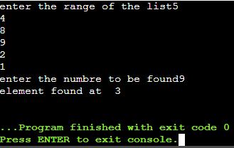

**Binary Search**

Code:

l=[]

n=int(input("enter the range of the list"))

for i in range (n):

x=int(input())

l.append(x)

key=int(input("enter the numbre to be found"))

low=0

high=n-1

while(low<=high):

mid=(low+high)//2

if(l[mid]==key):

print("element found at ",mid+1)

break

elif(l[mid]>key):

high=mid-1

else:

low=mid+1

Output:

