Study and use of commands for performing arithmetic operations using Unix/Linux.

CODE:

**echo “a-b : $val”  
val = $((a*b))**

**echo “a*b : $val”  
val = $((b/a))  
echo “b/a : $val”**

**val = $((b%a))**

**echo "b % a : $val"  
  
if [ $a == $b ]  
then  
   echo "a is equal to b"  
fi**

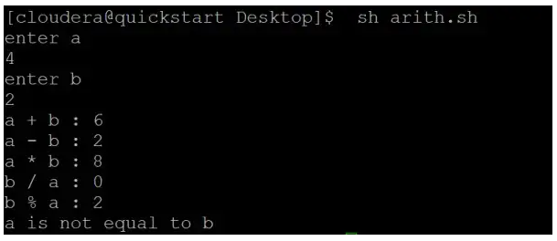

Write a shell script to find the smallest of three numbers that are read from the keyboard.

CODE:

**echo "enter a: "  
read a  
echo "enter b : "  
read b  
echo "enter c : "  
read c  
s=$a  
if [ $b -lt $s ]  
then  
s=$b  
fi  
if [ $c -lt $s ]  
then  
s=$c  
fi  
echo Smallest of $a $b $c is $s**

