PROGRAM 9 SATYENDRA SINGH

LINEAR SEARCH 2100290120150

CODE:

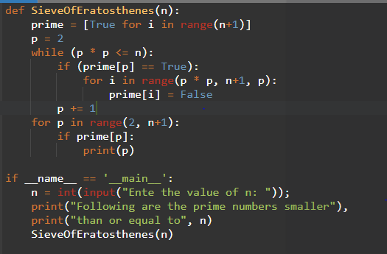

OUTPUT:

