Resource URLS:

**( Youtube ) : selftuts.com Channel**

**L1. What is AWS Lambda ?**

Amazon web services provides more than 30+ web services to us and aws lambda is one of them.

AWS lambda follows the Faas ( Function as a service ) Architecture. Basically these architecture is a serverless in nature, which means a single function act as a service, and there is nothing and no need of servers.

Aws lambda is a compute service from AWS. So basically there are so many service which is provided by aws and those service basically divided into multiple sections, you can check over aws site (inside the aws console.)

So you find lambda inside the compute services of lambda, all the services which comes under the compute sections were responsible to perform some calculations over the data.

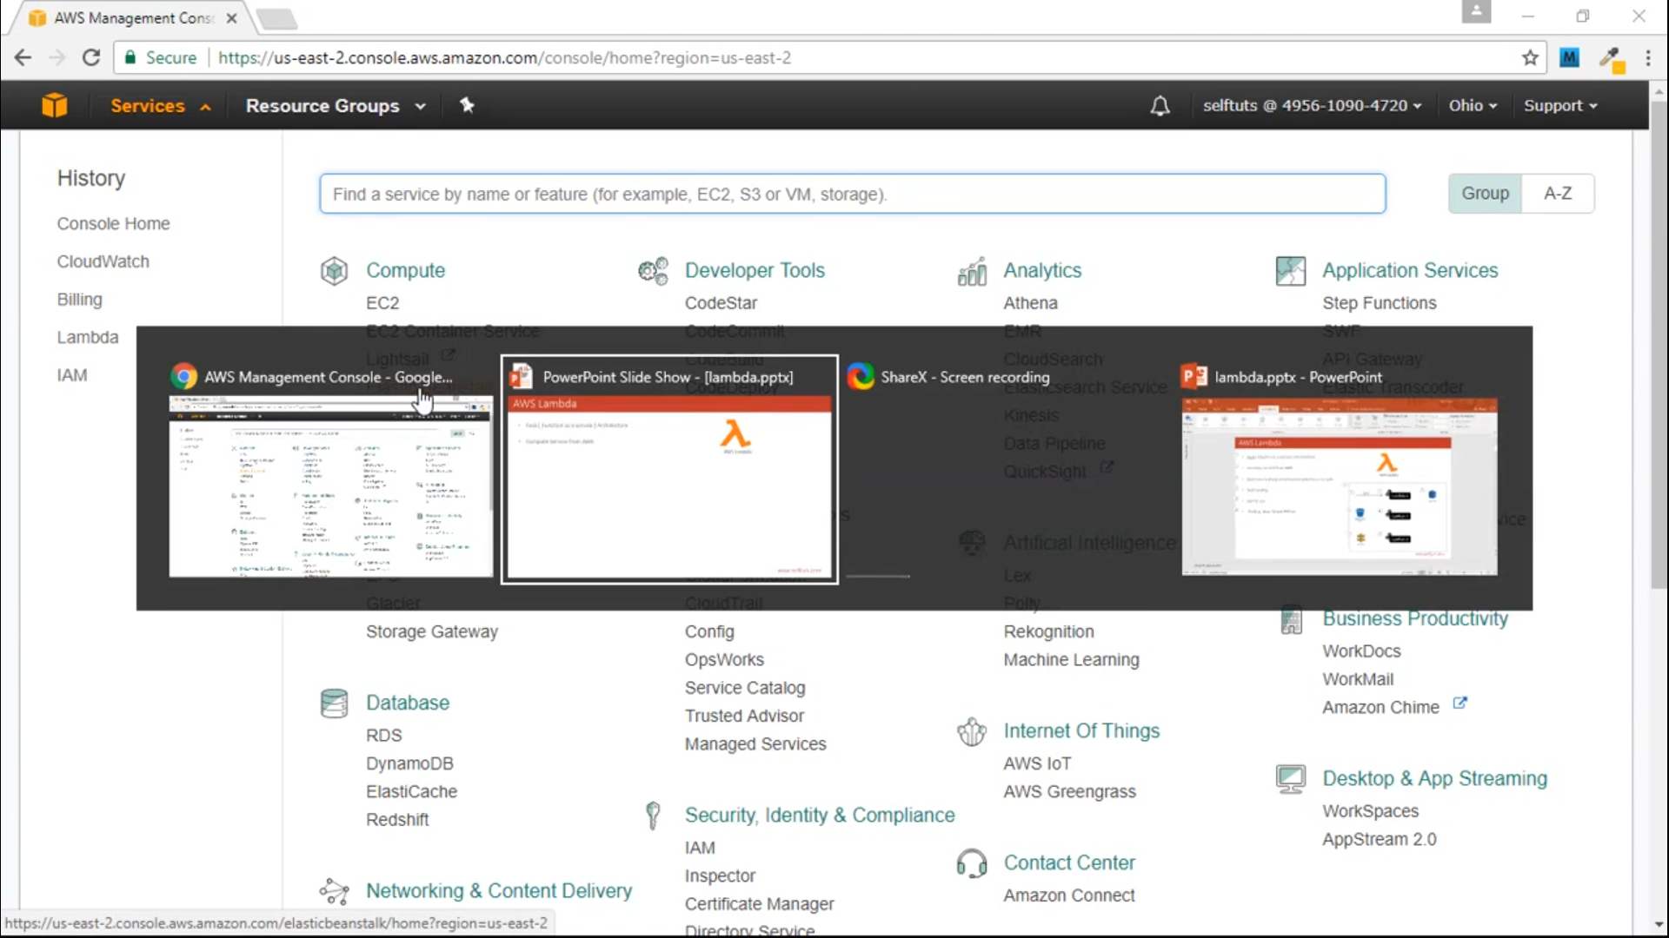

Suppose, yeh ek black box hai jo ki ek aws cloud hai or manlo ki isme koi amazon ki web services hosted hai,

Toh inside that aws cloud there is an lambda function, for now lambda function a a simple function that you write day to day in the code.

And we are tryin to send some data to the simple function(lambda 1 function), There are many ways to send the data towards to the lambda function.

Suppose in this case we are sending the data to the lambda through command line tool.

And lambda function is have the responsibility to write some data over the dynamo db(another amazon web service), and gives response back to us.

So We are only hosting the single function not the Whole Application, and this single function act as a action which is return in inside this lambda 1 function.

Now suppose we have a web application and user needs to upload image of 5mb or more than of it, then if you want to show that image, on mobile device or tablet, there is a heavy lose of our bandwidth, so what we do we allow user to upload 5mb size image, but what we do every time a 5mb image is stored in aws s3 bucket and the image is fired to this lambda2 function, and this lambda 2 function has the responsblty to take that 5 mb image, and reduce the size of it(this happends every time when image come from aws s3 bucket note image can come from anywhere here aws s3 bucket , command line ke through b askti hai).

Another scenario, suppose there is a API gateway, which exposes one API, to send two numbers and we need to find the random number thopse two number, So what will we do we write the lambda three function which have the responsblty, to accept two numbers and return a random number, to them, so this API gateway expose the REST endpoints.

Don’t worry about infrastructure only focus on code(like where these services is running , how much cpu and memory they utilize everything is taken care aws team).

Auto Scaling is done by aws itself (suppose the number of request is increase then the aws lambda handle it). Suppose there is a single request then single instance of lambda 1 function is available, what will happen if the number of request is increase, then the instances of this lambda function will increases by itself. Similarly decrease then reduces instance itself.

Pay for use. (Aws charges lambda function runs 1 then pay only 1 time, means jab lambda function use or run hoga tabi aws paise charge karega).

For current Aws architecture lambda, support Node.js , Java, C#, and Python. And you can write your code any one of them and deploy your code on aws.

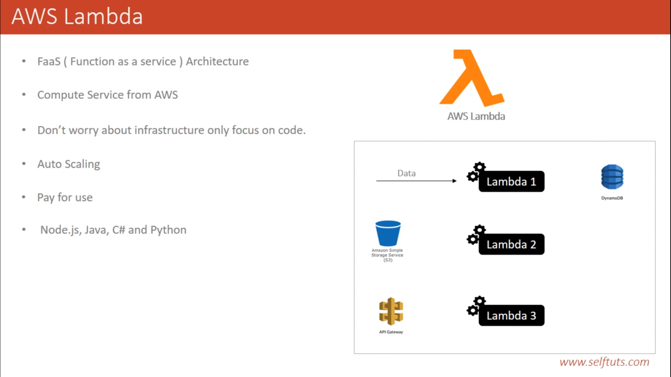

**L2 : How AWS Lambda works internally ?**