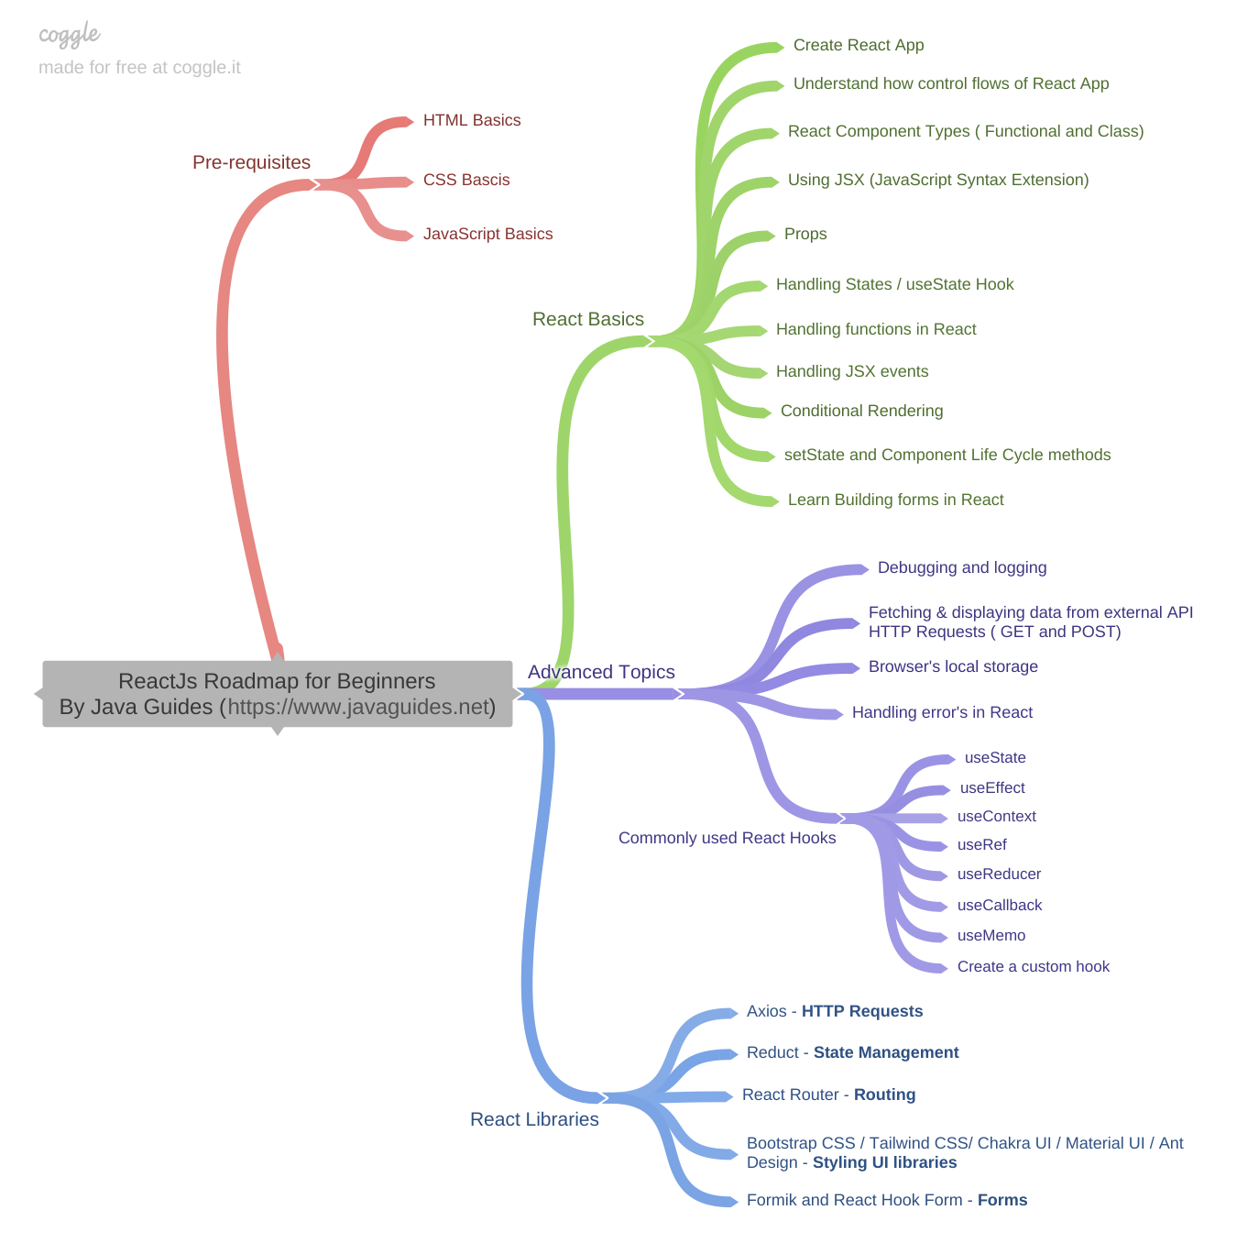

Theory

<https://www.javatpoint.com/reactjs-tutorial>

https://o7planning.org/11923/reactjs

<https://www.w3schools.com/REACT/DEFAULT.ASP>

https://www.tutorialspoint.com/reactjs/index.htm

https://www.guru99.com/reactjs-tutorial.html

<https://www.edureka.co/blog/reactjs-tutorial>

https://www.phptpoint.com/reactjs-jsx/

https://www.simplilearn.com/tutorials/reactjs-tutorial/what-is-reactjs?source=sl_frs_nav_playlist_video_clicked

https://www.fullstacktutorials.com/tutorials/reactjs/react-constructor.html

<https://www.dotnettricks.com/learn/react>

https://ibaslogic.com/react-tutorial-for-beginners/

<https://www.pragimtech.com/courses/react-js-tutorial-for-beginners/>

https://riptutorial.com/reactjs

https://tutorialsinhand.com/tutorials/reactjs-tutorial/reactjs-tutorial-basics/reactjs-first-example.aspx

Projects:

<https://www.golangprograms.com/memory-game-in-react-js.html>