|  |  |
| --- | --- |
| Project: React Admin Dashboard Template Design | **Created Date:** 10-01-2022 |

|  |  |
| --- | --- |
| **Project Resources** | |
| *Channel/Creator* | Lama Dev |
| *URL* | https://www.youtube.com/watch?v=aTPkos3LKi8 |
| *Github* | https://github.com/safak/youtube/tree/react-admin |
| *Others* | N/A |



**Project Starts**

**Step1**: Create a react app using windows cli.

* ~~npx create-react-app Myproject~~

**Note**: As you create react app like this way you will get a lot of unnecessary code and file, so instead of doing this you can use github repository template, and you can clone it in your project directory.

To do so you need to go through this link https://github.com/safak/youtube/tree/react-admin and clone it.

Now open your terminal and run some github commands like

* git clone – single-branch -b react-mini <https://github.com/safak/youtube.git> . (please postfix dot at the end)

**Step2**: Now install npm modules in your project.

* npm install

**Step3**: Now go to material ui by using this link https://mui.com/ and install it in your project

* npm install @mui/material

**Step4**: Now add Roboto font in your app inside public/index.html

<link rel="stylesheet" href=<https://fonts.googleapis.com/css?family=Roboto:300,400,500,700&display=swap> />

**Step5**: Now Add Material Ui Icon

* npm install @mui/icons-material or yarn add @mui/icons-material

**Step6**: Now Add Material Ui Custom Style

* npm i @mui/styles or yarn add @mui/styles

**Step6**: Now Add Material Ui Lab

* npm i @mui/lab or yarn add @mui/lab

**Step7**: Now start application

* npm start or yarn start



**Project Code**

My github link



**Project Snapshots**

Course Content

1. What is React JS?
2. How does React JS Work
3. Features of React Js
4. Google Trend React JS

What is React JS?

ReactJs is a Javascript library as like other popular js libraries Jquery, JqueryUI, Vanilla Js. ReactJs is a Advance Library of js, to help to create reactive,responsive,amazing interface.

ReactJs is not a framework as like Angular, VueJs. Because ReactJs have minimal setup, we can use standlone, no need to follow directory structure, less feature available as compare to framework like routing, gaurds.

ReactJs is open source, Free to use.

Developed and manage by facebook. Facebook itself developed in ReactJs and Instagram too.

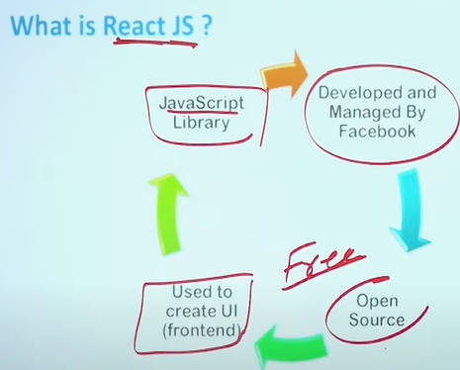

How does React JS Work

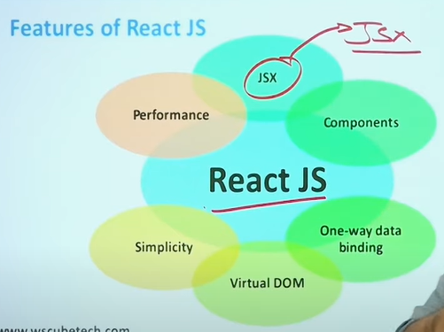

JSX:-

