|  |  |
| --- | --- |
| Project: 6.crud_posts_api_with_react_rtk_geeky | **Created Date:** 09-02-2022 |

*API Call and CRUD using Redux Toolkit Complete in One Video*

|  |  |
| --- | --- |
| **Project Resources** | |
| *Channel/Creator* | [*Geeky Shows*](https://www.youtube.com/channel/UCc5FkTYiWH5L3Gk5IyW6Rmw) |
| *URL* | *https://youtu.be/SKyEUS4heS0* |
| *Github* | *N/A* |
| *Others* | *N/A* |



**Project Starts**

**Step1**: First Create a new folder in your working directory as **6.crud_posts_api_with_react_rtk_geeky**.

**Step2**: Now create a react project using **create react-app**.

* **npx create-react-app 6.crud_posts_api_with_react_rtk_geeky**

**Step3**: Now navigate inside to the project folder and start react server

* **npm start**

**Step4**: Now install to more library to get work with redux and redux tool kit

* **npm install react-redux** (This is core redux package)
* **npm install @reduxjs/toolkit** And now install redux tool kit

**Step5**: Now start application

* npm start or yarn start



**Project Code**

My github link

**Project Snapshots**

Topics to Learn

[00:00:00](https://www.youtube.com/watch?v=SKyEUS4heS0&t=0s) Pre-Requisites

[00:04:24](https://www.youtube.com/watch?v=SKyEUS4heS0&t=264s) Create React JS Project

We use json placehoder api

<https://jsonplaceholder.typicode.com/>

posts - <https://jsonplaceholder.typicode.com/posts>

Rtk Query is the addon in react toolkit

[00:05:09](https://www.youtube.com/watch?v=SKyEUS4heS0&t=309s) Installing Redux Toolkit and React Redux

[00:07:05](https://www.youtube.com/watch?v=SKyEUS4heS0&t=425s) Running Project

[00:09:34](https://www.youtube.com/watch?v=SKyEUS4heS0&t=574s) RTK Query

[00:09:55](https://www.youtube.com/watch?v=SKyEUS4heS0&t=595s) Create an API Service

[00:12:40](https://www.youtube.com/watch?v=SKyEUS4heS0&t=760s) Endpoints

[00:13:06](https://www.youtube.com/watch?v=SKyEUS4heS0&t=786s) Fetching All Data from API

[00:17:05](https://www.youtube.com/watch?v=SKyEUS4heS0&t=1025s) Add the Service to Store

[00:20:13](https://www.youtube.com/watch?v=SKyEUS4heS0&t=1213s) Wrap Application with the Provider

[00:21:34](https://www.youtube.com/watch?v=SKyEUS4heS0&t=1294s) Use Query in Component

[00:38:16](https://www.youtube.com/watch?v=SKyEUS4heS0&t=2296s) Fetching Specific Data based on ID from API

[00:44:31](https://www.youtube.com/watch?v=SKyEUS4heS0&t=2671s) Fetching Limited Number of Data from API

Limit url



[00:50:25](https://www.youtube.com/watch?v=SKyEUS4heS0&t=3025s) Delete Data from API

[00:58:32](https://www.youtube.com/watch?v=SKyEUS4heS0&t=3512s) Create/Insert Data to API

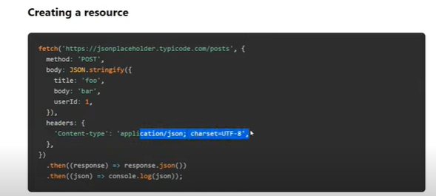

[01:06:31](https://www.youtube.com/watch?v=SKyEUS4heS0&t=3991s) Update Data to API

[01:16:45](https://www.youtube.com/watch?v=SKyEUS4heS0&t=4605s) Documentation