|  |  |
| --- | --- |
| Project: 7.react_redux_with_redux_toolkit **https://www.typingbaba.com/translator/hindi-to-english-translation.php** | **Created Date:** 10-02-2022 |

# React Redux with Redux Toolkit Complete in one Video

|  |  |
| --- | --- |
| **Project Resources** | |
| *Channel/Creator* | [*Geeky Shows*](https://www.youtube.com/channel/UCc5FkTYiWH5L3Gk5IyW6Rmw) |
| *URL* | *https://youtu.be/i3MWtUchXxc?list=PLbGui_ZYuhiipCzznFp8Lmpgt0Gt5lUm1* |
| *Github* | *N/A* |
| *Others* | *N/A* |



**Project Starts**

**Step1**: First Create a new folder in your working directory as **6.crud_posts_api_with_react_rtk_geeky**.

**Step2**: Now create a react project using **create react-app**.

* **npx create-react-app 6.crud_posts_api_with_react_rtk_geeky**

With plain js

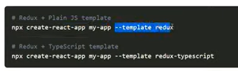

Agar aap yeh lagate hai project install krte time toh yeh react or redux ka project banak ke deta hai ek

Usme folder structure bhi create krke dega

**Step3**: Now navigate inside to the project folder and start react server

* **npm start**

**Step4**: Now install to more library to get work with redux and redux tool kit

* **npm install react-redux** (This is core redux package)
* **npm install @reduxjs/toolkit** And now install redux tool kit

**Step5**: Now start application

* npm start or yarn start



**Project Code**

My github link

**Project Snapshots**

Topics to Learn

Redux

[00:00:00](https://www.youtube.com/watch?v=i3MWtUchXxc&list=PLbGui_ZYuhiipCzznFp8Lmpgt0Gt5lUm1&index=1&t=0s) Introduction to Redux

Redux ek pridctable state container hai js apps ke liye.

Redux ka use krke aap apni js app ki state ko ache se manage kr skte hai, js apps like angular, nodejs, react etc

[00:02:18](https://www.youtube.com/watch?v=i3MWtUchXxc&list=PLbGui_ZYuhiipCzznFp8Lmpgt0Gt5lUm1&index=1&t=138s) Introduction to Redux Toolkit

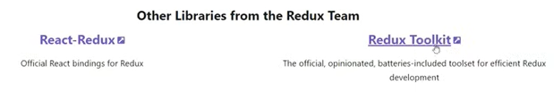

Redux Toolkit se phele redux use krte the jsme configuration hume khud krni padti thi or kafi messy code ho jata tha.

[00:02:32](https://www.youtube.com/watch?v=i3MWtUchXxc&list=PLbGui_ZYuhiipCzznFp8Lmpgt0Gt5lUm1&index=1&t=152s) Introduction to React Redux

[00:03:37](https://www.youtube.com/watch?v=i3MWtUchXxc&list=PLbGui_ZYuhiipCzznFp8Lmpgt0Gt5lUm1&index=1&t=217s) Create New Project using redux template

[00:06:22](https://www.youtube.com/watch?v=i3MWtUchXxc&list=PLbGui_ZYuhiipCzznFp8Lmpgt0Gt5lUm1&index=1&t=382s) Folder Structure and Dependencies

Package.json

{

  "name": "7.react_redux_with_redux_toolkit",

  "version": "0.1.0",

  "private": true,

  "dependencies": {

    "@reduxjs/toolkit": "^1.7.2",

    "@testing-library/jest-dom": "^4.2.4",

    "@testing-library/react": "^9.5.0",

    "@testing-library/user-event": "^7.2.1",

    "react": "^17.0.2",

    "react-dom": "^17.0.2",

    "react-redux": "^7.2.6",

    "react-scripts": "5.0.0"

  },

  "scripts": {

    "start": "react-scripts start",

    "build": "react-scripts build",

    "test": "react-scripts test",

    "eject": "react-scripts eject"

  },

  "eslintConfig": {

    "extends": "react-app"

  },

  "browserslist": {

    "production": [

      ">0.2%",

      "not dead",

      "not op_mini all"

    ],

    "development": [

      "last 1 chrome version",

      "last 1 firefox version",

      "last 1 safari version"

    ]

  }

}

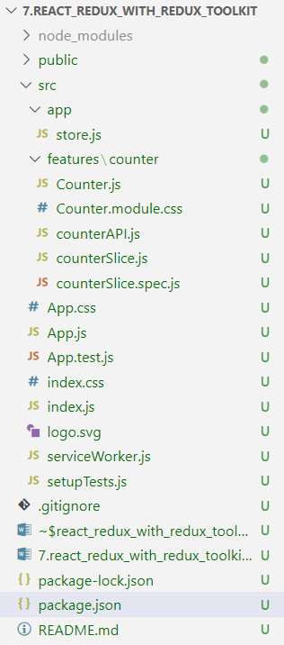

[00:08:52](https://www.youtube.com/watch?v=i3MWtUchXxc&list=PLbGui_ZYuhiipCzznFp8Lmpgt0Gt5lUm1&index=1&t=532s) Running default Redux Project

[00:10:16](https://www.youtube.com/watch?v=i3MWtUchXxc&list=PLbGui_ZYuhiipCzznFp8Lmpgt0Gt5lUm1&index=1&t=616s) Create React JS Project

[00:11:57](https://www.youtube.com/watch?v=i3MWtUchXxc&list=PLbGui_ZYuhiipCzznFp8Lmpgt0Gt5lUm1&index=1&t=717s) Folder Structure and Dependencies

[00:12:55](https://www.youtube.com/watch?v=i3MWtUchXxc&list=PLbGui_ZYuhiipCzznFp8Lmpgt0Gt5lUm1&index=1&t=775s) Installing Redux Toolkit and React Redux

[00:15:02](https://www.youtube.com/watch?v=i3MWtUchXxc&list=PLbGui_ZYuhiipCzznFp8Lmpgt0Gt5lUm1&index=1&t=902s) React JS Counter Example

[00:23:27](https://www.youtube.com/watch?v=i3MWtUchXxc&list=PLbGui_ZYuhiipCzznFp8Lmpgt0Gt5lUm1&index=1&t=1407s) State in Sibling Component and Other Components

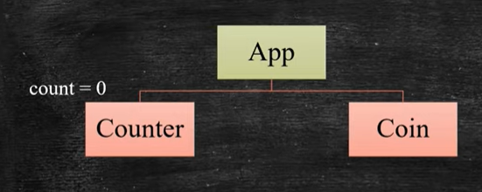

Here Two ways to use same count state in Coin component, first state ko lift up kijiye dusra use Context APi

Context API acha option hai , lifting badi heierachy mein acha option nahi hai bhut mehnat karwayega wahan, context API wahan acha option Banega.

Many App we can build with only context API

Lifting up state

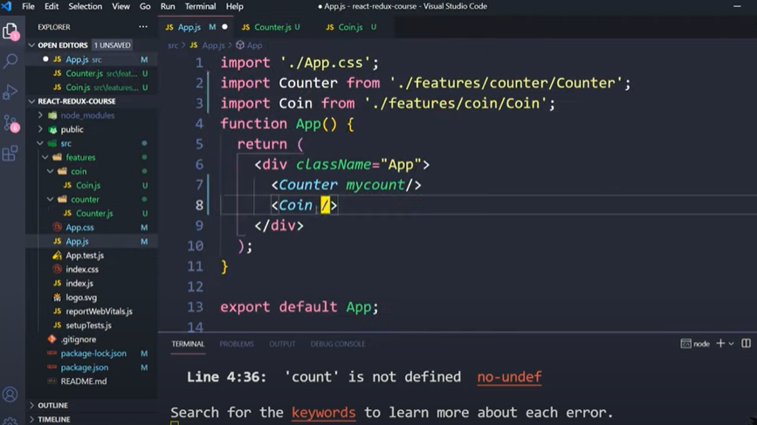

Also write App in app component

2nd Context API

Do Self

[00:28:50](https://www.youtube.com/watch?v=i3MWtUchXxc&list=PLbGui_ZYuhiipCzznFp8Lmpgt0Gt5lUm1&index=1&t=1730s) How Redux manage state

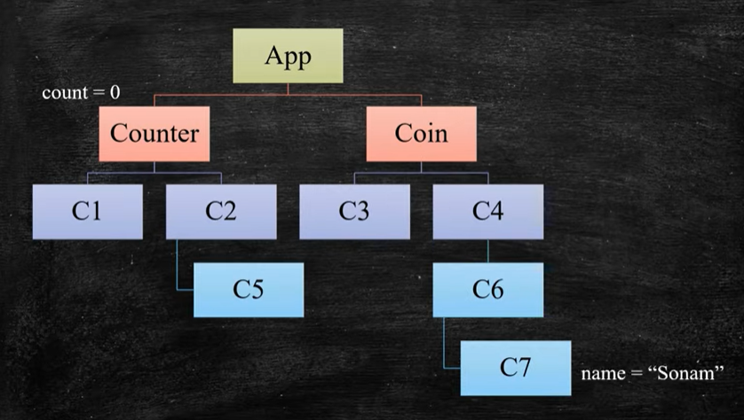

With props

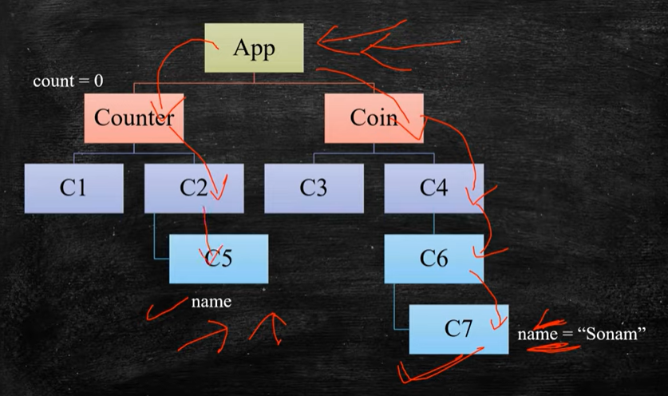

With Redux

Redux kehta hai mein apko store dunga, or apki jitni bhi store hai aap mere pass rakh dijiye or jab bhi chaie apko jis bhi component mein wahan mujhse tum le lena

Ise ab sare state ek jagah centralized hogye hai or aap store ki state ko modify bhi kr skte hai

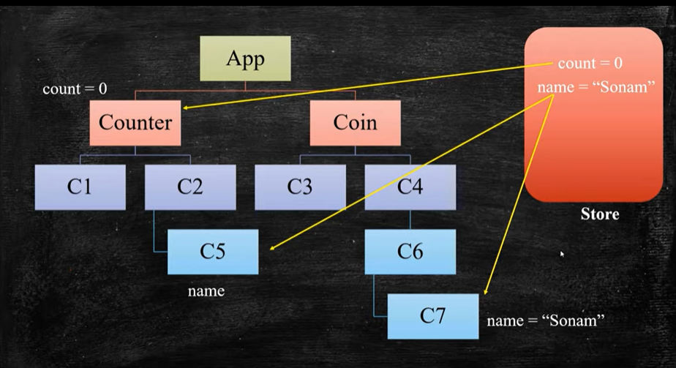

[00:34:17](https://www.youtube.com/watch?v=i3MWtUchXxc&list=PLbGui_ZYuhiipCzznFp8Lmpgt0Gt5lUm1&index=1&t=2057s) Create Redux Store

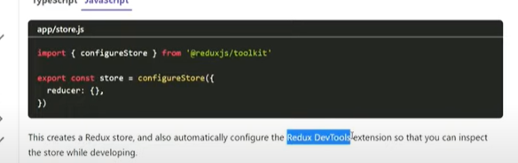

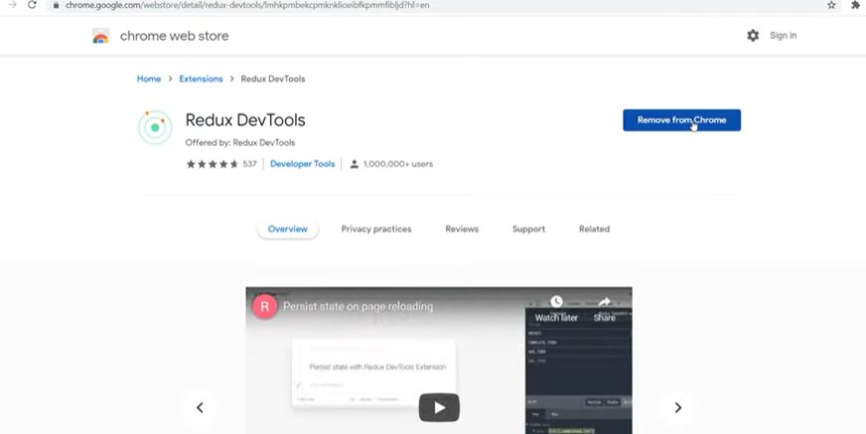

[00:36:52](https://www.youtube.com/watch?v=i3MWtUchXxc&list=PLbGui_ZYuhiipCzznFp8Lmpgt0Gt5lUm1&index=1&t=2212s) Provide Redux Store to React

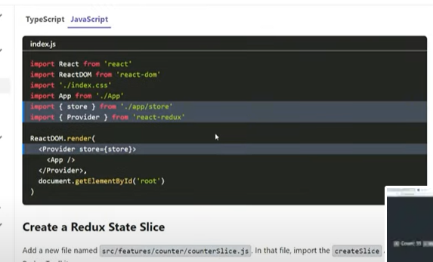

[00:39:52](https://www.youtube.com/watch?v=i3MWtUchXxc&list=PLbGui_ZYuhiipCzznFp8Lmpgt0Gt5lUm1&index=1&t=2392s) Create Redux State Slice

[00:44:40](https://www.youtube.com/watch?v=i3MWtUchXxc&list=PLbGui_ZYuhiipCzznFp8Lmpgt0Gt5lUm1&index=1&t=2680s) Add Slice Reducers to the Store

[00:46:12](https://www.youtube.com/watch?v=i3MWtUchXxc&list=PLbGui_ZYuhiipCzznFp8Lmpgt0Gt5lUm1&index=1&t=2772s) Use Redux State and Actions in React Components

[00:46:47](https://www.youtube.com/watch?v=i3MWtUchXxc&list=PLbGui_ZYuhiipCzznFp8Lmpgt0Gt5lUm1&index=1&t=2807s) useSelector - Accessing or Reading State from Store

[00:50:17](https://www.youtube.com/watch?v=i3MWtUchXxc&list=PLbGui_ZYuhiipCzznFp8Lmpgt0Gt5lUm1&index=1&t=3017s) useDispatch - Modifying State

[00:53:15](https://www.youtube.com/watch?v=i3MWtUchXxc&list=PLbGui_ZYuhiipCzznFp8Lmpgt0Gt5lUm1&index=1&t=3195s) State in Sibling Component and Other Components

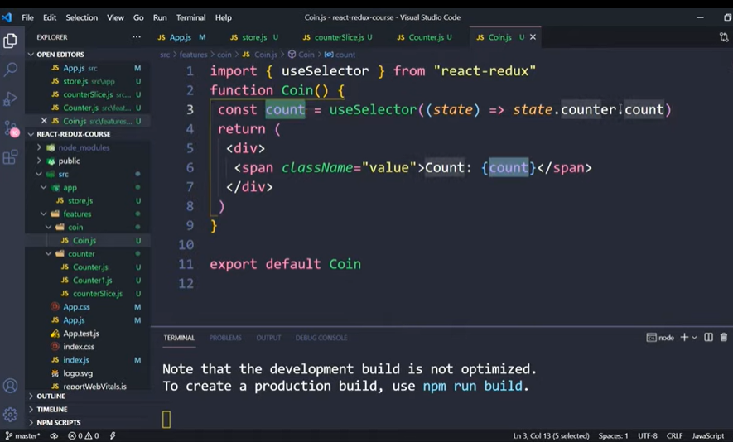

[00:55:43](https://www.youtube.com/watch?v=i3MWtUchXxc&list=PLbGui_ZYuhiipCzznFp8Lmpgt0Gt5lUm1&index=1&t=3343s) Action Payload

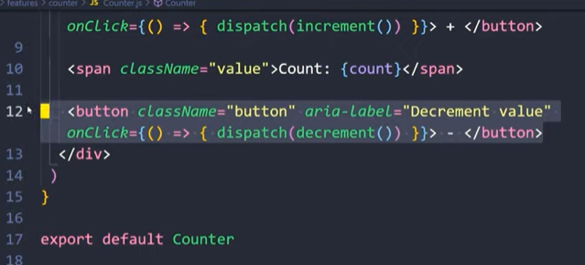

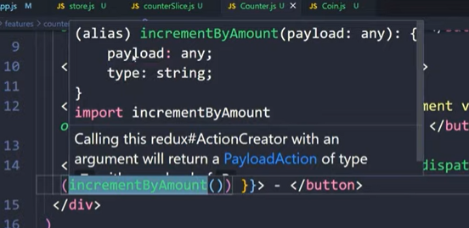

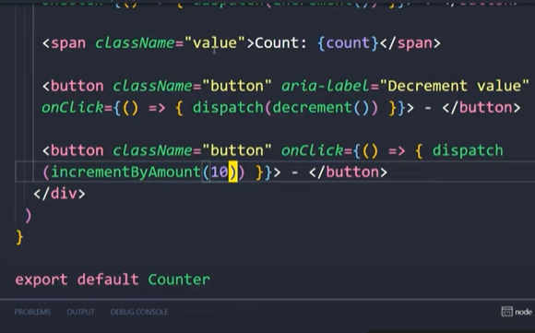

Yeh sirf number nahi object bhi ho dkta hai

[00:59:25](https://www.youtube.com/watch?v=i3MWtUchXxc&list=PLbGui_ZYuhiipCzznFp8Lmpgt0Gt5lUm1&index=1&t=3565s) More than one Reducer

[01:00:00](https://www.youtube.com/watch?v=i3MWtUchXxc&list=PLbGui_ZYuhiipCzznFp8Lmpgt0Gt5lUm1&index=1&t=3600s) Theme Feature Example

[01:12:21](https://www.youtube.com/watch?v=i3MWtUchXxc&list=PLbGui_ZYuhiipCzznFp8Lmpgt0Gt5lUm1&index=1&t=4341s) Debug Redux State

[01:17:41](https://www.youtube.com/watch?v=i3MWtUchXxc&list=PLbGui_ZYuhiipCzznFp8Lmpgt0Gt5lUm1&index=1&t=4661s) Clearing doubt of state reducer