|  |  |
| --- | --- |
| Project: 8_crud_react_rtk_vishal **https://www.typingbaba.com/translator/hindi-to-english-translation.php** | **Created Date:** 11-02-2022 |

# Learn Complete Redux-Toolkit & RTK Query with React in One Video | Redux-Toolkit RTK Query

|  |  |
| --- | --- |
| **Project Resources** | |
| *Channel/Creator* | [CodeWithVishal](https://www.youtube.com/channel/UC_ax8-CBuZ3ltn8x69Di4MA) |
| *URL* | *https://youtu.be/_R5XOF_MDmU* |
| *Github* | [*https://github.com/trickjsprogram/toolkit-crud*](https://github.com/trickjsprogram/toolkit-crud)  *https://github.com/trickjsprogram/RTKQuery-crud* |
| *Others* | *N/A* |



**Project Starts**

**Step1**: First Create a new folder in your working directory as **8_crud_react_rtk_vishal**

**Step2**: Now create a react project using **create react-app**.

* **npx create-react-app 8_crud_react_rtk_vishal**

**Step3**: Now navigate inside to the project folder and start react server

* **npm start**

**Step4**: Now install to more library to get work with redux and redux tool kit

* **npm install react-redux** (This is core redux package)
* **npm install @reduxjs/toolkit** And now install redux tool kit

**Step5**: Now start application

* npm start or yarn start



**Project Code**

My github link

**Project Snapshots**

Topics to Learn

Core Problem with ReactJS

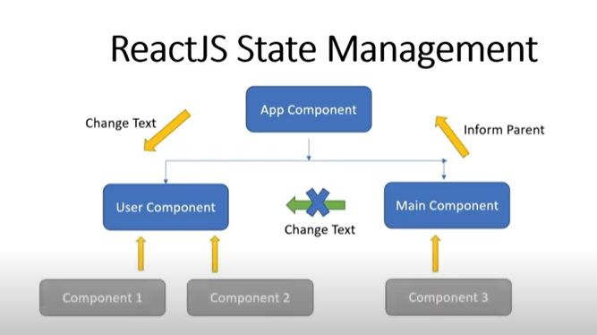

**Mujhe agar test ko change karna hai toh mein directly change nahi kr skta mujhe** parent component ko inform krna rahega or agar app mein component bhot jada hoge toh yeh problem dega

Redux

To overcome this problem, we have tool Redux state management tool

View dispatch an action, action will pases through the reducer, reducer have the task to take the action and old state and manipulate them based on the action, and return new state.

And this manipulation will happen immutable that means it wont change the old state, it will takes a old state as a basis and then create a brand new state, so kind of copy with the old state and changes apply rest untouched

So this immutable gives you the unique state in the app.

And then that return state reducer will store into the store and in the app, there is aonly a single store,

Store have simple task to store our state

You might have a multiple reducer but store is only one

And store will gets subscribe to the component thus whenever the state gets manipulate the subsribe fetchs the new state automatically sends to the view.

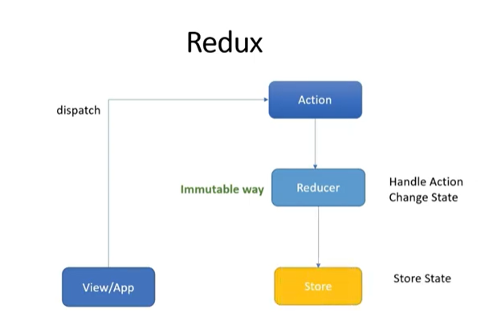

Example with redux

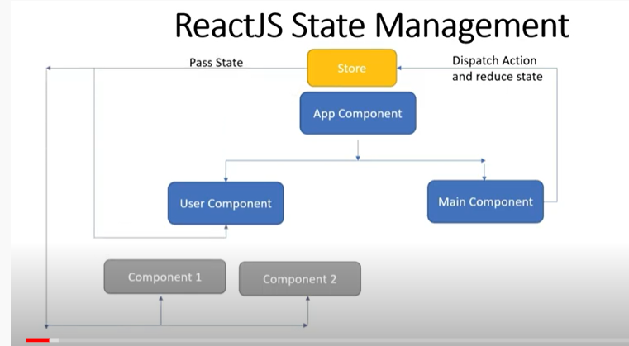

What is Redux toolkit

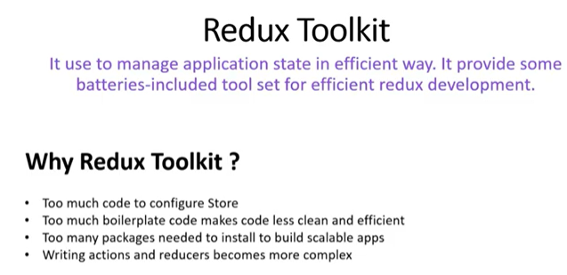

Rtk speedup the development with redux

Example redux toolkit with example

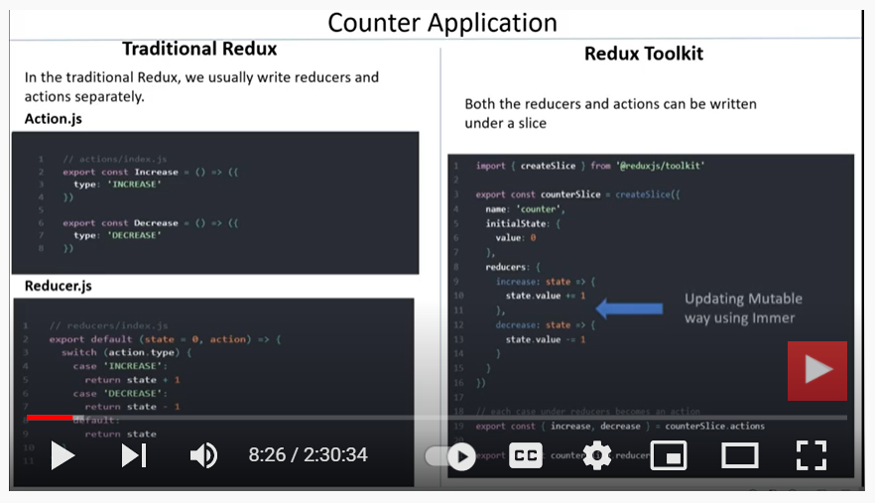

Both the reducer and action written in single slice file

One more thing here we are directly updating the state, instead of returning it this is actualy happen because of immer library, Which allows to writing the mutating logic in reducer

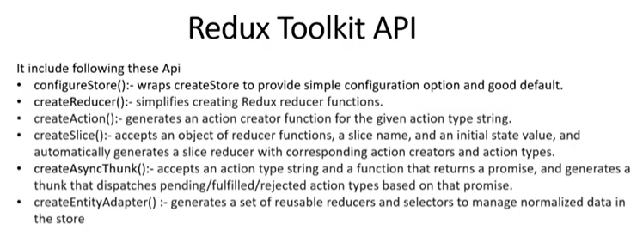

Note: Last two learn again

In redux whenever we perform async task we used middleware, middleware could be anything either redux thunk or redux saga to perform async task, and with redux toolkit redux thunk is already included which allows to perform asyn task before send the processed result to the reducer

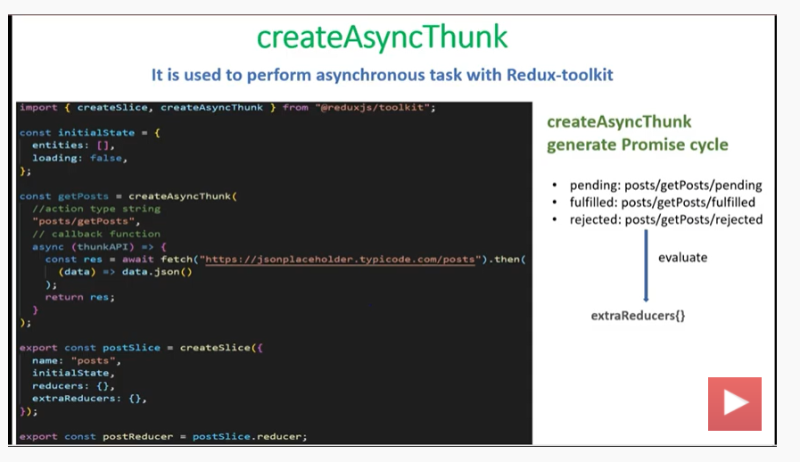

Name is the slice name, then we define initial state for our component, inside the reducer we have object which used to handle sync req.

Extra reducer- We handle async reqt, and asyn reqt is created by createAsynThunk, that accepts three parameter, action type, accept the promise and generate the thunk like pending, fulfilled, rejected and third one is option object in which we provide diff-diff configuration for our asyn api, 3rd parameter is optional

All these three lifecycles we can evaluate in extra reducer where we can make the desire changes to the store



We are using JSON placedholder fake API

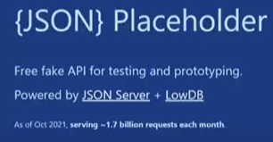

We are using antd to build our component

>npm i antd @reduxjs/toolkit react-router-dom react-redux

Above we Just used Redux Toolkit not used RTK query

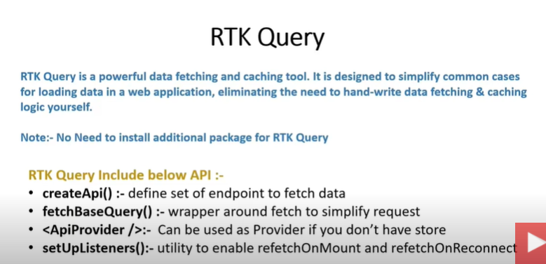

Work just like axios, fetching loading error it itself maintained behind the scene



If we don’t have the store tehn we get use ApiProvider approach

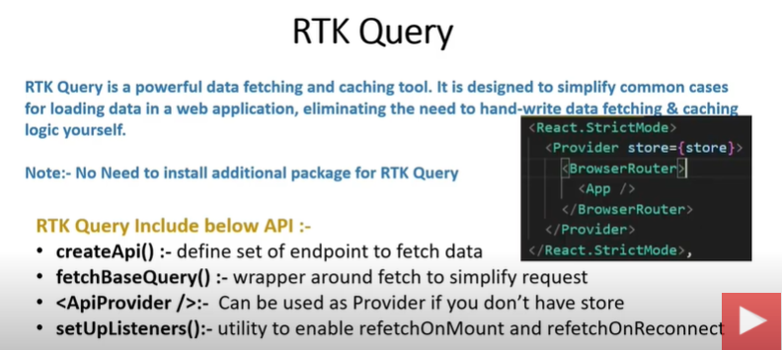

fetchBaseQuery, In which we defined our base url