|  |  |
| --- | --- |
| Project: 9_crud_contacts_react_typescript_rtk_vishal **https://www.typingbaba.com/translator/hindi-to-english-translation.php** | **Created Date:** 11-02-2022 |

# Learn Complete Redux-Toolkit & RTK Query with React in One Video | Redux-Toolkit RTK Query

|  |  |
| --- | --- |
| **Project Resources** | |
| *Channel/Creator* | [CodeWithVishal](https://www.youtube.com/channel/UC_ax8-CBuZ3ltn8x69Di4MA) |
| *URL* | *https://youtu.be/_R5XOF_MDmU* |
| *Github* | [*https://github.com/trickjsprogram/toolkit-crud*](https://github.com/trickjsprogram/toolkit-crud)  *https://github.com/trickjsprogram/RTKQuery-crud* |
| *Others* | *N/A* |



**Project Starts**

**Step1**: First Go inside to the working directory and open your cmd

**Step1**: Now create a react project using **create react-app**.

**npx create-react-app 9_crud_contacts_react_typescript_rtk_vishal --template redux-typescript**

**Step3**: Now navigate inside to the project folder and start react server

* **npm start**

**~~Step4~~**~~: Now install to more library to get work with redux and redux tool kit~~

* **~~npm install react-redux~~** ~~(This is core redux package)~~
* **~~npm install @reduxjs/toolkit~~** ~~And now install redux tool kit~~

**~~Step5~~**~~: Now start application~~

* ~~npm start or yarn start~~



**Project Code**

My github link

**Project Snapshots**

Topics to Learn

Above we Just used Redux Toolkit not used RTK query

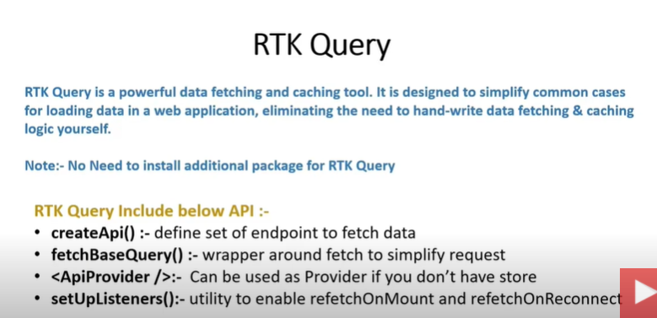

Work just like axios, fetching loading error it itself maintained behind the scene

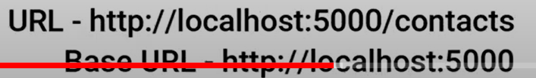

If we don’t have the store tehn we get use ApiProvider approach

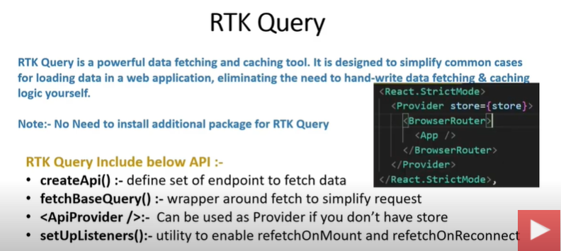

fetchBaseQuery, In which we defined our base url

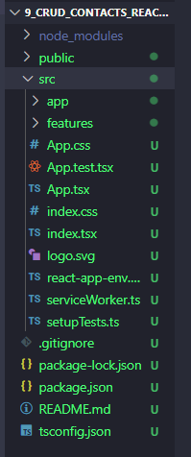

>npm i react-router-dom react-toastify

And Mean while create db.json while because we are using json server in this project

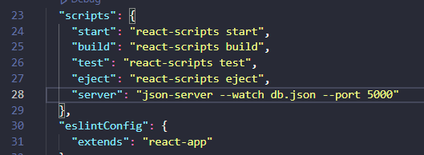

>npm install -g json-server

