|  |  |
| --- | --- |
| Project: React Admin Dashboard Template Design | **Created Date:** 10-01-2022 |

|  |  |
| --- | --- |
| **Project Resources** | |
| *Channel/Creator* | Lama Dev |
| *URL* | https://www.youtube.com/watch?v=aTPkos3LKi8 |
| *Github* | https://github.com/safak/youtube/tree/react-admin |
| *Others* | N/A |



**Project Starts**

**Step1**: Create a react app using windows cli.

* ~~npx create-react-app Myproject~~

**Note**: As you create react app like this way you will get a lot of unnecessary code and file, so instead of doing this you can use github repository template, and you can clone it in your project directory.

To do so you need to go through this link https://github.com/safak/youtube/tree/react-admin and clone it.

Now open your terminal and run some github commands like

* git clone – single-branch -b react-mini <https://github.com/safak/youtube.git> . (please postfix dot at the end)

**Step2**: Now install npm modules in your project.

* npm install

**Step3**: Now go to material ui by using this link https://mui.com/ and install it in your project

* npm install @mui/material

**Step4**: Now add Roboto font in your app inside public/index.html

<link rel="stylesheet" href=<https://fonts.googleapis.com/css?family=Roboto:300,400,500,700&display=swap> />

**Step5**: Now Add Material Ui Icon

* npm install @mui/icons-material or yarn add @mui/icons-material

**Step6**: Now Add Material Ui Custom Style

* npm i @mui/styles or yarn add @mui/styles

**Step6**: Now Add Material Ui Lab

* npm i @mui/lab or yarn add @mui/lab

**Step7**: Now start application

* npm start or yarn start



**Project Code**

My github link



**Project Snapshots**

Course Content

1. What is React JS?

Take from the main ReactJS Notes

1. Create React Project

<https://create-react-app.dev/>

* npx create-react-app my-app --template typescript

example npx create-react-app react-typescript-fundamentals –template typescript

1. Now look file structure
2. Npm start

.tsx = typescript file + xml file

1. What is component

It is a simple function

1. component props and state management
2. State and life cycle

useState help to manage our state in the app, it have some hvalue and function to update our state.

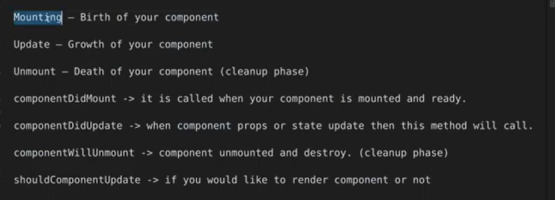

useEffect we used in functional component, toh kuch bhi effect ho toh yeh call ho jaye or destroy ke lie bhi hum isko hi use kr skte hai

L7: custom hooks

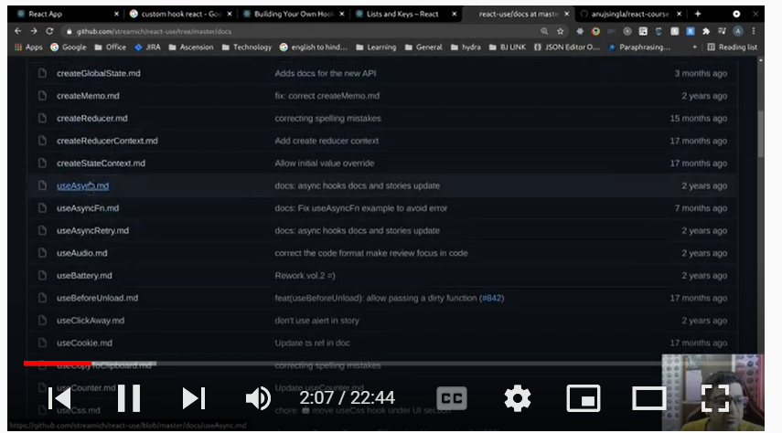

L9: useRef()

Mutable means we can change it

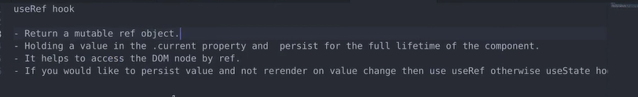

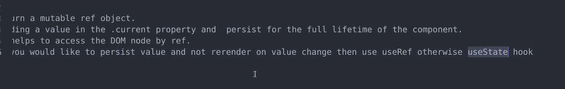

UseRef ko do tarike se use kr skte hai ek toh element ke ref ko maintain krne ke liye dusra value ko update krne ke liye but yeh component ko render nahi krega, agar apko component re render krna hai toh app useState use kre.

L10: useReducer

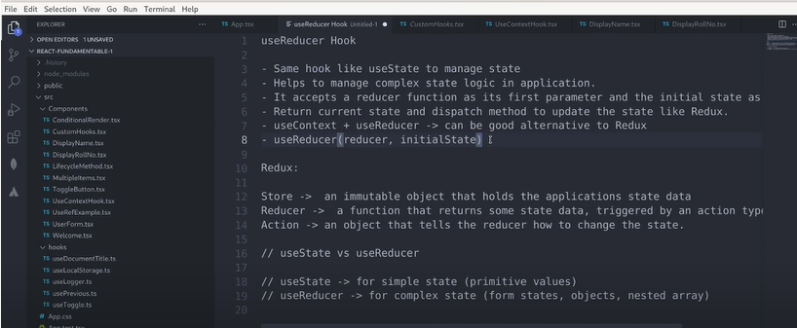

Both are same, useState use for manage complex state management and useReducer use for small state management like primitive Boolean, int etc but you can for complex too.

L11: useContext() Hook:

React Context hook mein props hume manually pass karne padte the hierarchy manner mein.

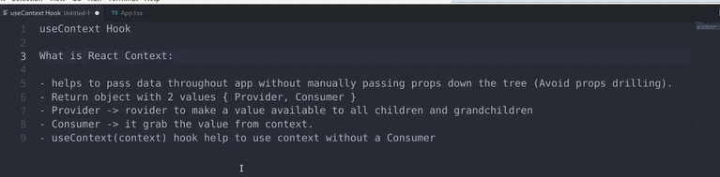

L12: useReducer + useContext :- To share the context between the multiple component like user Information name, or user authenticate hai ya nahi

Dono ko sath mein use krne se hum apne component mein global level ki state management kr skte hai or

Mean ek global level per store bana skte hai or kuch bhi store mein change hua toh wo un component mein re-render ho jayega jinme use kiya hai

useContext help to pass data at multiple level.

useReducer use to manage our state as same like useState but at complex level

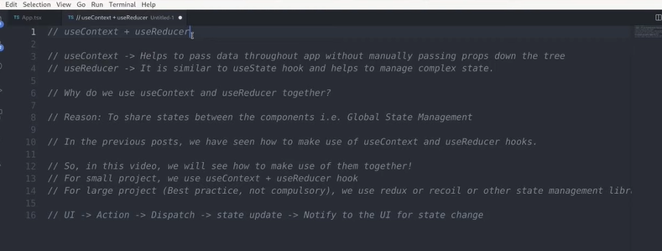

<https://reqres.in/>

Project 1:

install packages command

npx create-react-app my-app --template typescript

npx create-react-app crud_with_typescript –template typescript

npm install react-bootstrap bootstrap @types/react-bootstrap @types/bootstrap

<https://react-bootstrap.github.io/getting-started/introduction/#installation>

npm install --save react-toastify

<https://www.npmjs.com/package/react-toastify>

npm i react-query @types/react-query

<https://react-query.tanstack.com/installation>

npm i lodash @types/lodash

<https://lodash.com/docs/4.17.15>

Learn Redux

Introduction - [00:00](https://www.youtube.com/watch?v=iNhTmcAN4Jc&list=PLEtjGa9VEukNKslFyRlhODXXuKgRnvVyM&index=18&t=0s)

Redux Three principles: [1:07](https://www.youtube.com/watch?v=iNhTmcAN4Jc&list=PLEtjGa9VEukNKslFyRlhODXXuKgRnvVyM&index=18&t=67s)

Build Project: [7:27](https://www.youtube.com/watch?v=iNhTmcAN4Jc&list=PLEtjGa9VEukNKslFyRlhODXXuKgRnvVyM&index=18&t=447s)

Create redux store: [8:37](https://www.youtube.com/watch?v=iNhTmcAN4Jc&list=PLEtjGa9VEukNKslFyRlhODXXuKgRnvVyM&index=18&t=517s)

Create redux reducer: [18:07](https://www.youtube.com/watch?v=iNhTmcAN4Jc&list=PLEtjGa9VEukNKslFyRlhODXXuKgRnvVyM&index=18&t=1087s)

Create UI component: [40:47](https://www.youtube.com/watch?v=iNhTmcAN4Jc&list=PLEtjGa9VEukNKslFyRlhODXXuKgRnvVyM&index=18&t=2447s)

Redux error state: [51:27](https://www.youtube.com/watch?v=iNhTmcAN4Jc&list=PLEtjGa9VEukNKslFyRlhODXXuKgRnvVyM&index=18&t=3087s)

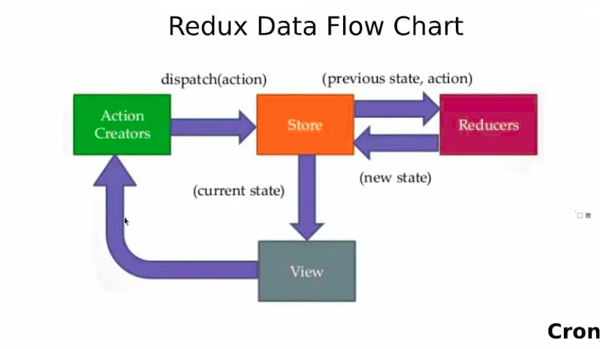

npm i @reduxjs/toolkit react-redux redux-logger

RTK Query

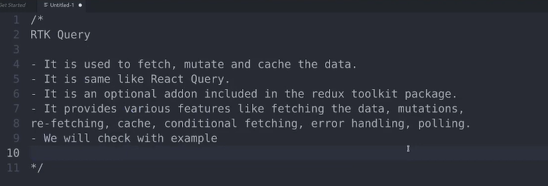

RTK Query - It is used to fetch, mutate and cache the data. - It is the same as React Query. - It is an optional add-on included in the redux toolkit package. - It provides various features like fetching the data, mutations, re-fetching, cache, conditional fetching, error handling, polling. - We will check with an example

[**https://redux-toolkit.js.org/rtk-query/overview**](https://redux-toolkit.js.org/rtk-query/overview)

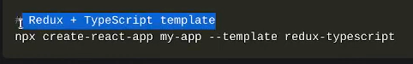

**Ise automatically redux configure hoke ayegi**

