<https://www.atlassian.com/git/tutorials/setting-up-a-repository>

<https://www.theserverside.com/blog/Coffee-Talk-Java-News-Stories-and-Opinions/Where-system-global-and-local-Windows-Git-config-files-are-saved>

<https://stackoverflow.com/questions/32238616/git-push-fatal-origin-does-not-appear-to-be-a-git-repository-fatal-could-n>

<https://stackoverflow.com/questions/5335197/gits-famous-error-permission-to-git-denied-to-user>

**( Youtube ) : Thapa Technical Channel**

**L1. What is Git?**

Git is a distributed version control system (DVCS).

* Each user has a local copy of the complete history of the project, which is known as repository (means folder).
* Users can work offline.
* Can easily synchronize repositories (work together synchronously).
* Git is a free and open source software project meaning that the code that implements Git is publically available (means git ko banana ka code already avialble hai or aap us code ko download krke edit krke contribute kr skte ho if feature is acceptable by git team). No single company owns Git, and anyone can make contributions to improve it.
* Git is created by linux OS created ‘Linus Torvalds’.

**What is DVCS?**

DVCS is the type of version control system.

**Note :**

Github, bitbucket, gitlab these are online clouds of git or online repository or remote center or data center, which are provided by git.

On these clouds we can put our code synchronously.

How to create account over git or gitlab (note gitlab is different).

1. Here we can create our account, and next we make our repository remotely but provide permission.

**L2. How to install git in your machine (Git command line interface):**

* Go to google and type <https://git-scm.com> or type git over the google and select first link.
* Download the latest version of git based on your os (win,linux) and bit (64, 32 bit)
* Version of git 2.20.1 (Date:- 14/03/2020)
* Now install git, run run run and select by default all the selected features.
* Now check git command line interface is installed or not on your local machine.
* Open cmd from any directory, and type > git --version
* Git also provide its own command line interface, type >git – -version
* > git help , this command gives all the command related to git

Or

git help , this command gives all the command related to git >git – -help , this is the flag which tell us the status it is similar to > git help

Note:- in git bash we can easily directly increase fontsize of the screen.

**L3. What is git init , and how to access/set user email, username or pass etc**

Cmd commands :

1. I want to move in D drive. > cd D:
2. I want to see content(drive,folder). In a particular drive and folder. > dir
3. To create new folder or directory inside the particular drive or folder or at root place. > mkdir sa_git_practice
4. Now if I want to move inside this folder. > cd sa_git_practice
5. Now if I want this folder as a git initializer then I need to hit git init. But before that hit git status to check your directory or folder is already git initialize or not.

sa_git_practice > git status

it gives fatal error as : fatal not a git repository (means iske ander .git ka folder hai hi nahi).

1. So for initizing git use :

sa_git_practice > git init

it gives : Initialized empty git repository in {folder_path}

1. Again hit

sa_git_practice > git status

Note: by default master branch rhta hai

Before

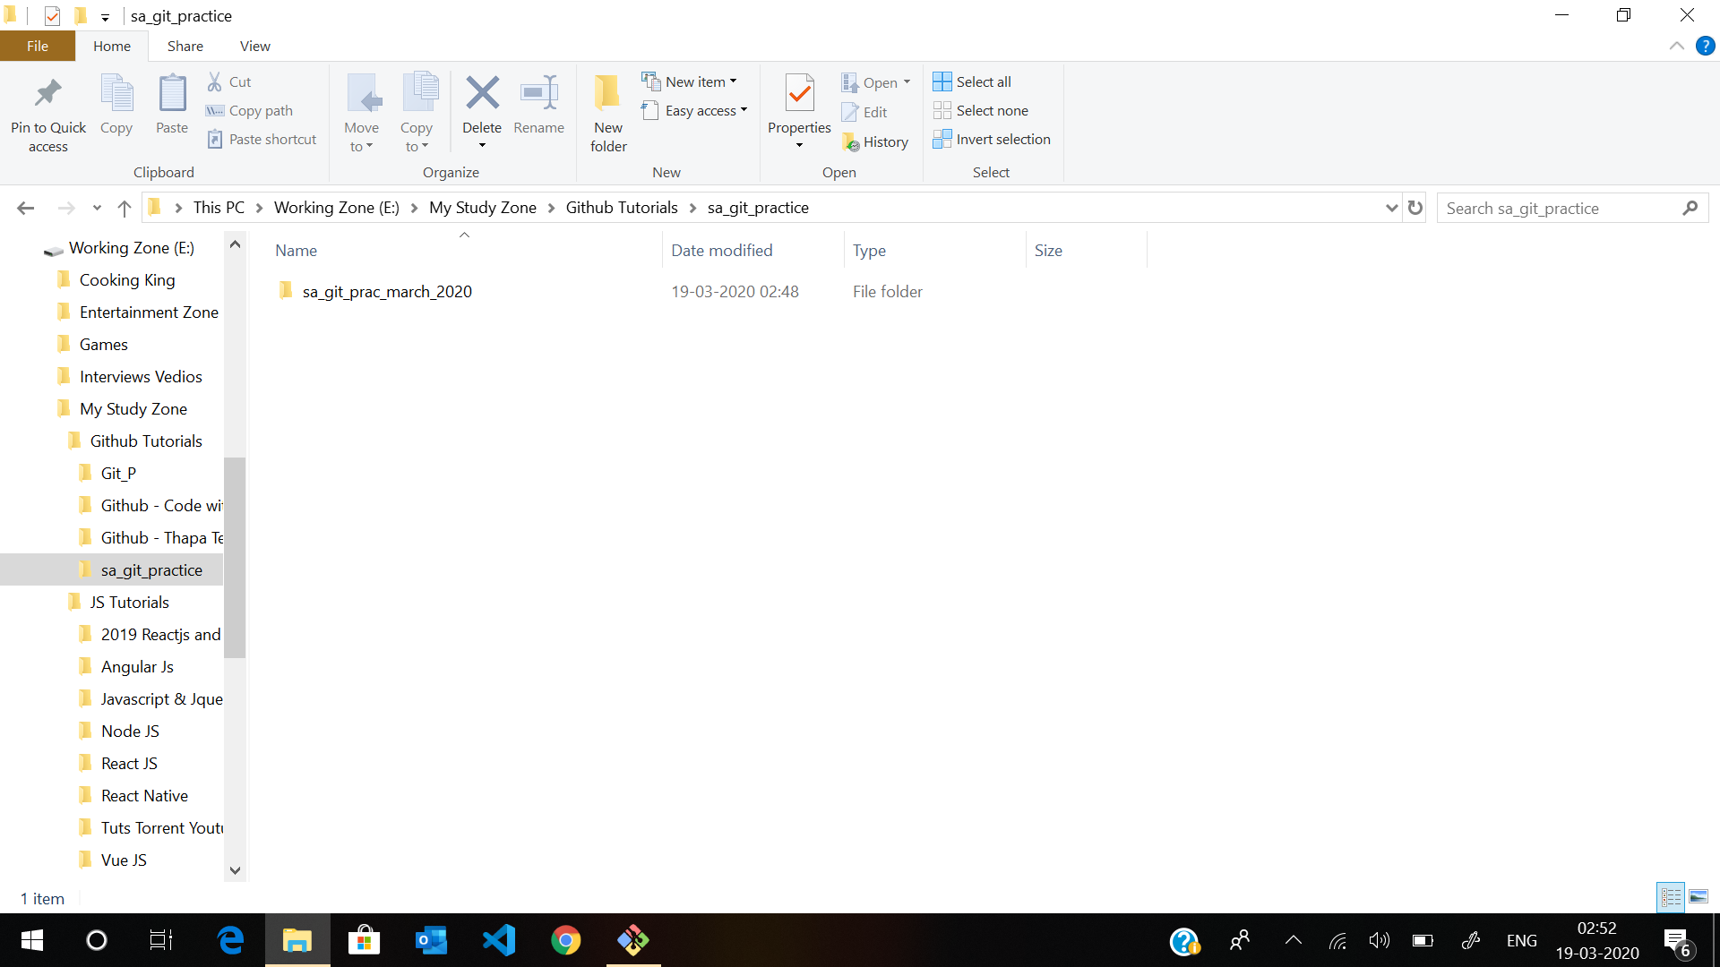

After

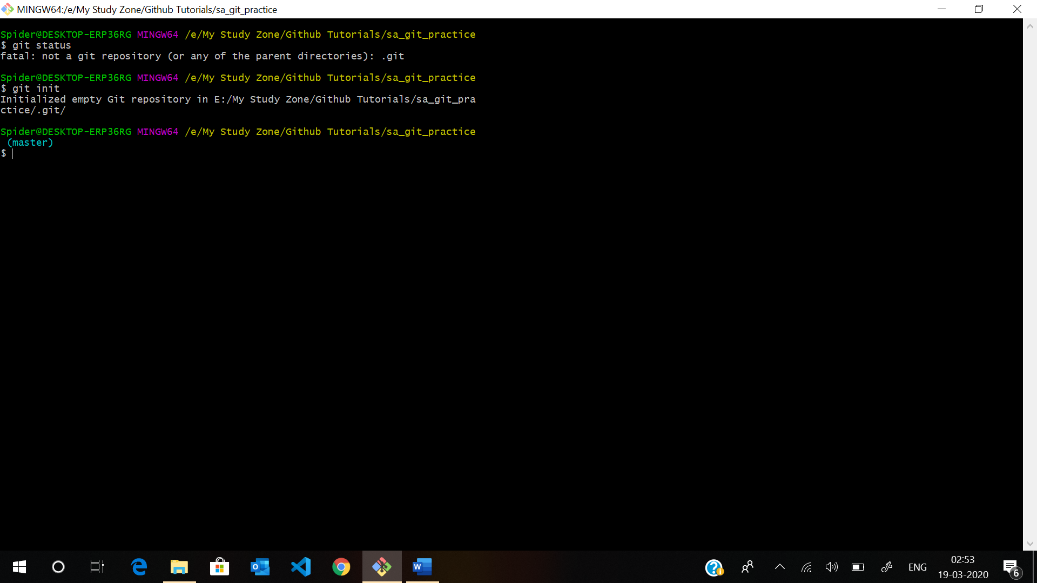

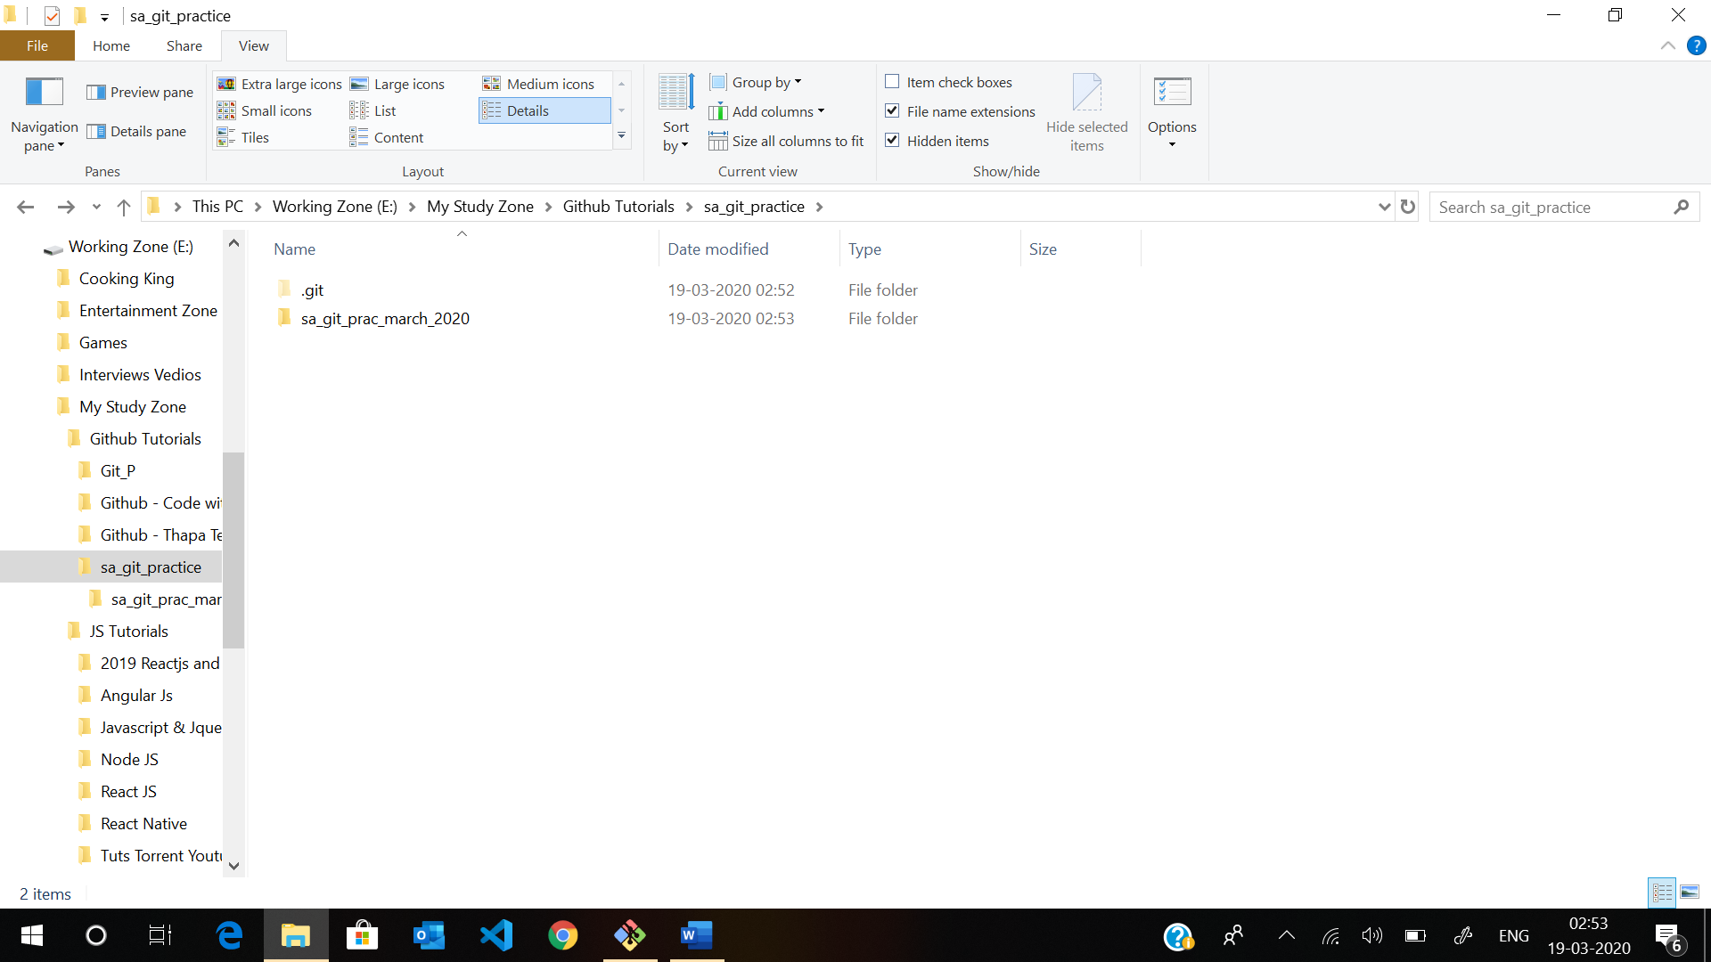

**Set user name and user email :**

1. First need to check git configuration. But note git configuration you can set local as well as global.
2. For global git configuration (means by default jitne bhi git init wale folder ya respositroy ho system mein sab mein same user name , email challe then you need to set to globally)

sa_git_practice (master)

* Git config –global user.name {HIT ENTER}

Is already set user name and email then it gives user name like satty thakur otherwise returns nothing.

* Git config –global user.name “satty thakur” {HIT ENTER} :- for set user name
* For rename git username you need to set it again. > Git config –global user.name “satty thakur 2” {HIT ENTER} :- for set user name

1. For locally git configuration (means by default jitne bhi git init wale folder ya respositroy ho system mein sab mein same user name , email na challe then you need to set to Locally, ab yeh user name sirf usi folder ke liye hoga)
2. Git config user.name {HIT ENTER}

Is already set user name and email then it gives user name like satty thakur otherwise returns nothing.

1. Git config user.name “satty thakur” {HIT ENTER} :- for set user name
2. For rename git username you need to set it again. > Git config user.name “satty thakur 2” {HIT ENTER} :- for set user name

Note: >clear clean the git terminal over bash

* Note:- aap global or local mein aag alag user name or email ralh skte hai
* Note agar apne local set nahi kiya hai toh by default yeh global ka email or username use krega.

1. Same things happens with email

Git config –global user.email {HIT ENTER}

Git config –global user.email “[satty@123gamil.com](mailto:satty@123gamil.com) “{HIT ENTER}

Git config user.email “[satty@123gamil.com](mailto:satty@123gamil.com) “ {HIT ENTER}

**What is git status, git commit, git log and git add . in git?**

**Git Workflow (As a local Repo)?**

**Working directory** (Local system means local drive or folder which have git initialize folder.) :- local per hum kuch bhi change krte hai toh wo git ko tab tak pta nahi chalega jab tak hum apna code git ke upper add nahi karege. (Local mein bhi and usko kehte hai staging area and uske liye hum kerege git add .)

Agar mein chahta hun meine apne local directory per jo bhi change kiya hai wo mere git ko pata challe so for that I need to > git add . (or Adding All files) or for Adding just one file put as > git add {File_name}

**Staging area :- git add.** Kerte hi wo file humare staging area mein ajati hai yeh wo area hota hai jahan se git humari file ko track krna start kr dega(like kya changes kiye ya kya nahi kiye hain).

**Ab staging** mein agar hume pta karna hai ki kab humne kya change kiya toh uske liye hum git per files ko commit krte hai, comiit se git ek refernce id bana deta hai jisko throw hum particular commit per ja skte hai.

* **Git commit -m “my first commit”**  -> now this will add this file into the Local Repository

Repository :- commit krte hi local repository mein ajyega

Push lrte hi wo remote repository mein chala jayega.