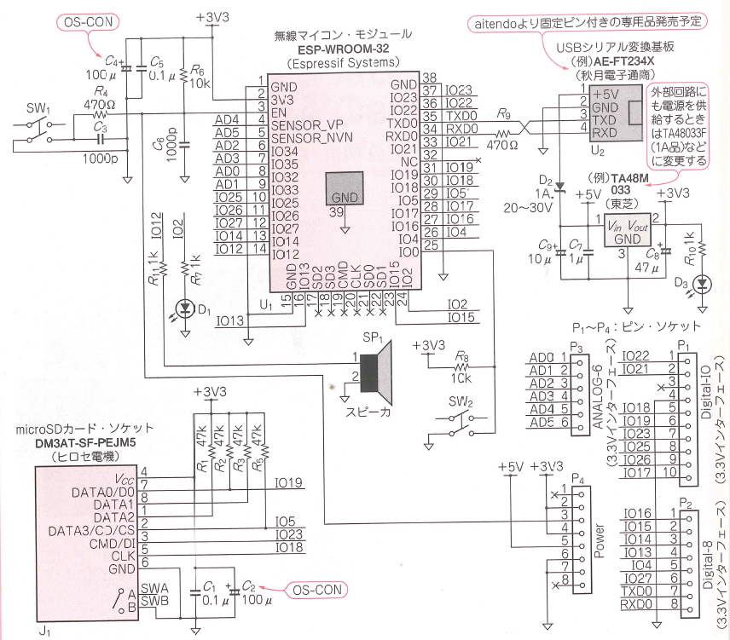

#LED:IO2

pinMode(2, OUTPUT);

digitalWrite(2,HIGH);

digitalWrite(2, LOW);

#Buzzer:IO12

ledcSetup(0,1000,8);

ledcAttachPin(12, 0);

ledcWrite(0, 128);