1. **Load Data into HDFS**

hdfs dfs -copyFromLocal /C:/Users/AYAN/Desktop/DATA SCIENCE PG/PROJECTS/INCOME CLASSIFIER/censusdata/censusdata.csv /user/edureka_806003/data

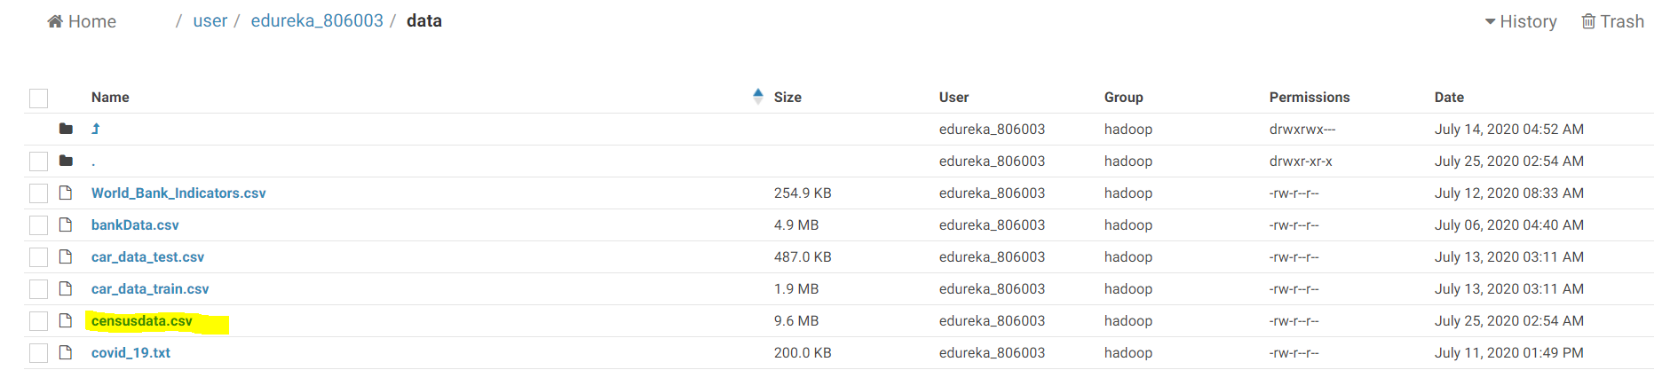

1. **Create an internal table in Hive to store the data**

**a. Create the table structure**

**b. Load the data from HDFS into the Hive table**

CREATE TABLE census_data(age INT,work_class STRING,fnlwgt INT,education STRING,education_num STRING,martial_status STRING,occupation STRING,relationship STRING,race STRING,sex STRING,capital_gain INT,capital_loss INT, hours_per_week INT,native_country STRING,income STRING);

load data inpath '/user/edureka_806003/data/censusdata.csv' into table census_data;

SELECT * FROM census_data

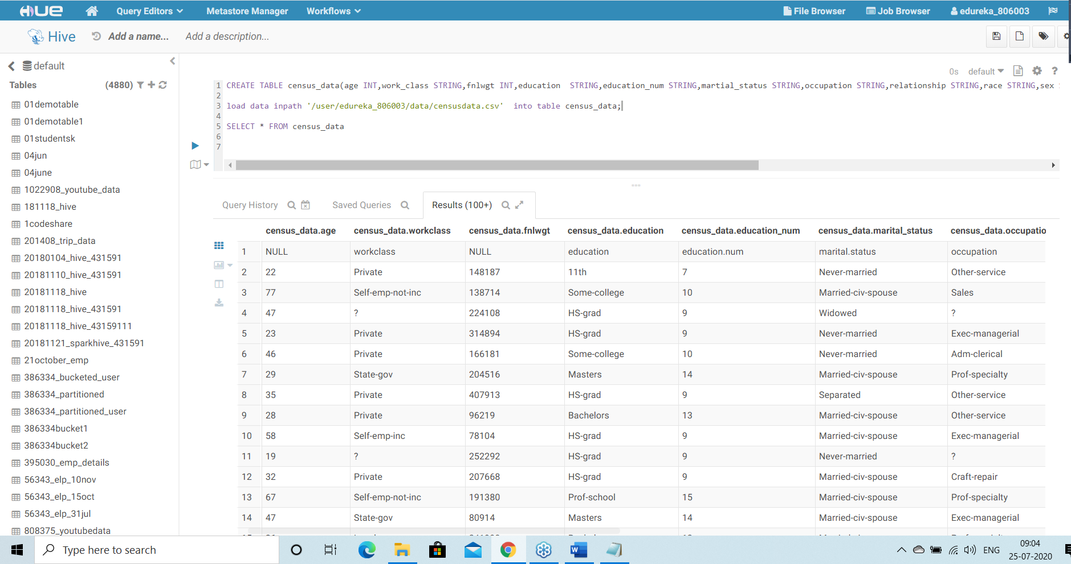

1. **Create an internal table in Hive with partitions**

**a. Create a Partition Table in Hive using “workclass” as the Partition Key**

**b. Load data from the staging table (Table created in Step 3) into this table**

CREATE TABLE census_partitioned (age INT,work_class STRING,fnlwgt INT,education STRING,education_num STRING,martial_status STRING,occupation STRING,relationship STRING,race STRING,sex STRING,capital_gain INT,capital_loss INT, hours_per_week INT,native_country STRING,income STRING) PARTITIONED BY(work_class STRING);

load data inpath '/user/edureka_806003/data/censusdata.csv' into table census_partitioned;

SELECT * FROM census_partitioned

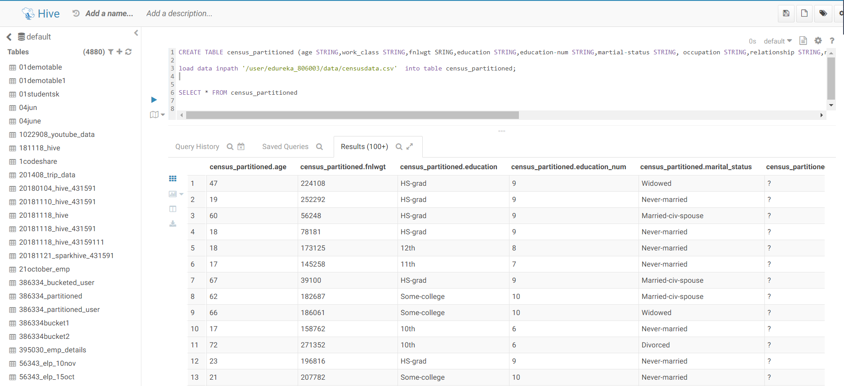

1. **Create an external table in Hive to hold the same data stored in HDFS**

CREATE EXTERNAL TABLE census_data_external(age INT,work_class STRING,fnlwgt INT,education STRING,education_num STRING,martial_status STRING,occupation STRING,relationship STRING,race STRING,sex STRING,capital_gain INT,capital_loss INT, hours_per_week INT,native_country STRING,income STRING);

load data inpath '/user/edureka_806003/data/censusdata.csv' into table census_data_external;

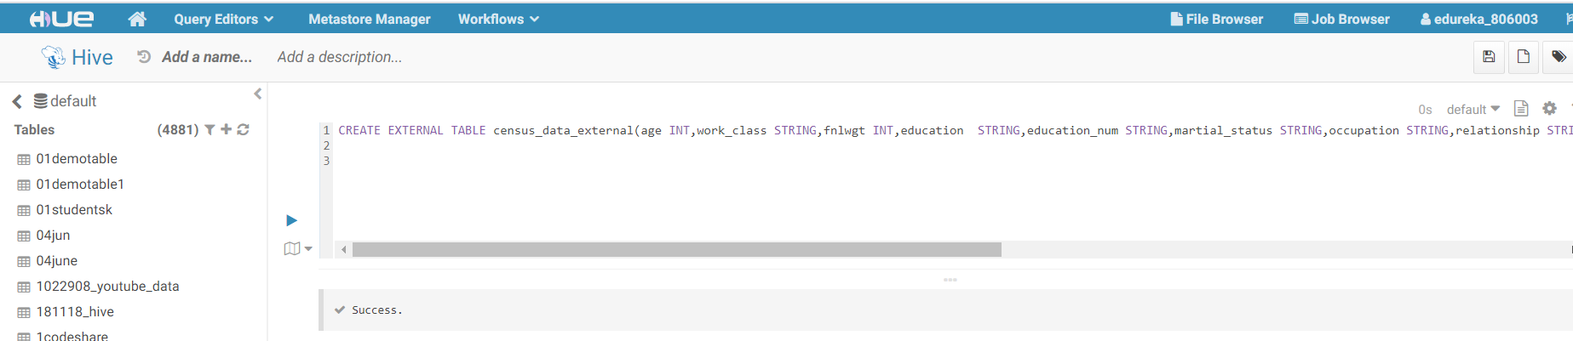

1. **Create an external table in Hive with partitions using “workclass” as Partition Key**

CREATE EXTERNAL TABLE census_data_partition_external(age INT,work_class STRING,fnlwgt INT,education STRING,education_num STRING,martial_status STRING,occupation STRING,relationship STRING,race STRING,sex STRING,capital_gain INT,capital_loss INT, hours_per_week INT,native_country STRING,income STRING) PARTITIONED BY(work_class_partition STRING);

load data inpath '/user/edureka_806003/data/censusdata.csv' into table census_data_partition_external;

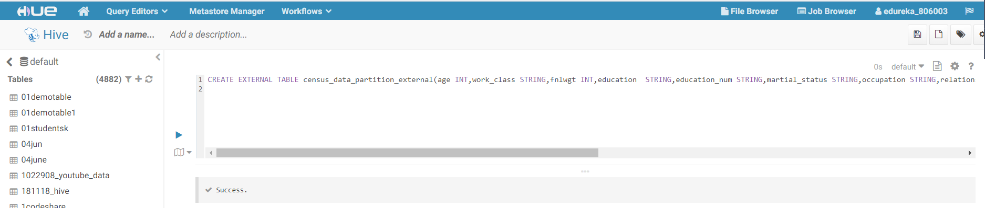

1. **For each of the four tables created above, perform the following operations**

**• Find out the number of adults based on income and gender. Note the time taken for getting the result**

**• Find out the number of adults based on income and workclass. Note the time taken for getting the result**

**• Write your observations by comparing the time taken for executing the commands between: a. Internal & External Tables b. Partitioned & Non-partitioned Tables**

select income,sex,count(*) from census_data group by census_data.sex,census_data.income

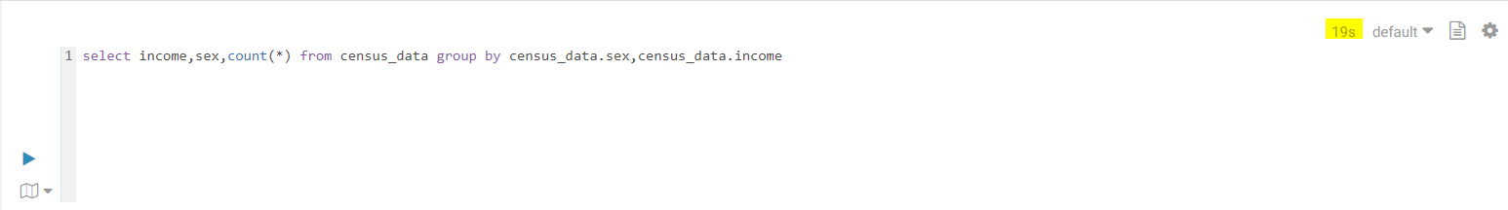

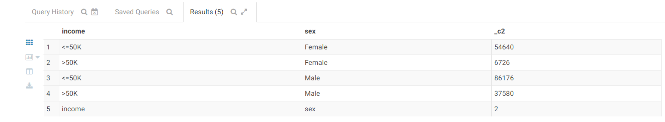

select income,sex,count(*) from census_partitioned group by census_partitioned.sex, census_partitioned.income

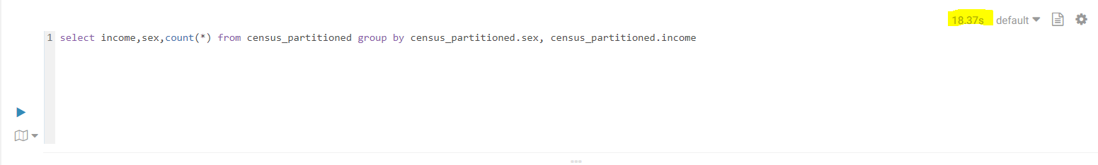



select income,sex,count(*) from census_data_external group by census_data_external.sex, census_data_external.income

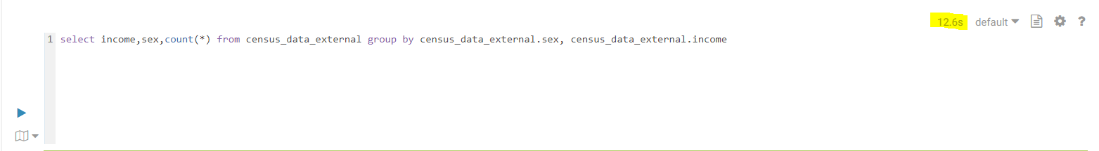



select income,sex,count(*) from census_data_partition_external group by census_data_partition_external.sex, census_data_partition_external.income

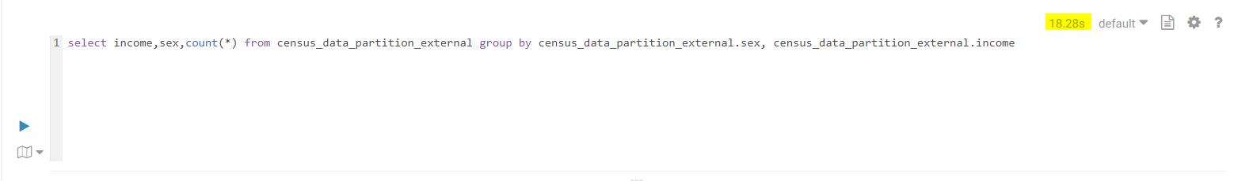



**Time taken:**

**Internal Non-Partitioned:- 19 sec**

**Internal Partitioned:- 18.37 sec**

**External Non-Partitioned:- 12.6 sec**

**External Partitioned:- 18.28 sec**

select income,workclass,count(*) from census_data group by census_data.workclass,census_data.income

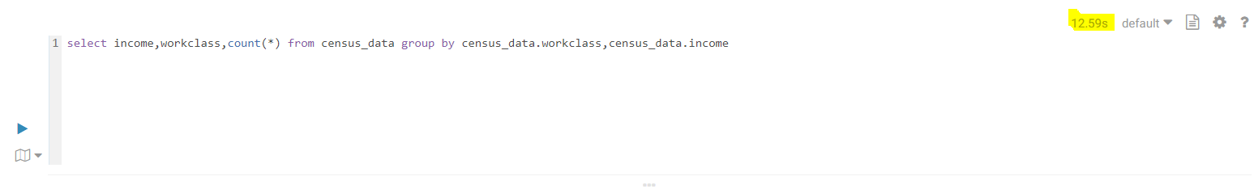

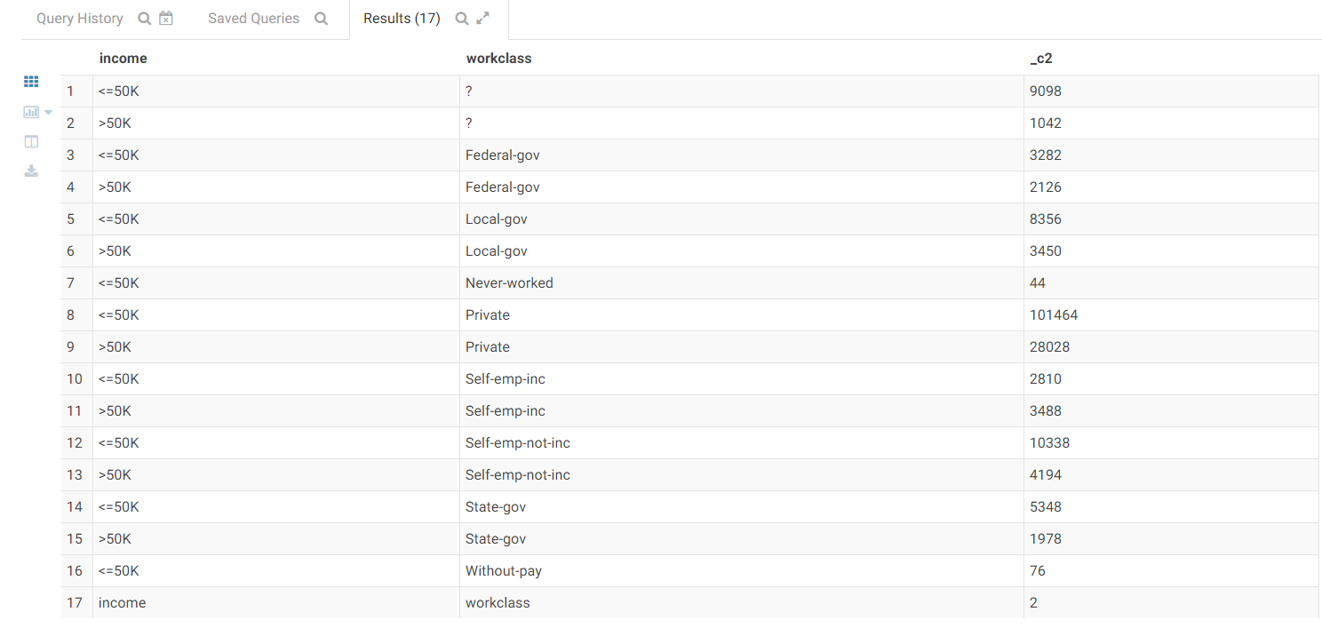

select income,workclass,count(*) from census_partitioned group by census_partitioned.workclass, census_partitioned.income

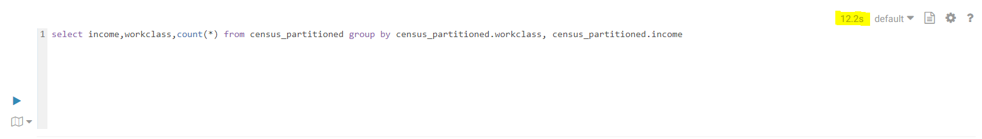



select income,work_class,count(*) from census_data_external group by census_data_external.work_class, census_data_external.income

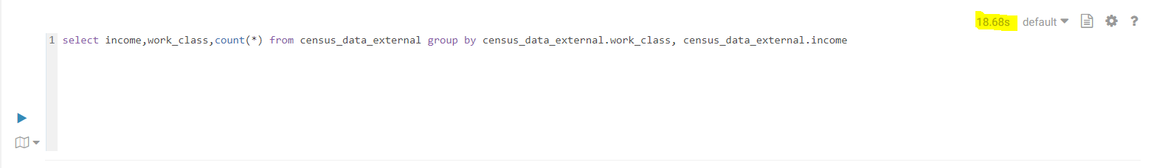



select income,work_class,count(*) from census_data_partition_external group by census_data_partition_external.work_class, census_data_partition_external.income

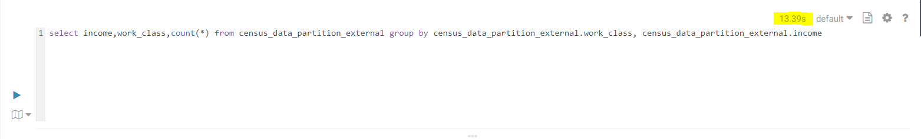



**Time taken:**

**Internal Non-Partitioned:- 12.59 sec**

**Internal Partitioned:- 12.2 sec**

**External Non-Partitioned:- 18.68 sec**

**External Partitioned:- 13.39 sec**