**1. Create the necessary structure in a MySQL database using the steps mentioned below:**

**a. Create a new database in MySQL with the name midproject**

**b. Create a table in this database with the name census_adult to store the input dataset**

**c. Load the dataset into the table**

**d. Verify whether data is loaded properly**

**e. Verify the table for unwanted data such as ‘?’,’Nan’ and ‘Null’**

**f. Get the counts for the columns which contain unwanted data**

**g. Clean the data by replacing the unwanted data with others**

1. mysql -u edu_labuser -pedureka -h dbserver.edu.cloudlab.com

CREATE DATABASE midproject;( do not have permissions for this)

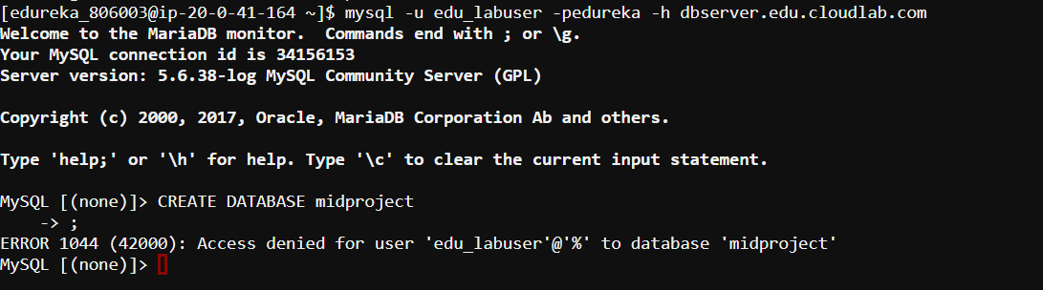

Show databases;

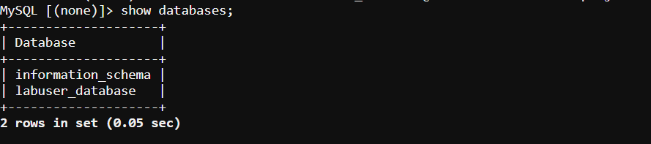

Use midproject

(using labuser_database since we do not have permissions to create a database)

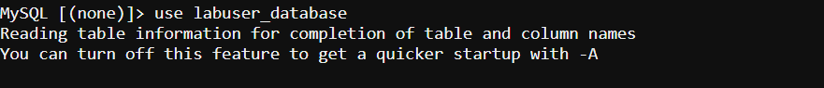

1. CREATE TABLE census_adult(age INT(2),work_class VARCHAR(50),fnlwgt VARCHAR(50), education VARCHAR(50),education_num VARCHAR(50),martial_status VARCHAR(50),occupation VARCHAR(50),relationship VARCHAR(50),race VARCHAR(50),sex VARCHAR(50),capital_gain INT(20),capital_loss INT(20),

hours_per_week INT(5),native_country VARCHAR(50),income VARCHAR(50));





1. load data local infile '/user/edureka_806003/data/ censusdata.csv ' into table census_adult fields terminated by ',';



select * from census_adult

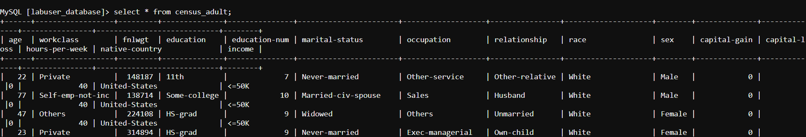

1. hdfs dfs -cat census_adult/part-m-*



1. and f.
2. select count(*) from census_adult where age is null or age='Nan' or age='?';

select count(*) from census_adult where workclass is null or workclass='Nan' or workclass='?';

select count(*) from census_adult where fnlwgt is null or fnlwgt ='Nan' or fnlwgt ='?';

select count(*) from census_adult where education is null or education='Nan' or education='?';

select count(*) from census_adult where education-num is null or education-num='Nan' or education-num='?';

select count(*) from census_adult where marital-status is null or marital-status ='Nan' or marital-status ='?';

select count(*) from census_adult where occupation is null or occupation='Nan' or occupation='?';

select count(*) from census_adult where relationship is null or relationship='Nan' or relationship='?';

select count(*) from census_adult where race is null or race ='Nan' or race ='?';

select count(*) from census_adult where sex is null or sex='Nan' or sex='?';

select count(*) from census_adult where capital-gain is null or capital-gain='Nan' or capital-gain='?';

select count(*) from census_adult where capital-loss is null or capital-loss ='Nan' or capital-loss ='?';

select count(*) from census_adult where hours-per-week is null or hours-per-week='Nan' or hours-per-week='?';

select count(*) from census_adult where native-country is null or native-country='Nan' or native-country='?';

select count(*) from census_adult where income is null or income ='Nan' or income ='?';

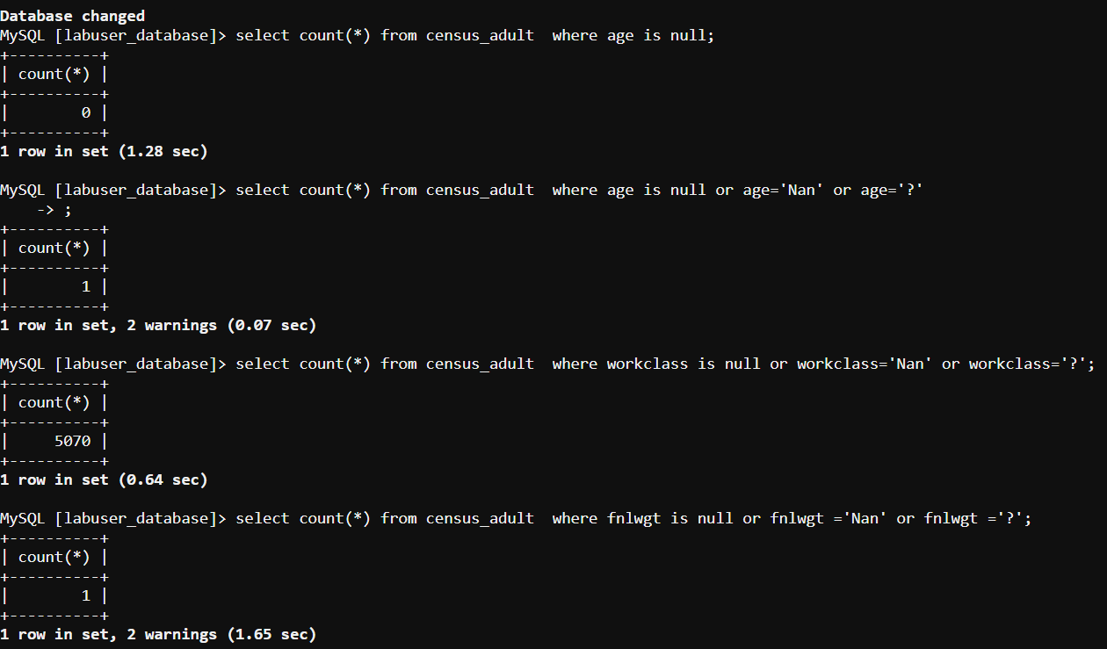

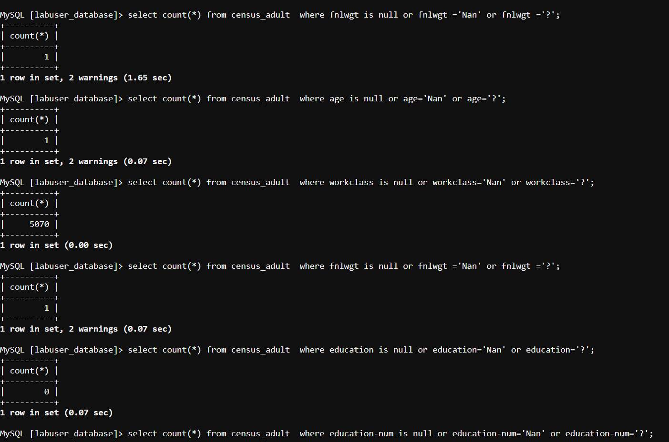

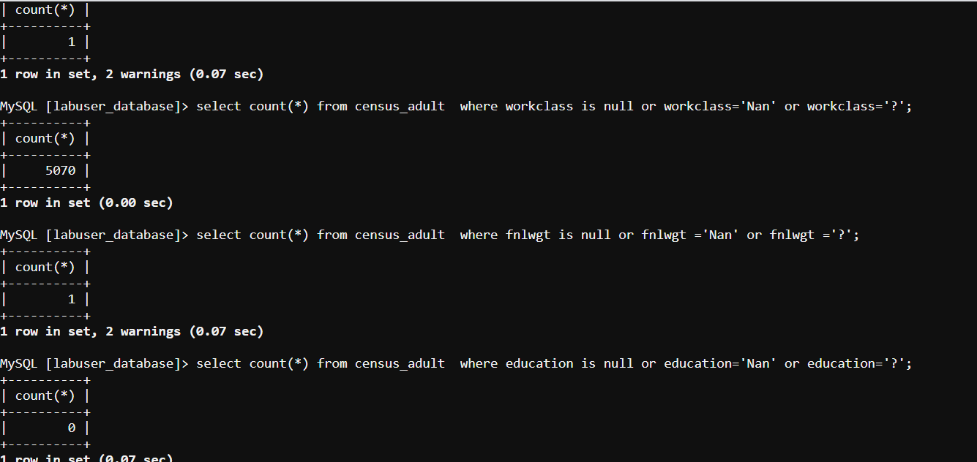

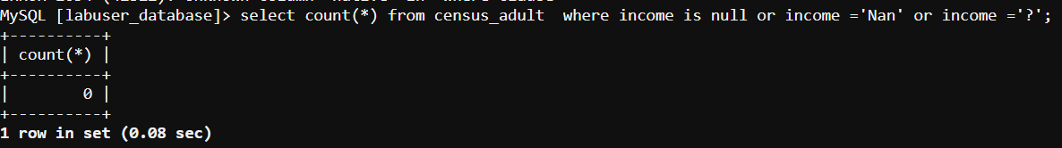

1. UPDATE census_adult SET age = 'others' WHERE age is null or age='Nan' or age='?';

UPDATE census_adult SET workclass = 'others' WHERE workclass is null or workclass='Nan' or workclass='?';

UPDATE census_adult SET fnlwgt = 'others' WHERE fnlwgt is null or fnlwgt ='Nan' or fnlwgt ='?';

UPDATE census_adult SET education = 'others' WHERE education is null or education='Nan' or education='?';

UPDATE census_adult SET education-num = 'others' WHERE education-num is null or education-num='Nan' or education-num='?';

UPDATE census_adult SET marital-status = 'others' WHERE marital-status is null or marital-status ='Nan' or marital-status ='?';

UPDATE census_adult SET occupation = 'others' WHERE occupation is null or occupation='Nan' or occupation='?';

UPDATE census_adult SET relationship = 'others' WHERE relationship is null or relationship='Nan' or relationship='?';

UPDATE census_adult SET race = 'others' WHERE race is null or race ='Nan' or race ='?';

UPDATE census_adult SET sex = 'others' WHERE sex is null or sex='Nan' or sex='?';

UPDATE census_adult SET capital_gain = 'others' WHERE capital_gain is null or capital_gain='Nan' or capital_gain='?';

UPDATE census_adult SET capital-loss = 'others' WHERE capital-loss is null or capital-loss ='Nan' or capital-loss ='?';

UPDATE census_adult SET hours-per-week = 'others' WHERE hours-per-week is null or hours-per-week='Nan' or hours-per-week='?';

UPDATE census_adult SET native-country = 'others' WHERE native-country is null or native-country='Nan' or native-country='?';

UPDATE census_adult SET income = 'others' WHERE income is null or income ='Nan' or income ='?';

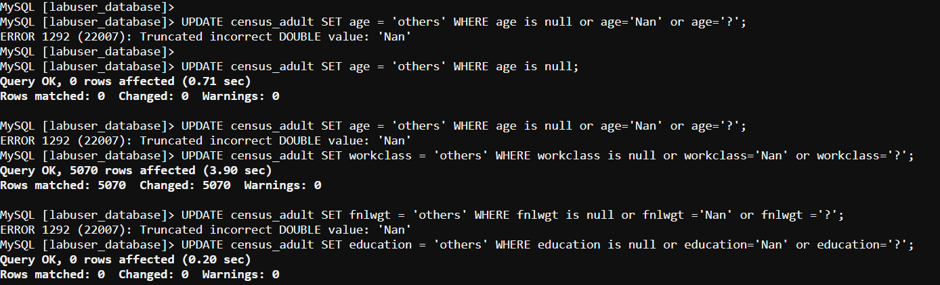

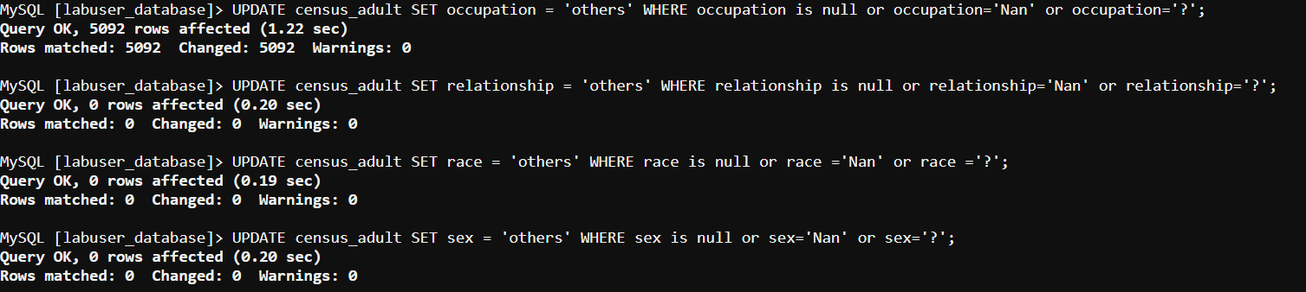



**2. Import the above data from MySQL into a Hive table using Sqoop**

sqoop import --connect jdbc:mysql://dbserver.edu.cloudlab.com/ labuser_database --username edu_labuser --password edureka --table census_adult-m 1

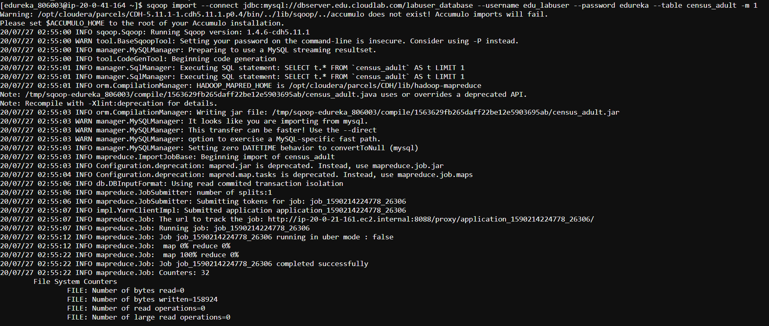

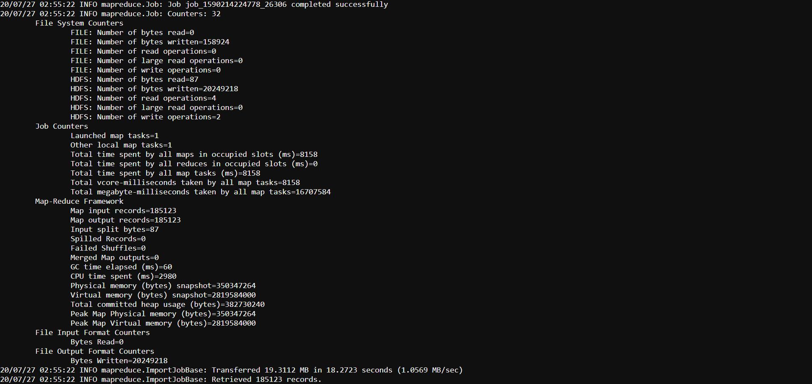

**3. Connect to PySpark using web console to access the created Hive table. Perform the following queries and note the time taken for execution in each of the queries.**

**a. Query the table to get the number of adults based on income and gender b. Query the table to get the number of adults based on income and workclass.**

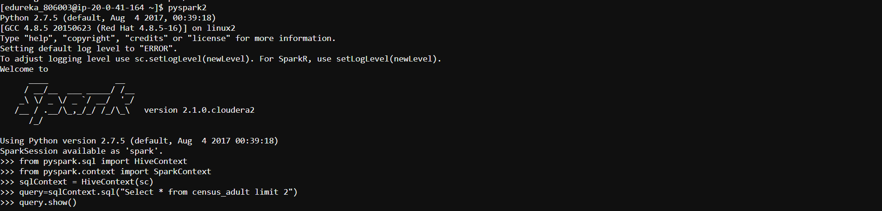



1. query=sqlContext.sql("select income,sex,count(*) from census_adult group by sex,income")

query.show()



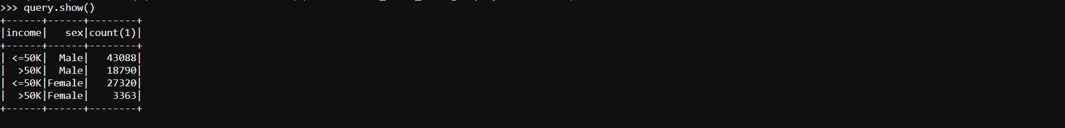

1. query=sqlContext.sql("select income,sex,count(*) from census_adult group by workclass,income")

query.show()

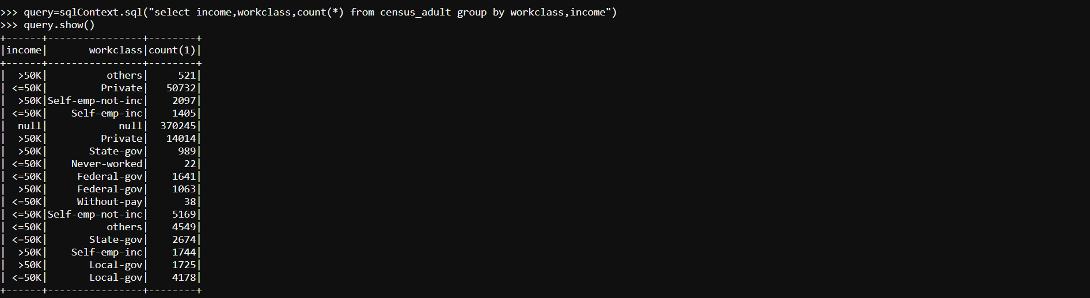

**4. Access the following two tables created as part of Problem 1 (HDFS and Hive) and perform the steps as mentioned below:**

**a. Access Hive External Table with partition**

**i. Query the table to get the number of adults based on income and gender**

**ii. Query the table to get the number of adults based on income and workclass**

**b. Access Hive Internal Table with Partition**

**i. Query the table to get the number of adults based on income and gender**

**ii. Query the table to get the number of adults based on income and workclass**

1. Hive External Tables
2. query=sqlContext.sql("select income,sex,count(*) from census_data_external group by sex,income")

query.show()



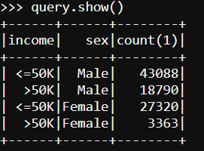

1. query=sqlContext.sql("select income, workclass,count(*) from census_data_external group by workclass,income")

query.show()



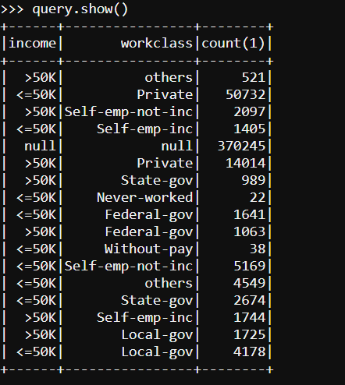

1. Hive Internal Tables
2. query=sqlContext.sql("select income,sex,count(*) from census_data group by sex,income")

query.show()





1. query=sqlContext.sql("select income,workclass,count(*) from census_data group by workclass,income")

query.show()

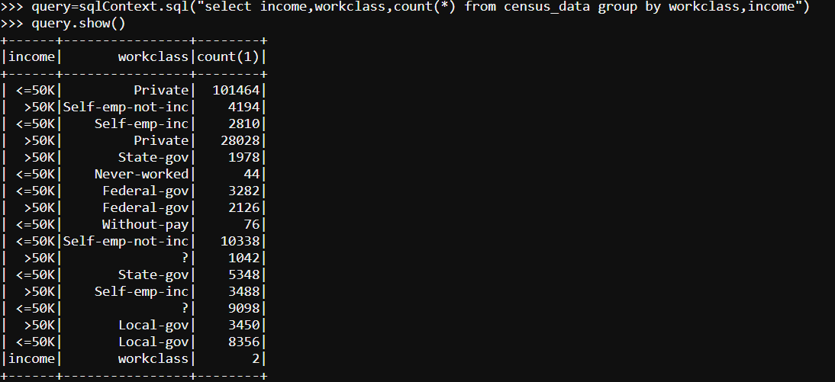

**5. Comment on the time taken for executing these commands using Spark as compared to the time taken for execution in Hive (Problem Statement 1).**

Time taken to execute Query in spark is much less than what it takes in hive.