《统计学习与数据科学课程设计》课程论文
(2025-2026学年第 2 学期)

论文题目： Enzyme Kinetic Parameter Prediction Based on Statistical Learning and Multimodal Representation Learning
学生姓名： 莫翊彰

提交日期： 2026 年 5 月 20 日 学生签名： 莫翊彰
学 号 | 202330332241 | 座位编号
学 院 | 数学学院 | 专业班级 | 24统计学
课程名称 | 统计学习与数据科学课程设计 | 任课教师 | 夏立
教师评语：

本论文成绩评定： 分

（以下内容供参考，可根据情况修改或删除）
说 明
1、课程论文一般要有题目、作者姓名、摘要、关键词、正文及参考文献。
2、论文要求自己动手撰写，如发现论文是从网上下载的，或者是抄袭剽窃别人文章的，按作弊处理，本门课程考核成绩计0分。
3、课程论文用A4纸双面打印。字体全部用宋体简体，题目要求用三号字加粗，标题行要求用小四号字加粗，正文内容要求用小四号字；英文论文字体全部用Times New Roman，题目要求用18号字加粗；标题行要求用14号字加粗，正文内容要求用12号字；行距为固定值20磅；页边距左为2.5cm、右为2.5cm、上为2.5cm、下为2.5cm；其它格式请参照本科设计（论文）的要求。
4、论文选题、篇幅、内容等由任课教师提出具体要求。

Title：Enzyme Kinetic Parameter Prediction Based on Statistical Learning and Multimodal Representation Learning
Student Name：YiZhang Mo

1. Introduction
Preprocessing and statistical inspection provide a transparent, reproducible foundation for sequence-based enzyme kinetics modeling. This report documents the dataset properties, quality controls, and the preparation steps that enable consistent experiments across runs.

2. Dataset Overview
The current pipeline uses the DLKcat subset from the EKP data warehouse (raw arrays in EKP_raw/DLKcat). Each sample pairs a protein token sequence with a compound token sequence and a regression target log10(kcat).
After cleaning, the dataset contains 22632 samples. Protein sequences are stored as integer token lists with lengths ranging from 7 to 2515 (mean 431.21), and compound sequences range from 1 to 1096 tokens (mean 44.47). The target spans [-6.0, 6.0], consistent with a precomputed log10(kcat) scale.

3. Data Cleaning
Cleaning is implemented in scripts/clean.py and emphasizes reproducibility and traceability:
- Duplicate removal: samples with identical protein, compound, and target are dropped.
- Empty sequence checking: zero-length protein or compound sequences are removed.
- Abnormal value filtering: targets outside [-6, 6] are discarded.
- Reproducibility settings: a fixed random seed (42) and deterministic 8/1/1 split are used during dataset partitioning.

4. Statistical Inspection

4.1 Protein Sequence Distribution
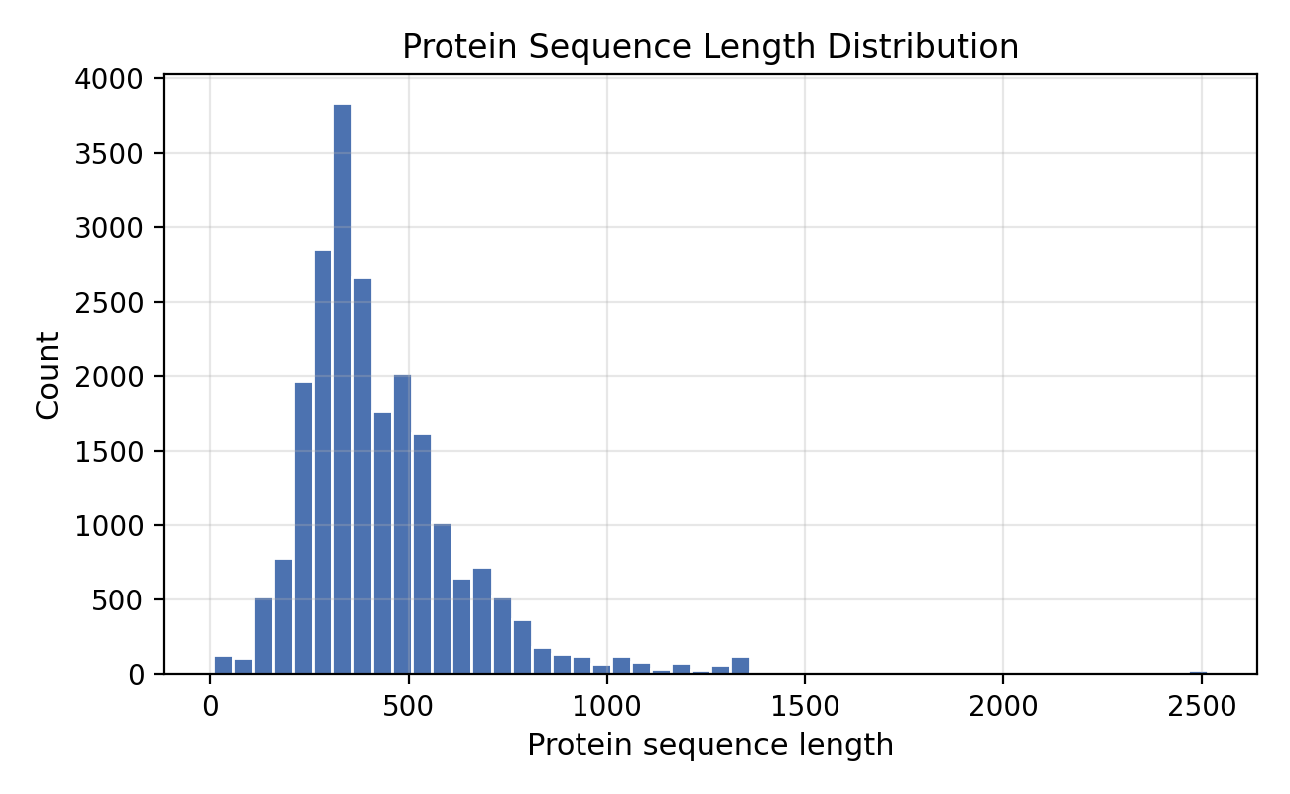
Figure 1. Protein sequence length distribution.
Protein lengths show a long-tailed distribution, with most sequences clustered below 600 tokens and a minority extending beyond 2000. This skew suggests that length-aware modeling or pooling is needed to avoid bias toward short sequences.
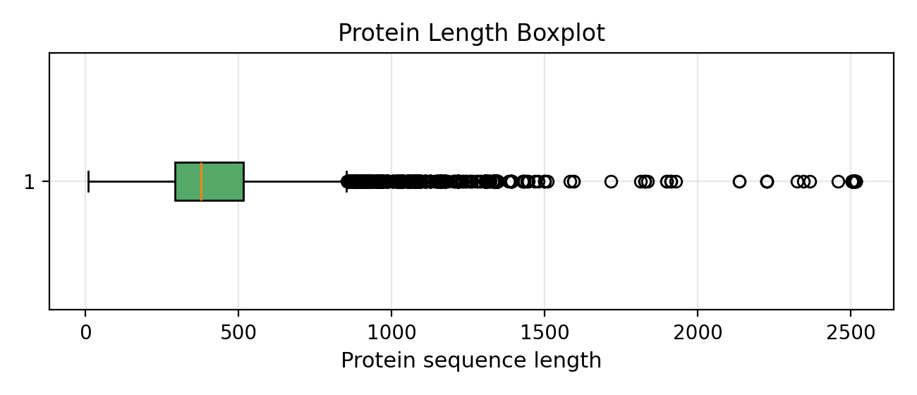
Figure 2. Protein sequence length boxplot.

4.2 Compound Token Distribution
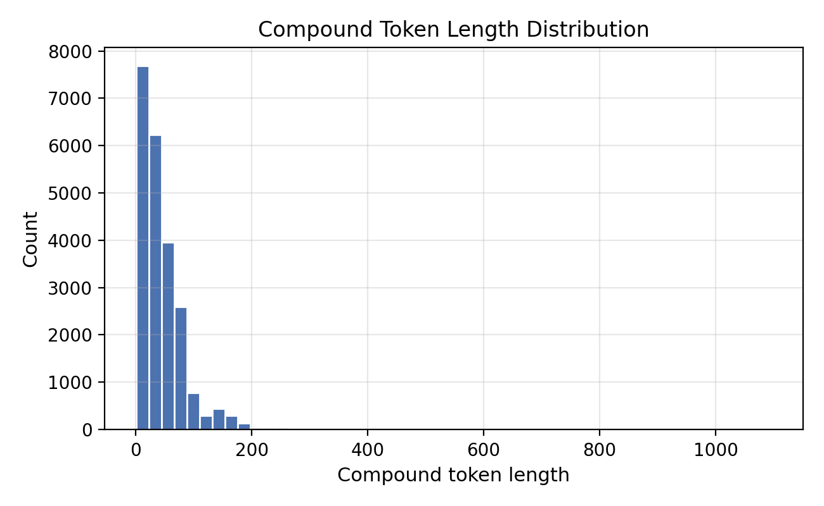

Figure 3. Compound token length distribution.
Compound token lengths are compact compared to proteins, centered around a few dozen tokens with fewer extreme outliers. This asymmetry reinforces the need for balanced fusion and normalization across modalities.
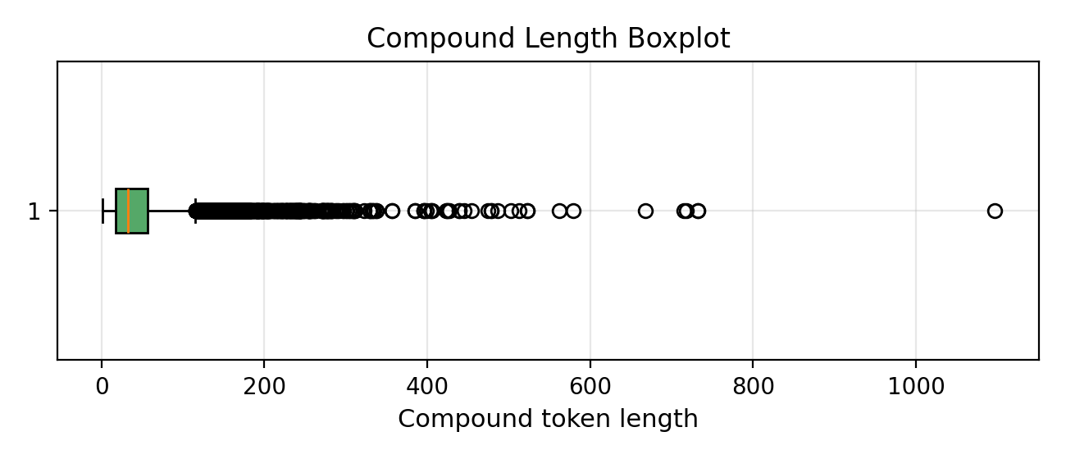
Figure 4. Compound token length boxplot.
4.3 Target Distribution
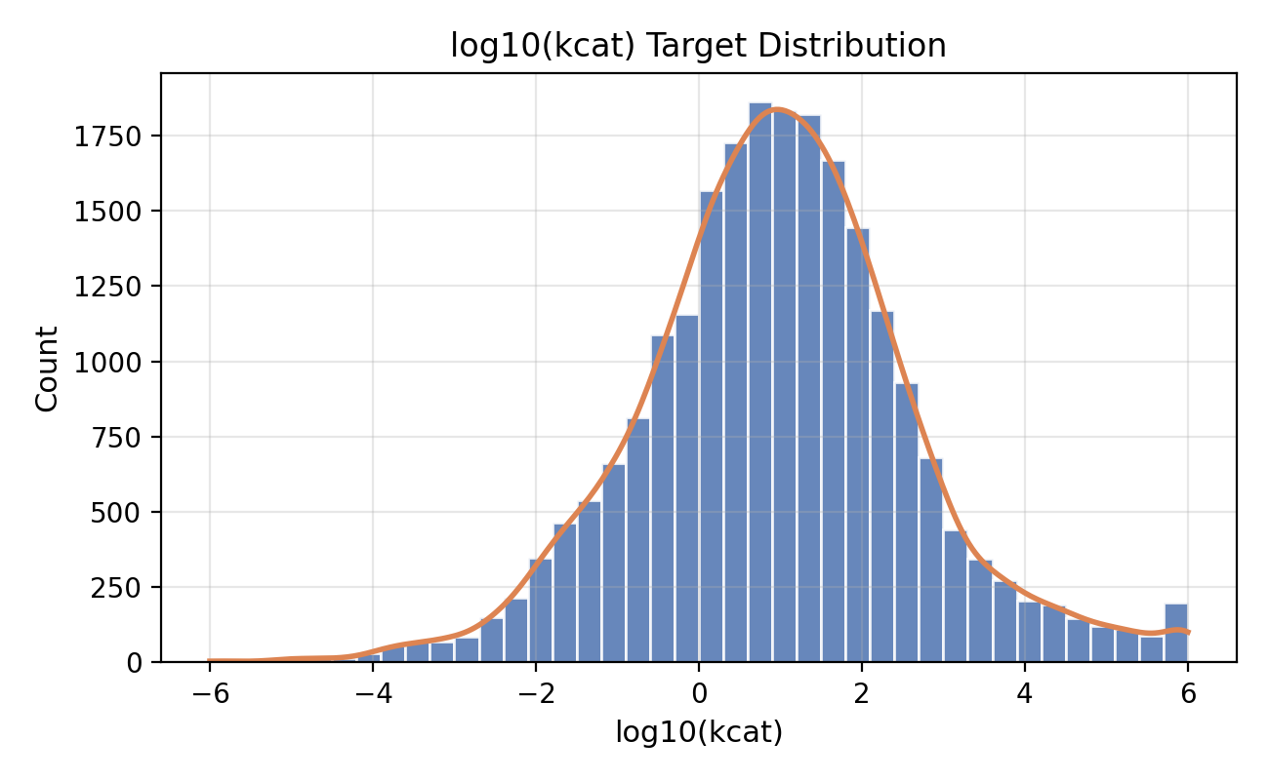
Figure 5. Distribution of log10(kcat) targets.
The target distribution is centered near 1.0 with a broad spread across the full [-6, 6] range, implying substantial variability and potential heteroscedasticity. This motivates robust loss functions and calibration checks in downstream models.

4.4 Dataset Split
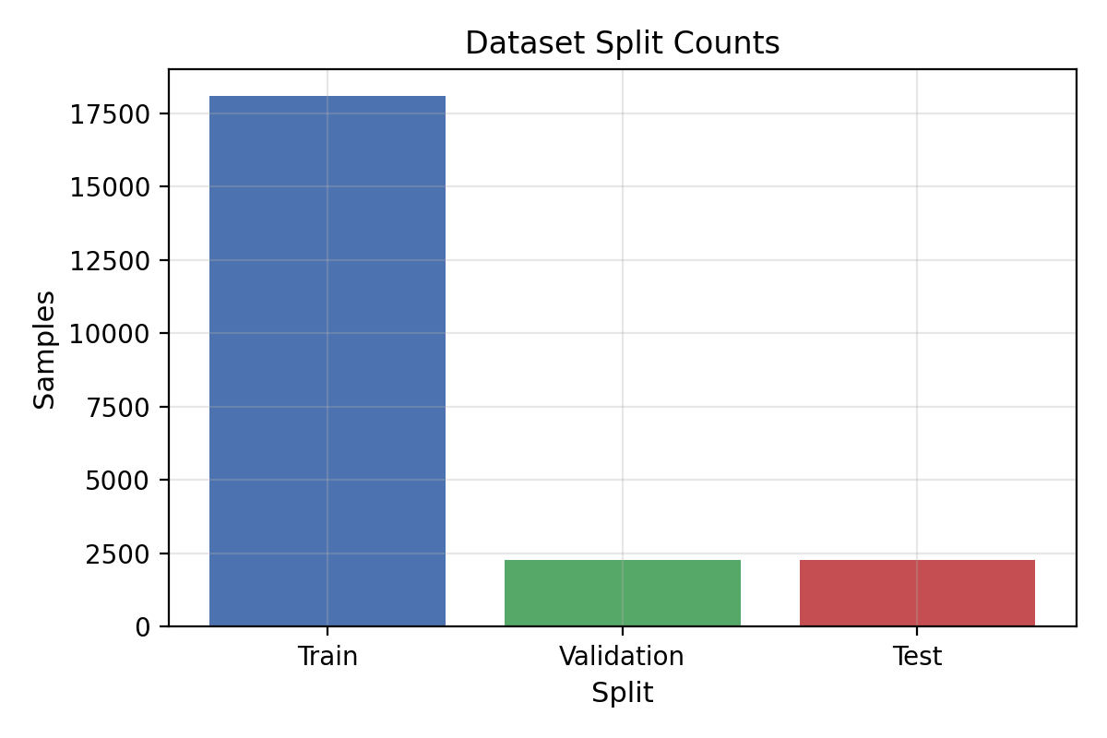
Figure 6. Train, validation, and test sample counts.
The split follows an 8/1/1 ratio with fixed random seed, yielding 18105 training samples, 2263 validation samples, and 2264 test samples. A fixed split improves reproducibility, allowing fair comparison across baseline and lightweight deep learning experiments.

4.5 Summary Statistics
Table 1. Summary statistics of cleaned DLKcat dataset.
project | Min | Max | Mean | Median | Std
Protein Length | 7.00 | 2515.00 | 431.21 | 378.00 | 222.20
Compound Length | 1.00 | 1096.00 | 44.47 | 33.00 | 43.83
log10(kcat) | -6.00 | 6.00 | 0.96 | 0.95 | 1.67

Protein lengths exhibit a clear long-tail pattern with large dispersion relative to the median, indicating that a small fraction of very long sequences dominates the range. This distribution motivates length-aware pooling or normalization to avoid overemphasizing short sequences.
Compound lengths are shorter on average but show variability of similar magnitude to the mean, while the target values span a wide interval with substantial standard deviation. The modality imbalance and target spread imply that stable optimization benefits from careful pooling strategy and regularization to maintain consistent regression behavior across diverse sequence scales.

5. Discussion
Protein lengths are markedly imbalanced, which can amplify the dominance of short sequences if pooling or truncation is not carefully designed. Target variability is wide, suggesting that models should capture both central tendencies and tail behavior. For lightweight deep learning models, pooling becomes critical: mean pooling stabilizes representation scale, while max pooling can be sensitive to sparse activations. Given the length skew, pooling strategies influence both convergence stability and predictive consistency.

6. Conclusion
The preprocessing pipeline produces a clean, reproducible dataset with verified sequence integrity and target ranges. Statistical inspection confirms the expected long-tailed protein lengths, compact compound lengths, and broad target variability. These findings establish readiness for reproducible experiments and motivate careful pooling and fusion choices in lightweight models.

