**OBJECTIVES:**

1. **Introduction to Visual Studio 2012/2015 and its environment.**
2. **Understanding Assembly.**
3. **Understanding and Developing Console Applications.**
4. **Practice Activities.**

Write following code in it.

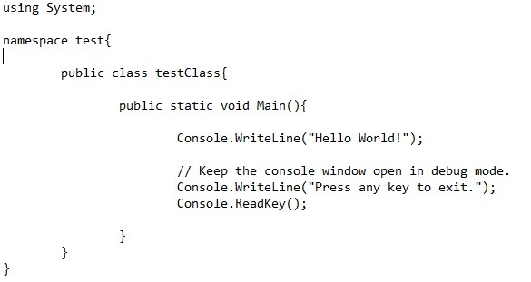

**ACTIVITIES SECTION**

# ACTIVITY 1: Creating a basic Console Application without visual studio.

Open notepad editor.

For code compilation open command prompt or developer console of visual studio 2015/2012.

In case of command prompt you need to set path for c-sharp compiler.

For path setting write

# Set path =”C:\Windows\Microsoft.NET\Framework64\v4.0.30319”

Writing following command will create an assembly with extension .exe.

csc name_of_csharp_file.cs

Writing Name of exe file that is generated by previous command will invoke the program.

name_of_assembly_created

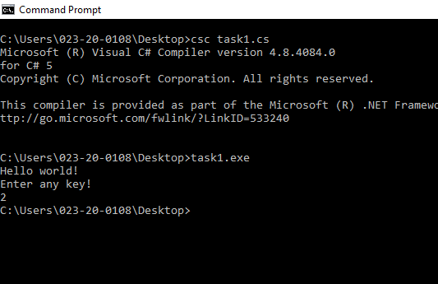

# ACTIVITY 2: Taking arguments at run time from console.

Open notepad editor.

Write following code that will take arguments at run time from user.

Compile code using c

-

sharp compiler.

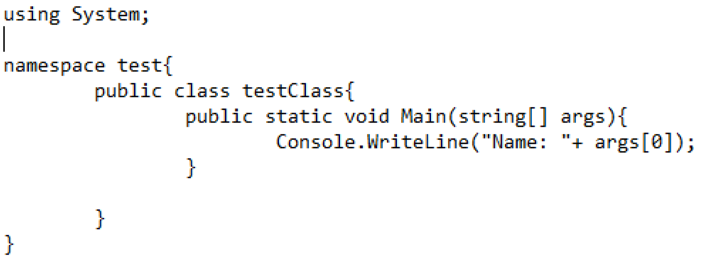

During assembly invocation provide single argument.

For example: test2 Saud

Output will be: Name: Sau

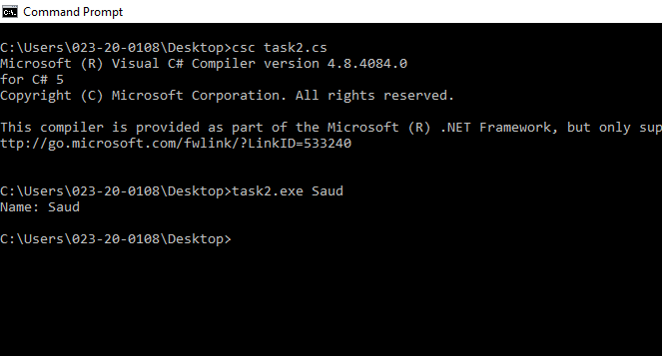

**ACTIVITY 3:** Create Console Application and take 3 values at run time, first value will be operator like + sign, second value will be first operand and third value will be second operand, perform the operation on the operands according to operator.

int.Parse (“string value”) is used to convert string value to integer.

For example: if input is like this: basisCalculator + 2 2

Then output should be: Addition is: 4

**Results portion:** Place screen shot of result obtained through this activity.

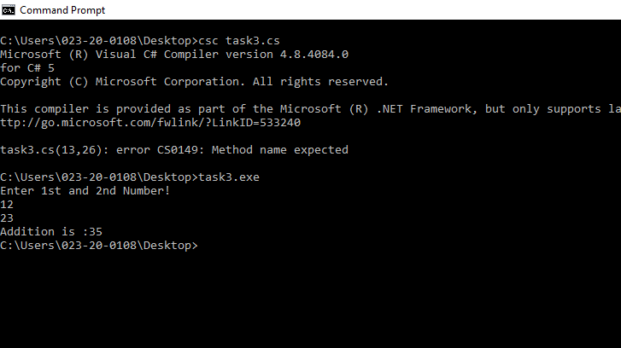

# ACTIVITY 4: Creating a basic Console Application using visual studio.

1. Open Microsoft Visual Studio 2012/2015.
2. Create a new console application project called ConsoleApplication1. - CTRL + SHIFT + N is shortcut after launching visual studio.

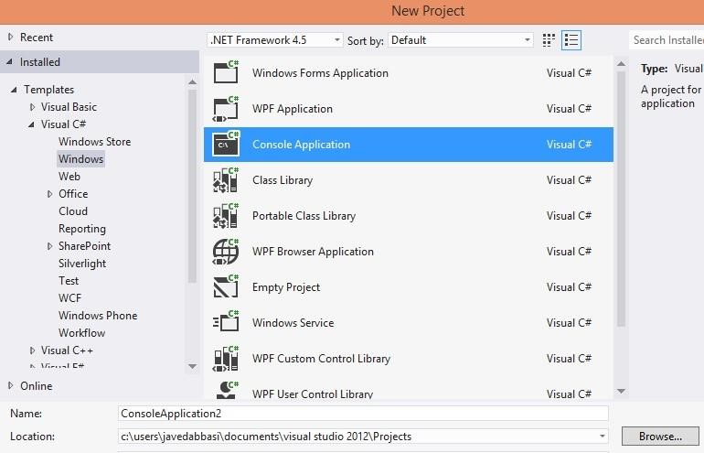

1. In the New Project dialog box, in the Installed Templates pane, expand Visual C#, and then click Windows.
2. In the Templates pane, click Console Application.
3. Provide following values for each of the properties in the dialog box, and then click OK
   * Name: ConsoleApplication
   * Location: default location of project

1. With step 5 a default class is added to a project named Program in that we have an entry point of program called Main method that is static in nature and can be called with the name of class and will be able to call only static methods in it.

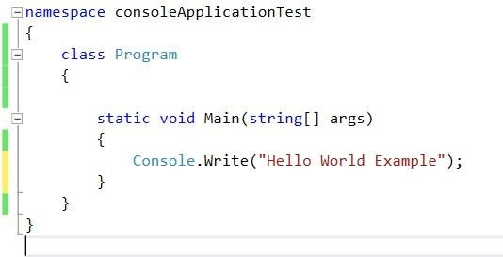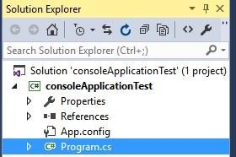

1. Run the program by pressing CTRL+F5 that is without debugging mode, it will take less time to execute the code as compared to compiling code in debugging mode.
2. If you want to run code using debugging mode press F5 only.

**Output:**

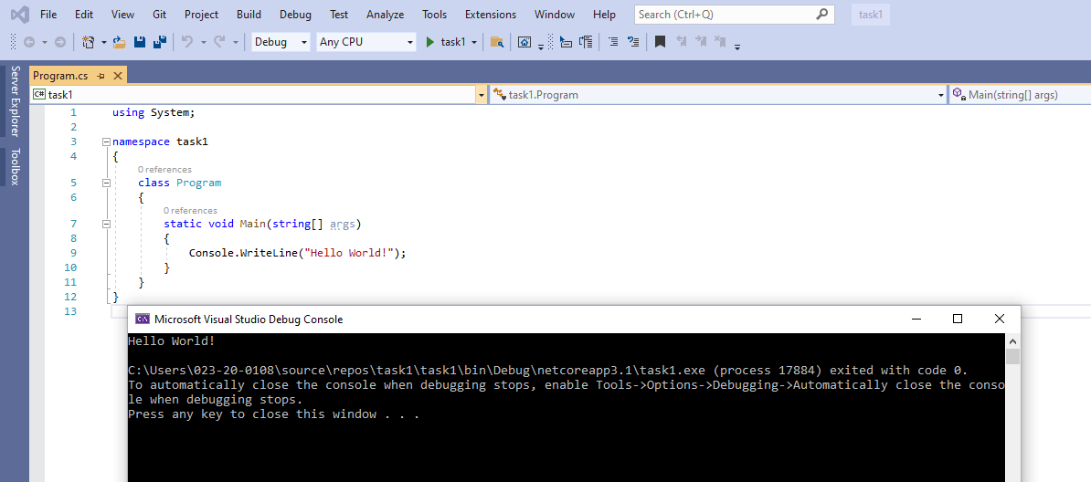

# ACTIVITY 5: Modifying console application created in Activity 1.

Continue with activity 1.

In the Main method add following code, which will be used to read a line of text from the keyboard.

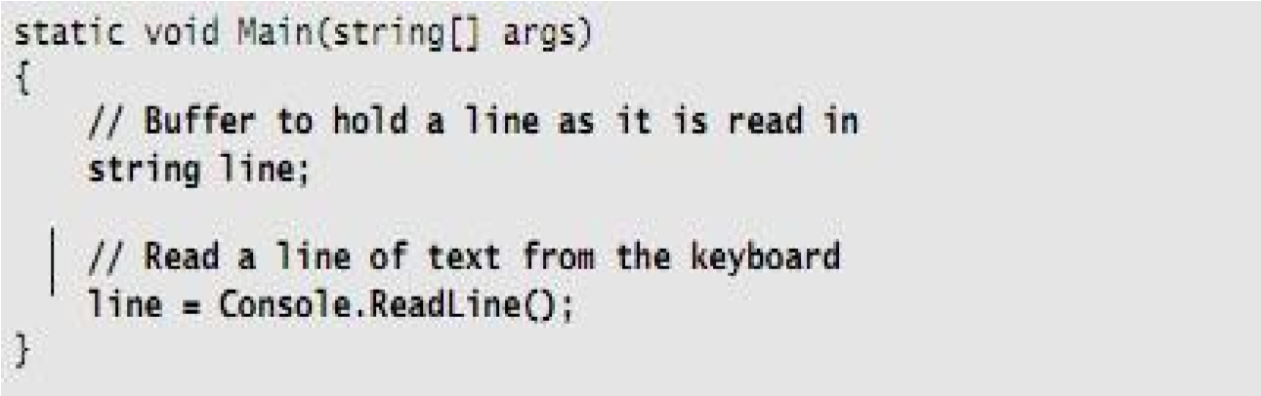

ReadLine() method of Console class is used to read line of text.

Now again add the statement and comment shown in bold in the following code example, which echo the text back to the console by using the Console.WriteLine method.

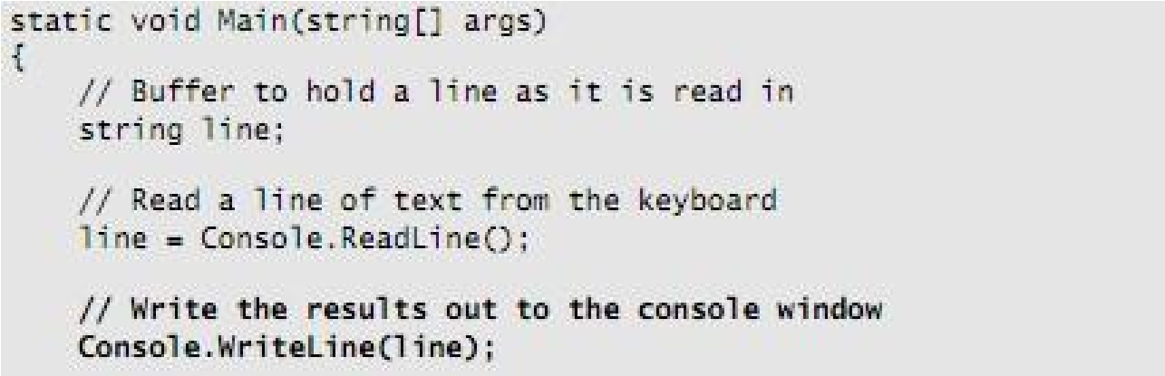

Run the application and verify that it works as expected. You should be able to enter a line of text and see that line echoed to the console.

* On the Debug menu, click Start without Debugging (CTRL + F5). - In the console window, type some text, and then press ENTER.
* Verify that the text that you typed is echoed to the console.
* Press ENTER to return to Visual Studio.

# ACTIVITY 6: Create a console application like in activity 3 but here you have to take values at runtime using Console.ReadLine() method instead of taking it from string array.

Create console application that prompt for two values and operator from user in order to perform mathematical operations on operands. According to operator an operation should be performed on values. int.Parse (“string value”) is used to convert string value to integer. **Results Portion: place snapshot of result and code in this portion.**

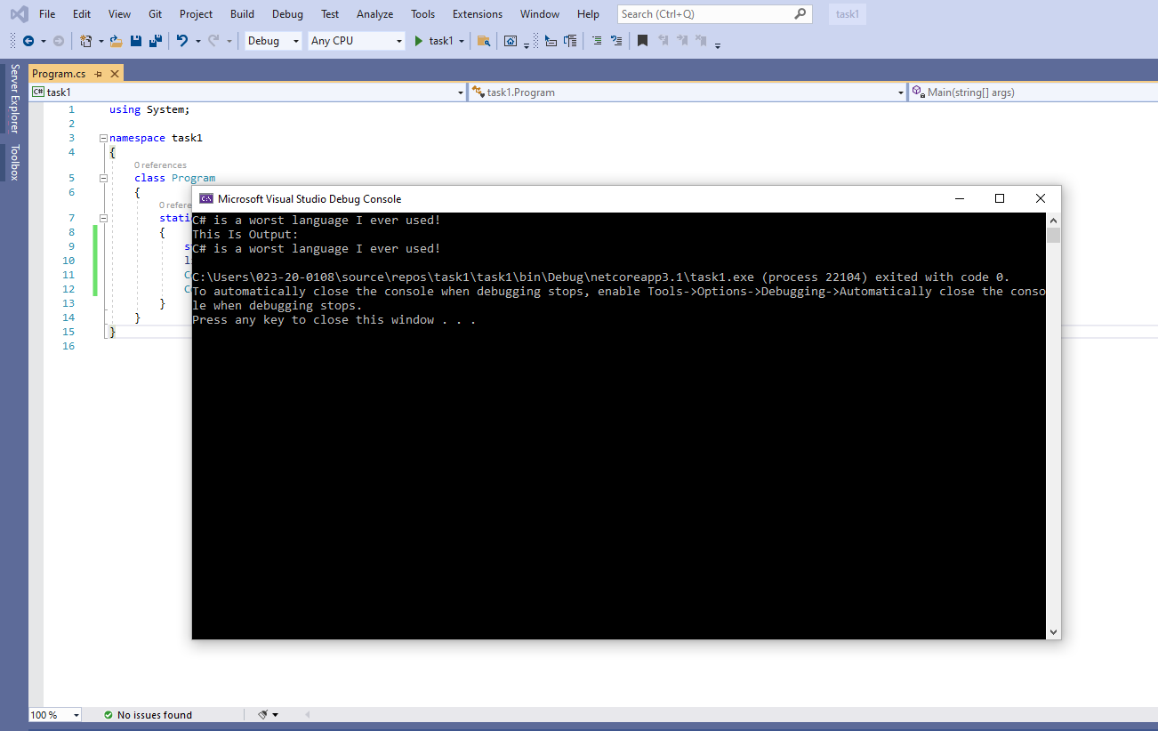

**ACTIVITY 7:** Write a static method named **DivideWithoutOperator** which takes two values dividend and divisor and displays result of division in console.

Note: Division operator should not be used for division.

Hint: Division is x number of times subtraction of divisor from dividend until you get remainder less than the divisor.

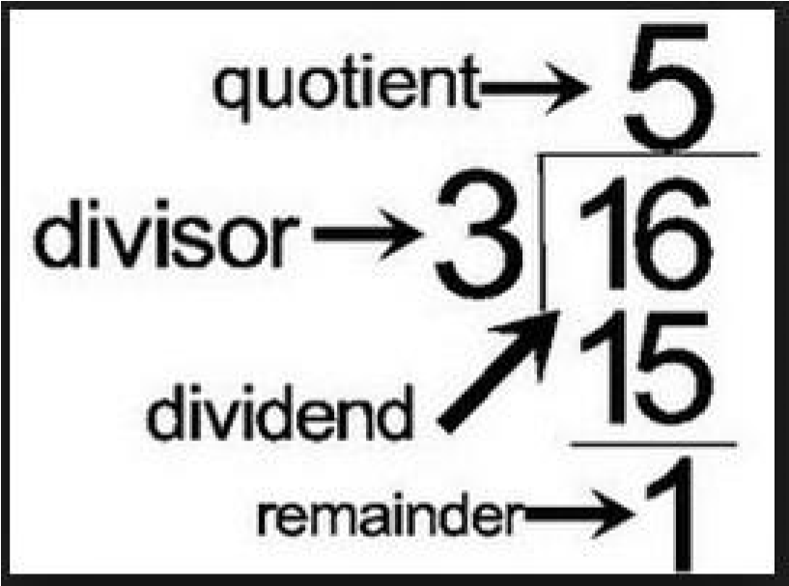

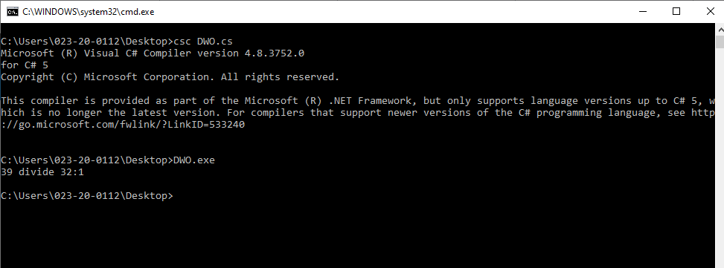**OUTPUT:**

**CODE:**

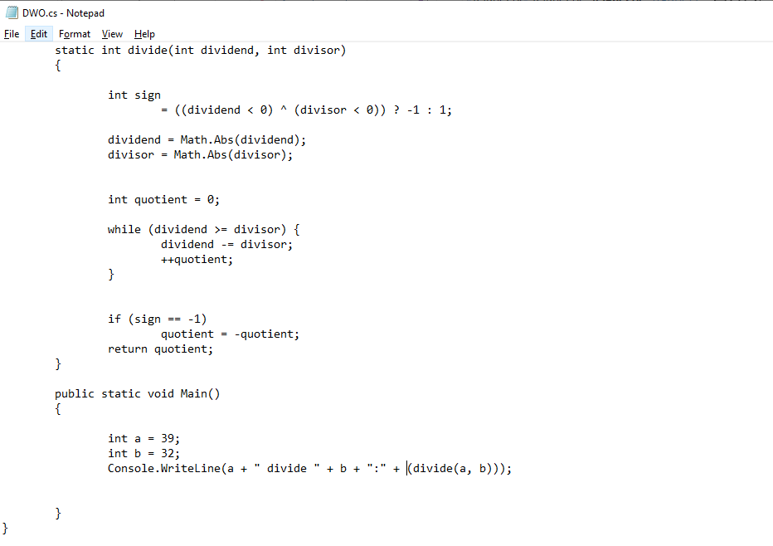

# ACTIVITY 9: Setting Book Marks in the code.

Create console application using visual studio.

Write few lines of code in Program.cs file.

Press CTRL + K + K by standing at line of code, this will add book mark. Press CTRL + K + K by standing at the same line to disable the book mark.

You can jump from one book mark to other by using book mark window. Press CTRL + K + W to display book mark window.

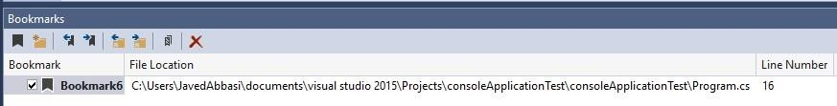

**Working:**

