DEVSPHERE
INTERNSHIP PROGRAM
WEEK 4 TASK REPORT
Artificial Intelligence (AI) & Machine Learning (ML)
Neural Networks Basics & Classification Models

Intern | Saud Masood
Domain | Artificial Intelligence & Machine Learning
Internship | AI/ML Internship
Week | 04
AI Task | Neural Networks Basics
ML Task | Classification Models
Report Date | 23 September 2026

1. Week 4 Overview
Week 4 contains two practical tasks: an Artificial Intelligence task on Neural Networks Basics and a Machine Learning task on Classification Models. The report presents the task requirements, implementation, code, screenshot spaces, output areas, workflow explanations, and conclusions for both tasks.
2. Artificial Intelligence (AI) — Week 4 Task
Topic: Neural Networks Basics
The AI Week 4 task focuses on implementing a simple neural network. The objective is to create a basic neural network model, train it on a dataset, make predictions, show the results, and briefly explain the workflow.
AI Task Requirements
• Create a basic neural network model.
• Train the model on a dataset.
• Show predictions/results.
• Explain the workflow briefly.
• Output: Basic neural network implementation.
AI Dataset
The student_scores_week4.csv dataset contains StudyHours and ExamScore. StudyHours is used as the input feature, while ExamScore is the value the neural network learns to predict.
StudyHours,ExamScore
1,50
2,55
3,60
4,65
5,70
6,75
7,80
8,85
9,90
10,95
AI Task Implementation
For this task, I used Pandas to load the dataset and scikit-learn's MLPRegressor to create a simple neural network. The input data is scaled before training. The network contains one hidden layer with 10 neurons and uses the ReLU activation function. After training, the model predicts exam scores for new study-hour values.
AI Python Code
import pandas as pd
from sklearn.neural_network import MLPRegressor
from sklearn.preprocessing import StandardScaler
print("======================================")
print(" AI WEEK 4 - NEURAL NETWORK")
print("======================================")
# Load dataset
df = pd.read_csv("student_scores_week4.csv")
print("\n========== DATASET ==========")
print(df)
# Input feature and target
X = df[["StudyHours"]]
y = df["ExamScore"]
# Scale input data
scaler = StandardScaler()
X_scaled = scaler.fit_transform(X)
# Create Neural Network model
model = MLPRegressor(
hidden_layer_sizes=(10,),
activation="relu",
solver="lbfgs",
max_iter=5000,
random_state=42
)
# Train model
model.fit(X_scaled, y)
print("\n========== MODEL TRAINING ==========")
print("Neural Network trained successfully!")
# New data for prediction
test_data = pd.DataFrame({
"StudyHours": [4, 6, 8]
})
# Scale test data
test_scaled = scaler.transform(test_data)
# Make predictions
predictions = model.predict(test_scaled)
print("\n========== PREDICTIONS ==========")
for hours, score in zip(test_data["StudyHours"], predictions):
print(
f"Study Hours: {hours} -> "
f"Predicted Exam Score: {score:.2f}"
)
print("\n========== NETWORK INFORMATION ==========")
print("Input Layer: 1 feature")
print("Hidden Layer: 10 neurons")
print("Activation Function: ReLU")
print("Output: Predicted Exam Score")
print("\n======================================")
print(" BASIC NEURAL NETWORK COMPLETED")
print("======================================")
AI Code Screenshot
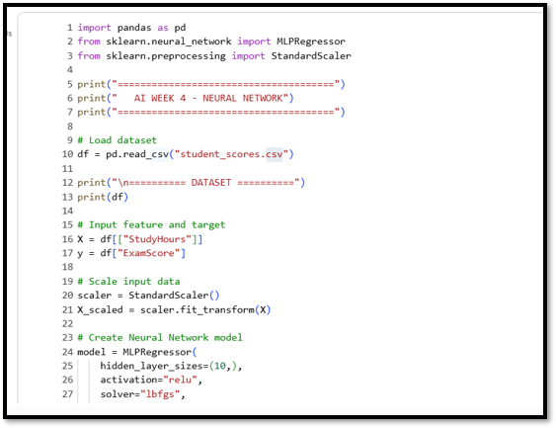
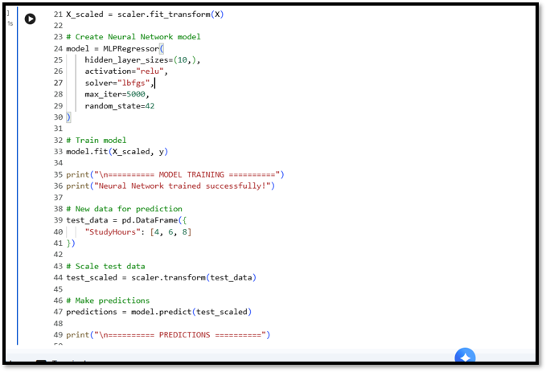
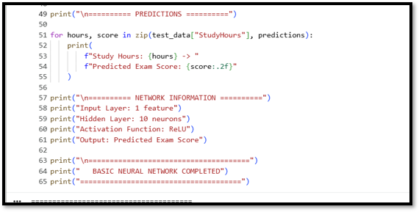
AI Week 4 — Neural Network Code Screenshot
AI Output Screenshot
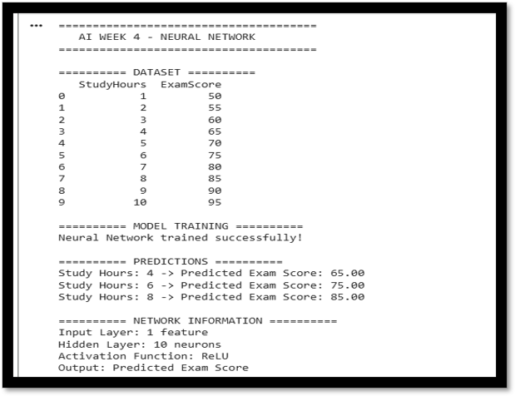
AI Week 4 — Neural Network Output Screenshot
AI Workflow Explanation
• Load the student score dataset using Pandas.
• Select StudyHours as the input and ExamScore as the target.
• Scale the input values before training.
• Create a neural network with one hidden layer containing 10 neurons.
• Train the neural network on the dataset.
• Provide new study-hour values to the trained model.
• Generate and display the predicted exam scores.
AI Result
The expected result is a successfully trained basic neural network that accepts study hours as input and produces predicted exam scores. The Google Colab output screenshot should be inserted above to document the actual execution.

3. Machine Learning (ML) — Week 4 Task
Topic: Classification Models
The ML Week 4 task focuses on implementing a classification model. The objective is to use a classification dataset, train a classification model, predict outputs, and show the model's accuracy score.
ML Task Requirements
• Use a classification dataset.
• Train a classification model.
• Predict outputs.
• Show accuracy score.
• Output: Working classification model.
ML Dataset
The student_classification.csv dataset contains StudyHours, Attendance, and Passed. StudyHours and Attendance are input features. Passed is the target classification label, where 0 represents Fail and 1 represents Pass.
StudyHours,Attendance,Passed
1,50,0
2,55,0
2,60,0
3,65,0
4,70,1
5,72,1
5,75,1
6,78,1
7,80,1
8,85,1
9,90,1
10,95,1
ML Task Implementation
For this task, I used Pandas to load the classification dataset and selected StudyHours and Attendance as input features. The data was divided into training and testing sets. A Logistic Regression model was trained on the training data, then used to predict the test labels. Finally, the accuracy score was calculated to evaluate the classification results.
ML Python Code
import pandas as pd
from sklearn.model_selection import train_test_split
from sklearn.linear_model import LogisticRegression
from sklearn.metrics import accuracy_score
print("======================================")
print(" ML WEEK 4 - CLASSIFICATION")
print("======================================")
# Load classification dataset
df = pd.read_csv("student_classification.csv")
print("\n========== DATASET ==========")
print(df)
# Features and target
X = df[["StudyHours", "Attendance"]]
y = df["Passed"]
# Split dataset into training and testing data
X_train, X_test, y_train, y_test = train_test_split(
X,
y,
test_size=0.25,
random_state=42,
stratify=y
)
# Create classification model
model = LogisticRegression()
# Train model
model.fit(X_train, y_train)
print("\n========== MODEL TRAINING ==========")
print("Logistic Regression model trained successfully!")
# Predict test data
y_pred = model.predict(X_test)
print("\n========== PREDICTIONS ==========")
print("Actual values: ", list(y_test))
print("Predicted values:", list(y_pred))
# Calculate accuracy
accuracy = accuracy_score(y_test, y_pred)
print("\n========== ACCURACY ==========")
print(f"Accuracy Score: {accuracy * 100:.2f}%")
# Predict new students
new_students = pd.DataFrame({
"StudyHours": [3, 6, 9],
"Attendance": [60, 80, 90]
})
new_predictions = model.predict(new_students)
print("\n========== NEW PREDICTIONS ==========")
for i, prediction in enumerate(new_predictions):
result = "Pass" if prediction == 1 else "Fail"
print(
f"Student {i + 1}: "
f"Study Hours = {new_students.iloc[i]['StudyHours']}, "
f"Attendance = {new_students.iloc[i]['Attendance']}% "
f"-> Prediction: {result}"
)
print("\n======================================")
print(" WORKING CLASSIFICATION MODEL")
print("======================================")
ML Code Screenshot
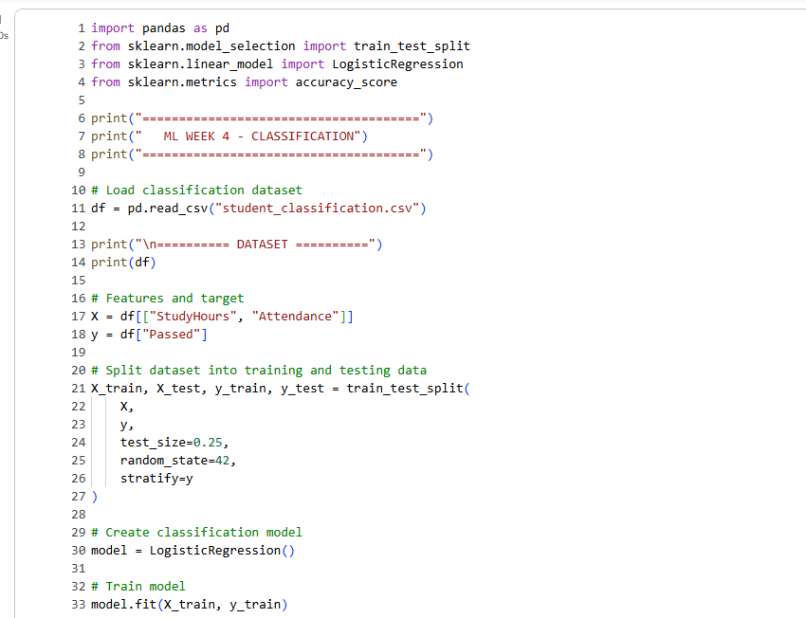
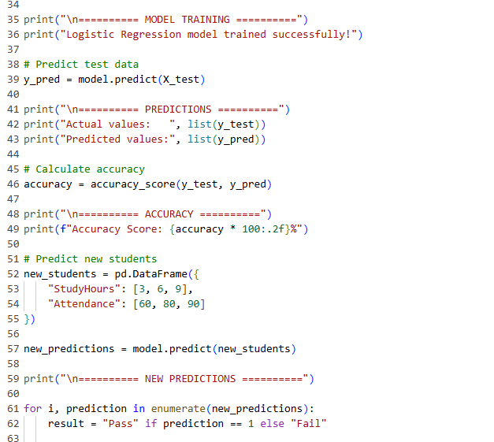
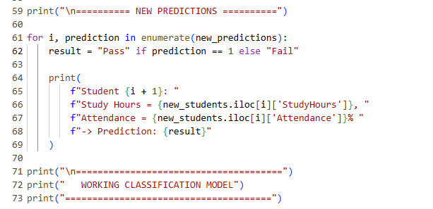
ML Week 4 — Classification Model Code Screenshot
ML Output Screenshot
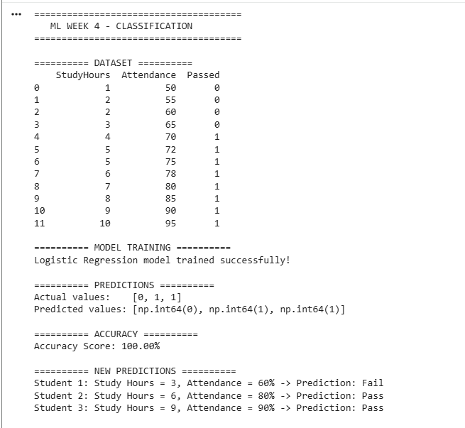
ML Week 4 — Classification Model Output Screenshot
ML Workflow Explanation
• Load the classification dataset using Pandas.
• Select StudyHours and Attendance as input features.
• Use Passed as the target classification label.
• Split the dataset into training and testing data.
• Create and train the Logistic Regression model.
• Predict the labels of the test data.
• Calculate the accuracy score.
• Use the trained model to classify new student examples.
ML Result
The final output should demonstrate that the Logistic Regression model was trained successfully, generated predictions, and produced an accuracy score. The actual Google Colab output should be captured and inserted into the screenshot area above.
4. Overall Conclusion
Week 4 provided practical experience with two important Machine Learning concepts. In the AI task, I implemented a basic neural network for prediction. In the ML task, I implemented a Logistic Regression classification model and evaluated its predictions using an accuracy score. Together, these tasks demonstrate the basic workflow of creating, training, and evaluating Machine Learning models.
5. Submission Information
Program | DevSphere Internship Program
Intern | Saud Masood
Domain | Artificial Intelligence & Machine Learning
Week | 04
Report Date | 23 September 2026

