DEVSPHERE
INTERNSHIP PROGRAM

WEEK 5 TASK REPORT
Artificial Intelligence (AI) & Machine Learning (ML)

Intern | Saud Masood
Program | DevSphere Internship Program
Domain | Artificial Intelligence & Machine Learning
Week | 05
Task Areas | AI Model Implementation + Model Evaluation & Tuning
Deadline | 8 October 2026

Internship Submission Report

1. Executive Summary
This report presents the completed Week 5 Artificial Intelligence and Machine Learning internship work assigned by DevSphere. The AI task develops an AI-based intelligent student performance prediction system. The ML task focuses on model evaluation and tuning by training multiple classification models, comparing evaluation metrics, and optimizing a Random Forest model through hyperparameter search.

2. Official Week 5 Requirements
Area | Requirements | Output
AI | Train AI/ML model  Data preprocessing  Prediction system  Accuracy evaluation  User input handling  Result visualization | Working AI-based intelligent system
ML | Train multiple models  Compare performance  Apply model tuning  Use evaluation metrics  Show graphs/charts for results | Optimized ML model with evaluation report

3. AI Task — AI Model Implementation
Topic: AI Model Implementation
Project: Student Performance Prediction System

3.1 Objective
The system performs an end-to-end prediction workflow: loading the dataset, preprocessing numerical data, training a Logistic Regression model, evaluating test accuracy, accepting new student information, predicting Pass/Fail, and visualizing prediction probabilities.

3.2 AI Workflow
Dataset → Data Preprocessing → Train/Test Split → Feature Scaling → Model Training → Accuracy Evaluation → User Input → Prediction → Result Visualization

3.3 AI Dataset
The AI dataset contains StudyHours, Attendance, PreviousScore, and Passed. The Passed column is the target variable, where 0 represents Fail and 1 represents Pass.

3.4 AI Implementation Code
import pandas as pd
import matplotlib.pyplot as plt
from sklearn.model_selection import train_test_split
from sklearn.preprocessing import StandardScaler
from sklearn.linear_model import LogisticRegression
from sklearn.metrics import accuracy_score
df = pd.read_csv("student_performance.csv")
numeric_columns = df.select_dtypes(include="number").columns
for column in numeric_columns:
df[column] = df[column].fillna(df[column].mean())
X = df[["StudyHours", "Attendance", "PreviousScore"]]
y = df["Passed"]
X_train, X_test, y_train, y_test = train_test_split(
X, y, test_size=0.25, random_state=42, stratify=y
)
scaler = StandardScaler()
X_train_scaled = scaler.fit_transform(X_train)
X_test_scaled = scaler.transform(X_test)
model = LogisticRegression()
model.fit(X_train_scaled, y_train)
y_pred = model.predict(X_test_scaled)
accuracy = accuracy_score(y_test, y_pred)
print(f"Model Accuracy: {accuracy * 100:.2f}%")
study_hours = float(input("Study Hours: "))
attendance = float(input("Attendance Percentage: "))
previous_score = float(input("Previous Exam Score: "))
user_data = pd.DataFrame({
"StudyHours": [study_hours],
"Attendance": [attendance],
"PreviousScore": [previous_score]
})
user_data_scaled = scaler.transform(user_data)
prediction = model.predict(user_data_scaled)
probability = model.predict_proba(user_data_scaled)
result = "PASS" if prediction[0] == 1 else "FAIL"
print("Prediction:", result)
print(f"Pass Probability: {probability[0][1] * 100:.2f}%")
print(f"Fail Probability: {probability[0][0] * 100:.2f}%")
labels = ["Pass Probability", "Fail Probability"]
values = [probability[0][1] * 100, probability[0][0] * 100]
plt.figure(figsize=(8, 5))
plt.bar(labels, values)
plt.title("AI Student Prediction Result")
plt.ylabel("Probability (%)")
plt.ylim(0, 100)
plt.tight_layout()
plt.show()
AI CODE EXECUTION SCREENSHOT
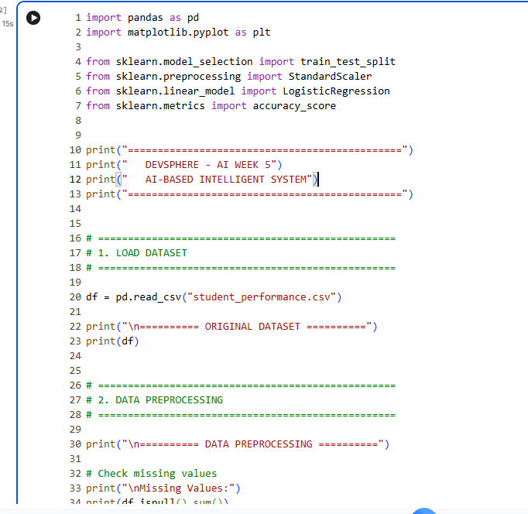
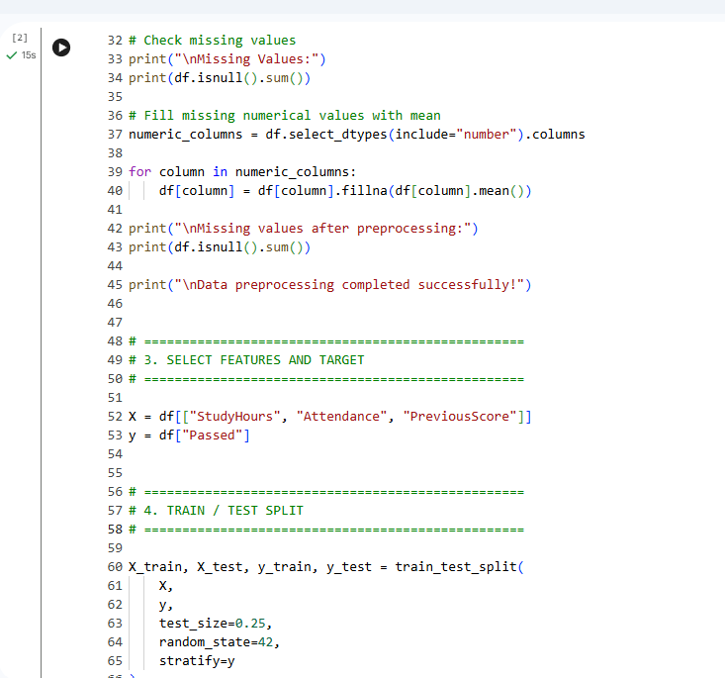
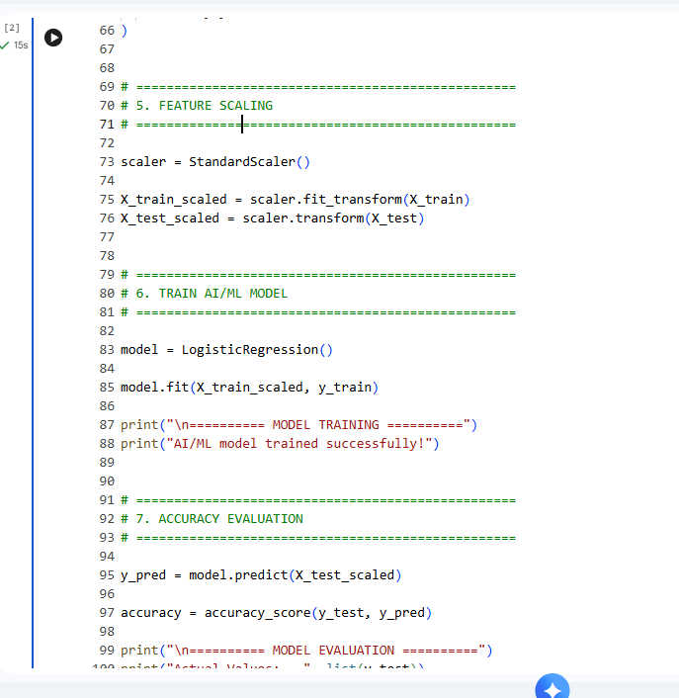
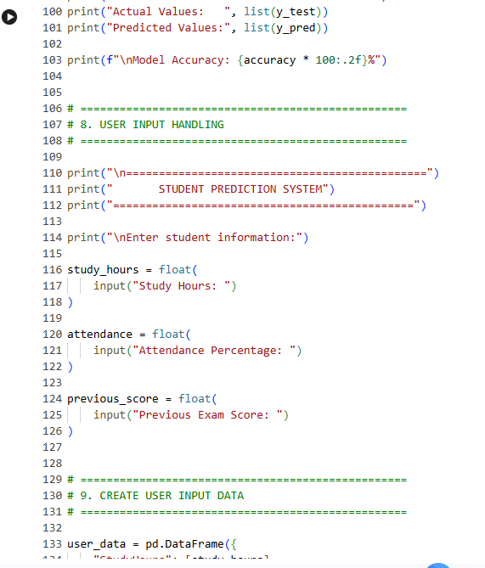
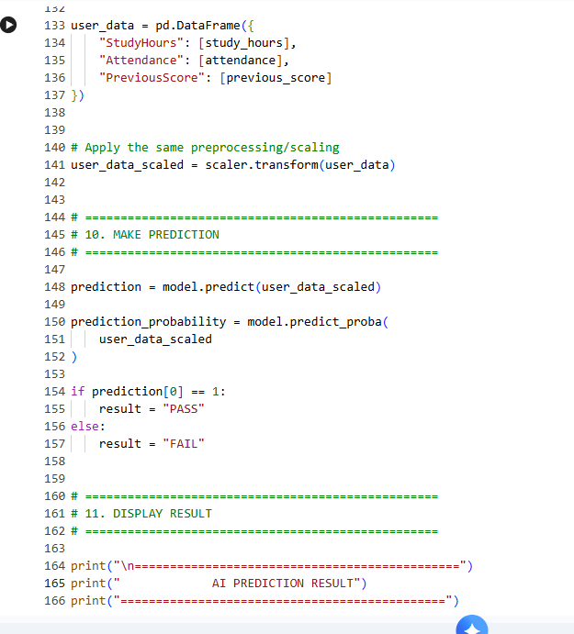
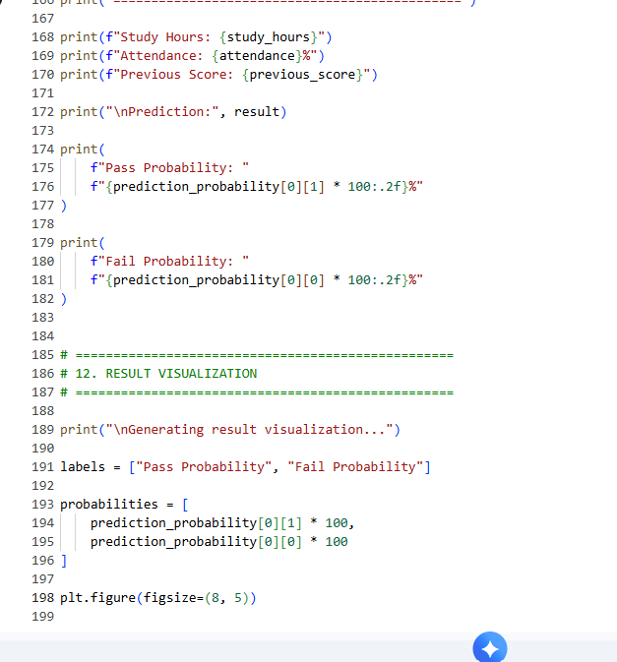
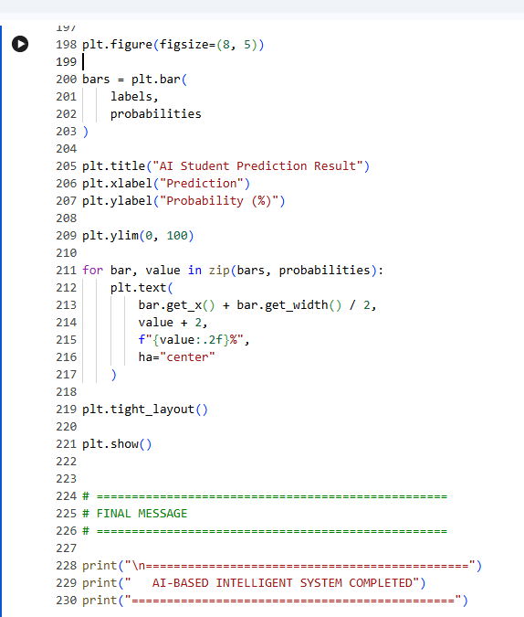

AI OUTPUT + VISUALIZATION SCREENSHOT
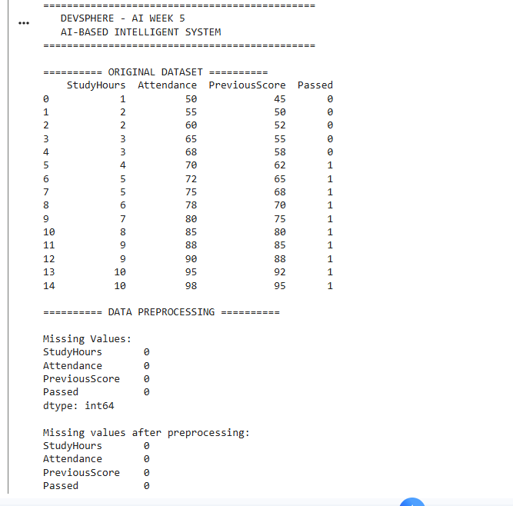
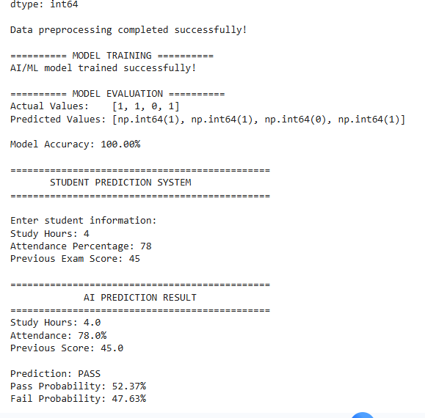
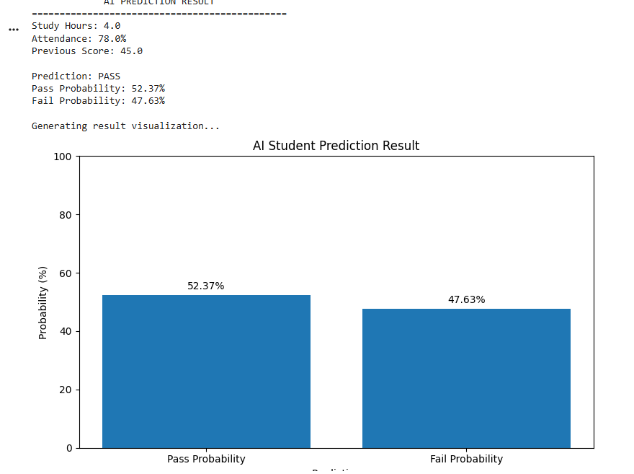

3.5 AI Implementation Explanation
- Data preprocessing: numerical columns are checked and missing numerical values are replaced with the corresponding column mean.
- Model preparation: StudyHours, Attendance, and PreviousScore are used as input features, while Passed is the target.
- Training: the data is split into training and testing subsets, standardized using StandardScaler, and used to train Logistic Regression.
- Evaluation: predictions on the test set are compared with the actual values using accuracy_score.
- User interaction: the system accepts Study Hours, Attendance, and Previous Exam Score from the user.
- Prediction and visualization: the trained model predicts Pass/Fail and displays pass/fail probabilities in a Matplotlib bar chart.

4. ML Task — Model Evaluation + Tuning
Topic: Model Evaluation + Tuning
Task: Optimize Machine Learning Model

4.1 Objective
The ML implementation trains multiple classification models, compares their performance using Accuracy, Precision, Recall, and F1 Score, applies GridSearchCV to tune a Random Forest classifier, and presents the evaluation through charts and a confusion matrix.

4.2 Models
- Logistic Regression
- Decision Tree
- Random Forest

4.3 Evaluation Metrics
- Accuracy
- Precision
- Recall
- F1 Score

4.4 Hyperparameter Tuning
GridSearchCV searches combinations of Random Forest hyperparameters including n_estimators, max_depth, and min_samples_split. Three-fold cross-validation is used with accuracy as the scoring metric.

4.5 ML Dataset
ML DATASET / CSV use Attached in Email submission

4.6 ML Implementation Code
import pandas as pd
import matplotlib.pyplot as plt
from sklearn.model_selection import train_test_split, GridSearchCV
from sklearn.preprocessing import StandardScaler
from sklearn.pipeline import Pipeline
from sklearn.linear_model import LogisticRegression
from sklearn.tree import DecisionTreeClassifier
from sklearn.ensemble import RandomForestClassifier
from sklearn.metrics import (
accuracy_score,
precision_score,
recall_score,
f1_score,
classification_report,
confusion_matrix
)
df = pd.read_csv("student_classification_week5.csv")
numeric_columns = df.select_dtypes(include="number").columns
for column in numeric_columns:
df[column] = df[column].fillna(df[column].mean())
X = df[["StudyHours", "Attendance"]]
y = df["Passed"]
X_train, X_test, y_train, y_test = train_test_split(
X, y, test_size=0.25, random_state=42, stratify=y
)
models = {
"Logistic Regression": Pipeline([
("scaler", StandardScaler()),
("model", LogisticRegression())
]),
"Decision Tree": DecisionTreeClassifier(random_state=42),
"Random Forest": RandomForestClassifier(
n_estimators=100, random_state=42
)
}
results = []
for name, model in models.items():
model.fit(X_train, y_train)
predictions = model.predict(X_test)
results.append({
"Model": name,
"Accuracy": accuracy_score(y_test, predictions),
"Precision": precision_score(
y_test, predictions, zero_division=0
),
"Recall": recall_score(
y_test, predictions, zero_division=0
),
"F1 Score": f1_score(
y_test, predictions, zero_division=0
)
})
results_df = pd.DataFrame(results)
print(results_df.to_string(index=False))
param_grid = {
"n_estimators": [50, 100, 150],
"max_depth": [None, 2, 3, 5],
"min_samples_split": [2, 3, 4]
}
grid_search = GridSearchCV(
RandomForestClassifier(random_state=42),
param_grid=param_grid,
cv=3,
scoring="accuracy",
n_jobs=-1
)
grid_search.fit(X_train, y_train)
optimized_model = grid_search.best_estimator_
optimized_predictions = optimized_model.predict(X_test)
accuracy = accuracy_score(y_test, optimized_predictions)
precision = precision_score(
y_test, optimized_predictions, zero_division=0
)
recall = recall_score(
y_test, optimized_predictions, zero_division=0
)
f1 = f1_score(
y_test, optimized_predictions, zero_division=0
)
print("Best Parameters:", grid_search.best_params_)
print(f"Accuracy: {accuracy * 100:.2f}%")
print(f"Precision: {precision * 100:.2f}%")
print(f"Recall: {recall * 100:.2f}%")
print(f"F1 Score: {f1 * 100:.2f}%")
print(classification_report(
y_test,
optimized_predictions,
target_names=["Fail", "Pass"],
zero_division=0
))
cm = confusion_matrix(y_test, optimized_predictions)
plt.figure(figsize=(10, 6))
x = range(len(results_df))
plt.bar(
[i - 0.3 for i in x],
results_df["Accuracy"],
width=0.2,
label="Accuracy"
)
plt.bar(
[i - 0.1 for i in x],
results_df["Precision"],
width=0.2,
label="Precision"
)
plt.bar(
[i + 0.1 for i in x],
results_df["Recall"],
width=0.2,
label="Recall"
)
plt.bar(
[i + 0.3 for i in x],
results_df["F1 Score"],
width=0.2,
label="F1 Score"
)
plt.xticks(x, results_df["Model"])
plt.ylabel("Score")
plt.xlabel("Machine Learning Model")
plt.title("Machine Learning Model Performance Comparison")
plt.ylim(0, 1.1)
plt.legend()
plt.tight_layout()
plt.show()
plt.figure(figsize=(6, 5))
plt.imshow(cm)
plt.title("Optimized Model Confusion Matrix")
plt.xlabel("Predicted Label")
plt.ylabel("Actual Label")
plt.xticks([0, 1], ["Fail", "Pass"])
plt.yticks([0, 1], ["Fail", "Pass"])
for i in range(len(cm)):
for j in range(len(cm[i])):
plt.text(
j, i, cm[i][j],
ha="center",
va="center"
)
plt.colorbar()
plt.tight_layout()
plt.show()
metrics = ["Accuracy", "Precision", "Recall", "F1 Score"]
values = [accuracy, precision, recall, f1]
plt.figure(figsize=(8, 5))
bars = plt.bar(metrics, values)
plt.title("Optimized Random Forest Model Metrics")
plt.ylabel("Score")
plt.ylim(0, 1.1)
for bar, value in zip(bars, values):
plt.text(
bar.get_x() + bar.get_width() / 2,
value + 0.02,
f"{value * 100:.2f}%",
ha="center"
)
plt.tight_layout()
plt.show()

ML CODE EXECUTION SCREENSHOT
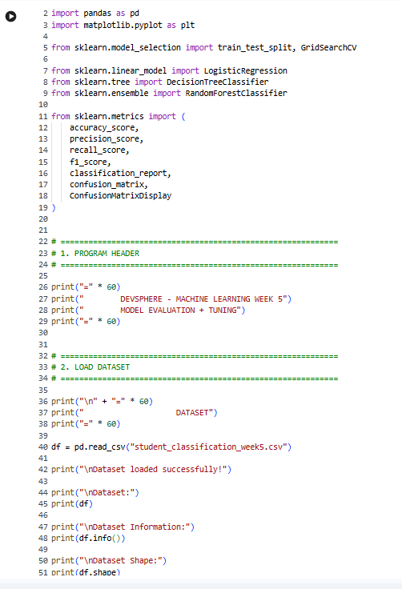
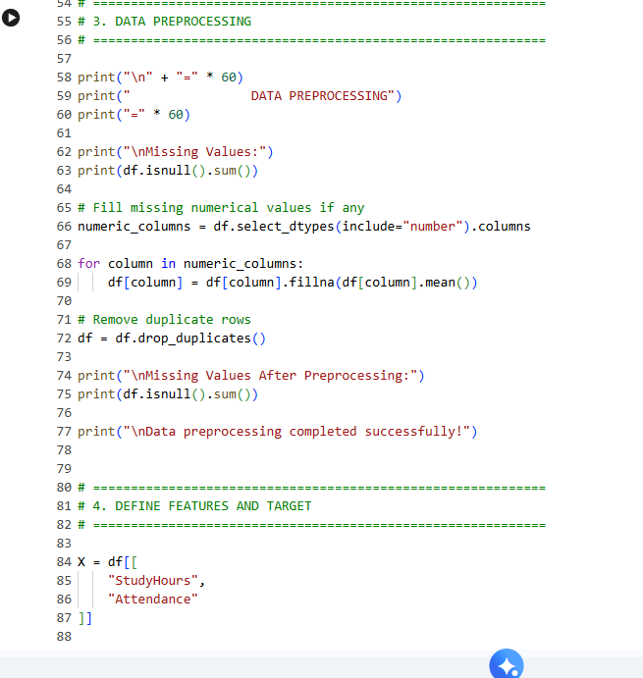
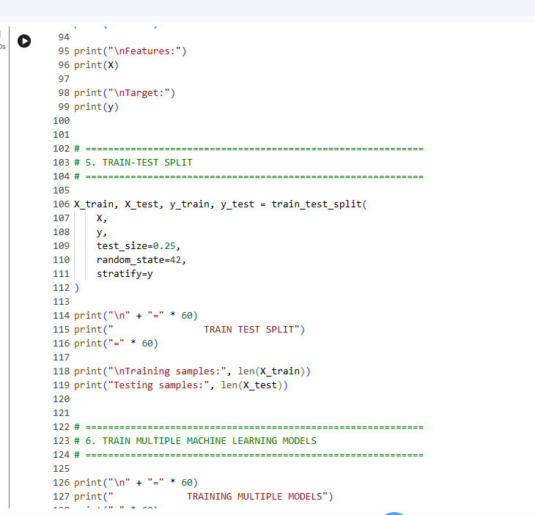
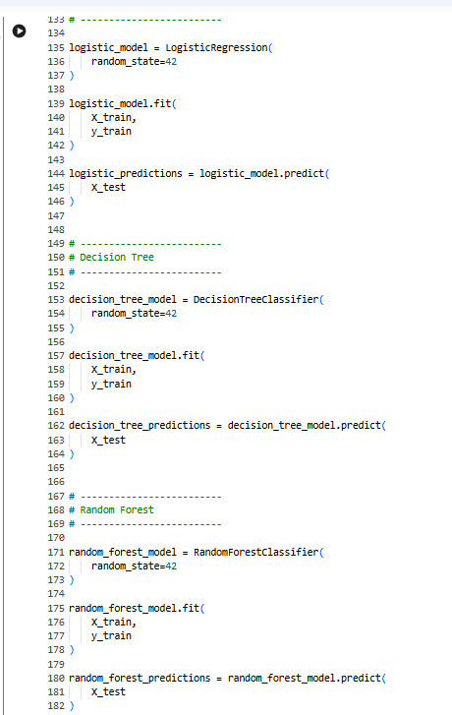
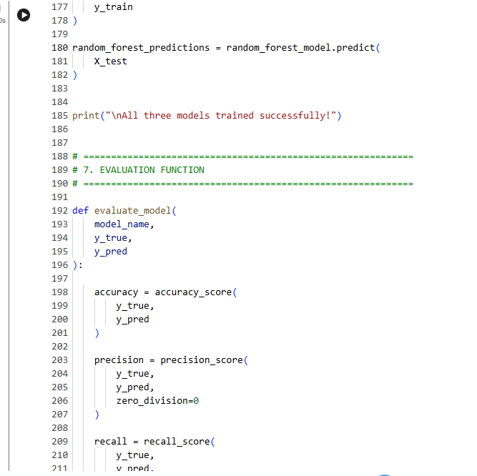
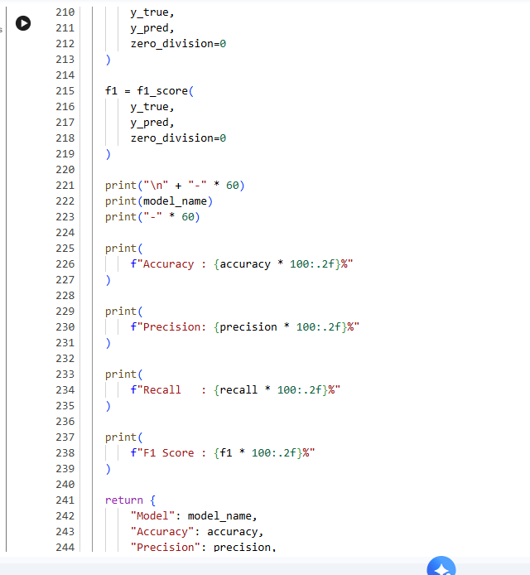
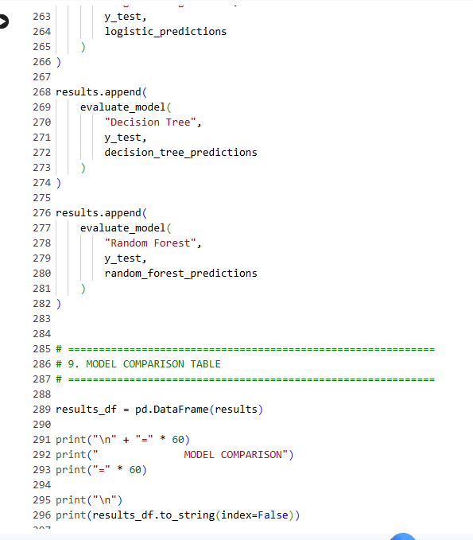
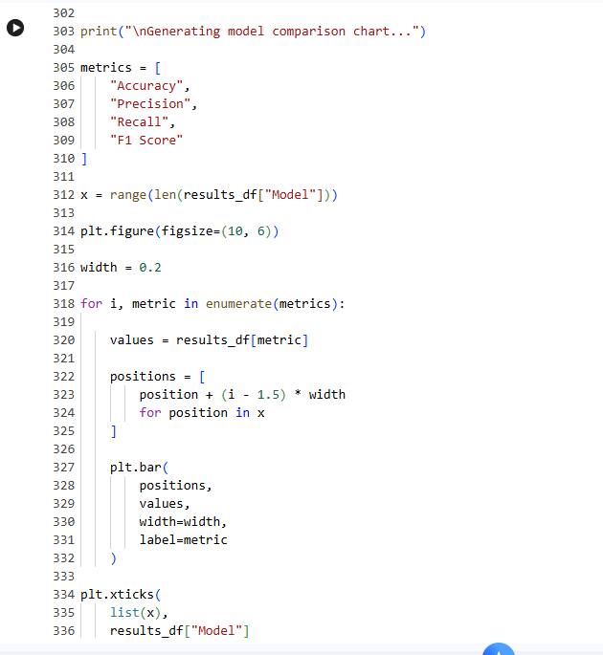
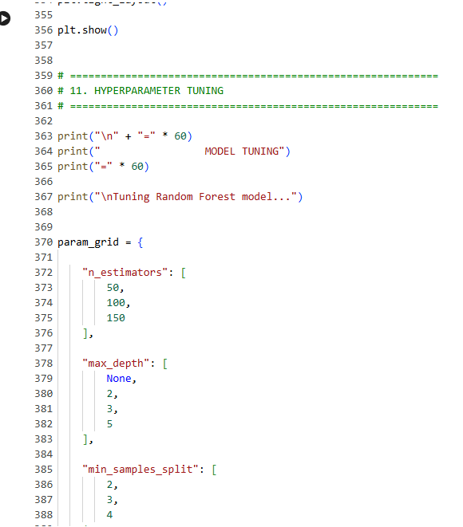
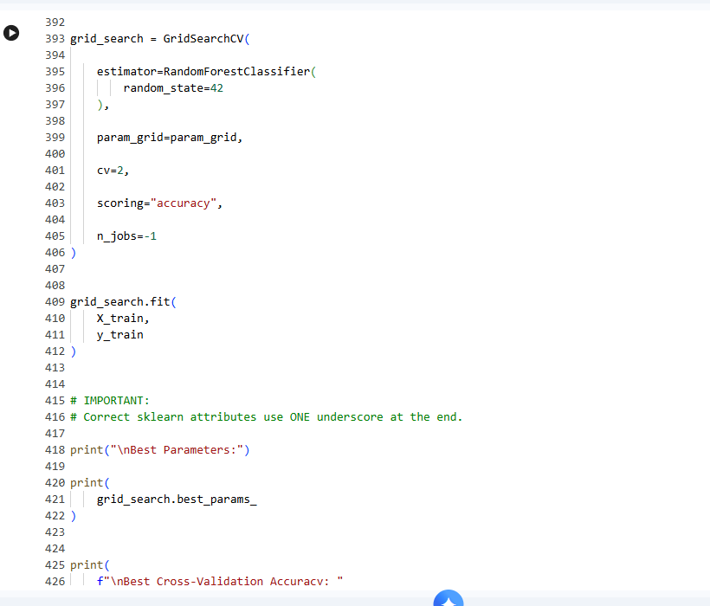
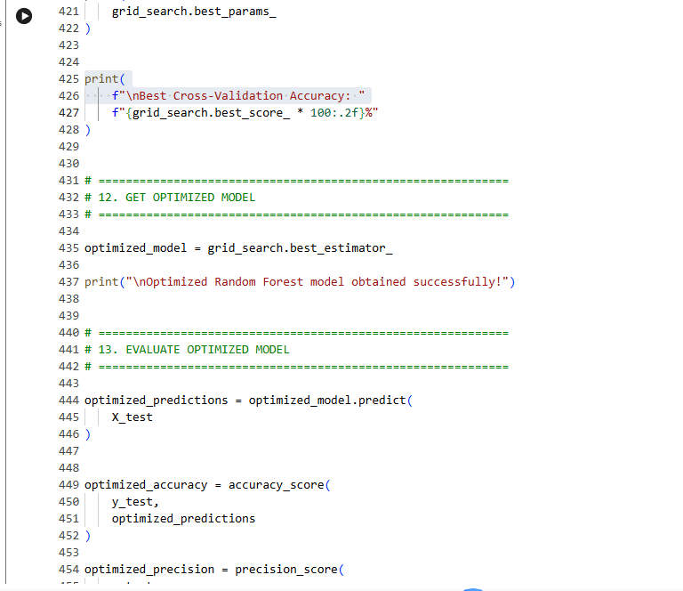
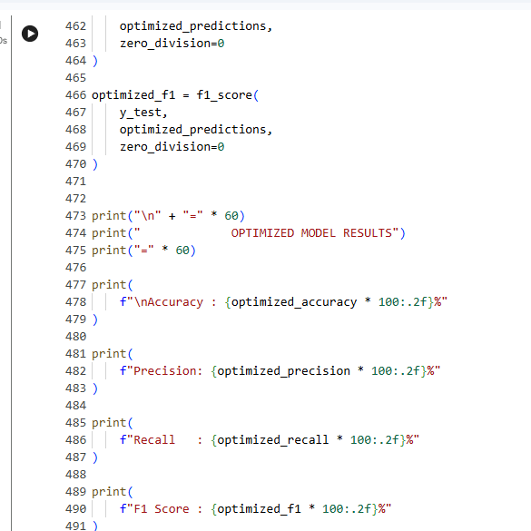
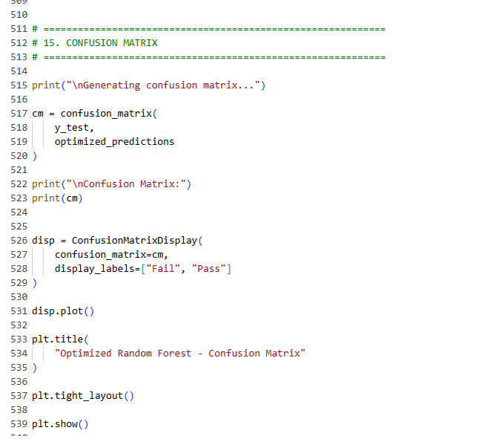
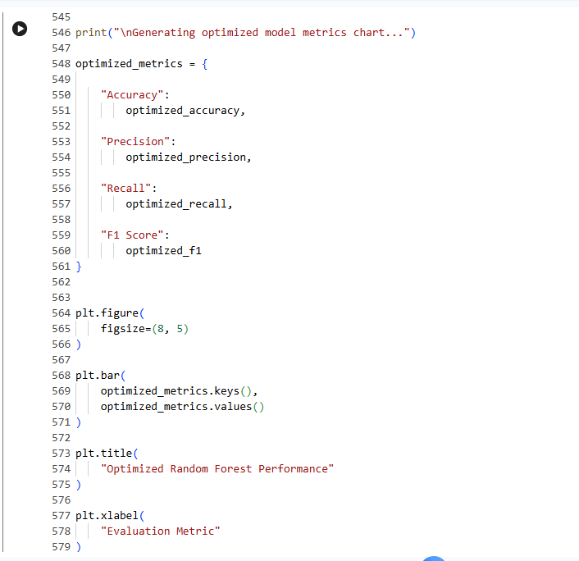
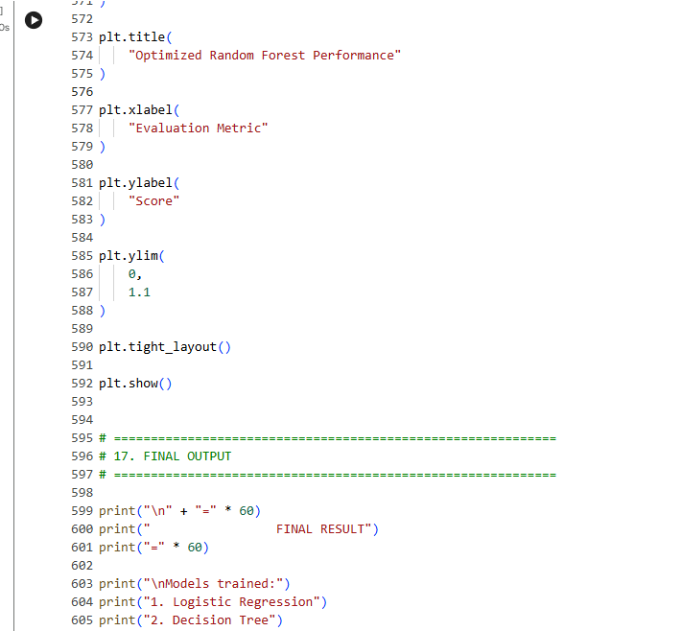
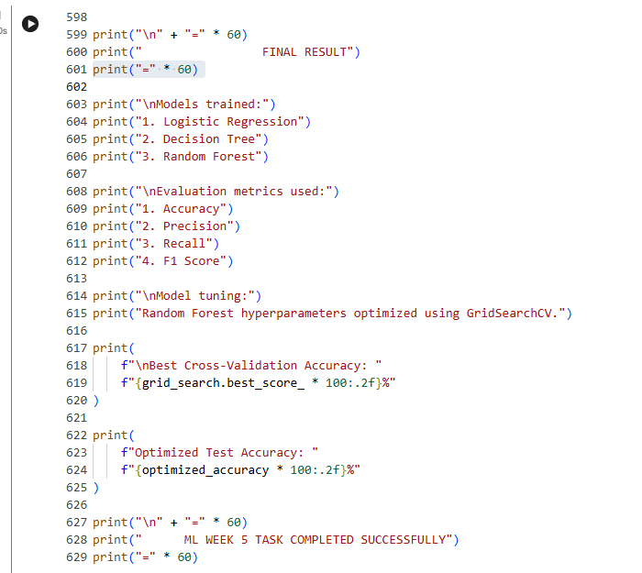

ML MODEL COMPARISON / OUTPUT SCREENSHOT
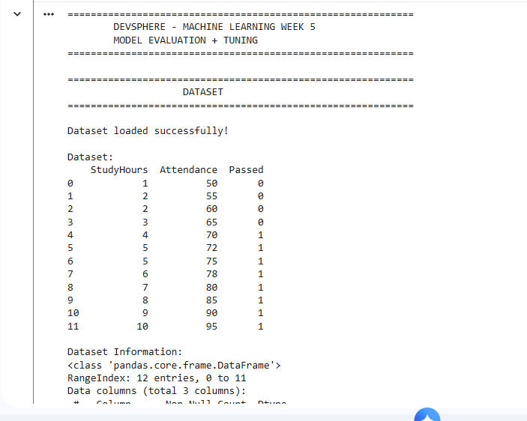
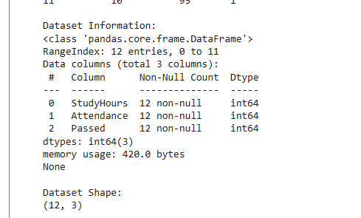
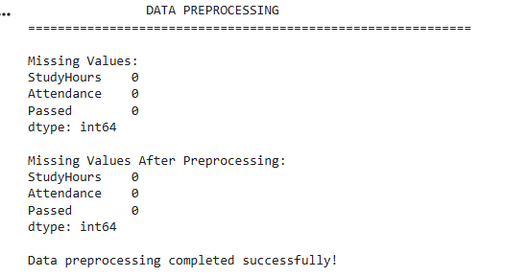
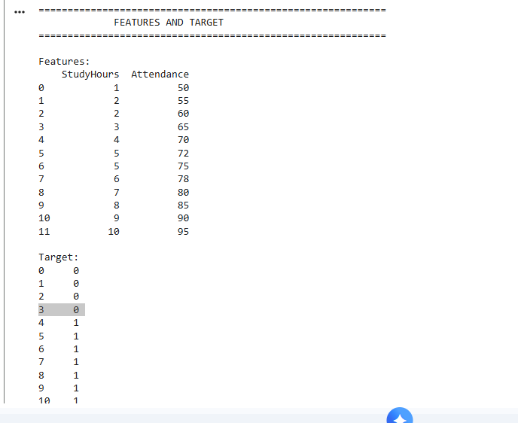
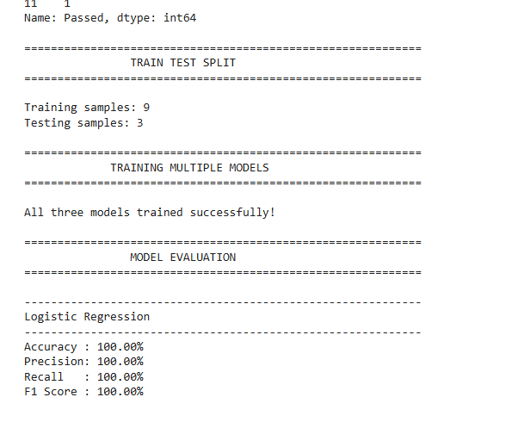
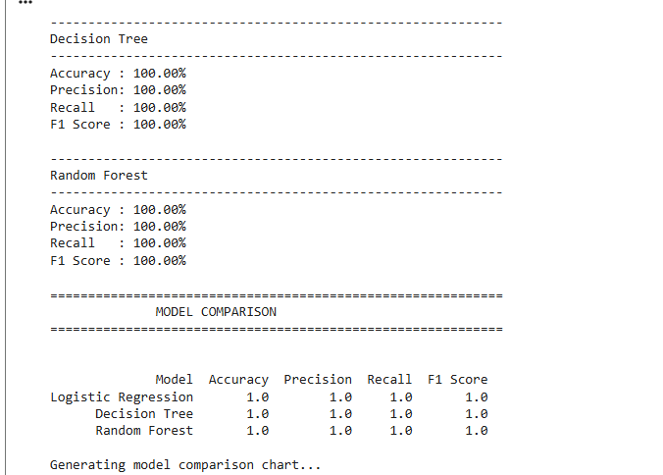
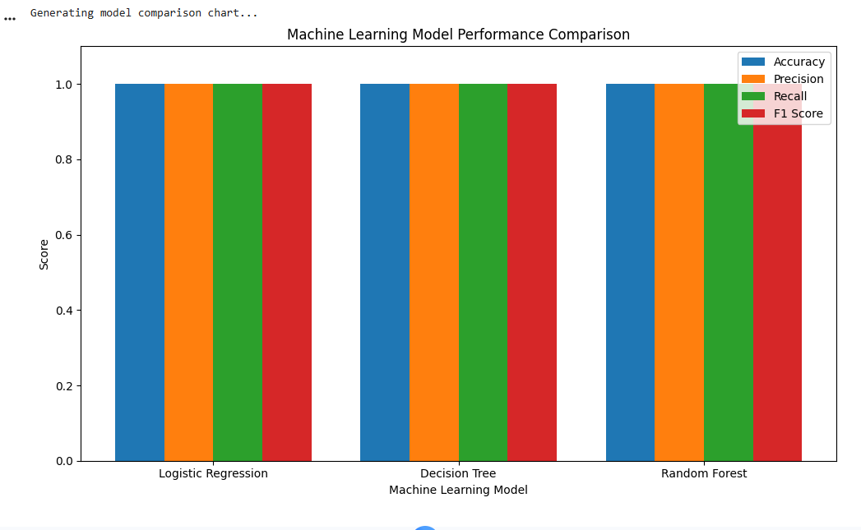
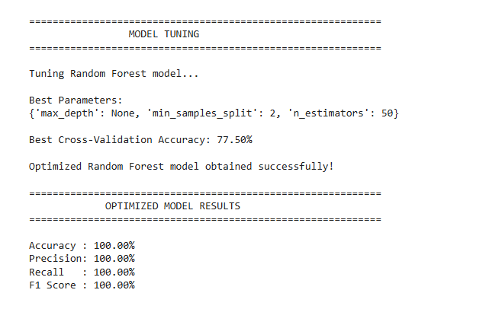
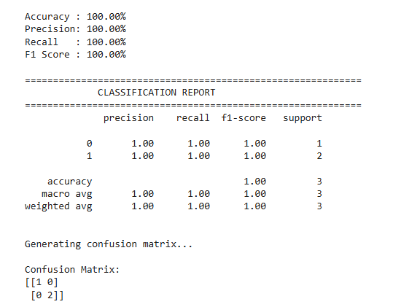
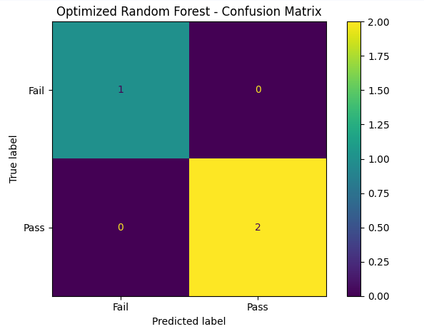
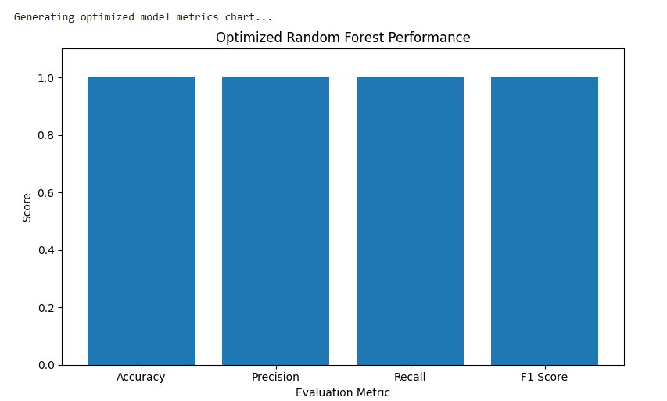

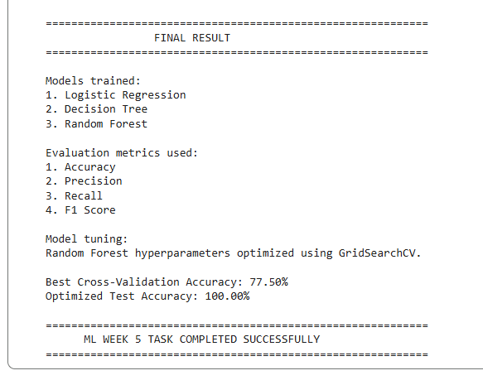

4.7 ML Implementation Explanation
- Data preprocessing: the classification dataset is loaded and numerical missing values are handled using column means.
- Multiple models: Logistic Regression, Decision Tree, and Random Forest are trained using the same train/test split.
- Performance comparison: Accuracy, Precision, Recall, and F1 Score are calculated for every model and displayed in a comparison chart.
- Model tuning: GridSearchCV evaluates Random Forest hyperparameter combinations using three-fold cross-validation.
- Optimized evaluation: the best Random Forest configuration is evaluated on the held-out test data.
- Visualization: the implementation displays a model comparison chart, confusion matrix, and optimized-model metric chart.

5. Results & Discussion
The AI implementation produces a working student performance prediction workflow, while the ML implementation provides a structured model evaluation and tuning workflow. The actual metric values, best hyperparameters, predictions, and charts should be taken from the execution screenshots included in this report.

5.1 AI Result
The AI system trains a Logistic Regression model, reports test accuracy, accepts user input, produces a Pass/Fail prediction, and visualizes the prediction probabilities.

5.2 ML Result
The ML system compares three classification models and applies GridSearchCV tuning to Random Forest. The final evaluation includes Accuracy, Precision, Recall, F1 Score, classification report, confusion matrix, and visual comparisons.

FINAL AI + ML RESULTS SCREENSHOT
PASTE SCREENSHOT HERE

6. Conclusion
Week 5 strengthened practical understanding of end-to-end AI/ML workflows. The AI task covered preprocessing, training, prediction, evaluation, user interaction, and visualization. The ML task extended this work by comparing multiple models, tuning model hyperparameters, evaluating several metrics, and visualizing performance.

7. Submission Information
Intern | Saud Masood
Program | DevSphere Internship Program
Domain | Artificial Intelligence & Machine Learning
Week | 05
Deadline | 8 October 2026
Submission Email | devsphere1.info@gmail.com

Prepared for DevSphere Internship Program

