NABARD Hackathon @ Global FinTech Fest 2026 — Round 1 Idea Submission
DhanDrishti धन-दृष्टि
Cash-flow foresight and early-warning intelligence for rural micro enterprises
Theme: AI-Driven Cash Flow Prediction & Risk Flagging System for Rural Micro Enterprises

1. Executive summary
DhanDrishti is an AI platform that gives lenders, NABARD field teams and rural entrepreneurs the same thing city CFOs take for granted: knowing what their cash position will look like three months from now. For every enrolled micro enterprise, it produces a probabilistic 12-week cash-flow forecast, a calibrated 0–100 risk score with discrete early-warning flags, plain-language bilingual (English/Hindi) reason codes explaining every alert, and a concrete recommended intervention for the field officer — weeks before a missed EMI would reveal the problem.
We are not submitting only an idea: a working prototype already exists. On a realistic 200-enterprise simulated panel it forecasts weekly net cash flow 25% more accurately than a seasonal-naive baseline, detects engineered distress episodes with AUC 0.83, and raises its first alert a median of 3 weeks before the distress event — with every alert carrying human-readable reasons and a suggested action.

2. The problem
- Only ~14% of India's 6.3 crore MSMEs have access to formal credit (Deloitte, 2025); the financing gap is ≥ ₹25 lakh crore and worst in rural districts (~32% vs ~20% urban).
- Rural micro enterprises — kirana stores, dairy units, tailoring shops, agri-input dealers, food processors, handloom weavers — are credit-invisible: cash-heavy, seasonal, with no audited books and thin bureau files.
- Lenders (RRBs, DCCBs, MFIs, SFBs) discover stress only after a missed instalment; field officers have no forward-looking tooling, so interventions come too late and NPAs crystallise.
- Meanwhile the raw signal now exists at national scale — UPI (~21.7 billion transactions/month), the Account Aggregator framework (₹1.67 lakh crore disbursed on AA rails in FY25), open mandi price and weather feeds — but nobody has stitched it into enterprise-level cash-flow foresight for Bharat.

3. What DhanDrishti delivers
Output | What it answers | For whom
12-week probabilistic cash-flow forecast (P10/P50/P90, conformally calibrated) | “Will this enterprise face a liquidity crunch before Diwali?” | Lenders, field officers
Risk score (0–100) + early-warning flags (liquidity crunch ahead, EMI stress, buyer concentration, payment irregularity, seasonal dip, negative trend) | “Who in my portfolio needs attention this week — and why?” | Portfolio & branch managers
Bilingual reason codes (TreeSHAP → curated English + Hindi templates) | “Explain this alert so I can act on it” | Field officers, BC sakhis
Recommended interventions | “What should I do — restructure the EMI, advance working capital, diversify buyers?” | Field officers, entrepreneurs

Surfaces: a lender/field dashboard (offline-capable PWA, English/Hindi toggle), a scoring API for bank LOS/LMS integration via OCEN-style rails, and (roadmap) SMS/WhatsApp/IVR vernacular nudges directly to the entrepreneur.

4. How it works

4.1 Data strategy — consent-first, DPI-native
Source | Signal | Access rail
Bank / UPI statements | Inflow-outflow rhythm, counterparty diversity, balance trajectory | Account Aggregator (consented)
QR / UPI merchant payments | Daily revenue proxy, customer count, ticket size | PSP APIs / AA
SHG/JLG ledgers, Udyam registry | Group repayment history, enterprise vintage & segment | NABARD / SHG federation MoUs
Mandi & commodity prices | Input-cost and realisation trends | Agmarknet / eNAM open data
Weather & crop calendar | Monsoon risk, harvest timing | IMD open data
Festival / event calendar | Demand seasonality | Curated

No Aadhaar numbers, no location tracking, no social-media scraping. Consent artefacts are logged per the AA framework; features are pseudonymous — aligned with the DPDP Act from day one. Cold start is handled with segment-level seasonality priors that refine as history accrues.

4.2 AI engine
- Probabilistic forecaster: gradient-boosted quantile regression (P10/P50/P90) over ~28 engineered weekly features, direct multi-horizon to 12 weeks, conformalized on a temporal holdout so the 80% band actually covers 80%.
- Early-warning classifier: gradient-boosted model predicting distress within 8 weeks, with domain monotonicity constraints (risk can only rise as runway falls, as EMI burden rises, as volatility rises …) and Platt calibration — smooth, defensible probabilities, not black-box spikes.
- Explainability as a feature: TreeSHAP attributions are mapped to a curated vocabulary of ~10 reason codes rendered from bilingual templates — e.g. “Revenue is down ~58% vs the same season last year” / “आय पिछले वर्ष की इसी अवधि से लगभग 58% कम है”.
- Rules overlay: transparent domain rules (stress-path balance projection, EMI-to-inflow, segment-relative concentration and volatility) generate discrete flags; the final score blends model probability with rule severity so the score and the flags can never contradict each other.
- Segment-aware by design: six enterprise archetypes (kirana, dairy, tailoring, agri-inputs, food processing, handloom) with distinct seasonality priors — a dairy unit's single-cooperative concentration is normal; a kirana store's is not.

5. Already built: working prototype and measured results
We built the full pipeline — synthetic-but-realistic data generator (200 enterprises × 104 weeks with harvest/festival/monsoon seasonality, UPI adoption drift, owner household draws, and ground-truth distress episodes), feature store, both models, and an offline-capable bilingual dashboard (FastAPI + zero-dependency SVG frontend; runs on a laptop, deployable on-prem at an RRB).
Metric (temporal holdout) | Result
Forecast MAE vs seasonal-naive baseline | −25% (skill 0.25)
P10–P90 band coverage after conformal calibration | 80% (nominal 80%)
Early-warning AUC / average precision | 0.83 / 0.51 (13× lift over 3.9% base rate)
Median warning lead time before distress event | 3 weeks
Portfolio triage on demo panel | 10 HIGH · 4 WATCH of 200 — every top-10 alert corresponds to a genuine engineered distress ramp
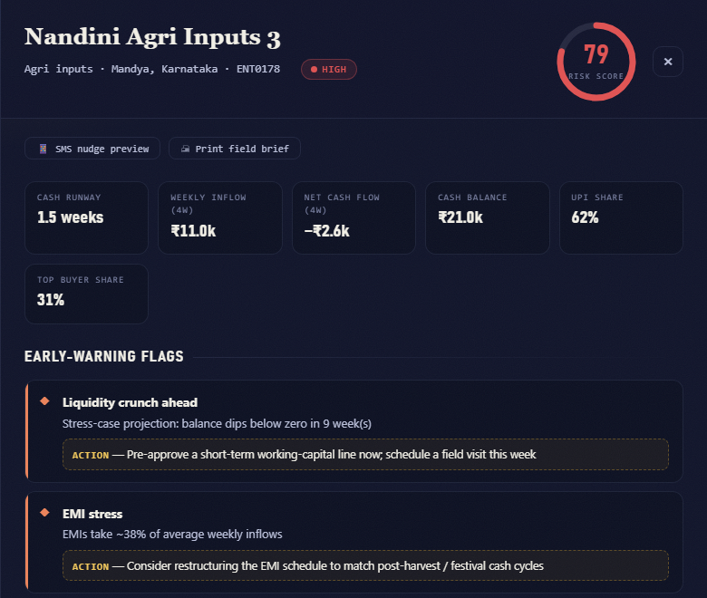
The working dashboard drill-down: calibrated risk dial, early-warning flags with recommended actions, SMS-nudge and printable field-brief tools, bilingual (EN/हिंदी) throughout — fully offline-capable.
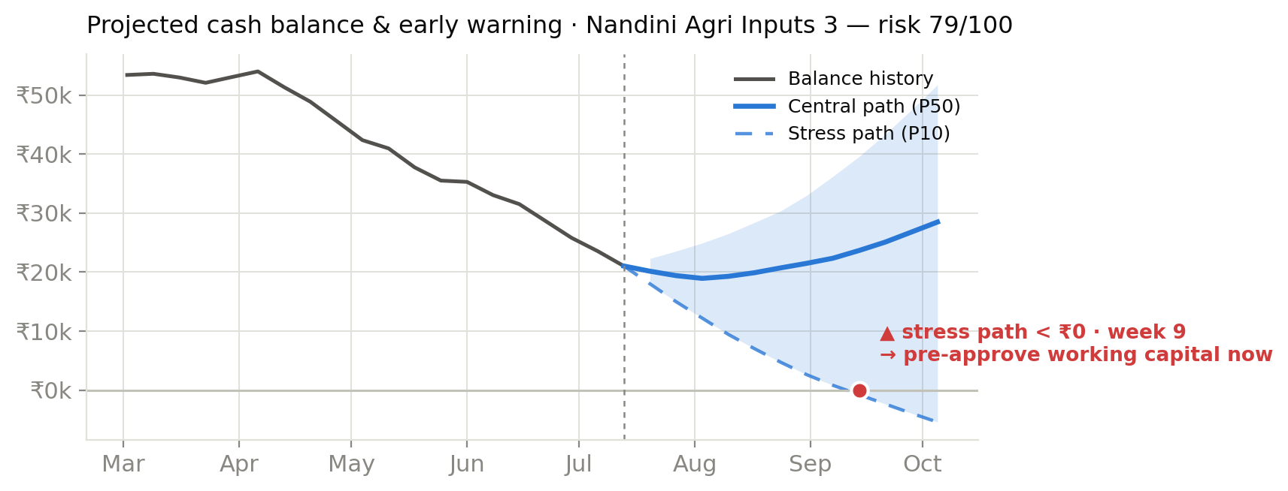
Actual prototype output: projected balance with conformal stress path — flagged 9 weeks before the projected ₹0 crossing, with a concrete recommended action.
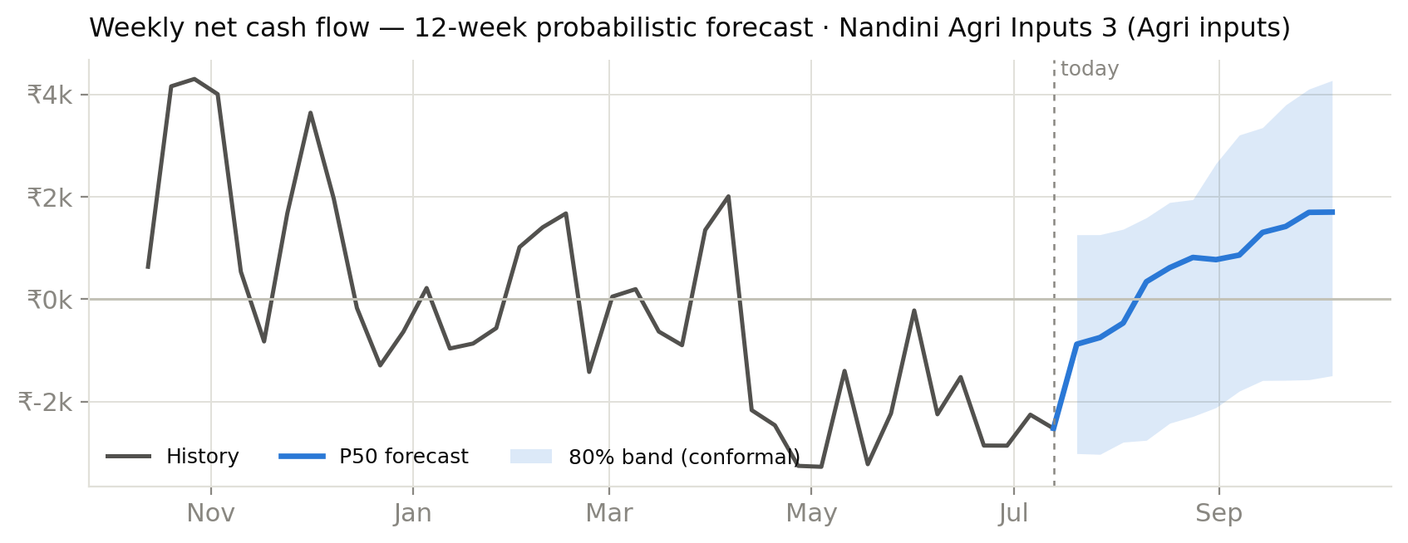
Actual prototype output: 12-week probabilistic net cash-flow forecast for the same enterprise.

6. Why this is different
- Probabilistic, not point estimates: lending decisions ride on the stress path (P10), not an average that hides tail risk — and the bands are honest (conformalized).
- Explainable in the field officer's language: every alert ships with Hindi/English reason codes and one recommended action — adoption lives or dies on this, and it anticipates RBI's digital-lending transparency expectations.
- Score and flags can never disagree: a noisy-OR blend of calibrated model probability and transparent rules — auditors and field staff see the same story.
- Low-network by design: offline-capable PWA, zero external assets, CPU-only models (LightGBM) that run on-prem at an RRB data centre; SMS fallback on the roadmap.
- DPI-native: designed around Account Aggregator consent, OCEN-style APIs, Agmarknet/IMD open data — no proprietary data moats, which is exactly what makes it deployable by public institutions.

7. Feasibility and deployment path
The stack is deliberately boring where it should be: Python, LightGBM, FastAPI — no GPUs, no exotic infrastructure. A district pilot needs one server (or a NABARD/partner-bank VM), AA consent journeys for enrolled enterprises, and field-officer onboarding. The models retrain weekly in minutes on CPU. Because the entire demo runs offline on synthetic data, the same artefact doubles as a training simulator for field staff.

8. Impact
- For lenders: earlier intervention → lower slippage and NPAs on micro-enterprise books; a defensible, explainable basis for cash-flow-based lending to the credit-invisible.
- For entrepreneurs: a bankable, consent-based cash-flow record — the on-ramp from informal moneylenders to formal working capital; vernacular nudges that help them plan for lean seasons.
- For NABARD: portfolio-level early-warning heatmaps across districts and segments; evidence for policy design; a reusable public-good scoring rail for RRBs, DCCBs and SHG federations.

9. Roadmap
Phase | Scope
Prototype (done) | Full pipeline on simulated panel: forecaster + early-warning + bilingual explainability + dashboard
Round 2 (Jul–Aug 2026) | Hardening, live AA-sandbox integration demo, SMS nudge prototype, demo video and deployment guide
Pilot (post-GFF) | One district, one RRB/DCCB partner, 500–1,000 consented enterprises; measure lead time, intervention uptake, repayment outcomes vs control
Scale | State roll-out via NABARD ecosystem; OCEN-integrated scoring API; multilingual expansion (Marathi, Telugu, Bangla …)

10. Technology stack
Python 3.10 · LightGBM (quantile + monotone-constrained classifiers) · scikit-learn (calibration) · TreeSHAP · conformal prediction · FastAPI · zero-dependency SVG dashboard (PWA-ready, EN/HI) · Account Aggregator & OCEN-style APIs (integration path) · Agmarknet / eNAM / IMD open data. Optional GenAI layer (LLM) for free-form vernacular advisory over structured outputs — roadmap, not a dependency.

11. Team
«Team name» — «member 1, role» · «member 2, role» · «member 3, role» | Contact: «email / phone»
Note: all data in this submission is synthetic; no real enterprise or personal data was used. The prototype avoids sensitive personal information by design and supports low-network environments.

