Supplementary Materials for

Influences of inversion polymorphisms on human genomic variation and complex traits

Scott C. Sauers,¹ Bailey Huepenbecker,² PingHsun Hsieh,^{1,2,3}*

*Corresponding author
Correspondence: hsiehph@umn.edu

This PDF file includes:

Figs. S1 to S13

Other Supplementary Materials for this manuscript include the following:

Tables S1 to S20

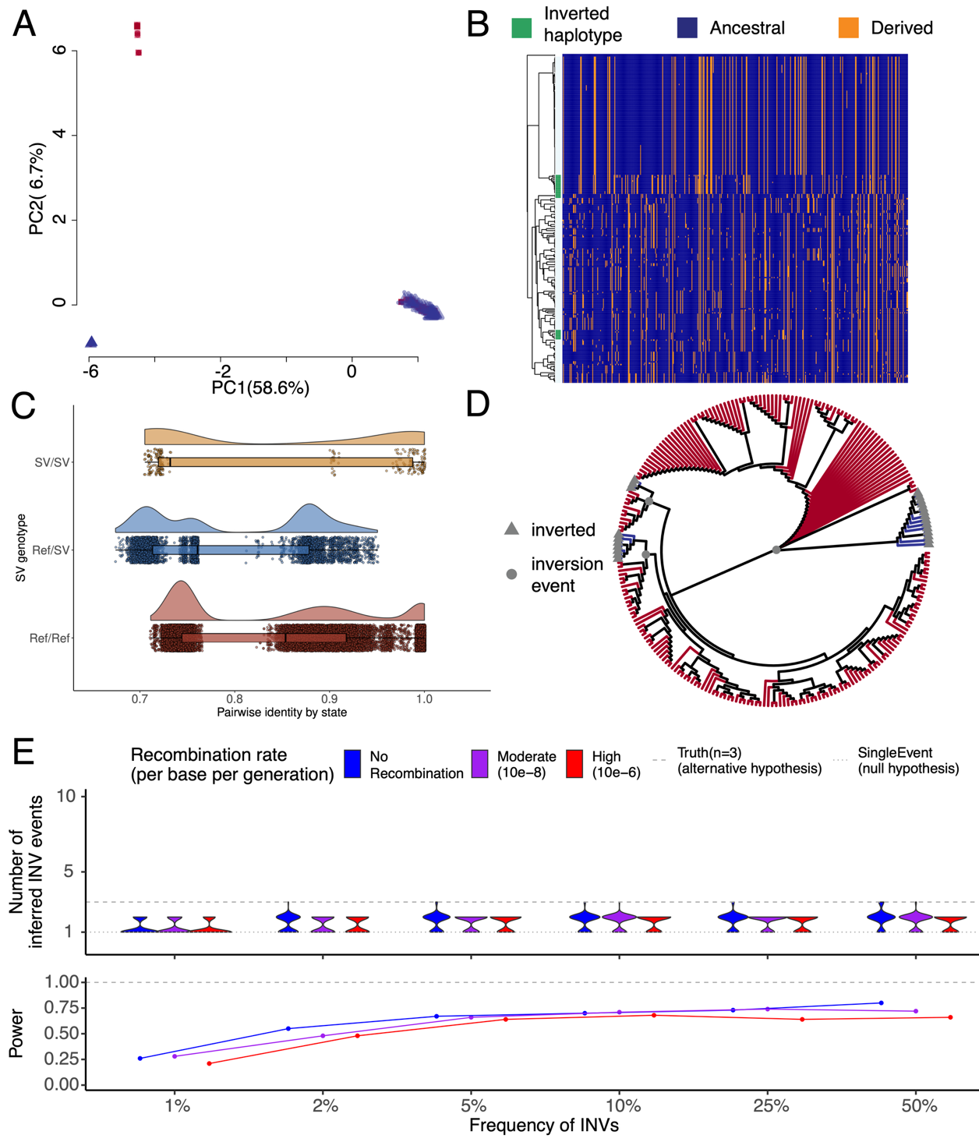
Figure S1. Power analysis under scenarios of old recurrent inversion events (500, 250, 100 thousand years ago). (A) Haplotype-based principal component (PC) analysis indicates that both inverted (blue triangles) and direct (red squares) haplotypes are found in the same PC clusters. Percentages on axes indicate the amounts of variance explained by individual PCs. (B) Dendrograms (centroid hierarchical clustering method) show relationships among inverted (green) and direct haplotypes. (C) Distribution of identity by state between inverted (SV/SV), heterokaryotypes (Ref/SV), and direct (Ref/Ref) haplotypes, respectively. (D) Phylogeny describes underlying genealogical relationships among heterokaryotypes. Inverted haplotypes (grey triangles) form three distinct clusters and the grey circles indicate the putative inversion events on the tree. (E) Summary of power analysis for models with three recurrent inversion events incorporating three different recombination rates. Violin plots (top) show the distribution of inferred inversion events, while curves (bottom) indicate the statistical power to reject the null (single-event) model for each scenario.

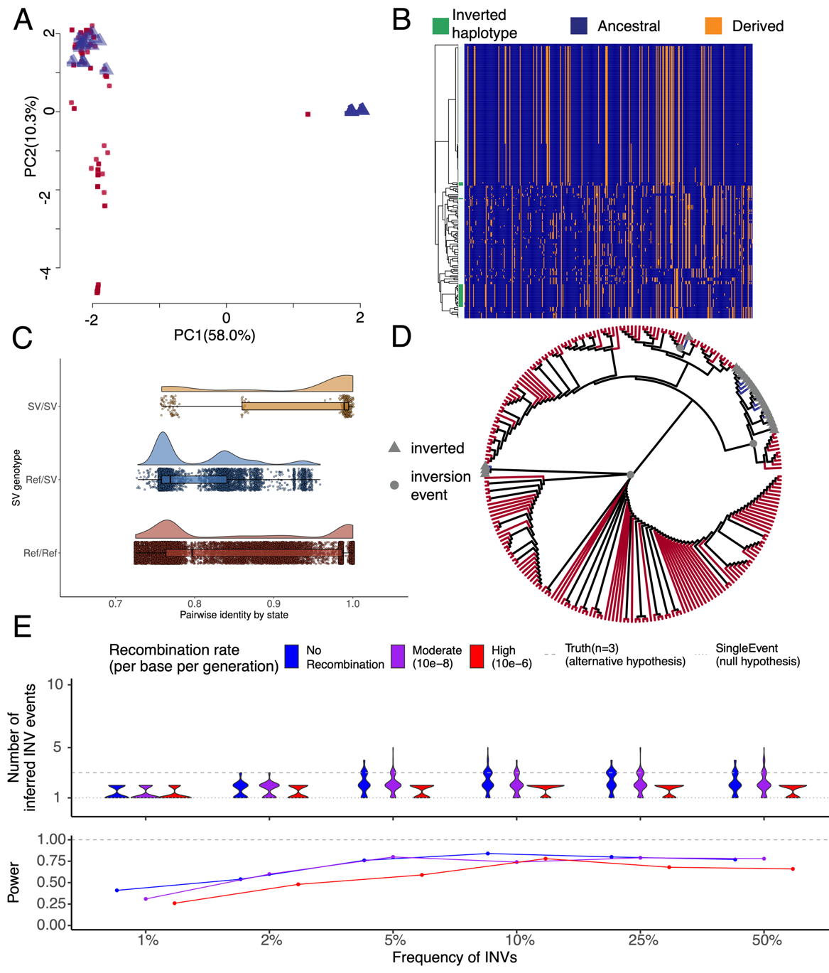
Figure S2. Power analysis under scenarios of younger recurrent inversion events (250, 100, 50 thousand years ago). (A) Haplotype-based principal component (PC) analysis indicates that both inverted (blue triangles) and direct (red squares) haplotypes are found in the same PC clusters. Percentages on axes indicate the amounts of variance explained by individual PCs. (B) Dendrograms (centroid hierarchical clustering method) show relationships among inverted (green) and direct haplotypes. (C) Distribution of identity by state between inverted (SV/SV), heterokaryotypes (Ref/SV), and direct (Ref/Ref) haplotypes. (D) Phylogeny describes underlying genealogical relationships among heterokaryotypes. Inverted haplotypes (grey triangles) form three distinct clusters and the grey circles indicate the putative inversion events on the tree. (E) Summary of power analysis for models with three recurrent inversion events incorporating three different recombination rates. Violin plots (top) show the distribution of inferred inversion events, while curves (bottom) indicate the statistical power to reject the null (single-event) model for each scenario.

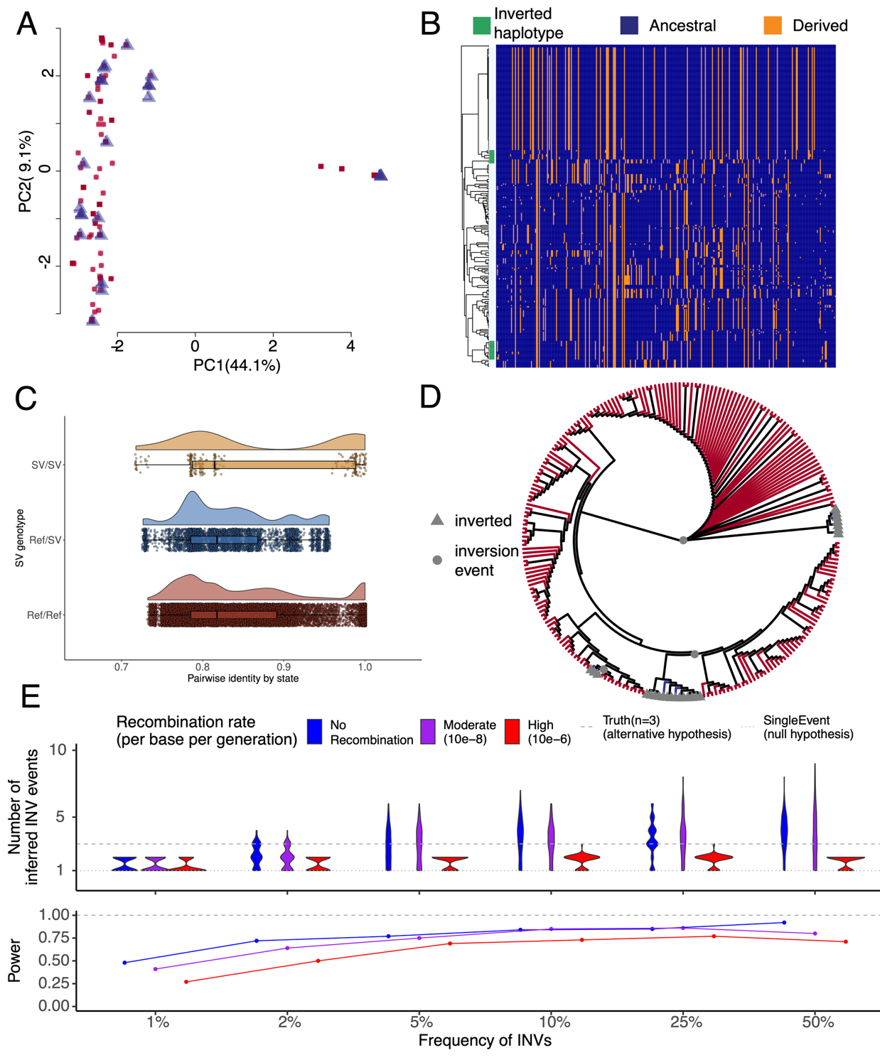
Figure S3. Power analysis under scenarios of recent recurrent inversion events (100, 50, 25 thousand years ago). (A) Haplotype-based principal component (PC) analysis indicates that both inverted (blue triangles) and direct (red squares) haplotypes are found in the same PC clusters. Percentages on axes indicate the amounts of variance explained by individual PCs. (B) Dendrograms (centroid hierarchical clustering method) show relationships among inverted (green) and direct haplotypes. (C) Distribution of identity by state between inverted (SV/SV), heterokaryotypes (Ref/SV), and direct (Ref/Ref) haplotypes, respectively. (D) Phylogeny describes underlying genealogical relationships among heterokaryotypes. Inverted haplotypes (grey triangles) form three distinct clusters and the grey circles indicate the putative inversion events on the tree. (E) Summary of power analysis for models with three recurrent inversion events incorporating three different recombination rates. Violin plots (top) show the distribution of inferred inversion events, while curves (bottom) indicate the statistical power to reject the null (single-event) model for each scenario.
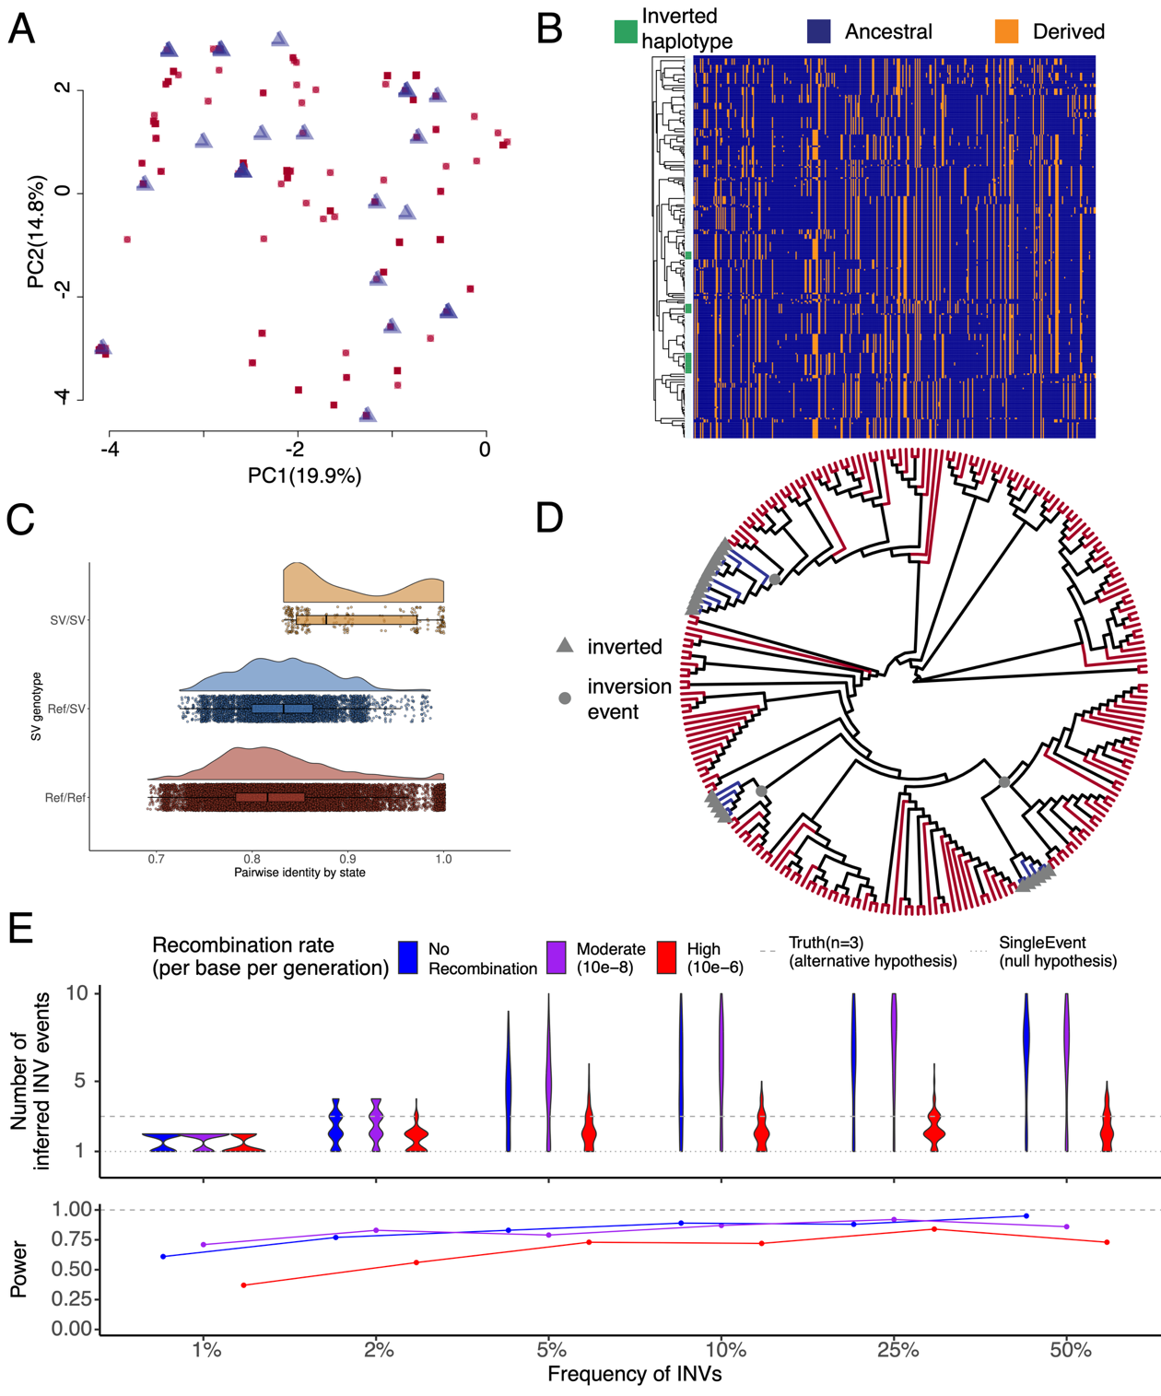
Figure S4. Power analysis under scenarios of very recent recurrent inversion events (50, 25, 10 thousand years ago). (A) Haplotype-based principal component (PC) analysis indicates that both inverted (blue triangles) and direct (red squares) haplotypes are found in the same PC clusters. Percentages on axes indicate the amounts of variance explained by individual PCs. (B) Dendrograms (centroid hierarchical clustering method) show relationships among inverted (green) and direct haplotypes. (C) Distribution of identity by state between inverted (SV/SV), heterokaryotypes (Ref/SV), and direct (Ref/Ref) haplotypes, respectively. (D) Phylogeny describes underlying genealogical relationships among heterokaryotypes. Inverted haplotypes (grey triangles) form three distinct clusters and the grey circles indicate the putative inversion events on the tree. (E) Summary of power analysis for models with three recurrent inversion events incorporating three different recombination rates. Violin plots (top) show the distribution of inferred inversion events, while curves (bottom) indicate the statistical power to reject the null (single-event) model for each scenario.
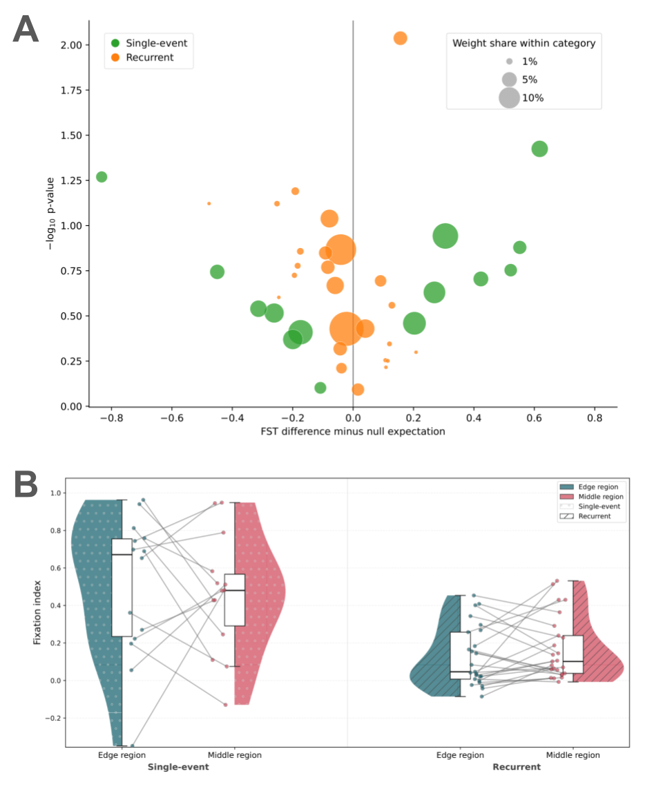
Figure S5. F_{ST} differences between breakpoint-proximal and middle regions of inversion loci. (A) Hudson’s F_{ST} was computed between direct and inverted orientations. Each point corresponds to a single inversion’s difference in Hudson’s F_{ST} between a region towards the edges of the inversion and a region towards the middle of the locus. Single-event inversions are green, whereas recurrent inversions are orange. The x-axis displays the following per-inversion difference: (F_{ST} in the observed breakpoint-proximal region - F_{ST} in the observed middle region) - (mean F_{ST} in the null breakpoint-proximal regions - mean F_{ST} in the null middle regions). Null F_{ST} values are defined by circularly rotating the within-inversion F_{ST} values (Methods). Positive values indicate higher differentiation at breakpoints and negative values indicate higher differentiation in the middle of the inversion. The y-axis shows the negative log two-sided p-value computed via the difference metric divided by its standard error. Points higher on the plot indicate more extreme deviations from the null distribution. Variance for the breakpoint F_{ST} enrichment effect was derived via permutation (Methods). The area of each point is proportional to the inverse-variance precision weight in its category (single-event or recurrent), such that larger circles correspond to inversions contributing a larger portion of information to the meta-analysis. (B) Hudson’s F_{ST} was computed between direct and inverted orientation haplotypes and is shown on the y-axis. For each inversion, windows near the inversion edge and windows near the inversion middle are shown as a pair of connected points. For each inversion category, the left half of the violin displays the distribution of edge region F_{ST} values, and the right half shows the distribution of middle region F_{ST} values. Single-event inversions are shown on the left half of the plot, and recurrent inversions are shown on the right half. Box plots indicate the median and interquartile range of F_{ST} in each of the four categories on the x-axis.

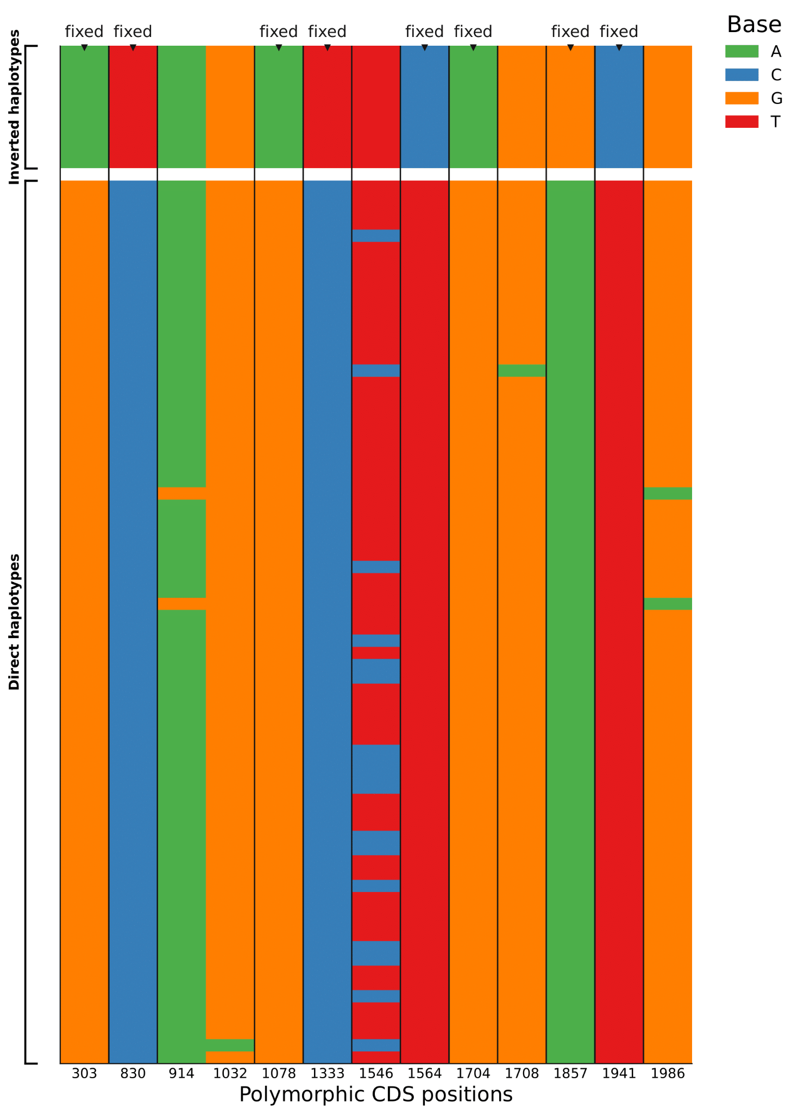
Figure S6. MAPT coding sequence polymorphisms across the 17q21.31 inversion locus’s inverted and direct haplotypes. Each row (y-axis) corresponds to a haplotype, with inverted haplotypes shown above direct haplotypes. Columns (x-axis) indicate polymorphic sites across all haplotypes (non-polymorphic sites are not shown). Color indicates nucleotide base (A = green, C = blue, G = orange, T = red). Fixed differences are indicated by a downward triangle.

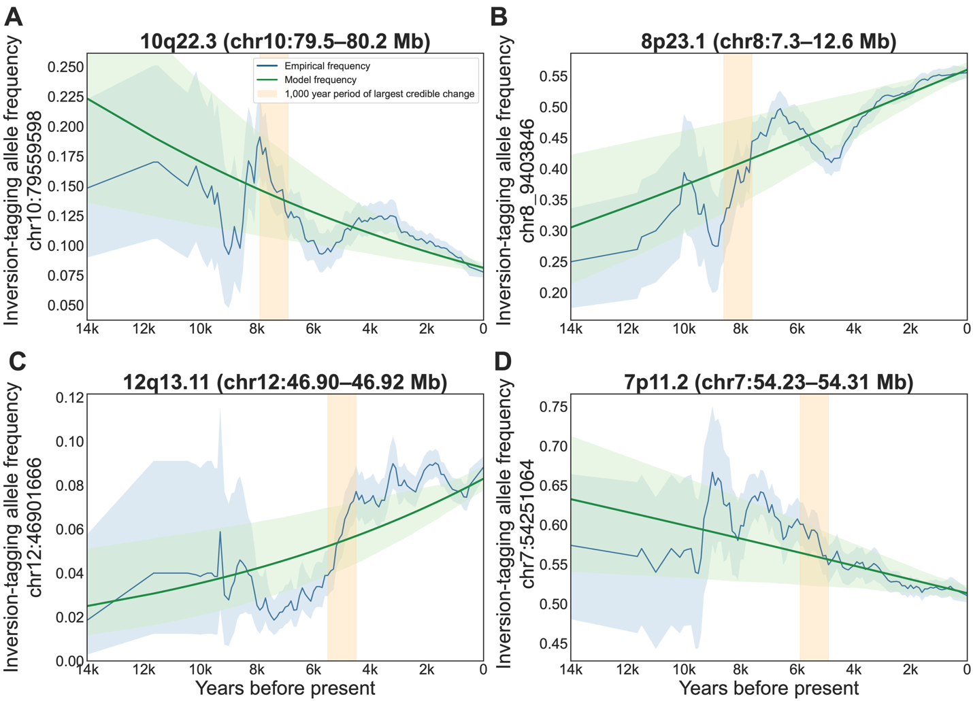
Figure S7. Allele frequency changes over time of the inversion tagging SNPs. The x-axis shows the midpoint of the 1,000-year window in which allele frequency was calculated. The y-axis shows the allele frequency of the derived allele (in GRCh38 coordinates). All data are from the AGES database (https://reich-ages.rc.hms.harvard.edu/). The green line indicates the precomputed model’s estimate for the allele frequency adjusting for demographic confounding. Allele frequency trajectories in the AGES database were computed via a 1,000 year sliding window with a step size of 100 years.

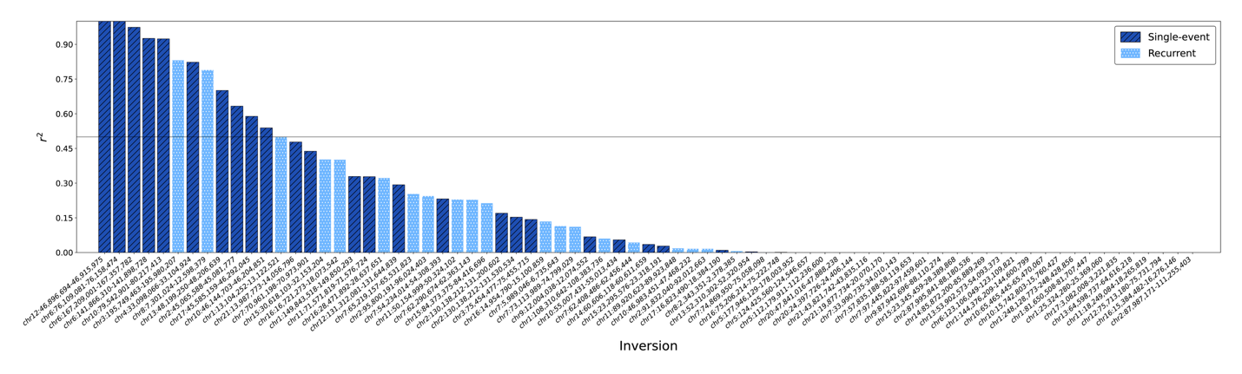
Figure S8. Cross-validated imputation accuracy (r²) for inversion allele dosage across loci. Each bar indicates the variance in inversion dosage explained (r²) by the dosage of inversion alleles predicted by partial least squares regression. r² was evaluated in held-out samples for high-confidence ground-truth inversion calls across outer cross-validation folds. The x-axis shows each inversion loci, ordered by r². Dark blue bars indicate single-event inversions and light blue bars indicate recurrent inversions. The number of partial least squares components was determined via inner cross-validation (Methods).

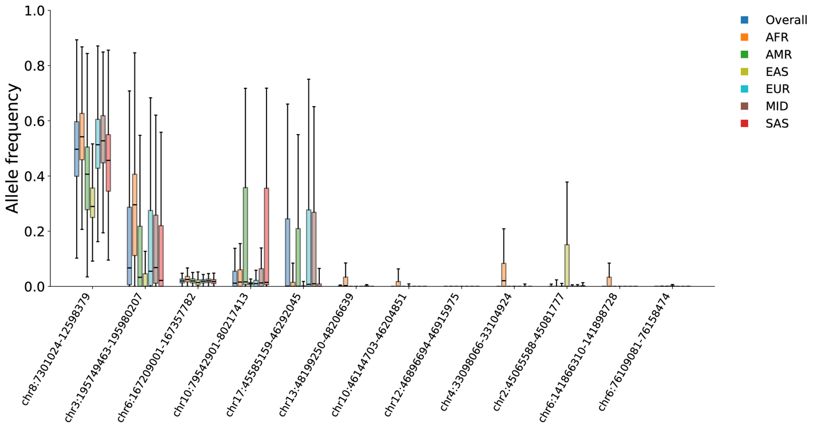
Figure S9. Imputed allele frequency by population in the NIH All of Us cohort for the 12 high-quality inversion loci with imputation r² > 0.5. Allele frequencies were imputed using the proposed machine learning model as described (Methods) for individual populations. Population labels were extracted from the NIH All of Us Research Program Curated Data Repository v8. AFR: African, AMR: Admixed American, EAS: East Asian, EUR: European, MID: Middle Eastern, SAS: South Asian. Each boxplot represents the median (the thick line in the box), the upper and lower quartiles (depicted by the box), and whiskers show the range of data within 1.5× IQR of the box edges.

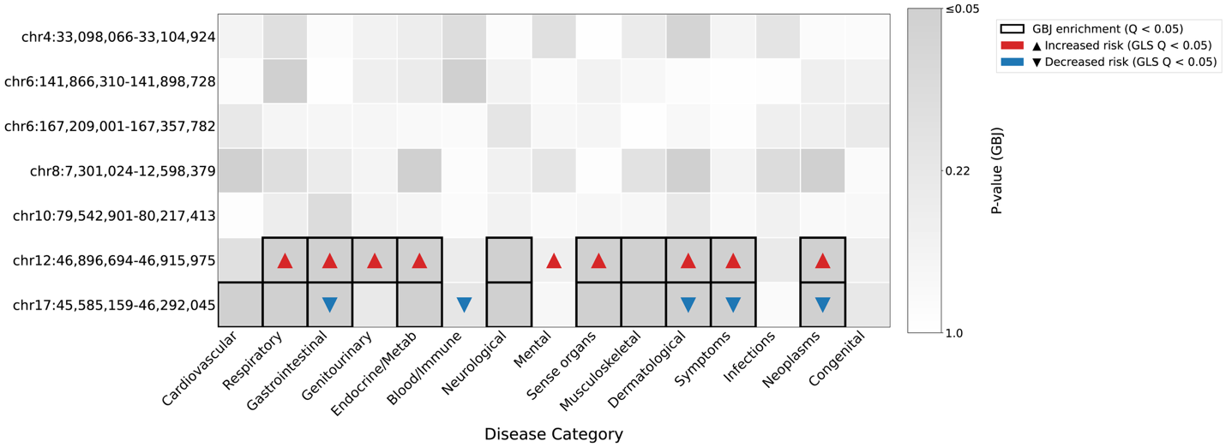
Figure S10. Category-level meta-analysis of disease associations across the seven inversion loci tested in PheWAS. Each row corresponds to a single inversion locus. Each column represents a disease category. The cell background gradient indicates the strength of the omnibus association for that category-inversion pair, where white is less significant and darker gray is more significant. Two tests are displayed. Within each test, Benjamini-Hochberg correction was performed. The bold black outline indicates significance via Generalized Berk-Jones (GBJ), the omnibus association test. This evaluates if any phenotype within the category has an association with the inversion, above the null expectation due to case overlap between phenotypes. To understand directional trends within each category, we performed a generalized least squares (GLS) test, which estimates the average effect of the inversion on phenotypes in the category. Significant directional effects are indicated by upward-facing red triangles for risk-increasing associations, whereas downward-facing blue triangles refer to risk-decreasing inversion dosage associations.

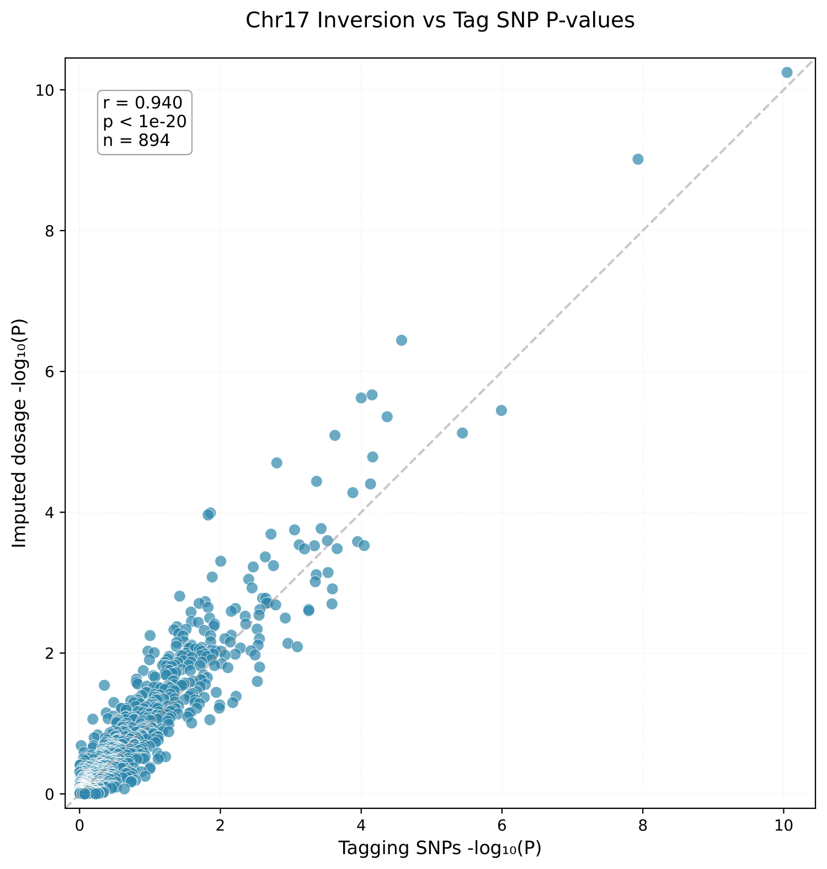
Figure S11. Correlation of 17q21.31 inversion phecode association p-values between tagging SNP and imputed dosage approaches. Scatterplot showing the negative log p-values from the phenome-wide association analyses of the 17q21.31 inversion via two methods of deriving inversion dosage: tagging SNP-based dosage hard-calling (x-axis) and imputed dosage via PLS regression (y-axis). Each point represents a phecode tested in both analyses. Tagging SNP dosage was determined via unanimity on three tagging SNPs on 17q21.31 at chr17:45,996,523, chr17:46,003,698, and chr17:45,974,480. Samples were assigned to a dosage of 0, 1 or 2, only when all three tagging SNPs agreed. Missing or discordant samples were excluded from the tagging SNP results. For example, a sample which appears homozygous for the inversion tagging SNP on two of the three SNPs, yet is heterozygous on the third SNP, would be excluded. The same controls were used in both analyses (Methods).

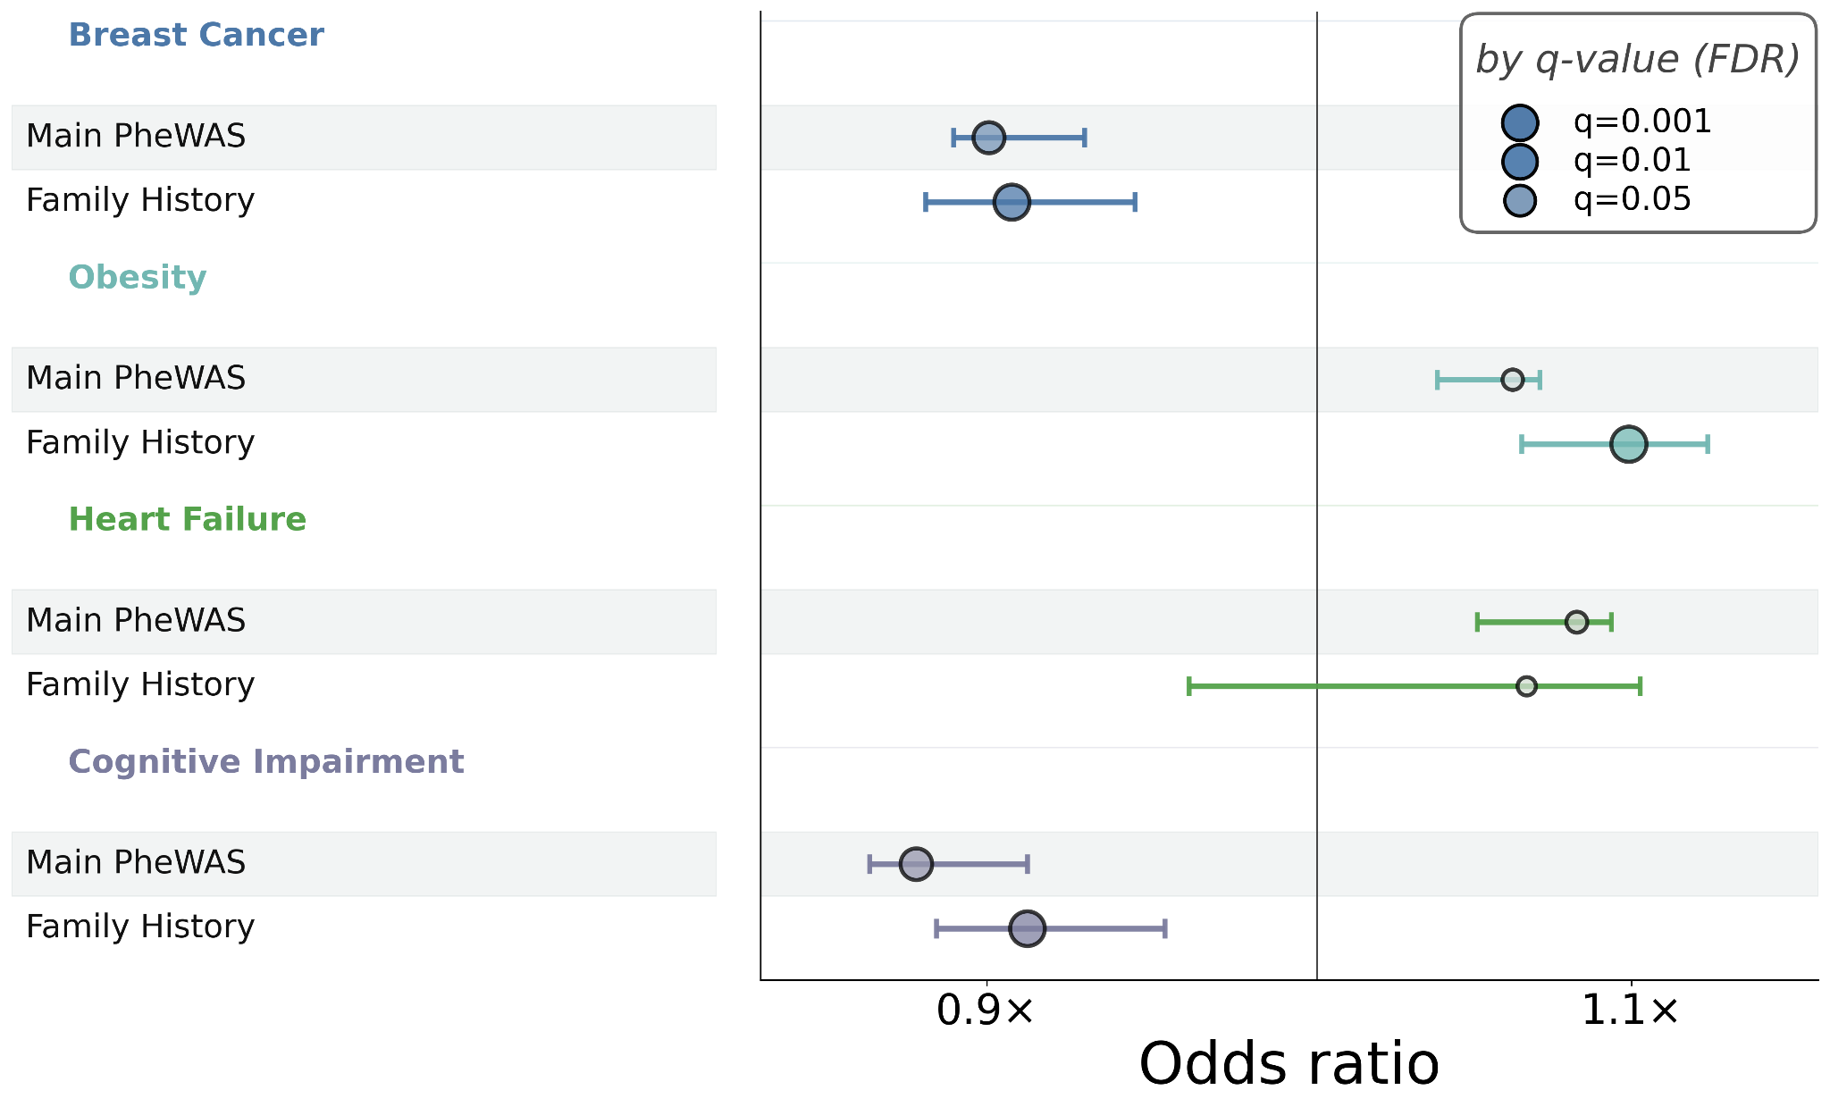
Figure S12. Concordance between family and personal history for 17q21.31 allele associations. Forest plot showing the effect estimate of the 17q21.31 inversion allele across four categories. For each phenotype, the odds ratio from the main PheWAS effect is shown, and below it, the odds ratio for family history is shown. The horizontal bars indicate the 95% confidence interval. Family history associations used kinship-weighted models to estimate the allelic effect transmitted to relatives (Methods). Electronic healthcare records (EHRs) were used for personal history. Survey data was used for family history. For breast cancer, personal history is for "malignant neoplasm of the breast," and likewise "breast cancer" for the family history survey data. "Obesity" was used for both the EHR data and the survey question. For heart failure, EHR for heart failure was used, whereas the survey data specifically indicated "congestive heart failure." For cognitive impairment, the personal history used EHR records for mild cognitive impairment, whereas the survey reports used questions for "dementia" and "memory loss or impairment."

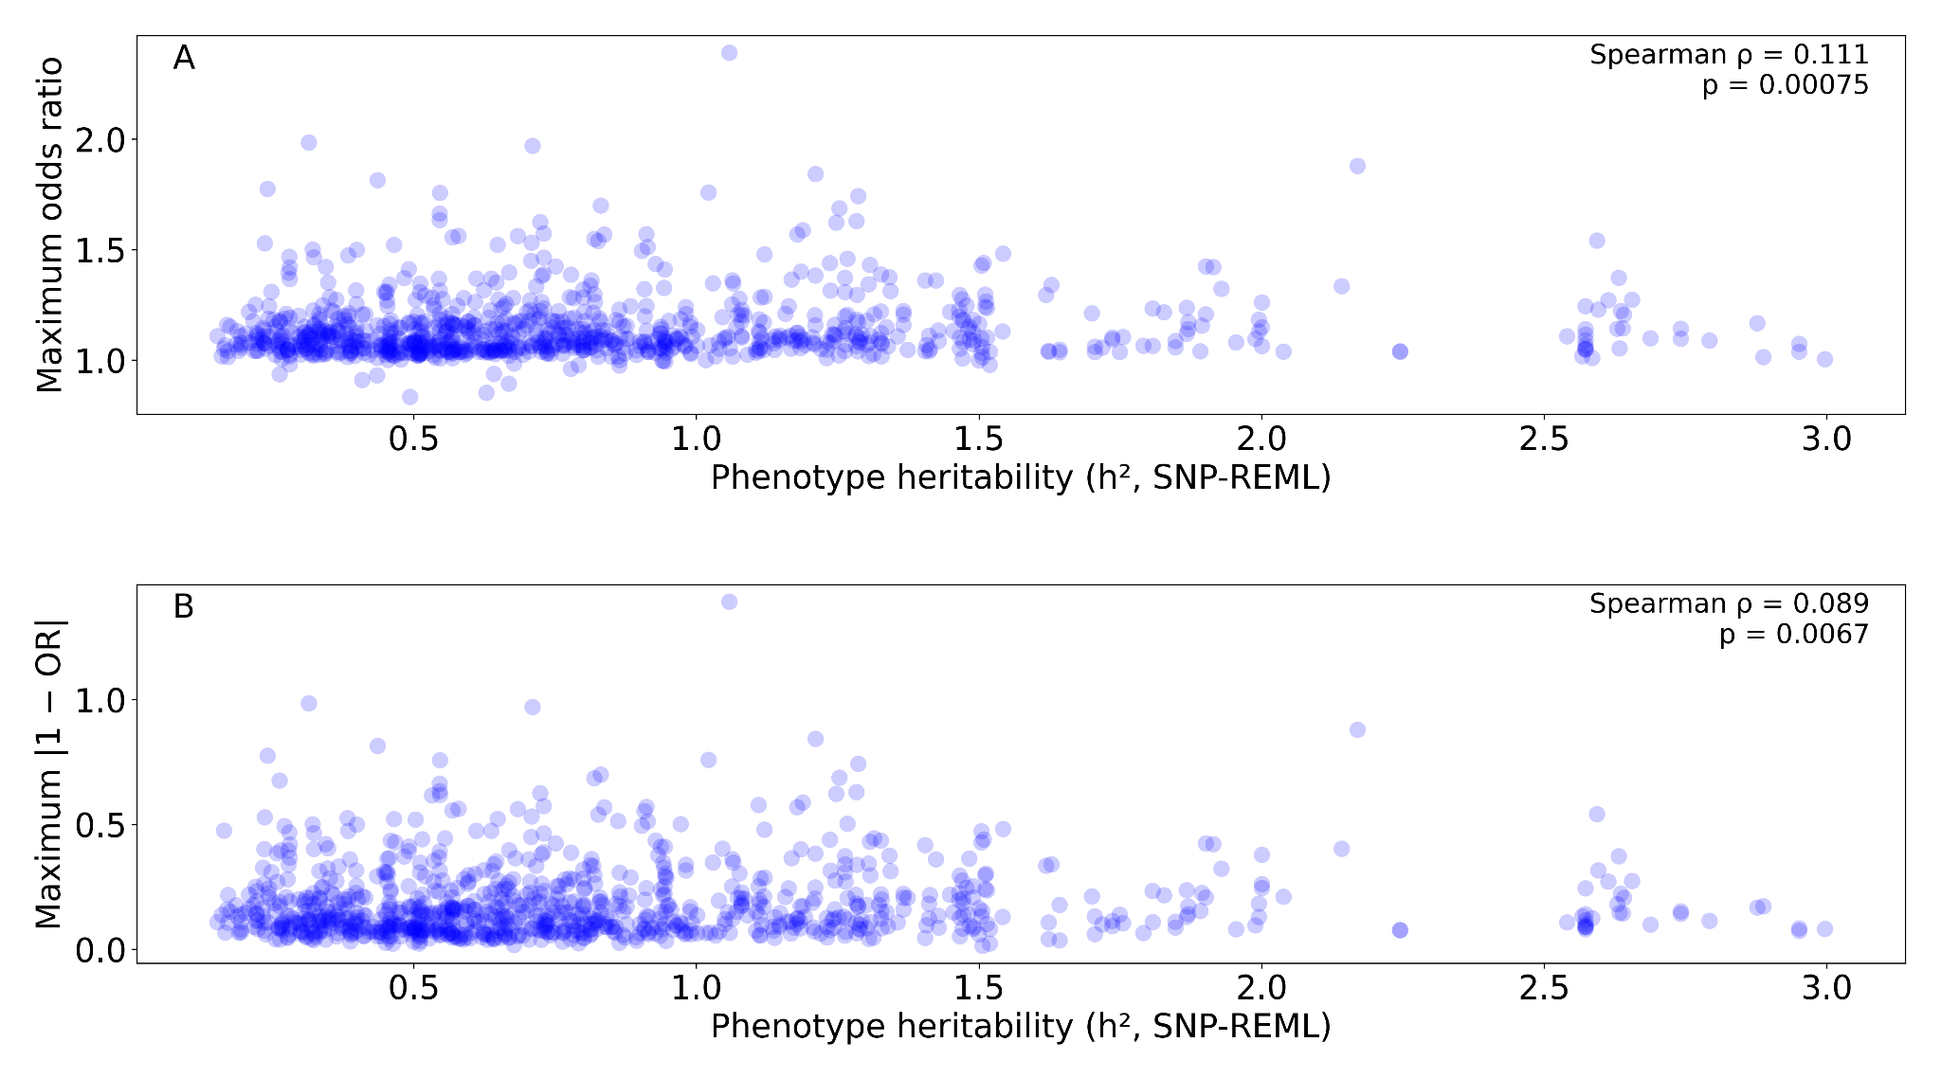
Figure S13. Correlations between heritability and inversion effects. (A) Scatterplot showing the correlation of phenotype SNP heritability and maximum Odds Ratio (OR) across inversions in the main phenome-wide association study. (B) Correlation between phenotype SNP heritability and the maximum deviation from OR = 1.0 in order to capture both risk-increasing and protective effects. Heritability estimates were derived from the Pan-UK Biobank project. The REML h² values shown are a meta-analytic aggregate of heritability estimates across population groups (Methods).

