**NEPAL COLLEGE OF INFORMATION TECHNOLOGY**

BALKUMATI, LALITPUR



(Affiliated to Pokhara University)

**A Lab Report on**

**Subject: Web Technology-I**

**Submitted by: Submitted to:**

**Saugat Khadka Name: Pradip Bhattarai**

**232038 Department of BCA**

**BCA**

**3rd Semester**

**IP COMMANDS**

1. **Ping [IP Address]**

**Description:** The ping command tests the connectivity between a host and a target (IP address or domain name). It sends Internet Control Message Protocol (ICMP) Echo Request packets to the target and waits for Echo Reply packets. The output shows the response time (in milliseconds) and packet loss information.

**Syntax:** ping [IP address or domain name]

**Example:** ping 192.168.1.1

**Output:**

Pinging 192.168.1.1with 32 bytes of data:

Reply from 192.168.1.1: bytes=32 time=15ms TTL=118

Reply from 192.168.1.1: bytes=32 time=15ms TTL=118

Reply from 192.168.1.1: bytes=32 time=14ms TTL=118

Reply from 192.168.1.1: bytes=32 time=14ms TTL=118

Ping statistics for 192.168.1.1:

Packets: Sent = 4, Received = 4, Lost = 0 (0% loss),

Approximate round trip times in milli-seconds:

Minimum = 14ms, Maximum = 15ms, Average = 14ms

1. **Ping [Domain Name]**

**Description:** The ping command can also be used with domain names instead of IP addresses. When executed, it resolves the domain name to its corresponding IP address and sends ICMP Echo Request packets to test the connection. The results provide information about the domain's server, including its IP address, response time, and packet loss statistics.

**Syntax**: ping [domain name]

**Example:** ping [www.facebook.com](http://www.facebook.com)

**Output:**

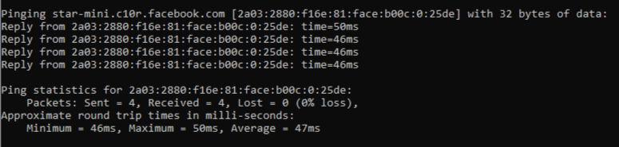

**IPCONFIG COMMANDS**

1. **Ipconfig**

**Description:** The ipconfig command displays information about our network configuration and refreshes DHCP and DNS Settings. By default, the ipconfig command displays your IP Address, Subnet Mask, and default gateway.

**Syntax:** ipconfig

**Example:** ipconfig

**Output:**

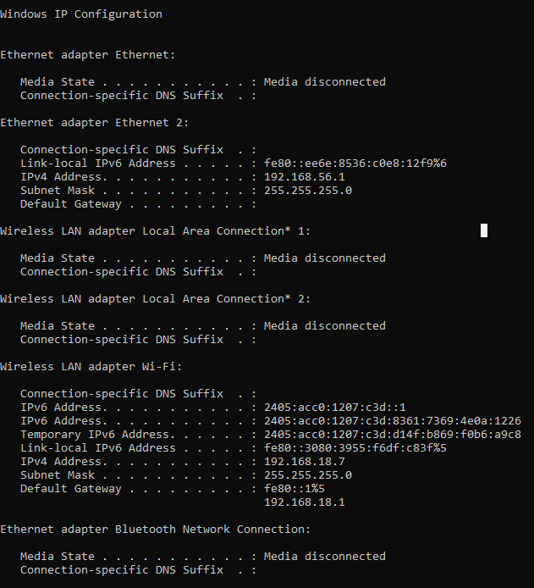

1. **IPCONFIG/ALL**

**Description:** Displays detailed information about all adapters, including the IP address, subnet mask, default gateway, DHCP server, and DNS servers. ipconfig /all command releases the DHCP lease for the specified adapter.

**Syntax:** ipconfig/all

**Example:** ipconfig/all

**Output:**

Windows IP Configuration

Host Name . . . . . . . . . . . . : DESKTOP-N83KHLK

Primary Dns Suffix . . . . . . . :

Node Type . . . . . . . . . . . . : Hybrid

IP Routing Enabled. . . . . . . . : No

WINS Proxy Enabled. . . . . . . . : No

Ethernet adapter Ethernet:

Media State . . . . . . . . . . . : Media disconnected

Connection-specific DNS Suffix . :

Description . . . . . . . . . . . : Realtek PCIe GBE Family Controller

Physical Address. . . . . . . . . : D8-C4-97-0F-C5-38

DHCP Enabled. . . . . . . . . . . : Yes

Autoconfiguration Enabled . . . . : Yes

Ethernet adapter Ethernet 2:

Connection-specific DNS Suffix . :

Description . . . . . . . . . . . : VirtualBox Host-Only Ethernet Adapter

Physical Address. . . . . . . . . : 0A-00-27-00-00-06

DHCP Enabled. . . . . . . . . . . : No

Autoconfiguration Enabled . . . . : Yes

Link-local IPv6 Address . . . . . : fe80::ee6e:8536:c0e8:12f9%6(Preferred)

IPv4 Address. . . . . . . . . . . : 192.168.56.1(Preferred)

Subnet Mask . . . . . . . . . . . : 255.255.255.0

Default Gateway . . . . . . . . . :

DHCPv6 IAID . . . . . . . . . . . : 772407335

DHCPv6 Client DUID. . . . . . . . : 00-01-00-01-2B-1A-3B-9E-D8-C4-97-0F-38

DNS Servers . . . . . . . . . . . : fec0:0:0:ffff::1%1

fec0:0:0:ffff::2%1

fec0:0:0:ffff::3%1

NetBIOS over Tcpip. . . . . . . . : Enabled

Wireless LAN adapter Local Area Connection* 1:

Media State . . . . . . . . . . . : Media disconnected

Connection-specific DNS Suffix . :

Description . . . . . . . . . . . : Microsoft Wi-Fi Direct Virtual Adapter

Physical Address. . . . . . . . . : 9A-22-EF-68-F1-D5

DHCP Enabled. . . . . . . . . . . : Yes

Autoconfiguration Enabled . . . . : Yes

Wireless LAN adapter Local Area Connection* 2:

Media State . . . . . . . . . . . : Media disconnected

Connection-specific DNS Suffix . :

Description . . . . . . . . . . . : Microsoft Wi-Fi Direct Virtual Adapter #2

Physical Address. . . . . . . . . : AA-22-EF-68-F1-D5

DHCP Enabled. . . . . . . . . . . : No

Autoconfiguration Enabled . . . . : Yes

Wireless LAN adapter Wi-Fi:

Connection-specific DNS Suffix . :

Description . . . . . . . . . . . : Qualcomm Atheros QCA9377 Wireless Network Adapter

Physical Address. . . . . . . . . : 98-22-EF-68-F1-D5

DHCP Enabled. . . . . . . . . . . : Yes

Autoconfiguration Enabled . . . . : Yes

IPv6 Address. . . . . . . . . . . : 2405:acc0:1207:c3d::1(Preferred)

Lease Obtained. . . . . . . . . . : Sunday, December 1, 2024 5:36:06 PM

Lease Expires . . . . . . . . . . : Wednesday, December 4, 2024 5:36:06 PM

IPv6 Address. . . . . . . . . . 2405:acc0:1207:c3d:8361:7369:4e0a:1226(Preferred)

TemporaryIPv6 Address. . 2405:acc0:1207:c3d:d14f:b869:f0b6:a9c8(Preferred)

Link-local IPv6 Address . . . . . : fe80::3080:3955:f6df:c83f%5(Preferred)

IPv4 Address. . . . . . . . . . . : 192.168.18.7(Preferred)

Subnet Mask . . . . . . . . . . . : 255.255.255.0

Lease Obtained. . . . . . . . . . : Sunday, December 1, 2024 5:36:07 PM

Lease Expires . . . . . . . . . . : Sunday, December 1, 2024 7:06:06 PM

Default Gateway . . . . . . . . . : fe80::1%5

192.168.18.1

DHCP Server . . . . . . . . . . . : 192.168.18.1

DHCPv6 IAID . . . . . . . . . . . : 77079279

DHCPv6 Client DUID. . . . . . . . : 00-01-00-01-2B-1A-3B-9E-D8-C4-97-0F-38

DNS Servers . . . . . . . . . . . : 192.168.18.1

NetBIOS over Tcpip. . . . . . . . : Enabled

Ethernet adapter Bluetooth Network Connection:

Media State . . . . . . . . . . . : Media disconnected

Connection-specific DNS Suffix . :

Description . . . . . . . . . . . : Bluetooth Device (Personal Area Network)

Physical Address. . . . . . . . . : 98-22-EF-68-F1-D6

DHCP Enabled. . . . . . . . . . . : Yes

Autoconfiguration Enabled . . . . : Yes

1. **IPCONFIG/FLUSHDNS**

**Description:** It removes the local computer cache and forces our device to retrieve the information from the DNS again. This can help resolve security, internet connectivity, and other issues.

**Syntax:** ipconfig/flushdns

**Example:** ipconfig/flushdns

**Output:**

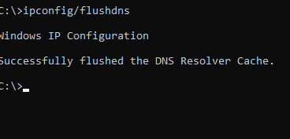

**CONCLUSION:**

Basic commands in an operating system include tools like **ping**, **ipconfig**, and its variations such as **ipconfig /all** and **ipconfig /flushdns**.

* The **ping** command checks the reachability of a host on an IP network, making it useful for diagnosing network connectivity.
* **ipconfig** displays detailed information about network adapters, including the IP address, subnet mask, default gateway, DHCP server, and DNS servers.
* The **ipconfig /flushdns** command clears the local DNS cache on the computer.