**NEPAL COLLEGE OF INFORMATION TECHNOLOGY**

BALKUMATI, LALITPUR



(Affiliated to Pokhara University)

**A Lab Report on**

**Subject: Web Technology-I**

**Submitted by: Submitted to:**

**Saugat Khadka Name: Pradip Bhattarai**

**232038 Department of BCA**

**BCA**

**3rd Semester**

HTML

HTML (Hyper Text Markup Language) is the standard language used to create and design web pages. It structures the content on the web by using tags and elements.

Syntax:

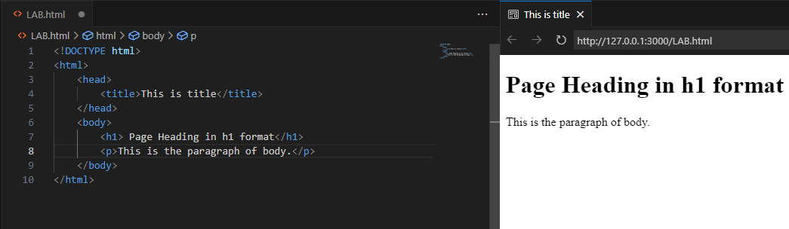

HTML Elements

1. **<!DOCTYPE html>**

* Declares the document type and version of HTML being used.
* Ensures the browser renders the document in standards mode.

2. **<html>**

* Represents the root element of an HTML document.
* Encloses all other HTML elements to define the structure of the webpage.

3. **<head>**

* Contains meta-information (metadata) about the webpage.
* Includes elements such as the title, character set, viewport settings, links to stylesheets, and scripts.

4. **<title>**

* Sets the title of the webpage, displayed on the browser tab.
* Important for accessibility and search engine optimization (SEO).

5. **<body>**

* Contains the main content of the webpage that is visible to users.
* Includes elements such as headings, paragraphs, images, links, tables, lists, and multimedia elements.

6. **<h1> to <h6>**

* Define headings, where <h1> is the largest and most important, and <h6> is the smallest.

7. **<p>**

* Represents a paragraph of text.

HTML Tags

HTML uses **tags** to structure and organize content on a webpage. Tags are enclosed in angle brackets (< >), and most have a corresponding closing tag to define the start and end of the content. For example, <p> starts a paragraph, and </p> closes it. However, some tags are **self-closing**, meaning they don't require a closing counterpart (e.g., <img>, <br> ).

**Types of HTML**

1. **Text Formatting Tags**
   * Style and format text.
   * Examples: <b>, <i>, <u>, <mark>, <sup>, <sub>.
2. **Listing Tags**
   * Create lists.
   * Examples: <ul>, <ol>, <li>, <dl>, <dt>, <dd>.
3. **Tabular Tags**
   * Structure tables.
   * Examples: <table>, <tr>, <th>, <td>, <caption>.

Text Formatting Tags :

In HTML, text formatting tags are used to apply different styles or emphasize certain parts of text

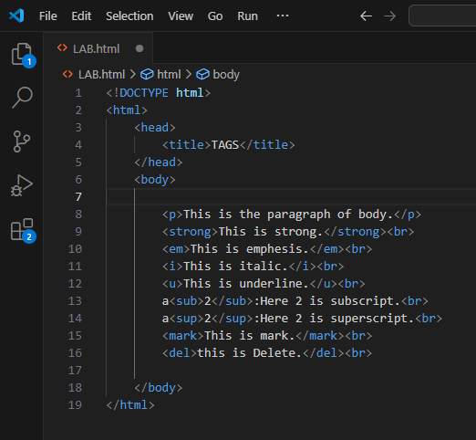

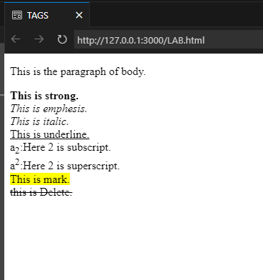

Conclusion

In this lab, we explored the basics of HTML and its key components, with a focus on tags and text formatting. We examined how HTML structures web pages using elements such as <html>, <head>, and <body>. To style text, we utilized formatting tags like <strong>, <em>, <b>, <i>, and <u> to make text bold, italicized, underlined, or emphasized. Additionally, we worked with <sub> and <sup> for subscripts and superscripts, as well as <del> and <ins> for indicating deletions and insertions. This lab improved our understanding of text formatting and presentation, enabling us to create visually appealing and well-organized web content.