**NEPAL COLLEGE OF INFORMATION TECHNOLOGY**

BALKUMATI, LALITPUR



(Affiliated to Pokhara University)

**A Lab Report on**

**Subject: Web Technology-I**

**Submitted by: Submitted to:**

**Saugat Khadka Name: Pradip Bhattarai**

**232038 Department of BCA**

**BCA**

**3rd Semester**

List

In HTML, a list is created using the <ul> (unordered list) or <ol> (ordered list) elements, with each item within the list represented by a <li> (list item) element. On the other hand, a nested list refers to a list containing another within one of its list items. This can be achieved by placing a <ul> or <ol> element inside a <li> element. Nested lists allow for a hierarchical organization of information, making presenting data in a structured, layered format easier.

HTML Code and Output:

<!DOCTYPE html>

<html>

    <head>

        <title>List</title>

    </head>

    <body>

        <h2>Unordered Nested List</h2>

        <ul>

            <li>coffee

                <ul>

                    <li>Latte</li>

                    <li>Cappucino</li>

                    <li>Mocha</li>

                </ul>

            </li>

            <li>Tea

                <ul>

                    <li>Green Tea</li>

                    <li>Milk Tea</li>

                    <li>Black tea</li>

                </ul>

            </li>

        </ul>

        <h2>Ordered Nested List</h2>

        <ol>

            <li>Sweets

                <ol type="a">

                    <li>Cake</li>

                    <li>Sugar Cookies</li>

                    <li>Brownie</li>

                </ol>

            </li>

            <li>Breads

                <ol type="a">

                    <li>white Bread</li>

                    <li>Brown Bread</li>

                    <li>Whole-wheat Bread</li>

                </ol>

            </li>

        </ol>

        <h2>Mixed List</h2>

        <ul>

            <li>Juice

                <ol>

                    <li>Apple juice</li>

                    <li>Mango juice</li>

                    <li>Orange juice</li>

                </ol>

            </li>

        </ul>

    </body>

</html>

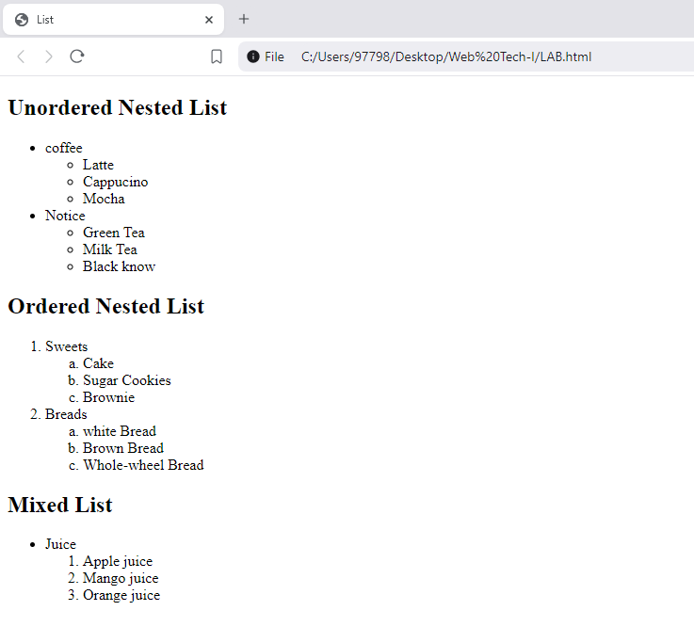

Anchor Tags

Anchor tags in HTML are used to create hyperlinks that enable users to navigate between different web pages or to various sections of the same page. The <a> (anchor) tag is used to define a hyperlink. You can link to external websites, email addresses, internal sections of the page, and more. The href attribute is used to specify the URL or destination of the link.

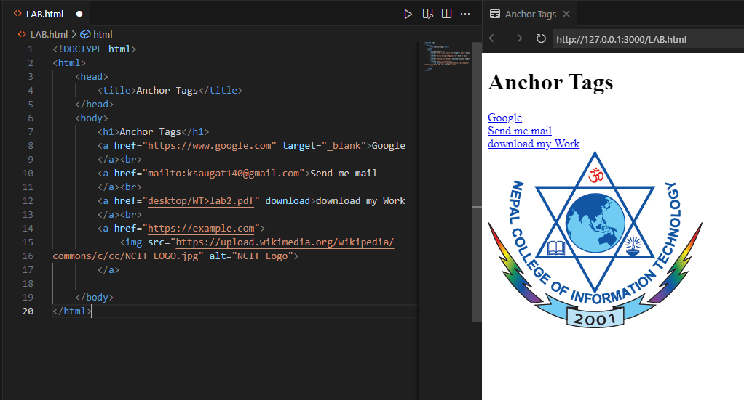

Conclusion

Anchor tags and nested lists are essential components of HTML that significantly enhance both the functionality and organization of a webpage. Anchor tags (<a>) create hyperlinks, enabling users to navigate between different pages, sections of the same page, or even external resources such as email addresses or downloadable files. The href attribute defines the destination of the link, while other attributes like target="_blank" allow links to open in a new tab, making anchor tags versatile and vital for navigation.

Nested lists, on the other hand, help developers display information in an organized, hierarchical way. By embedding one list within another, nested lists make it possible to structure complex data or group items logically. Whether using unordered (<ul>) or ordered lists (<ol>), the ability to nest lists enhances content organization, making it easier for users to understand relationships between different elements.

Together, anchor tags and nested lists contribute to a smooth, well-structured web experience, improving both navigation and content organization.