**NEPAL COLLEGE OF INFORMATION TECHNOLOGY**

BALKUMATI, LALITPUR



(Affiliated to Pokhara University)

**A Lab Report on**

**Subject: Web Technology-I**

**Submitted by: Submitted to:**

**Saugat Khadka Name: Pradip Bhattarai**

**232038 Department of BCA**

**BCA**

**3rd Semester**

**HTML FORM**

HTML forms are used to collect user input and send it to a server for processing. Forms are an essential part of web development and are used in applications like user authentication, data entry, surveys, and more.

A form consists of a container element (<form>) and various input elements that enable the user to enter data. The data submitted is processed using client-side or server-side scripts.

Tags for HTML form

1. **<form>**: Defines the form and its attributes such as action (URL to send data) and method (HTTP method, e.g., GET or POST).

2. **<input>**: Used to create input fields. The type attribute specifies the type of input (e.g., text, password, email, checkbox, etc.).

* <input type="text">
* <input type="password">
* <input type="email">
* <input type="checkbox">
* <input type="radio">
* <input type="submit">

3. **<textarea>**: Creates a multiline text input field.

4. **<button>**: Adds a clickable button for submitting or performing other actions.

5. **<select>** and **<option>**: Used for creating dropdown lists.

<select>

<option value="1">Option 1</option>

<option value="2">Option 2</option>

</select>

6. **<label>**: Provides a label for form elements, improving accessibility.

<label for="name">Name:</label>

<input type="text" id="name">

7. **<fieldset>** and **<legend>**: Groups related elements within a form for better organization.

<fieldset>

<legend>Personal Information</legend>

<input type="text" name="firstname">

</fieldset>

8. **<datalist>**: Provides a list of predefined options for an <input> field.

9. **<output>**: Displays the result of a calculation or action.

10. **<input type="hidden">**: Stores hidden data that is not visible to the user but can be sent with the form submission.

Sample code of HTML form:

<!DOCTYPE html>

<html>

    <head>

        <title>Student Registration Form</title>

    </head>

    <body bgcolor="lightblue">

        <form>

            <div >

                <label for="First Name">First Name:</label>

                <input type="text" id="First Name" name="First_name" value="" size="15" required><br>

                <label for="Last Name">Last Name :</label>

                <input type="text"  id="Last Name" name="First_name" value="" size="15" required>

            </div>

            <div><br><br>

                Gender:<br>

                <input type="radio" id="Male" name="subect" value="Male">

                <label for="Male">Male</label><br>

                <input type="radio" id="Female" name="subect" value="female">

                <label for="Female">Female</label><br>

                <input type="radio" id="Other" name="subect" value="Others">

                <label for="Other">Other</label>

            </div>

            <div><br><br>

                <label for="Phone">Phone</label>

                <input type="number" id="Phone" name="Phone" value=""> <br>

                <label for="Email">Email:</label>

                <input type="text" id="Email" name="Email" value="" size="15">

            </div>

            <div><br><br>

                <label for="fathername">Father Name:</label>

                <input type="text" id="fathername" name="fathernamr" value="" size="15"><br>

                <label for="mathername">Mother Name:</label>

                <input type="text" id="mothername" name="mothername" value="" size="15">

            </div>

            <div><br>

                Program:<br>

                <select  name="dropdown" multiple>

                    <option value="BCA">BCA</option>

                    <option value="BBA">BBA</option>

                    <option value="BEIT">BEIT</option>

                    <option value="BSC">BSC</option>

                    <option value="BECIT">BECIT</option>

                </select>

            </div>

            <div><br>

                Interest:<br>

                <input type="checkbox" id="cybersecurity" name="cybersecurity" value="on">

                <label for="cybersecurity">CyberSecurity</label><br>

                <input type="checkbox" id="datascience" name="datascience" value="on">

                <label for="datascience">Data Science</label><br>

                <input type="checkbox" id="Web Development" name="webdevelopment" value="on">

                <label for="Web Development">Web Development</label>

            </div>

        </form>

    </body>

</html>

**Output:**

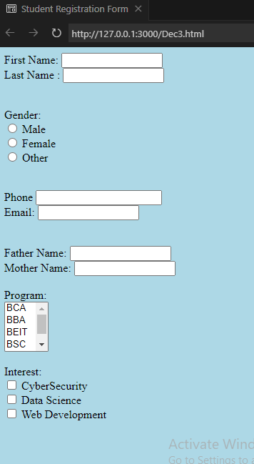

**Conclusion:**

HTML forms are a fundamental component of web development, enabling user interaction and data collection. By utilizing various form elements such as <input>, <textarea>, <select>, and others, developers can create intuitive and accessible interfaces for user input. With attributes and styling, forms can be tailored to meet diverse application needs. Combined with client-side and server-side technologies, HTML forms bridge users and web applications, making them an indispensable tool in building dynamic and responsive websites.