



DEPARTMENT OF COMPUTER SCIENCE

COMPUTER NETWORK

LAB 2

Windows Basic Networking Commands and DHCP Network Configuration

Submitted By: | Submitted To: | Signature:
Name: Saugat Tamang CRN: 024bscit036 Semester: 4th  Section: B | Er. Sanjay Kumar Yadav Department of Computer Science St. Xavier’s College, Maitighar

Date of Submission: 07/08/2026

Lab No. 2

Title: Windows Networking Utilities and DHCP Network Configuration

Lab 2.1: Introduction to Windows Network Administration Commands
Objective: To gain hands-on experience with Windows CLI tools utilized in network management, troubleshooting, and configuration.

Theory

Microsoft Windows includes a powerful array of built-in networking command-line tools tailored for network administration, configuration, and diagnostics. These utilities allow administrators to effortlessly audit IP configurations, test end-to-end network connectivity, and troubleshoot domain name resolution issues. Additionally, they offer critical insights into active data paths and real-time network connections, making it easier to monitor traffic, isolate performance issues, and efficiently manage network services.

Components Required
- Computer System
- Windows Operating System
- Command Prompt (CMD)
- Network Connection

Procedure:

Opening Command Prompt
  - Press Windows + R.
  - Type cmd or command prompt and press Enter.
  - The Command Prompt window will open (without administration access at first )
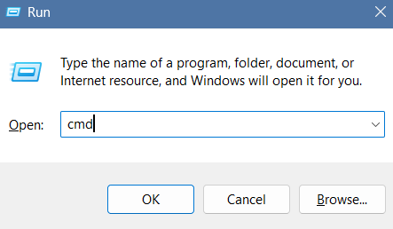

Key Commands used:

- ipconfig
Provides a quick overview of the host's primary network settings: IP address, subnet mask, and default gateway.
Syntax: ipconfig

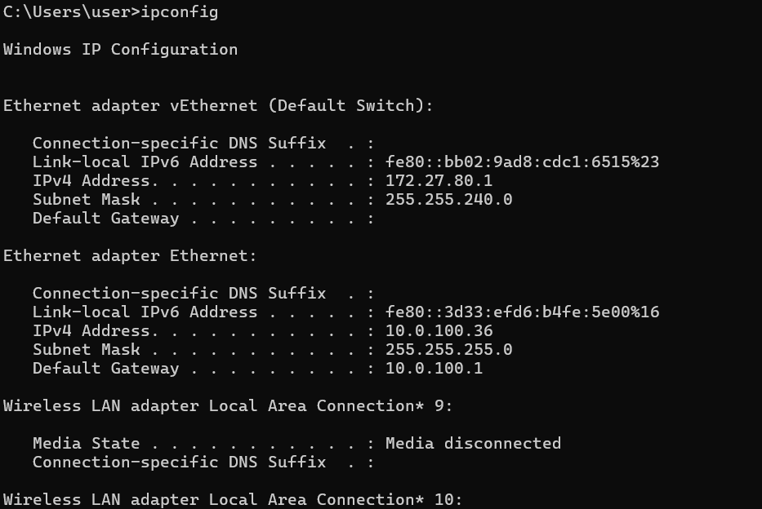
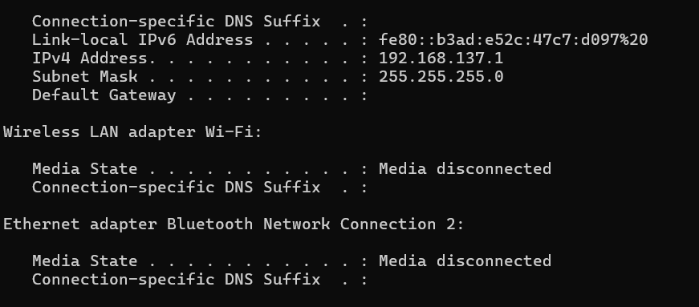

ipconfig /all
Provides an exhaustive breakdown of all network adapters, including MAC addresses, DNS servers, and DHCP lease details.
Syntax: ipconfig /all
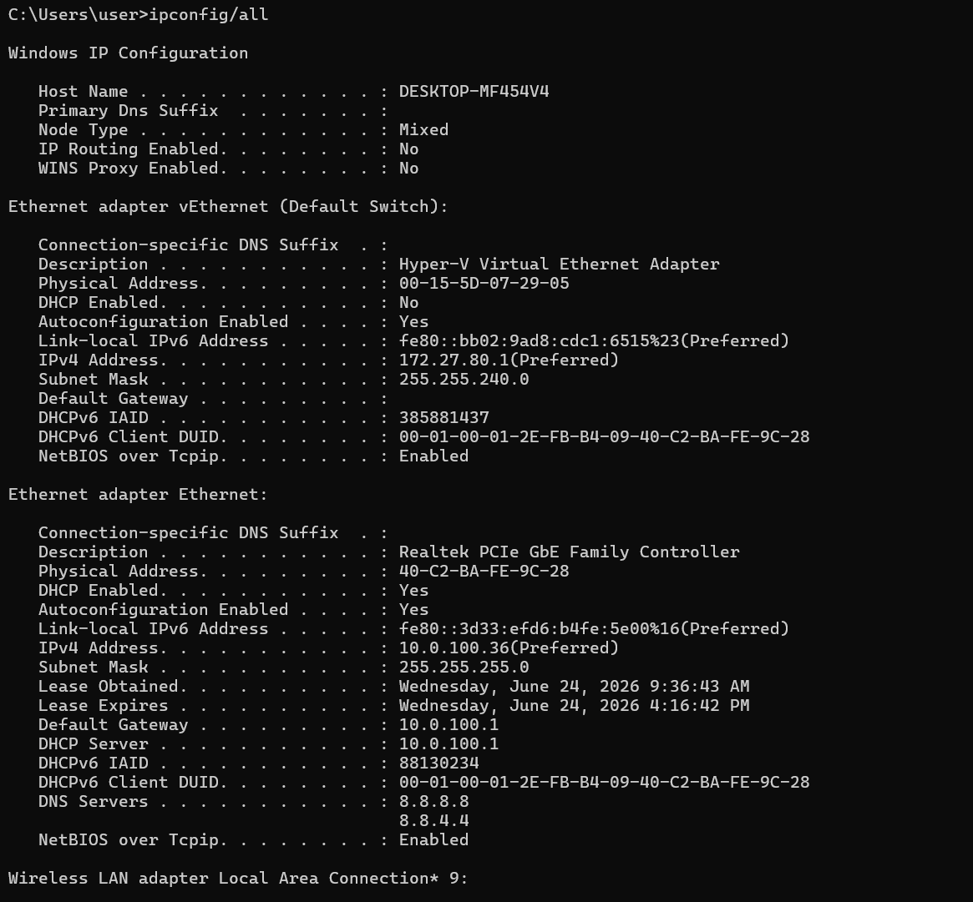

ipconfig /release
Releases the current IP address obtained from the DHCP server.
Syntax: ipconfig /release
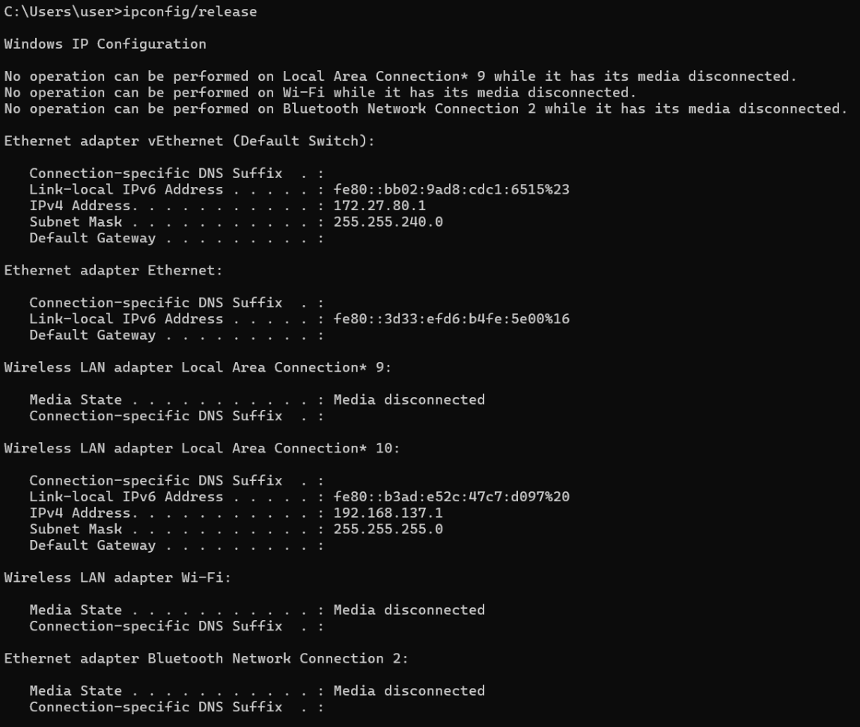

ipconfig /renew
Requests a new IP address from the DHCP server.
Syntax: ipconfig /renew
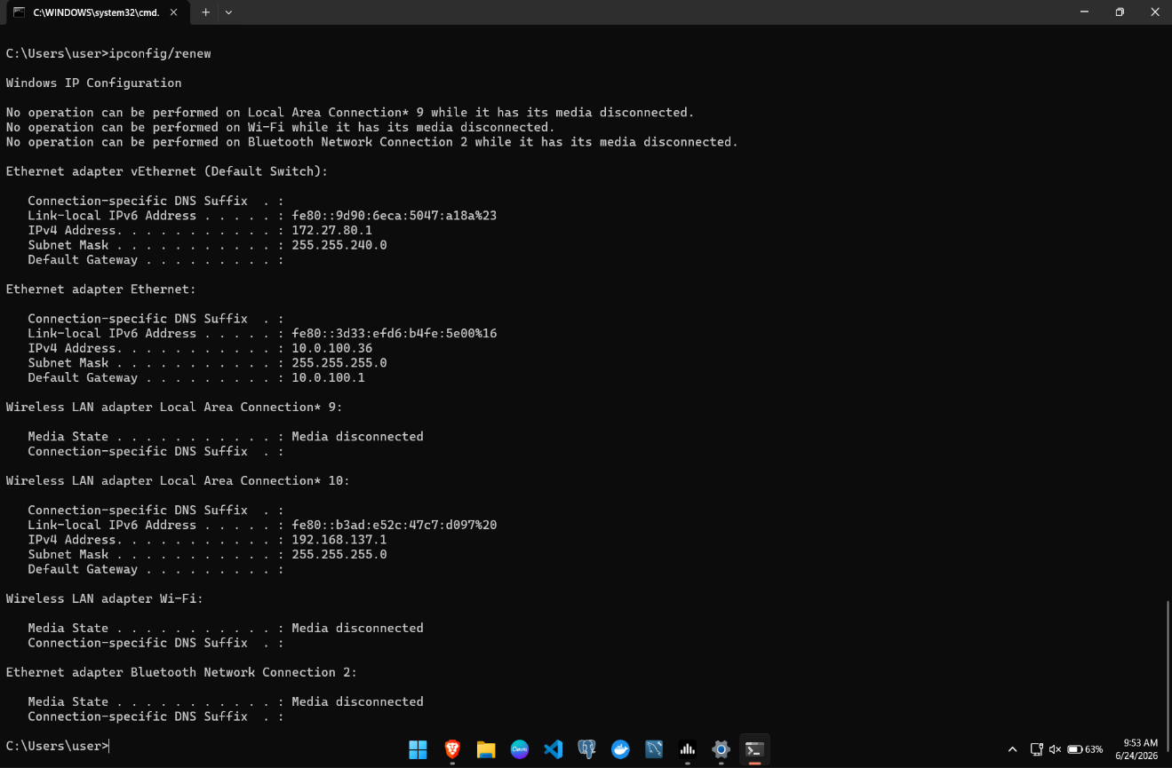w

ipconfig /flushdns
Clears the DNS resolver cache stored on the local computer.
Syntax: ipconfig /flushdns

6.ping
Tests connectivity between two devices by sending ICMP Echo Request packets.
Syntax: ping <IP Address> or ping website URL.
Example: ping 8.8.8.8 or ping sxc.edu.np
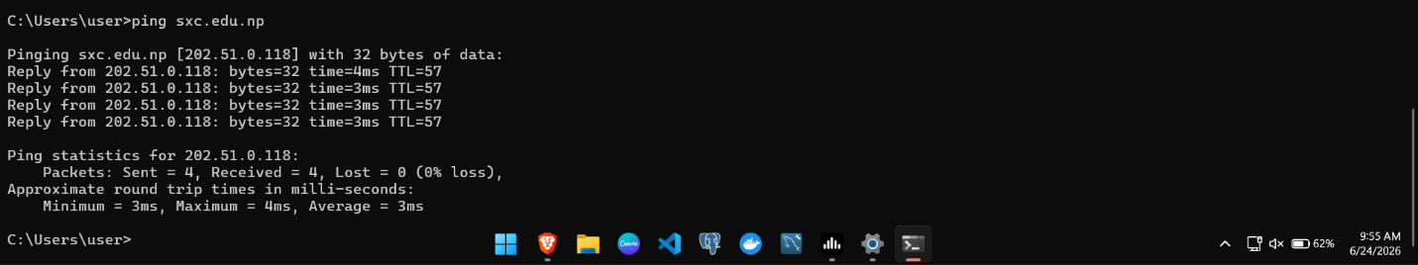

7.ping -t
Continuously sends ping requests until manually stopped using Ctrl + C.
Syntax: ping <Address> -t Example: ping google.com -t
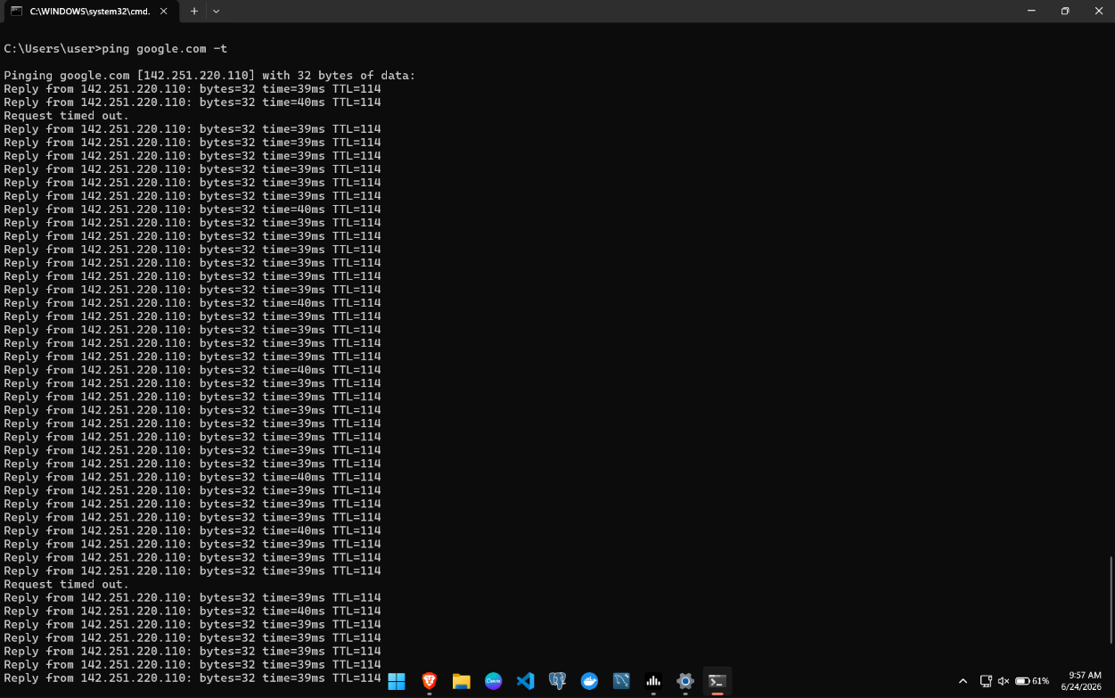

- ping -l <size> -t
Sends continuous ping requests with a specified packet size. Syntax: ping <IP Address> -l <packet_size> -t Example: ping google.com -l 1500 -t
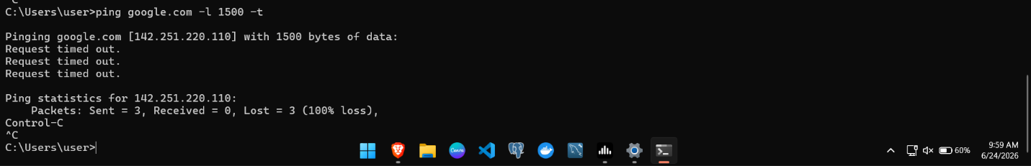

tracert
Displays the path taken by packets from the source to the destination.
Syntax: tracert <Address> Example: i. tracert google.com
ii.tracert sxc.edu.np

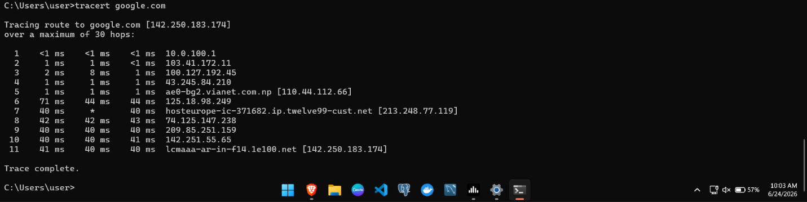
fig I. tracert google.com
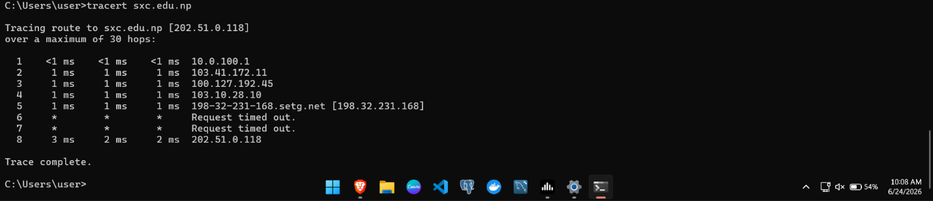
Fig II. Tracert sxc.edu.np

nslookup
Queries DNS servers to obtain IP addresses corresponding to domain names.
Syntax: nslookup <domain_name> Example: nslookup google.com
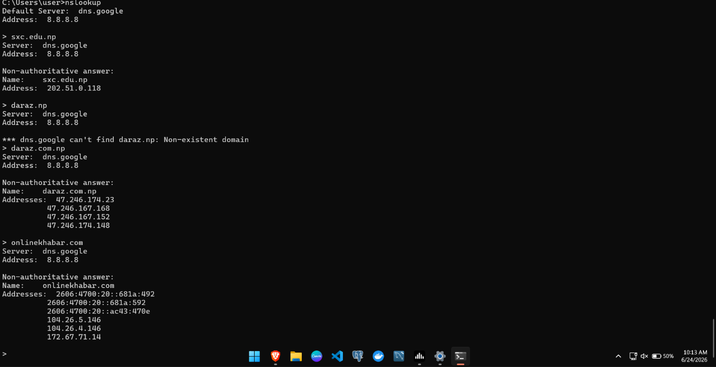

netstat
Displays active network connections and network statistics.
Syntax: netstat
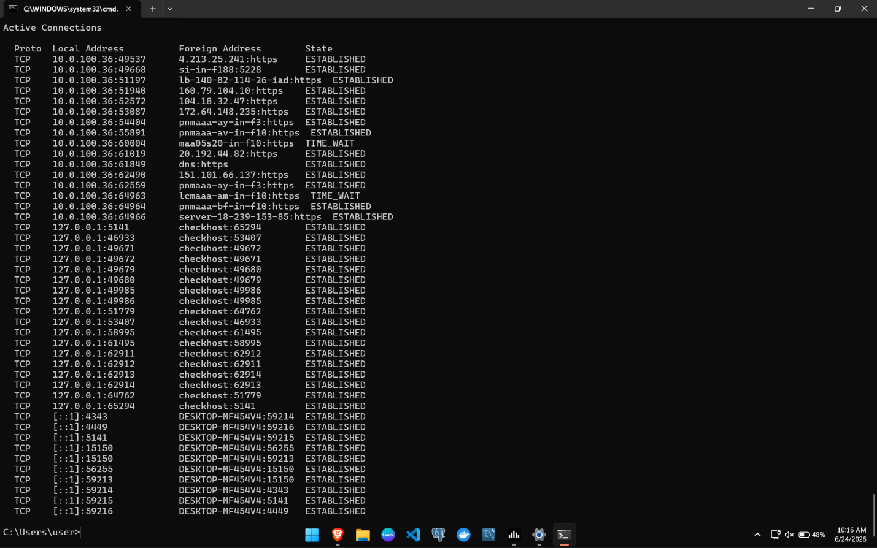

netstat -an
Displays all active connections and listening ports numerically.
Syntax: netstat -an
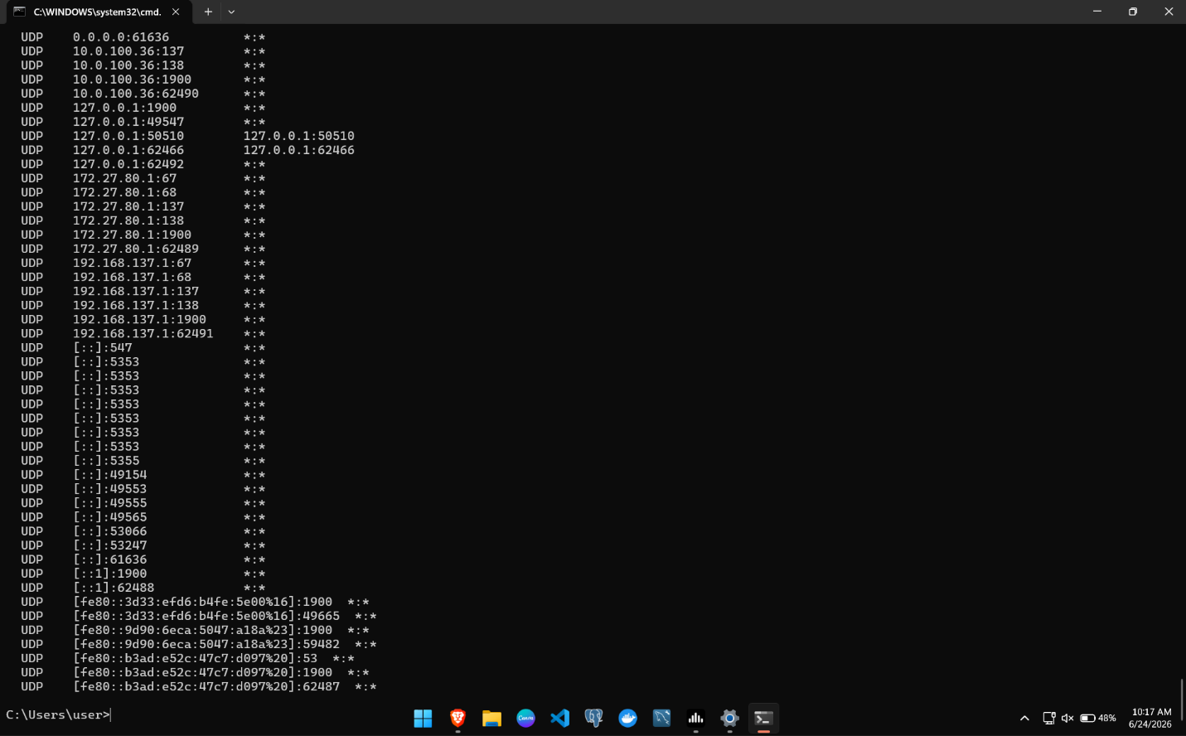

arp -a
Displays the Address Resolution Protocol (ARP) cache containing IP-to-MAC address mappings.
Syntax: arp -a
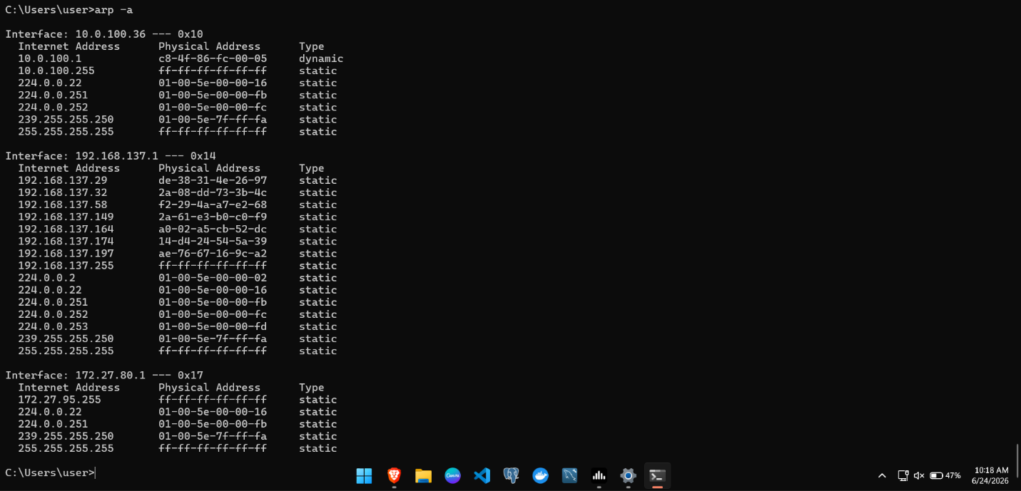

hostname
provides the name of the local computer or the user in the network.
Syntax: hostname

getmac
Displays the MAC addresses of network adapters installed on the computer.
Syntax: getmac
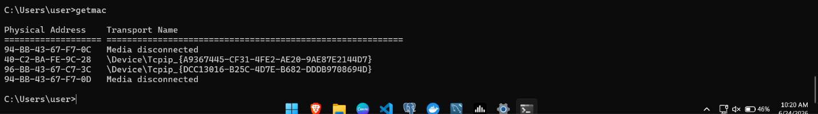

net share
Displays shared folders and resources available on the computer.
Syntax: net share
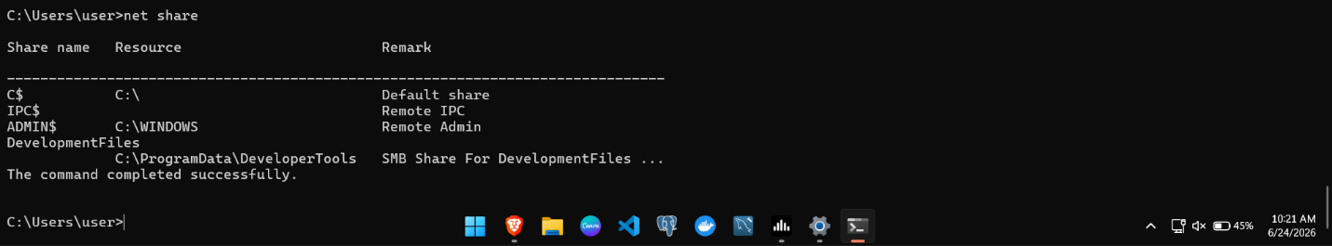

net start
Displays currently running Windows services.
Syntax: net start
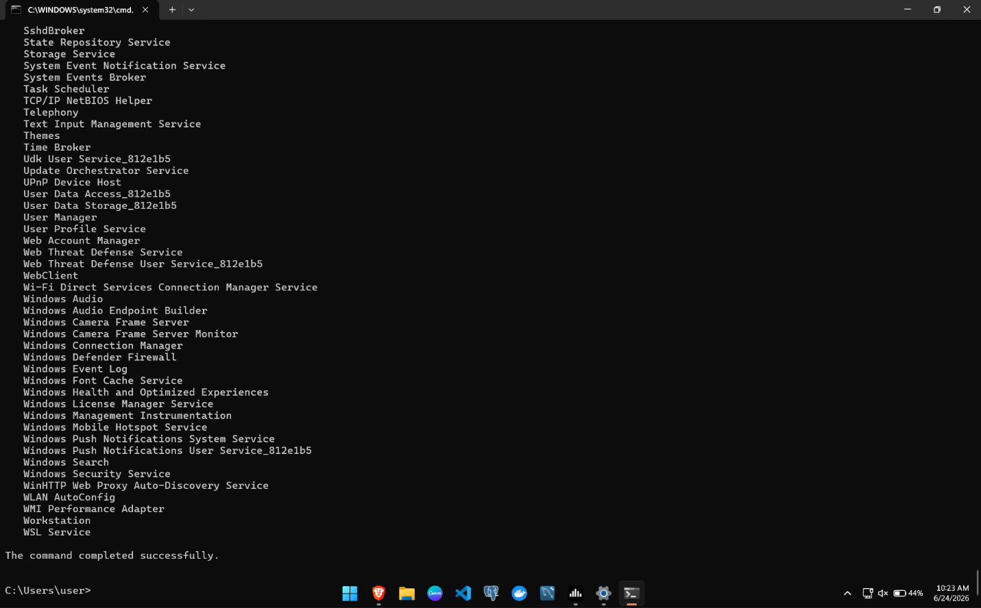

net stop
Stops a specified Windows service. Syntax: net stop <service_name> Example: net stop spooler
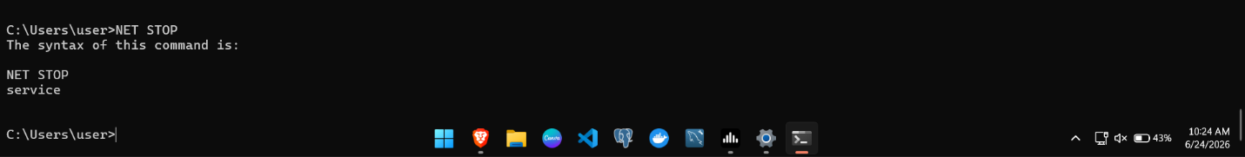

color
Changes the foreground and background colors of the Command Prompt window.
Syntax: color n (where n is the integer)
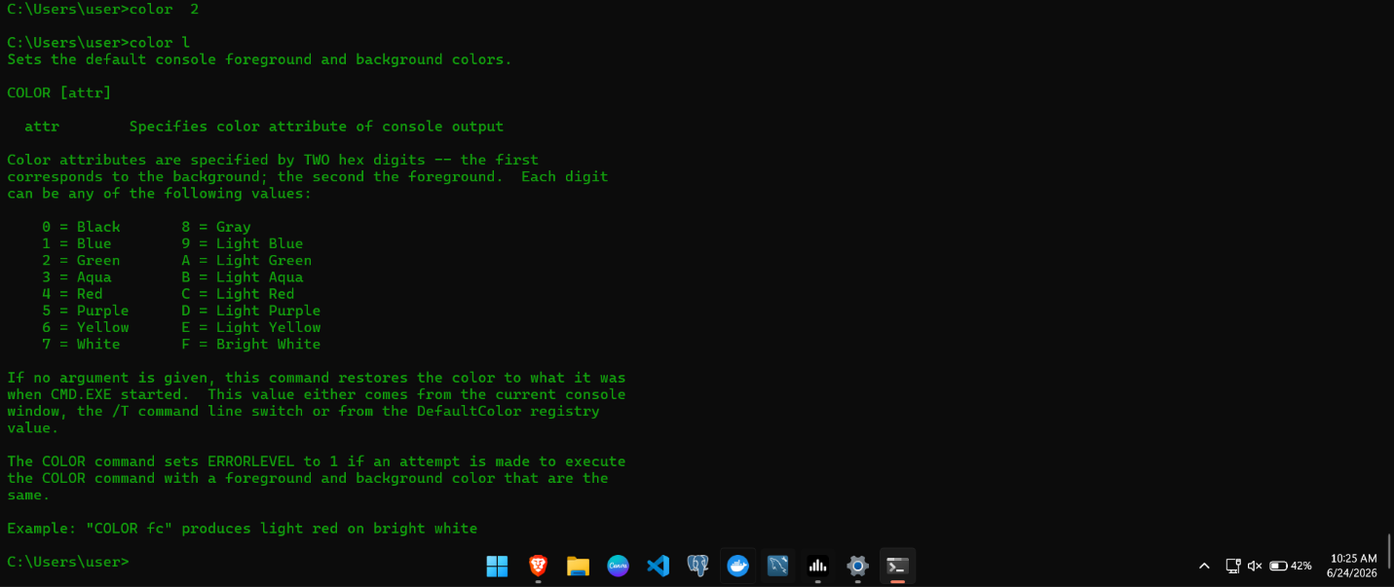

Examples: color 1F: Blue background with bright white text. color 2F: Green background with bright white text. color 3F: Aqua background with bright white text.

Lab 2.2: DHCP Server Configuration and Dynamic IP Address Allocation Using Cisco Packet Tracer
Objective: Demonstrates how to configure a DHCP server and validate automatic IP address deployment to network hosts within Packet Tracer.

Theory

While Lab 1 utilized manual (static) IP addressing, a method viable only for small-scale environments. Scaling a network makes manual configuration highly inefficient and prone to human error.

To resolve this management bottleneck, Dynamic Host Configuration Protocol (DHCP) is deployed. Operating at the application layer, DHCP automates the distribution of IP addresses alongside critical network parameters like subnet masks, default gateways, and DNS server addresses. This automation significantly reduces administrative overhead and eliminates configuration conflicts across the network.

COMPONENTS IN THE DHCP CONFIGURATION
- DHCP SERVER

A DHCP server manages a centralized IP address pool, dynamically allocating addresses to network clients upon request.

DHCP Client

A DHCP client is any network host configured to automatically request and receive its IP parameters from a DHCP server.

DHCP Scope
The range of IP addresses available for assignment. Example:
Network: 192.168.1.0/24
Range: 192.168.1.2 – 192.168.1.254
Gateway: 192.168.1.1

DHCP Process (DORA) I. DISCOVER
The client broadcasts a DHCP Discover message to locate available DHCP servers.

II. OFFER
The DHCP server replies with an available IP address.

III. REQUEST
The client requests the offered IP address.

IV. ACKNOWLEDGEMENT

This final confirmation completes the DORA transaction—a four-step message exchange consisting of Discover, Offer, Request, and Acknowledgment—which governs how a client secures an IP lease.

Components Required
- Router 2901
- Switch 2960
- Server
- PCs/Laptops
- Copper Straight-Through Cable

Procedure:

Creating the Network Topology
  - Launch Cisco Packet Tracer and open a blank workspace.
  - Place the following devices in the workspace:
    - 1 * Router (2901)
    - 1* Switch (2960)
    - 1* Server
    - 2 * PCs
    - 2 * Laptops
  - Interconnect all host endpoints and the server to the central Switch using standard Copper Straight-Through media.
  - Connect the Router’s LAN interface to an available port on the Switch using a Copper Straight-Through cable to finalize physical topology.
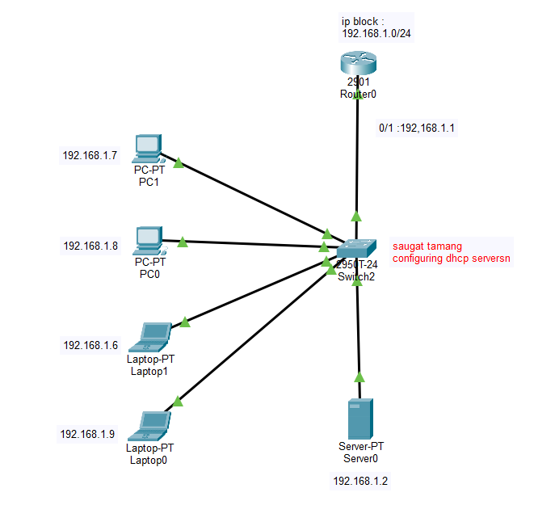

Configuring the Router
  - Open the Router CLI.
  - Enter privileged mode: Router> enable
  - Enter configuration mode: Router# conf t
  - Configure the router interface:
Router(config)# interface gigabitEthernet 0/0
Router(config-if)# ip address 192.168.1.1 255.255.255.0 Router(config-if)# no shutdown
  - Save the configuration.
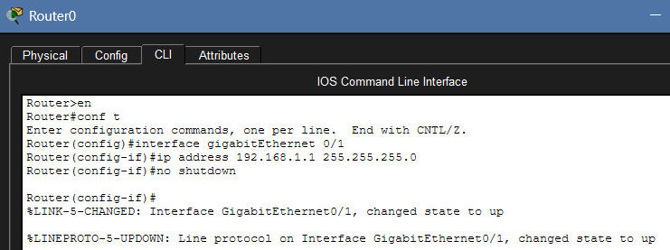

Configuring DHCP on the Router
  - Open the Router CLI and enter global configuration mode.
Router> enable
Router# configure terminal
  - Exclude reserved IP addresses:
Router(config)# ip dhcp excluded-address 192.168.1.1 192.168.1.5
  - Create a DHCP pool: Router(config)# ip dhcp pool surakshya_dahal
  - Configure the network, gateway, and DNS server:
Router(dhcp-config)# network 192.168.1.0 255.255.255.0
Router(dhcp-config)# default-router 192.168.1.1
Router(dhcp-config)# dns-server 10.10.10.10
  - Exit and save the configuration:
Router(dhcp-config)# exit
Router# wr
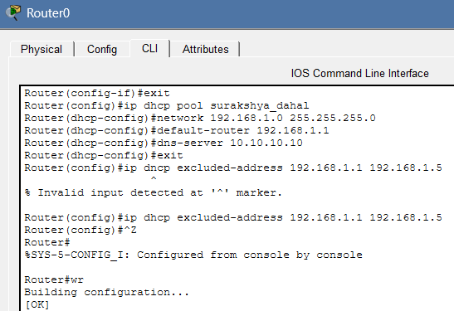

Configuring the DHCP Server
  - Open the Server.
  - Navigate to: Services → DHCP
  - Turn the DHCP service ON.
  - Create a DHCP pool.
  - Click Add to create the pool.

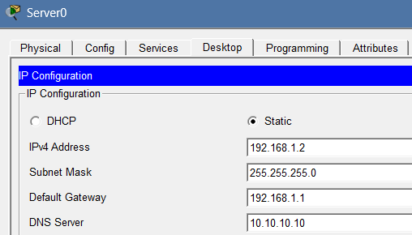

Configuring Clients
  - Open each PC and Laptop.
  - Navigate to: Desktop → IP Configuration
  - Select: DHCP
  - Wait for the device to obtain an IP address automatically.
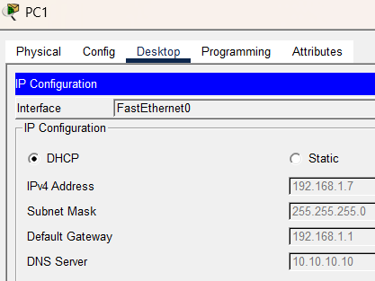
  - Verify that valid IP addresses have been assigned.
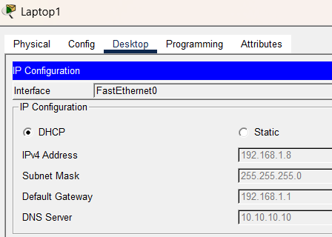
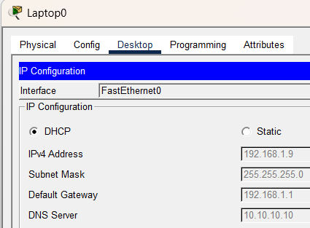
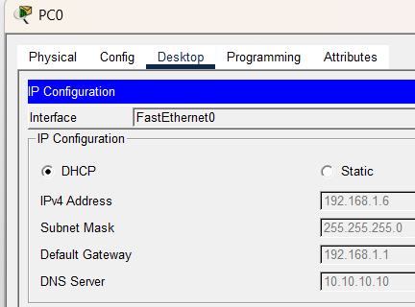

Testing Connectivity
    - Open Command Prompt on a client device (P0)
    - Ping the router: ping 192.168.1.1
    - Ping the server: ping 192.168.1.2
    - Verify successful replies.
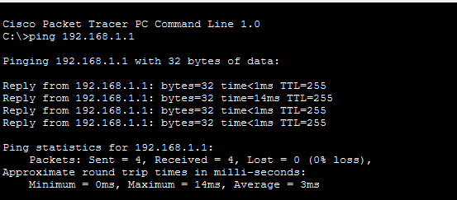

Fig: Pinging the router (192.168.1.1) from
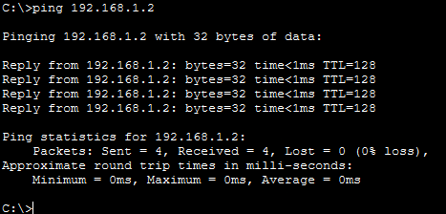

Fig: Pinging the server (192.168.1.2) from client( pc 0,1 or laptop 0,1)

Simulation Verification
    - Switch Packet Tracer to Simulation Mode.
    - Generate network traffic using the ping command. (pinging PC0 to Laptop1)
    - Observe packet exchange between the DHCP server and clients.
    - Verify successful network communication.

Output
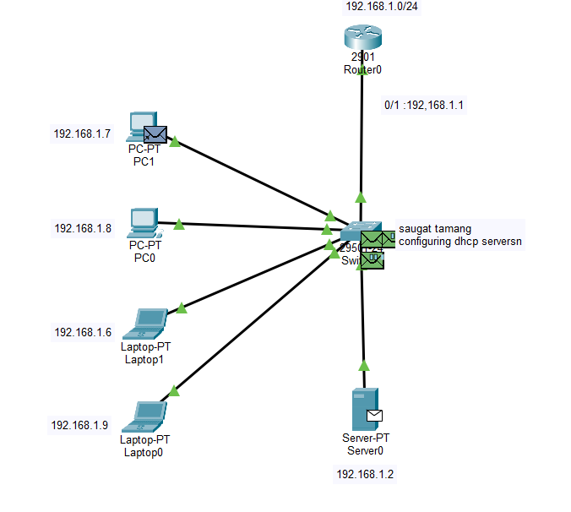

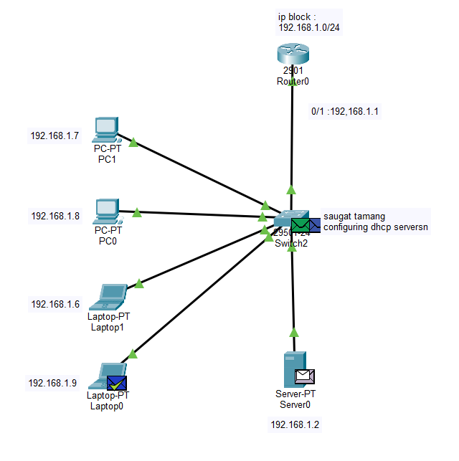

Conclusion
This lab successfully combined the study of Windows command-line diagnostics with automated network design. Utilizing commands like ipconfig, ping, tracert, nslookup, netstat, and arp provided essential hands-on experience in network monitoring and troubleshooting. Furthermore, by configuring a DHCP server in Cisco Packet Tracer, the lab demonstrated a shift from the manual addressing used in Lab 1 to an automated model. The seamless distribution of IP configurations and subsequent connectivity checks proved the scalability and efficiency of dynamic IP management.

