Lab1 :

OBJECTIVE:
- To build several topologies for getting familiar with Cisco Packet Tracer software
- To learn about the network Cabling fundamentals

THEORY:

i.) Cisco packet tracer
Cisco Packet Tracer is the powerful network simulation and visualization tool designed by the Cisco Systems for the educational and training purposes. It allows user to create virtual network topologies by dragging and dropping various networking devices, such as routers, switches, access points, and end-user hosts.
Additionally, its dual-mode functionality features a logical view for designing network architecture and a simulation mode that provides real-time, packet-by-packet data flow visualization. Ultimately, it serves as an invaluable tool for bridging the gap between theoretical networking concepts and practical hands-on application

ii.) Cable Networking
Network Connectivity relies on the specific media types, primarily UTP (Unshielded Twisted Pair) and fiber-optics cables, to transmit data. Cables function by converting digital data into the electrical signals or light pulses that travel across a physical medium. In modern times of networking, these cables from the backbone of Ethernet networks, linking the devices like routers, switches and PCs
Physical connections are established using standardized modular connectors, such as RJ-45 plugs, crimped onto the cable ends. Proper termination adheres to strict wiring standards to ensure the signal integrity and reduce interference. Depending on the pin configuration, cables are deployed either as straight through or cross-over patches to connect different device types.

- CREATE A BUS TOPOLOGY USING THE CISCO PACKET TRACER.
The steps for creating the bus topology using the cisco packet tracer is:
- Choose the switch (preferably 2950-24 switch model) from “Network devices” section and drag 4 switches into workspace and put them in straight horizontal arrangement
- Go to the end devices, select PC model and place those PCs on the workspace, positioning one directly above and one directly below each of four switches.
- Use a copper Straight-Through cable (solid line) to connect top rows of the computer and as well as the bottom rows as well, to each separate “fast ethernet” port of the switches
- Wait for the connection signal to configure from orange to green to indicate that the connection is now viable and the connection is working. (You can use fast forward time to cut down the waiting period as well)
- Use the place note tool to add the documentation or the identification text label

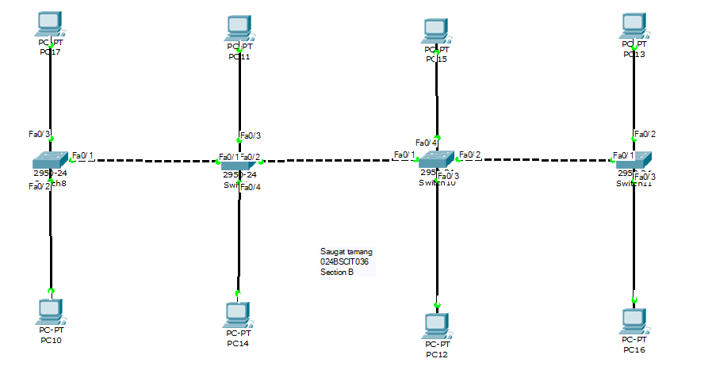

Fig: Bus topology using cisco packet tracer

- CREATE A STAR TOPOLOGY USING CISCO PACKET TRACER
The steps of creating a star topology using the Cisco packet tracer is:
- Select the “2950-24” Switch model from the Network Devices menu and place a single switch in the center of the workspace to act as the central hub of the star topology.
- Go to End Devices, select the PC model and place the numbers of the PC (typically from 4 to 8) in a circular layout around the switch (PCs connected to switch)
- Click on the first PC, select its FastEthernet0 port, and connect it to the FastEthernet0/1 port on the central switch.
- Repeat this cabling process for every remaining PC, connecting each device's network card to an available, unique FastEthernet port on the central switch until all links are physically established.
- Use the place note tool to add the documentation or the identification text label
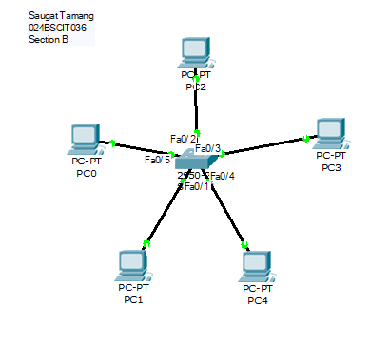

Fig: Star Topology using Cisco Packet Tracer
- CREATE A RING TOPOLOGY USING THE CISCO PACKET TRACER
The steps to create the ring topology are as follows:
- Select the “2950-24” Switch model from the Network Devices menu and place four switches onto the workspace, arranging them in a distinct circular layout.
- Go to End Devices, select the PC model, and place four PCs on the workspace, positioning one next to each of the four switches.
- Select the Automatically Choose Connection Type tool (the orange lightning bolt icon) from the connections menu to handle the cabling automatically.
- Click on the first switch and then click on the second switch; Packet Tracer will automatically draw a dashed Copper Cross-Over cable between them to link the backbone.
- Repeat this automatic connection process to link all the remaining switches together in a chain, and then use the same tool to connect every PC to its respective switch.
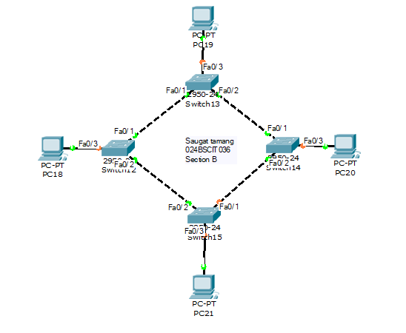

Fig: Ring Topology using Cisco Packet Tracer

- CREATE A MESH TOPOLOGY USING THE CISCO PACKET TRACER
The steps to create the mesh topology using the cisco packet tracer is:
- Select the “2950-24” Switch model from the Network Devices menu and place four or five switches onto the workspace, arranging them in a wide circular pattern.
- Go to End Devices, select the PC model, and place a computer next to each of the switches you deployed on the workspace.
- Use the automatic connection tool to link every single switch to every other switch in the network, creating a fully redundant web of interconnected backbone pathways.
- Use the same automatic connection tool to connect each individual PC to its nearest local switch using a straight-through link
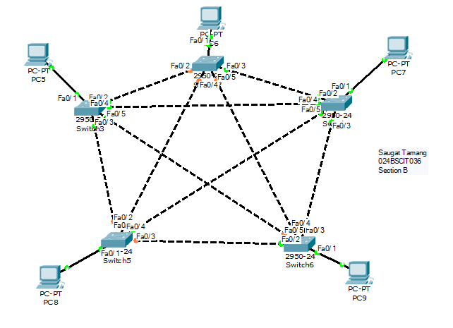
- Use the Note tool to add your identification details
Fig: mesh topology in the cisco packet tracer

