Git Basics Command
1. git branch
show all the branches in repository

2. git checkout -b <branchname>
create and switch branch

3. git checkout <branchname>
Switch to desired branch

4. git log
show all logs of commit (author of the commit, date of the commit, and commit message)
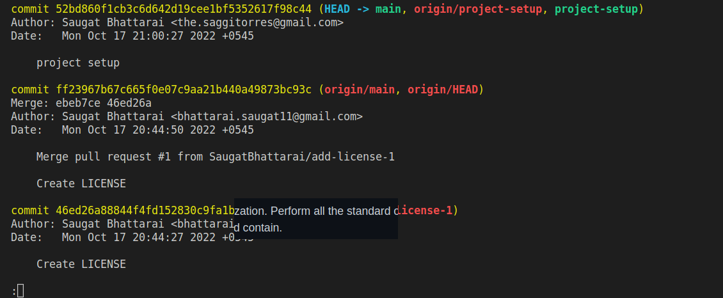
5. git push origin <branchname>
Push the commit to some branch

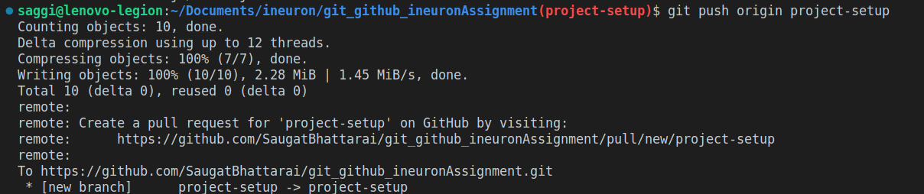

6. git commit
git commit code with commit message that have been staged.

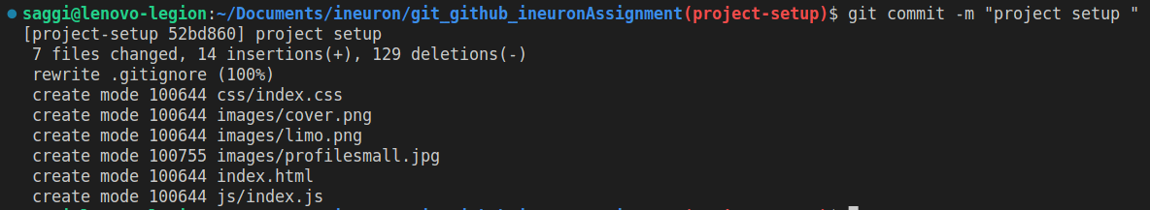
7. git pull
The git pull command is actually a combination of two other commands, git fetch followed by git merge.

8. git merge
Merge two branch

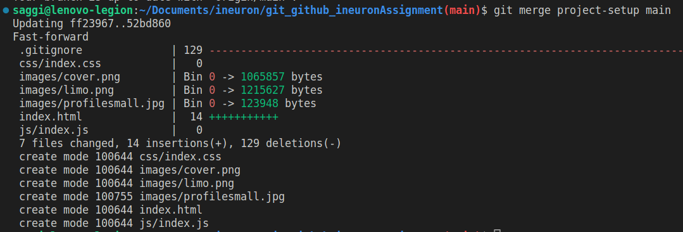
9. git remote
show remote url

10. git add
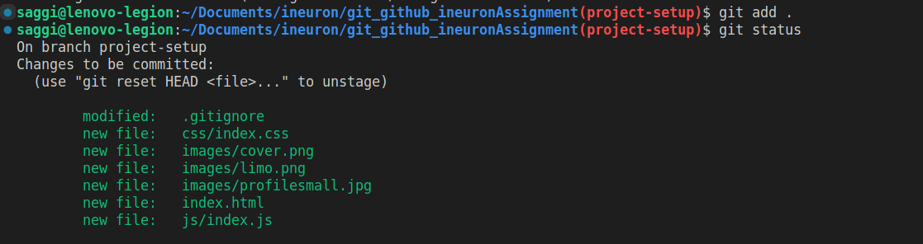
Add the changes to staging area before pushing.

11. git status
Check if there is any new changes

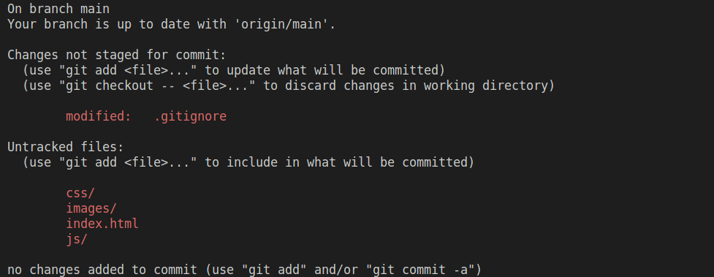
12. git stash
The git stash command takes your uncommitted changes (both staged and unstaged), saves them away for later use, and then reverts them from your working copy.

13. git stash apply
You can reapply stashed changes with the commands git stash apply.

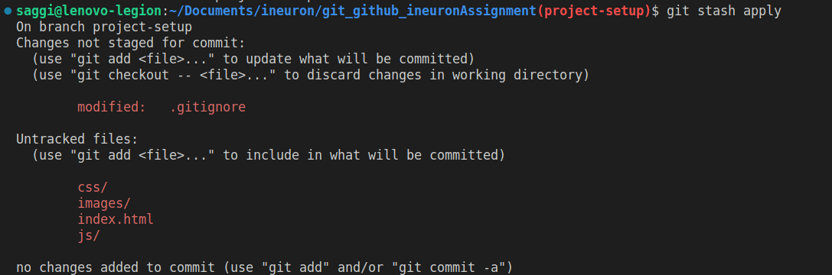

14. git version
check the version of git

15. git reset
reset HEAD before commit

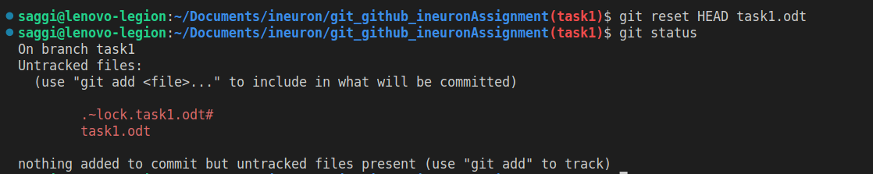

16. git clean -fd
remove untrack files and folder

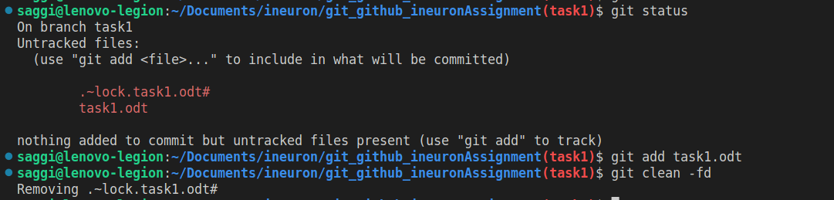
17. git add <filename>
add specific file to the staging area

