Assignment 1

1. Pull Docker images

docker pull hello-world

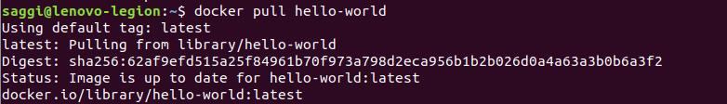

2. Build image from Dockerfile

docker build -t testprogram .

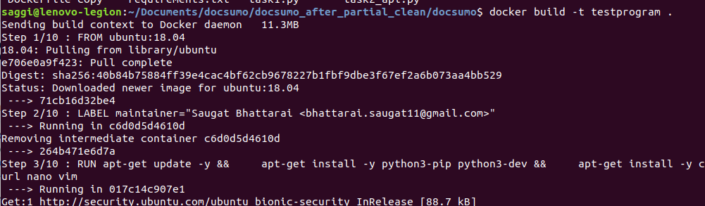

3. Run docker container in the background with the image name or id

docker run -d -p host_port:container_port <image>

4. Show docker version and build

docker -v

5. Show all docker images

docker images

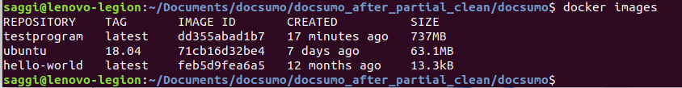

6. Show all running container

docker ps

7. Remove Image

docker rmi <image-id>

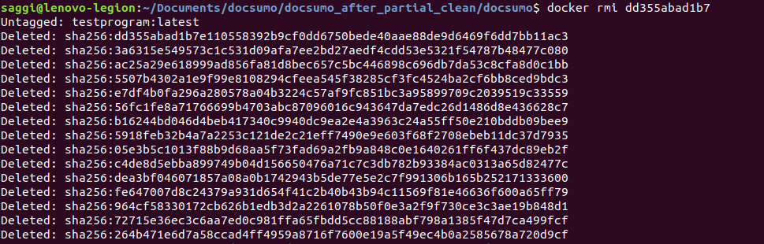

8. Remove all stopped containers

docker rm $(docker ps –filter status=exited -q)

9. Remove all images

docker rmi $(docker images -a -q)

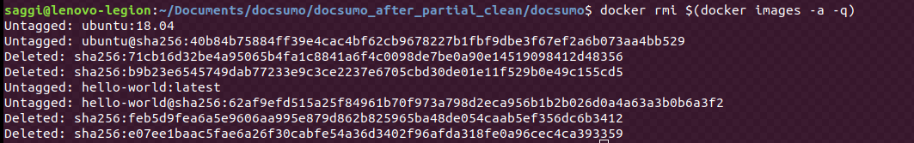

10. Show docker disk usage, including space reclaimable by pruning

docker system df

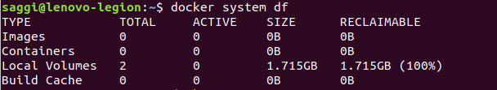

11. Show all the volumes

docker volume ls

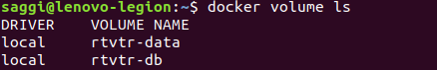

12. Remove docker volumes

docker remove volumes

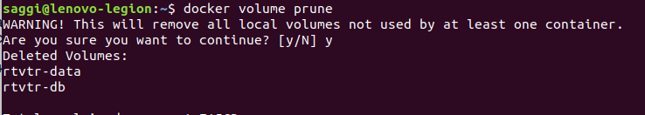

13. Remove all stopped containers, all networks not used by at lease one container, all dangling images, all dangling build cache.

docker system prune

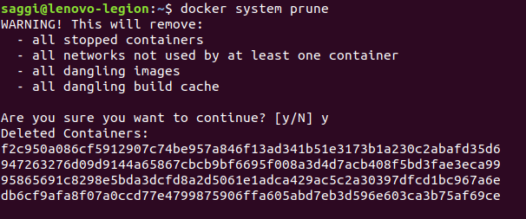

14 Login into docker hub

docker login

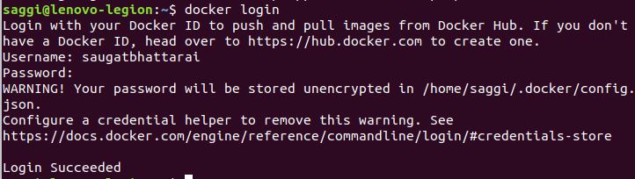

15. Logout from docker hub

docker logout

Assignment 2
Run Hello World Docker Image Locally.

Step 1:
Pull hello world image from docker hub using following command:

docker pull hello-world

Step 2:
To run the image follow the following command.

docker run hello-world

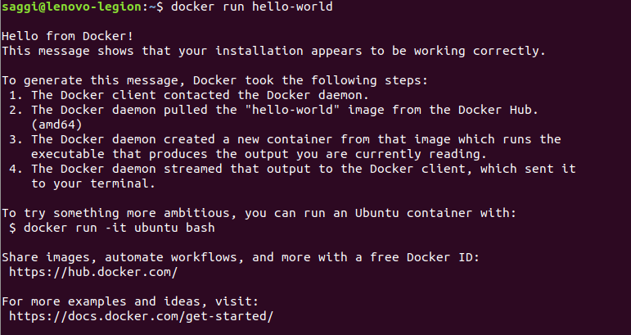

Assignment 3

