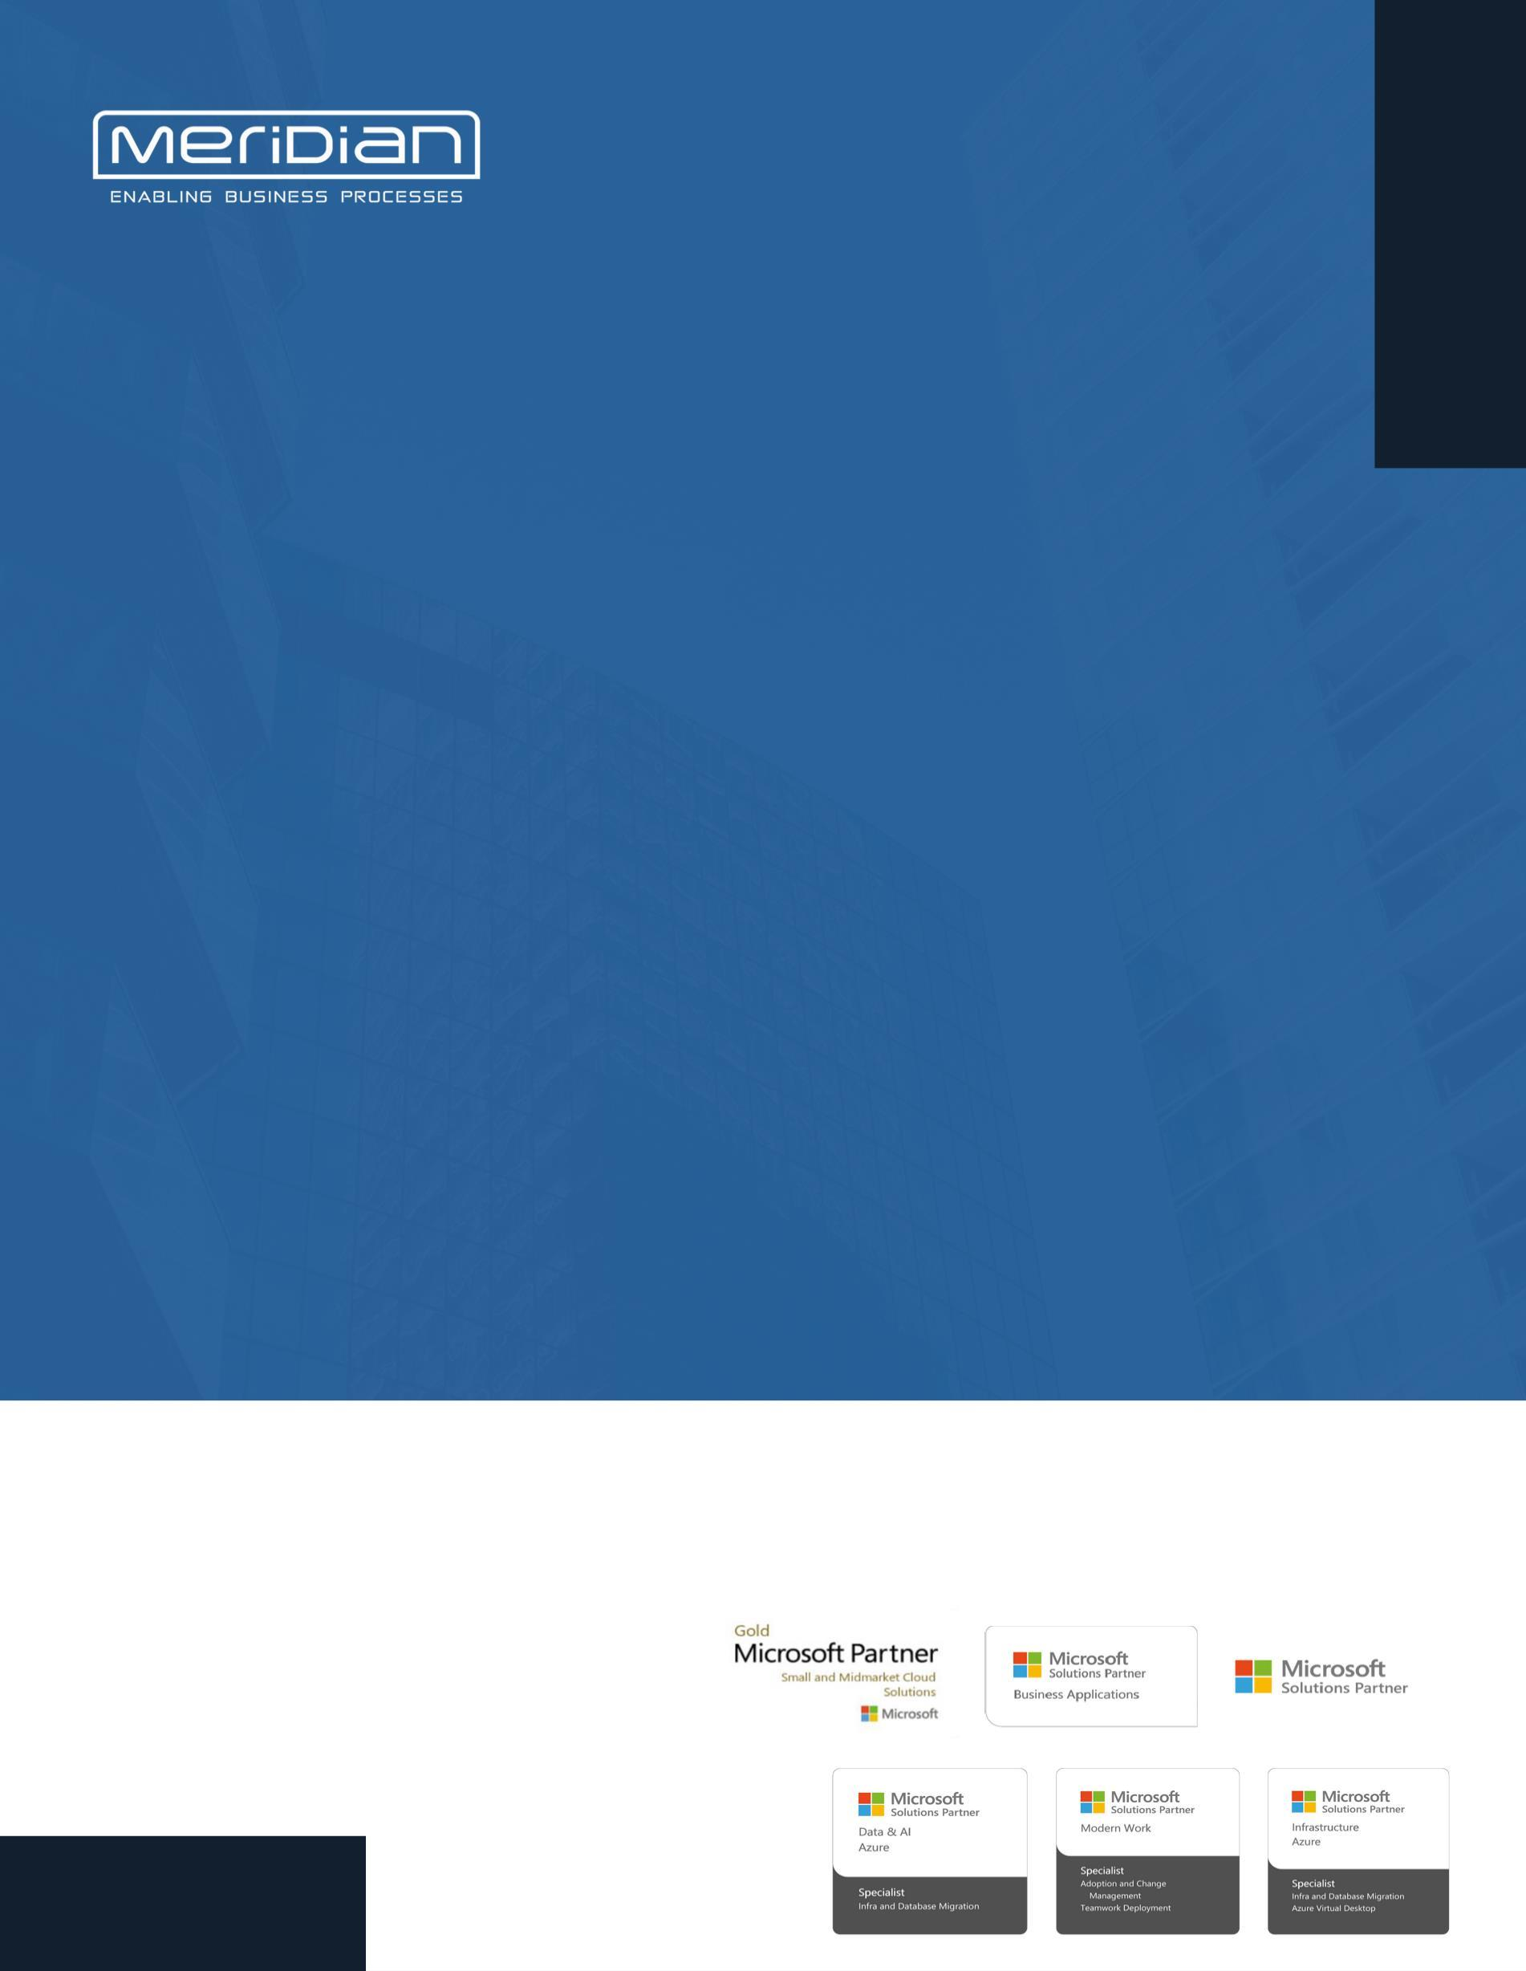

OFFICE 365 SERVICE STATUS REPORT {reportDate}

{tenantName}

Overview of Activities

1.1 User and License Management

License Type | Total License Allotted | Assigned License | Available License
{#licenses}{name} | {total} | {assigned} | {available}{/licenses}

{%licenseChart}

Tenant User Summary:
- Total Users in the Tenant: {totalUsers}
- Blocked/Unlicensed Users: {disabledUsers}
Active/Licensed Users: {activeUsers}
Action Required: Review the unlicensed users and remove any unnecessary accounts from the tenant.
https://admin.microsoft.com/?login_hint=migration%40incwert.com&source=applauncher#/users

Shared mailbox:
A shared mailbox can be used by a group of people, like a support team, to receive and send email from the same email address. Select a shared mailbox to add or remove members, set up automatic replies, manage aliases, and more. Learn more about shared mailboxes

Total shared mailboxes created in the tenant: {sharedMailboxes}

1.2 Teams and Groups:

Group Type | Total Count | Created in May
M365 Groups | {m365Groups}
Distribution Lists | {distLists}
Mail-Enabled Groups | {mailEnabled}
Security Groups | {secGroups}

To learn more about the different types of groups and where to create teams, watch the video in the link. https://www.microsoft.com/videoplayer/embed/RW10GYp

Service Health and Incident Resolution:

Microsoft ticket raised: {ticketCount} tickets raised to Microsoft

Security Updates:

2.1 Secure score:

‎Microsoft Secure Score‎ measures total opportunity for protection of your identities, data, devices, apps, and infrastructure, and your points achieved toward that protection.

{%mfaChart}

The Secure Score of {scorePct}% indicates that there is room for improvement in the organization's security posture.

Key Recommendations:

Please go through the below link for more recommendations Microsoft Secure Score - Microsoft Defender

2.2 Compliance Score:

Compliance Manager measures your progress in completing actions that help reduce risks around data protection and regulatory standards. Find guidance and documentation

Improvement actions provide guidance on task completion which can improve your org's compliance score. Action points can take up to 24 hours to update. Learn more about improvement actions

Compliance Score: {complianceScore}2.3 Adoption Score:

Your organization's ‎Adoption Score‎ is the total of its people’s experiences and technology experiences scores, which are each comprised of several categories of data. Scores are not provided at the individual user level.
{%scoreChart}

To improve the Adoption score please follow the link for recommendations
h
Adoption Score: {adoptionScore}ttps://admin.microsoft.com/?login_hint=migration%40incwert.com&source=applauncher#/adoptionscore

2.4 Usage Reports:

2.4.1 Email Usage:

Paste original screenshot here

Please go through the given link for complete details on the usage of emails

https://admin.microsoft.com/?login_hint=migration%40incwert.com&source=applauncher#/reportsUsage/EmailActivity

2.4.2 Teams Usage:
Paste original screenshot here

Please go through the given link for complete details on the usage of Teams

Teams Usage: {teamsUsage}https://admin.microsoft.com/?login_hint=migration%40incwert.com&source=applauncher#/reportsUsage/OneDriveSiteUsage

2.4.3 OneDrive Usage:

{odStorageTxt}

Please go through the given link for complete details on the usage of OneDrive

https://admin.microsoft.com/?login_hint=migration%40incwert.com&source=applauncher#/reportsUsage/OneDriveSiteUsage

2.4.4 SharePoint Usage:

Paste original screenshot here

Paste original screenshot here

Paste original screenshot here

{spStorageTxt}
Please go through the given link for complete details on the usage of Share point
https://admin.microsoft.com/?login_hint=migration%40incwert.com&source=applauncher#/reportsUsage/SharePointSiteUsageV1

Security Policies:

3.1 Devices:

Devices managed by Platform:

Devices managed by Platform: Windows: {devWindows}

MacOS: {devMac}

IOS: {devIos}

Android: {devAndroid}

3.2 Policies:

1. Configuration policies:
Policy name | Platform | Policy Type | Remarks
{#configPolicies}{name} | {platform} | {type} | {status}{/configPolicies}

2. Compliance policy
Policy name | Platform or OS | Status | How many Users | Remarks
{#compPolicies}{name} | {platform} | {status} | {users} | {remarks}{/compPolicies}

3. Conditional policy

{%deviceChart}

Reports:

1. Sign in logs shared

2. Audit logs of the tenant have been shared.

THANK YOU
For further information, please contact. Email: tech.support@onmeridian.com Web: http://onmeridian.com
Meridian Solutions Private Limited,
Office no-1103 -1105, Tower B4, Spaze I-Tech Park, Sohna Road, Sector 49, Gurugram, Haryana, 122018 Toll Free: 1-800-102-2150

