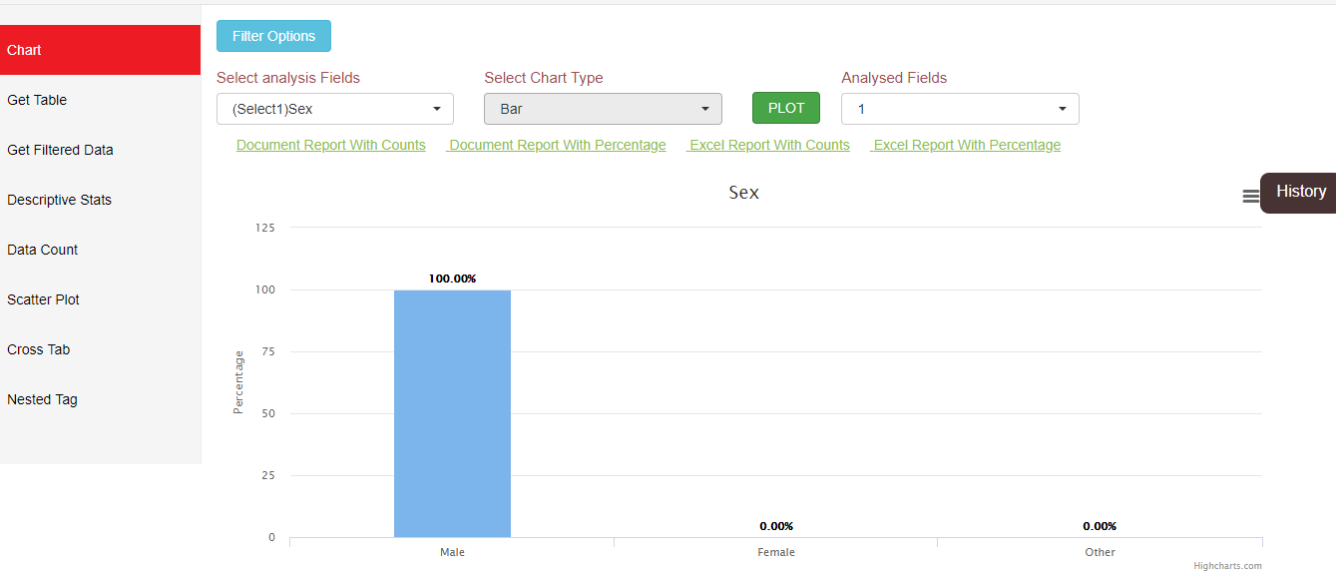

1. Visualization using HighchartJs

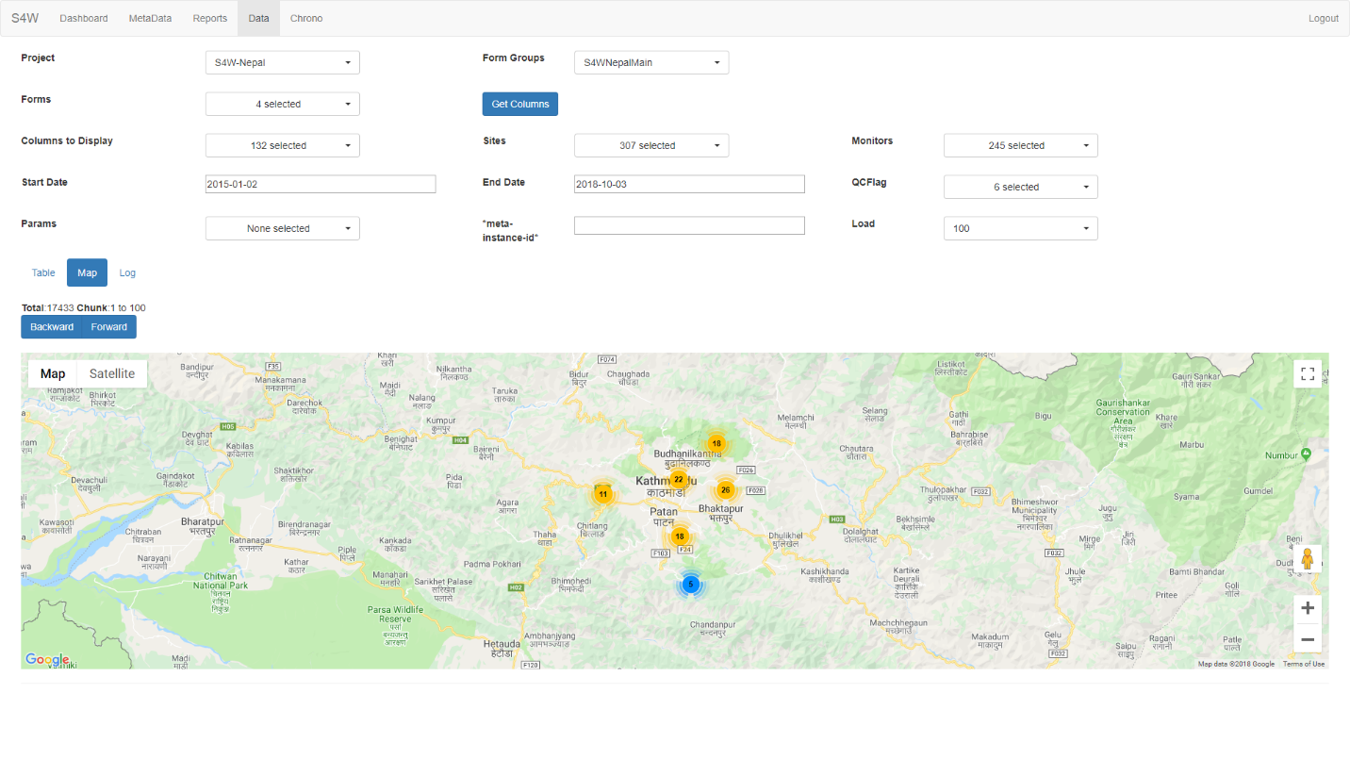

2) Google Map integrated with Filter Feature

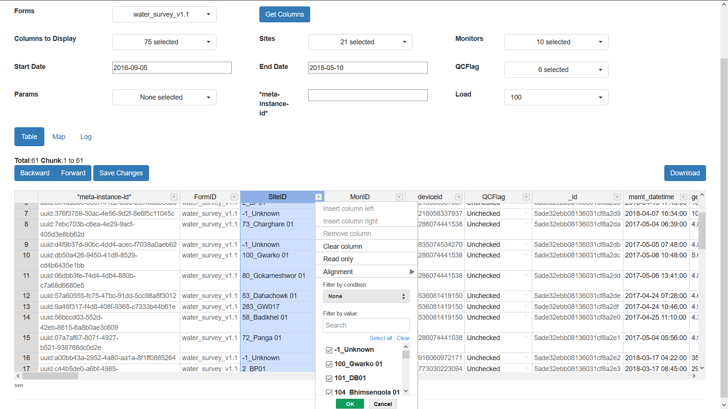

3) Implemented Handsontable (table) which has search, filter and sorting features.

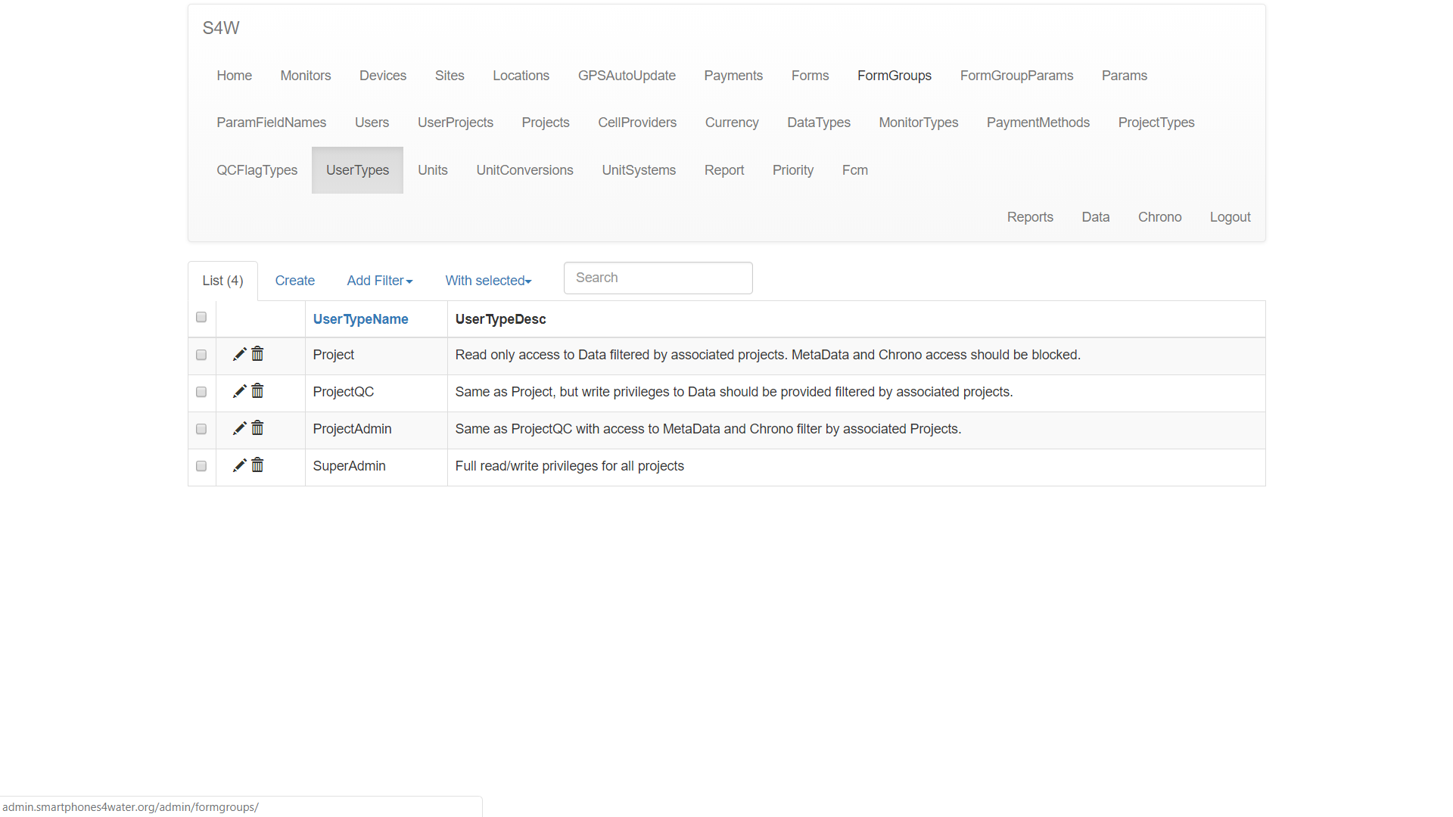

4) Flask Admin that provides database interface to view database records.