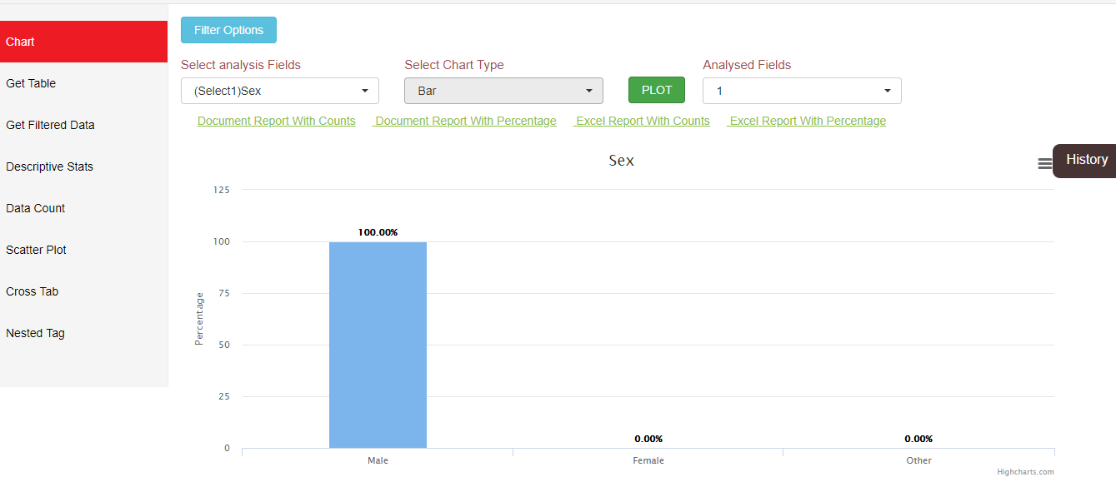

1. Visualization using HighchartJs

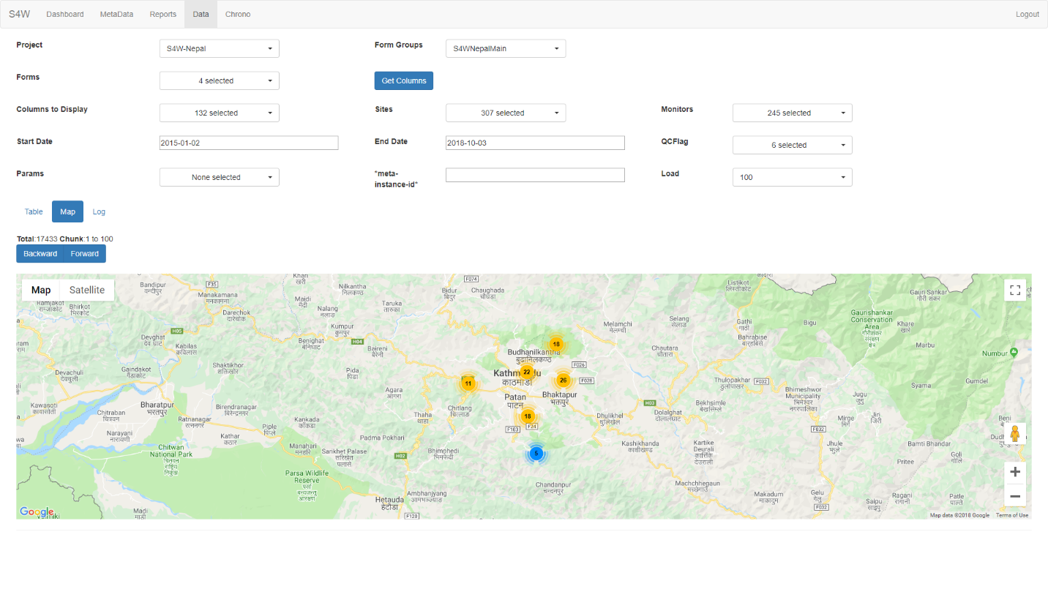

2) Google Map integrated with Filter Feature

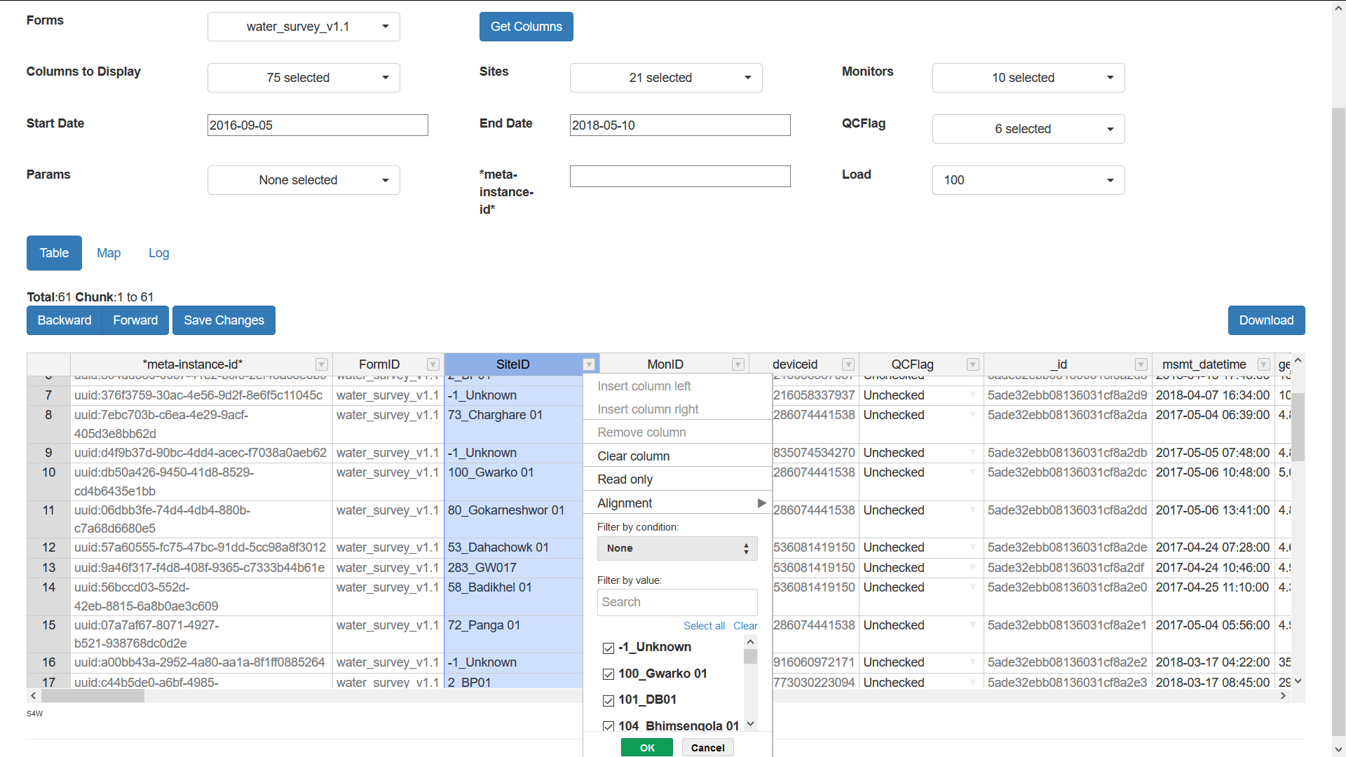

3) Implemented Handsontable (table) which has search, filter and sorting features.

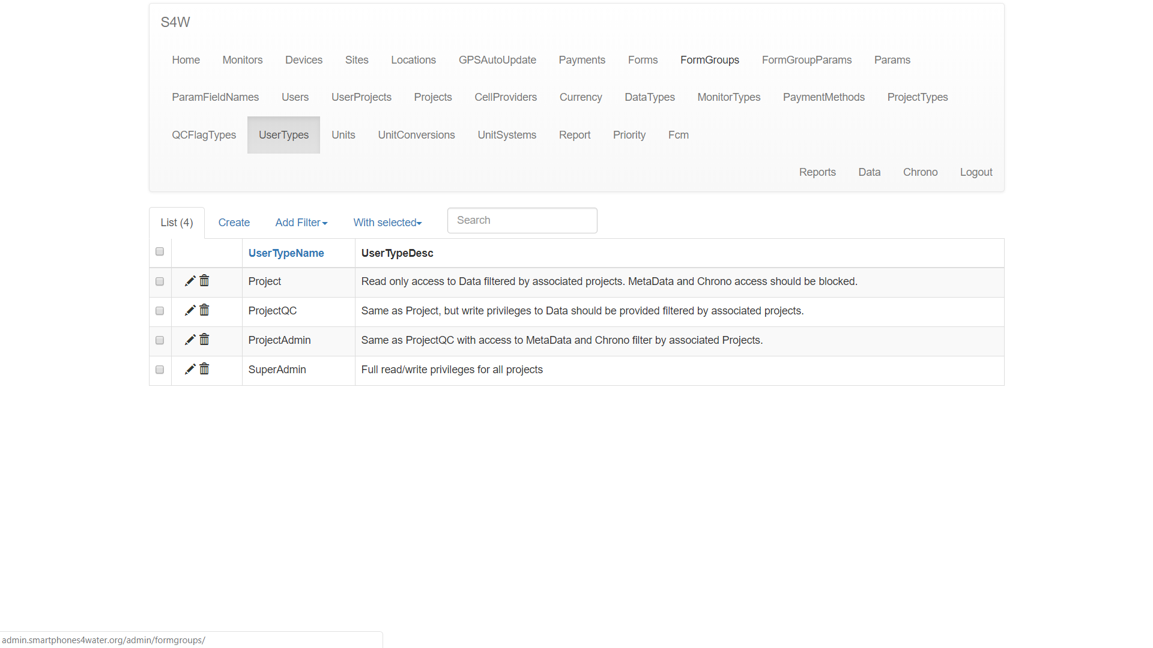

4) Flask Admin that provides database interface to view database records.

**Output of Python Custom Scripts**

Programming tool : python , pandas

Database : MongoDB/MySQL

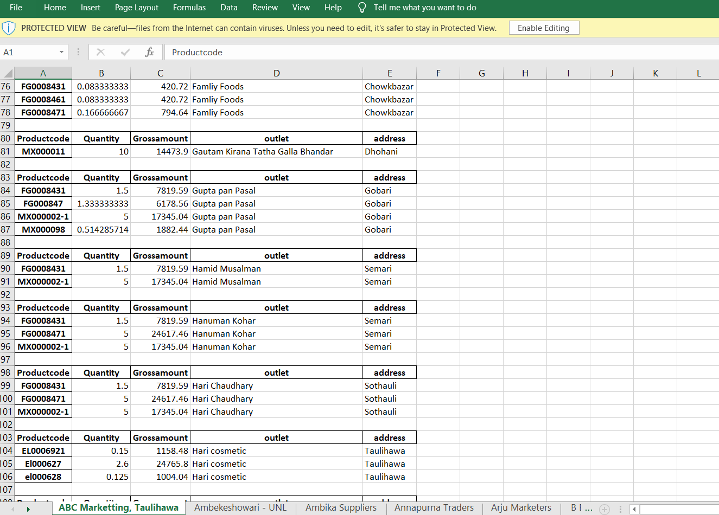

Programming tool : Python , Matplotlib

Data Source : Raw CSV

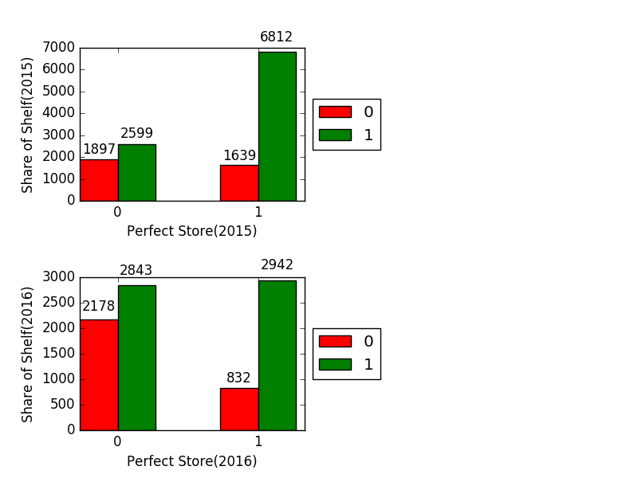

**QGIS and Python**

Auto Generation of few Maps reports using QGIS and python scripts (PyQGIS).

