***“AUTOMATED QUIZ”***

A MINI- PROJECT REPORT ON

Submitted in partial fulfilment of the requirements

For the degree of

Bachelor of Engineering

In

Information Technology

by

**Niraj Ratnawat, Roll No. 18IT1015**

**Rudresh Paradkar, Roll No. 18IT2020**

**Saujanya Pandey, Roll No. 18IT1046**

Supervisor

**Nilima Dongre**



Department of Information Technology

Dr. D. Y. Patil Group’s

**Ramrao Adik Institute of Technology**

Dr. D. Y. Patil Vidyanagar, Sector 7, Nerul, Navi Mumbai 400706.

(Affiliated to University of Mumbai)

( 2020)

# rait logo

Ramrao Adik Institute of Technology

(Affiliated to the University of Mumbai)

Dr. D. Y. Patil Vidyanagar, Sector 7, Nerul, Navi Mumbai 400706.

CERTIFICATE

This is to certify that, Mini Project entitled

“Automated Quiz”

is a bonafide work done by

Niraj Ratnawat, Rudresh Paradkar, Saujanya Pandey

and is submitted in the partial fulfillment of the requirement for the

degree of

Bachelor of Engineering

in

Information Technology

to the

University of Mumbai

Supervisor

Prof. Nilima M. Dongre

Project Guide Head of the department

Nilima Dongre Dr. Ashish Jadhav

Certificate of Approval by Examiners

This Mini Project report entitled “Automated Quiz” is a bonafide work done by Niraj Ratnawat, Rudresh Paradkar, Saujanya Pandey under the supervision of Prof. Nilima Dongre approved for the award of Bachel or Degree in Information Technology, University of Mumbai.

Examiners :

1. . . . . . . . . . . . . . . . . . . . . . . . . . . . . . .

2. . . . . . . . . . . . . . . . . . . . . . . . . . . . . . .

Supervisors :

1. . . . . . . . . . . . . . . . . . . . . . . . . . . . . . .

2. . . . . . . . . . . . . . . . . . . . . . . . . . . . . . .

Principal :

. . . . . . . . . . . . . . . . . . . . . . . . . . . . . .

Date :

Place :

# **DECLARATION**

We declare that this written submission represents our ideas in our own words and where others' ideas or words have been included, we have adequately cited and referenced the original sources. We also declare that we have adhered to all principles of academic honesty and integrity and have not misrepresented or fabricated or falsified any idea/data/fact/source in our submission. We understand that any violation of the above will be cause for disciplinary action by the Institute and can also evoke penal action from the sources which have thus not been properly cited or from whom proper permission has not been taken when needed.

**Name and Roll No. of Students Signature**

1. Niraj Ratnawat, 18IT1015
2. Rudresh Paradkar, 18IT2020
3. Saujanya Pandey, 18IT1046

Date:

Place:

# ACKNOWLEDGEMENT

The project “AUTOMATED QUIZ” is creative work of many minds. A proper synchronization between individual is must for any project to be completed successfully. One cannot imagine the power of the force that guides us all and neither can we succeed without acknowledging it.

We take this opportunity to express my profound gratitude and deep regards to our Guide **Nilima Dongre**, Department of the Information Technology Engineering for her or her exemplary guidance, monitoring and constant encouragement throughout the completion of this mini project.

We would like to express our gratitude to **Dr. Ashish Jadhav,** Head of the department, Information Technology Engineering for encouraging and inspiring us to carry out the project in the department lab. We take this privilege to express my sincere thanksare thankful to **Dr. Mukesh D. Patil, Principal RAIT,** for his constant support and motivation.

We also would like to thank all the staff members Department of the Information Technology Engineering for providing us with the required facilities and support towards the completion of the project.

Last but not the least we are thankful to our parents and friends for their constant Inspiration, encouragement and well wishes by which we have made a challenging project.

STUDENT-NAME (ROLLNO) Signature

1. Niraj Ratnawat (18IT1015)
2. Rudresh Paradkar (18IT2020)
3. Saujanya Pandey (18IT1046)

# **PREFACE**

We take great opportunity to present this Mini Project report on “**Automated Quiz”** and put before readers some useful information regarding our project.

We have made sincere attempts and taken every care to present this matter in precise and compact form, the language being as simple as possible. We are sure that the information contained in this volume certainly prove useful for better insight in the scope and dimension of this project in it true perspective.

The task of the completion of the project though being difficult was made quite simple, interesting and successful due to deep involvement and complete dedication of our group members.

**TABLE OF CONTENTS**

**Declaration …………….…….………………………………………… I**

**Acknowledgement ……...……………………………………………… II**

**Preface …………….…………………………………………………… III**

**Table of Contents ……………………………………………………… IV**

**Table of figures ...…………………………………………………….… V**

**Abstract…….....…………………………………………………..…….. VI**

**TABLE OF CONTENTS**

**Sr. No. Topic Page No.**

1. **INTRODUCTION………………………………………………………………..8**
   1. **INTRODUCTION TO SCRIPTING LANGUAGES………………………10**
   2. **WHY PARTICULAR SCRIPTING LANGUAGE………………………...11**
   3. **PROBLEM STATEMENT………………………………………………….12**
   4. **OBJECTIVES………………………………………………………………..13**
2. **LITERATURE SURVEY……………………………………………………….14**
   1. **MOTIVATION………………………………………………………………15**
3. **PROPOSED SYSTEM…………………………………………………………..16**
   1. **INTRODUCTION OF PROPOSED SYSTEM AND**

**ARCHITECTURE …………………………………………………………...16**

* 1. **HARDWARE AND SOFTWARE REQUIREMENTS……………………17**

1. **IMPLEMENTATION……………………………………………………………21**
   1. **SYSTEM BLOCK DIAGRAM……………….……………………………...21**
   2. **CODE………………………………………………………………………….22**
2. **RESULT…………………………………………………………………………...36**
   * 1. **OUTPUT SNAPSHOTS**
     2. **TESTING AND VALIDATION**
3. **CONCLUSION AND FUTURE SCOPE………………………………………..37**
   1. **CONCLUSION……………………………………………………………….37**
   2. **FUTURE SCOPE…………………………………………………………….37**
   3. **BENEFITS TO SOCIETY…………………………………………………..38**
4. **REFERENCES……………………………………………………………………47**

**ABSTRACT**

As our mini-project, we have created a simple yet informative ‘Automated Quiz’ with the help of shell scripting language.

In today’s world, it is really important to be up-to-date with facts regarding general knowledge or in general knowing basic things related to your country or culture. So, we saw quizzes as a very interactive and fun way to test and also impart new knowledge, ranging from the field of sports to politics to the different ecosystems.

We have created this automated quiz with the idea that it’ll not only be fun but also impart or refresh some knowledge to the user. This quiz follows a basic format of a question presented with two options having one right answer. Each right answer gives a single score point and, in the end, the user gets to know his final score and score percentage according to the no. of correct answers given.

**CHAPTER -1**

**INTRODUCTION**

**INTRODUCTION**

* 1. **INTRODUCTION TO SCRIPTING LANGUAGES**

For our mini project we have used SHELL Scripting Language.

A shell is special user program which provide an interface to user to use operating system services. Shell accept human readable commands from user and convert them into something which kernel can understand. It is a command language interpreter that execute commands read from input devices such as keyboards or from files. The shell gets started when the user logs in or start the terminal.

**WHY PARTICULAR SCRIPTING LANGUAGE**

There are many reasons to write shell scripts –

* To avoid repetitive work and automation
* System admins use shell scripting for routine backups
* System monitoring
* Adding new functionality to the shell etc.
  1. **PROBLEM STATEMENT**
* Prone to costly errors, a single mistake can change the command which

might be harmful

* Slow execution speed
* Design flaws within the language syntax or implementation
* Not well suited for large and complex task
  1. **OBJECTIVES**
* The command and syntax are exactly the same as those directly entered in
* command line, so programmer do not need to switch to entirely different
* syntax: Writing shell scripts are much quicker
* Quick start

**CHAPTER -2**

**LITERATURE SURVEY**

**2.1** **MOTIVATION**

Automated quiz is a form of entertainment and information. An Automated Quiz is generally free to play & for entertainment and informational purposes only.

Automated quiz is setup to actually test knowledge or identity a person’s attribute. Some companies use of quiz as an efficient way of testing a potential hire’s knowledge without that candidate needing to travel.

**This can be used in educational institutions as well.**

The **Automated Quiz** can be used take online test in an efficient manner and no time wasting for checking the paper.

The main objective of **Automated Quiz** is to efficiently evaluate the candidate thoroughly through a fully automated system that not only saves lot of time but also gives fast results. For students they give papers according to their convenience and time and there is no need of using extra thing like paper, pen etc.

**CHAPTER -3**

**PROPOSED SYSTEM**

**3.1 HARDWARE AND SOFTWARE REQUIREMENTS**

The following mini-project of **Automated Quiz** programmed using bash shell scripting language does not involve a conventional graphical user interface and thus it's specific requirements with their corresponding information is mentioned below

⦁ Shell can be accessed by a user using a command-line interface. A special program called Terminal in Linux/macOS or Command Prompt in Windows OS is provided to type in the human-readable commands such as “cat”, “ls” etc. and then it is being executed. The result is then displayed on the terminal to the user. It will list all the files in current working directory in a long listing format. Working with the command-line shell is bit difficult for the beginners because it’s hard to memorize so many commands. It is very powerful, it allows user to store commands in a file and execute them together. This way any repetitive task can be easily automated. These files are usually called batch files in Windows and Shell Scripts in Linux/macOS systems

⦁A command-line interface (CLI) is an operating system shell that uses alphanumeric characters typed on a keyboard to provide instructions and data to the operating system, interactively. For example, a teletypewriter can send codes representing keystrokes to a command interpreter program running on the computer; the command interpreter parses the sequence of keystrokes and responds with an error message if it cannot recognize the sequence of characters, or it may carry out some other program action such as loading an application program, listing files, logging in a user and many others. Operating systems such as UNIX have a large variety of shell programs with different commands, syntax and capabilities. Some operating systems had only a single style of command interface; commodity operating systems such as MS-DOS came with a standard command interface but third-party interfaces were also often available, providing additional features or functions such as menuing or remote program execution.

**CHAPTER –4**

**IMPLEMENTATION**

**4.1 System Block Diagram**

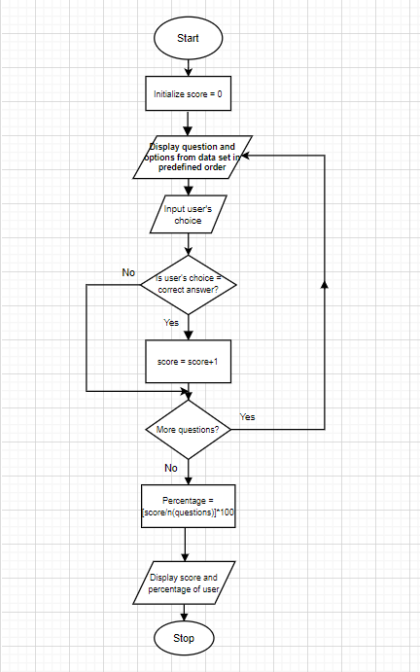

**4.2 CODE**

**Shell script ( quiz.sh ) :-**

clear

score=0

qno=1;

while IFS='#' read -r question choices answer

do

echo

echo " ---------------------------------------------- "

echo

font="\033#6"

printf "$font WELCOME TO THE QUIZ ! "

echo

echo

echo " ---------------------------------------------- "

echo

echo "There are a total of 15 questions in this quiz"

echo " from various categories."

echo

echo " ------------------------ "

echo

echo "Q"$qno"." $question

qno=`expr $qno + 1`

echo

echo "-> "$choices

echo

echo "Your Answer: "

read student_answer </dev/tty

if [ "$student_answer" = "$answer" ]; then

score=`expr $score + 1`

fi

clear

done <quiz_dataset.txt

echo

echo "Your Score is: $score"

echo "Your Score Percentage is: " $(echo "scale=2 ; ($score/15*100)" | bc)

echo

**Dataset ( quiz_dataset.txt ) :-**

Which is the faster animal ?#a) Jaguar b) Cheetah#b

Which is the longest river ?#a) Nile b) Ganges#a

Which is the older university?#a) IIT, Roorkee b) University of Mumbai#a

What is India's population density?#a) 382/km^2 b) 423/km^2#a

When is Hindi Diwas celebrated in India?#a) 14th September b) 12th April#a

Which state is known as India's spice garden?#a) Assam b) Kerala#b

Which Russian town suffered an infamous nuclear disaster in 1986?#a) Chernobyl b) Moscow#a

Which major football club is based in the city of London?#a) Liverpool FC b) Chelsea FC#b

Which of these events is NOT part of a decathlon?#a) Hammer throw b) High jump#a

What country won the very first FIFA World Cup?#a) Argentina b) Uruguay#b

Who is often credited with creating the world’s first car?#a) Henry Ford b) Karl Benz#b

Which European nation was said to invent hot dogs?#a) Germany b) France#a

Which cricketer had scored highest individual score in first-class cricket?#a) Don Bradman b) Brian Lara#b

What is the name given to the border which separates Pakistan and Afghanistan?#a) Durand Line b) McMohan Line#a

Which is the world's oldest known continuously inhabited city?#a) Damascus, Syria b) Athens, Greece#a

**CHAPTER –5**

**RESULT**

**5.1 OUTPUT SNAPSHOTS**

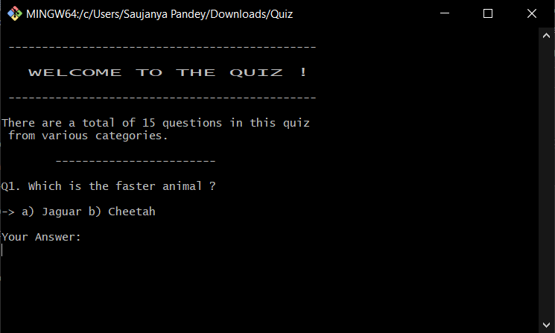

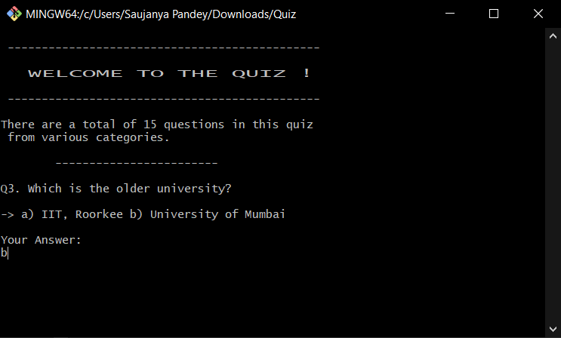

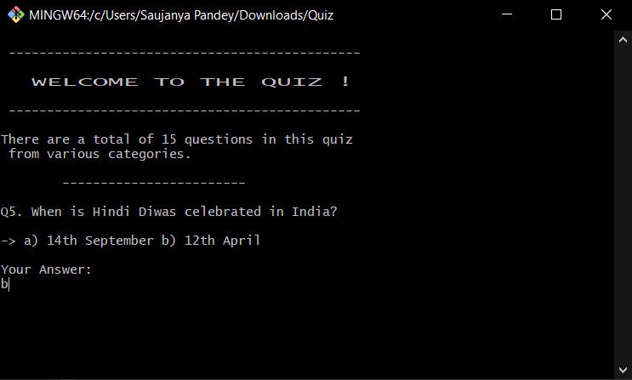

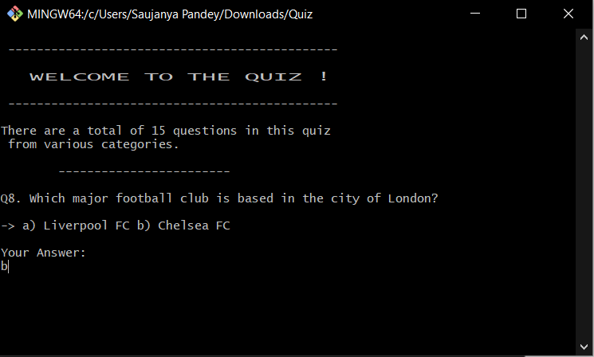

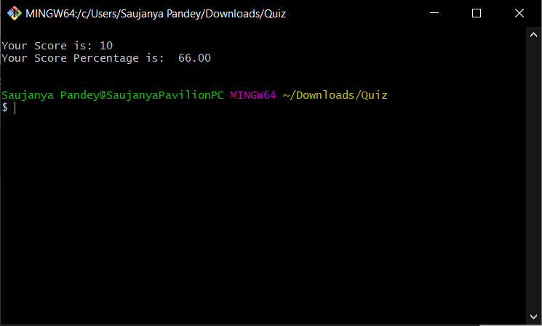

**CHAPTER –6**

**CONCLUSION AND FUTURE SCOPE**

**6.1 CONCLUSION**

In the end, we would like to conclude that we aimed to make ‘Automated Quiz’ using Bash script. It can be used from entertainment as well as an educational point of view.

**6.2 FUTURE SCOPE**

The scope of this project is very broad in terms of other manually checking yourself.

*Few of them are*: -

-Many categories can be added to attempt a quiz having questions only from specific topics like politics or sports.

-A user login system can be incorporated so that different users can log their previous attempts and compare high scores.

-This can be used in educational institutions as well as in the corporate sector with different and dynamic data sets.

-This can be one possible substitution for the pen and paper exam using data sets consisting of syllabus related questions.

**6.3 REFERENCES**

* [**www.google.com**](http://www.google.com)
* [**www.tutorialpoint.com**](http://www.tutorialpoint.com)
* [**www.w3schools.com**](http://www.w3schools.com)
* [**www.youtube.com**](http://www.youtube.com)
* [**www.geeksforgeeks.com**](http://www.geeksforgeeks.com)