# Instructions

Write a function that returns the earned points in a single toss of a Darts game.

**[Darts](https://en.wikipedia.org/wiki/Darts" \t "https://exercism.org/tracks/csharp/exercises/_blank)** is a game where players throw darts at a **[target](https://en.wikipedia.org/wiki/Darts" \l "/media/File:Darts_in_a_dartboard.jpg" \t "https://exercism.org/tracks/csharp/exercises/_blank)**.

In our particular instance of the game, the target rewards 4 different amounts of points, depending on where the dart lands:

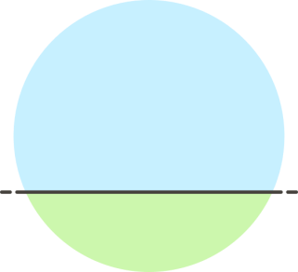

* If the dart lands outside the target, player earns no points (0 points).
* If the dart lands in the outer circle of the target, player earns 1 point.
* If the dart lands in the middle circle of the target, player earns 5 points.
* If the dart lands in the inner circle of the target, player earns 10 points.

The outer circle has a radius of 10 units (this is equivalent to the total radius for the entire target), the middle circle a radius of 5 units, and the inner circle a radius of 1. Of course, they are all centered at the same point — that is, the circles are **[concentric](https://mathworld.wolfram.com/ConcentricCircles.html" \t "https://exercism.org/tracks/csharp/exercises/_blank)** defined by the coordinates (0, 0).

Write a function that given a point in the target (defined by its **[Cartesian coordinates](https://www.mathsisfun.com/data/cartesian-coordinates.html" \t "https://exercism.org/tracks/csharp/exercises/_blank)** x and y, where x and y are **[real](https://www.mathsisfun.com/numbers/real-numbers.html" \t "https://exercism.org/tracks/csharp/exercises/_blank)**), returns the correct amount earned by a dart landing at that point.