Direcciones IP
Equipo | Dirección IP | Subnet mask | Default gateway | VLAN
Server ADM | 172.16.4.2 | 255.255.255.0 | 172.16.4.1 | 103
ADM1 | 172.16.4.3 | 255.255.255.0 | 172.16.4.1 | 103
ADM2 | 172.16.4.4 | 255.255.255.0 | 172.16.4.1 | 103
Server ACA | 172.16.5.2 | 255.255.255.0 | 172.16.5.1 | 203
ACA1 | 172.16.5.3 | 255.255.255.0 | 172.16.5.1 | 203
ACA2 | 172.16.5.4 | 255.255.255.0 | 172.16.5.1 | 203
Server INV | 172.16.6.2 | 255.255.255.0 | 172.16.6.1 | 303
INV1 | 172.16.6.3 | 255.255.255.0 | 172.16.6.1 | 303
INV2 | 172.16.6.4 | 255.255.255.0 | 172.16.6.1 | 303
Server ADM | 172.16.7.2 | 255.255.255.0 | 172.16.7.1 | 403
ADM1 | 172.16.7.3 | 255.255.255.0 | 172.16.7.1 | 403
ADM2 | 172.16.7.4 | 255.255.255.0 | 172.16.7.1 | 403

Topología
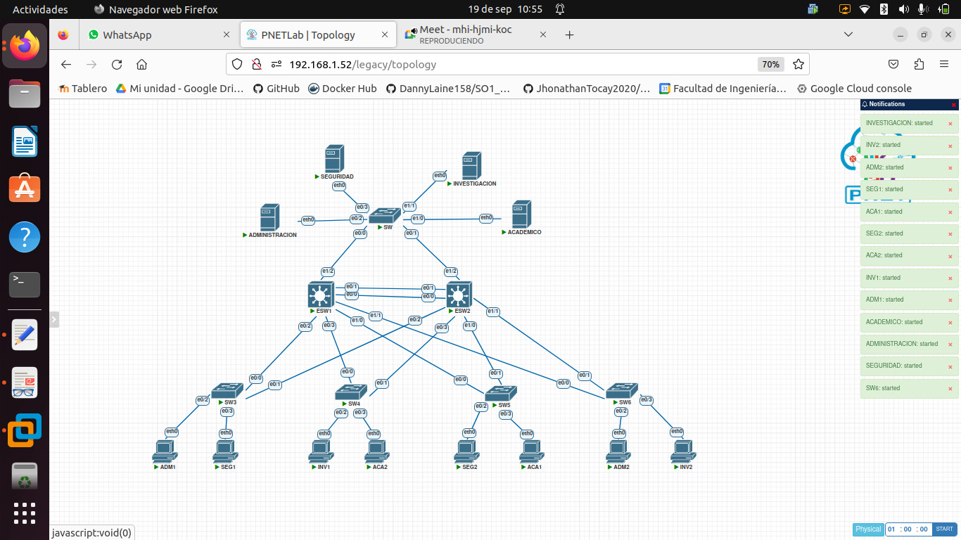

Comandos usados

ESW1
enable
configure terminal
hostname ESW1

interface range ethernet 0/0-3
switchport trunk encapsulation dot1q
switchport mode trunk
switchport trunk native vlan 99

interface range ethernet 1/0-2
switchport trunk encapsulation dot1q
switchport mode trunk
switchport trunk native vlan 99

vlan 103
name Administracion
vlan 203
name Control Academico
vlan 303
name Centro de Inves
vlan 403
name Seguridad
vlan 99
name Nativa
vlan 999
name Blackhole

interface ethernet 1/3
switchport mode access
switchport access vlan 999

configure terminal
vtp mode server
vtp domain pareja03
vtp password usac

spanning-tree mode rapid-pvst

end
copy running-config startup-config

SW5
enable
configure terminal
hostname SW5

interface range ethernet 0/0-1
switchport trunk encapsulation dot1q
switchport mode trunk
switchport trunk native vlan 99

vtp mode client
vtp domain pareja03
vtp password usac

interface ethernet 0/2
switchport mode access
switchport access vlan 403

interface ethernet 0/3
switchport mode access
switchport access vlan 203

spanning-tree mode rapid-pvst

end
copy running-config startup-config

SW
enable
configure terminal
hostname SW

interface range ethernet 0/0-1
switchport trunk encapsulation dot1q
switchport mode trunk
switchport trunk native vlan 99

vtp mode client
vtp domain pareja03
vtp password usac

interface ethernet 0/2
switchport mode access
switchport access vlan 103

interface ethernet 0/3
switchport mode access
switchport access vlan 403

interface ethernet 1/0
switchport mode access
switchport access vlan 303

interface ethernet 1/1
switchport mode access
switchport access vlan 203

interface range ethernet 1/2-3
switchport mode access
switchport access vlan 999

spanning-tree mode rapid-pvst

end
copy running-config startup-config

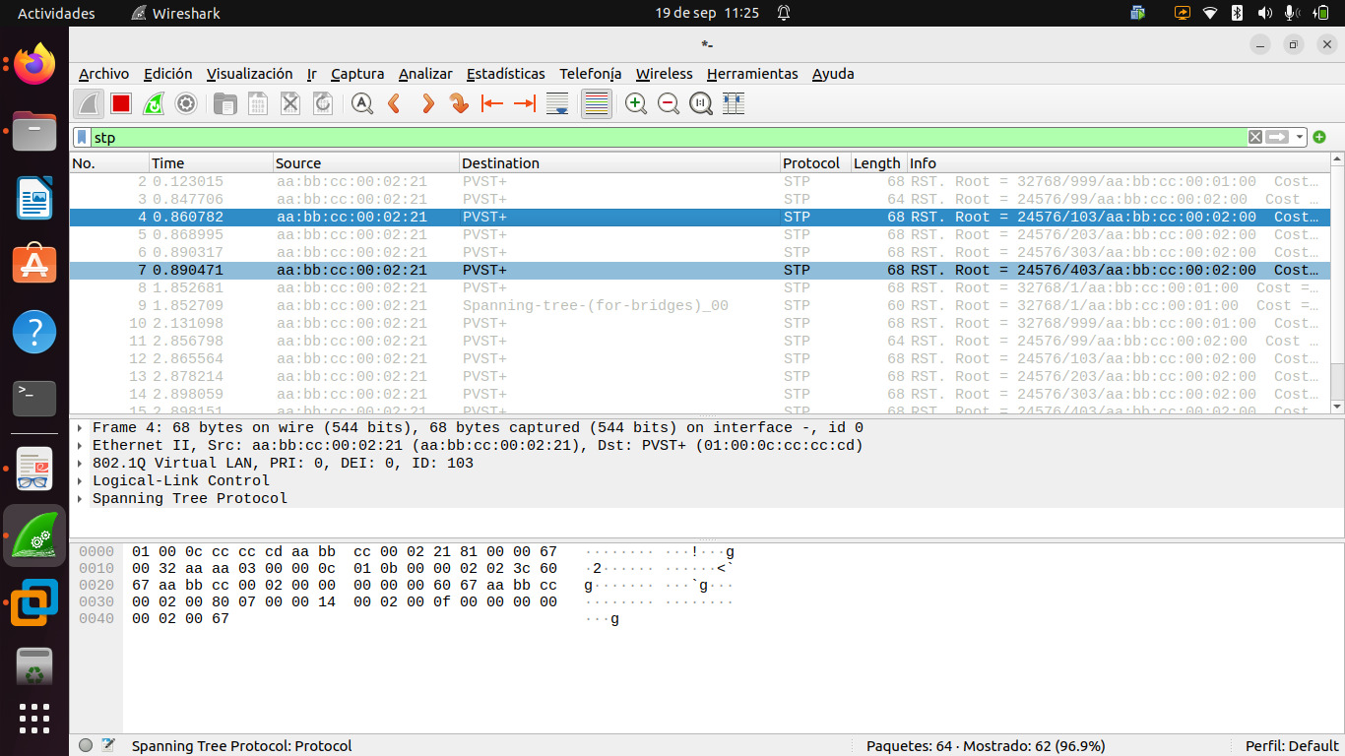Figura 1: Captura de paquetes en wireshark del protocolo STP
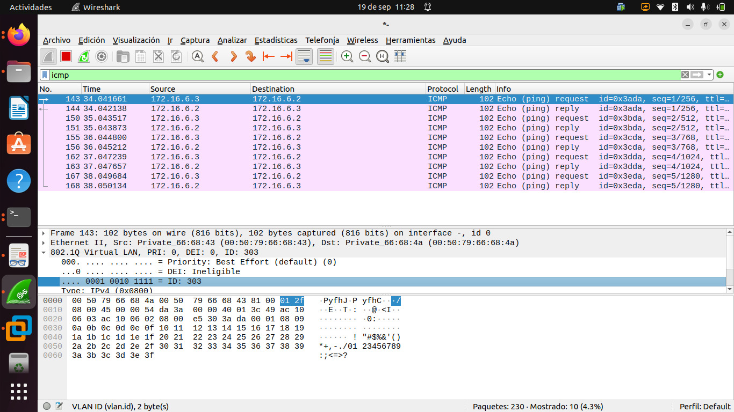Figura 2: Captura en wireshark de paquete ICMP

