**EP U1 Activity 02**

1. Observe the CEFRL language proficiency scheme.

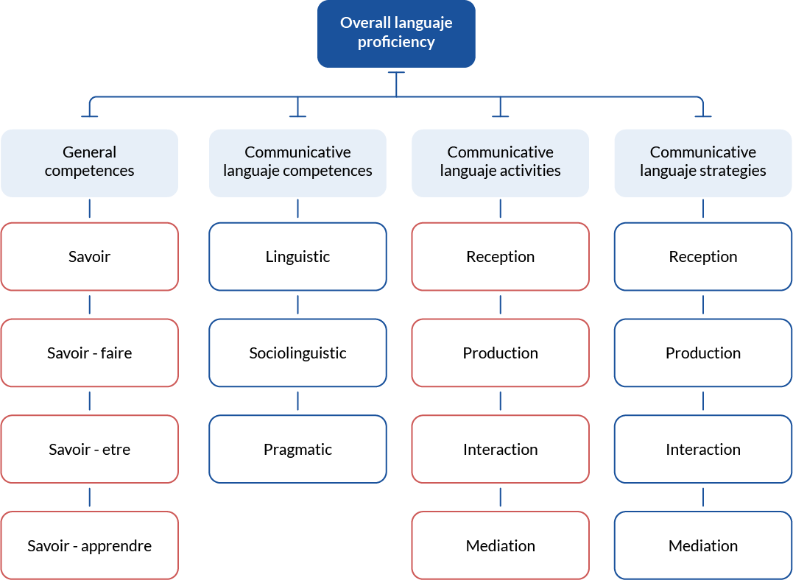

2. Identify the elements from communicative competence you revised in Activity **EP U1 Activity01**. Answer the following questions:

a. Which model(s) is/are, according to you, reflected in the CEFRL scheme?

b. What additional components can you identify in this scheme?

Write here…

Write here…

c. Why do you think these additional components are important for measuring language proficiency? Elaborate on your response.

Write here…

d. Can you relate the CEFR language proficiency scheme with the information on the extracts you read? Indicate how.

Write here…