Accuracy

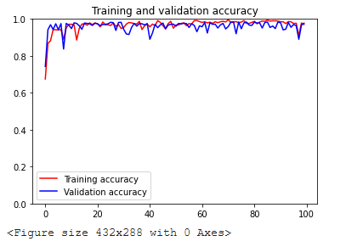

Accuracy en ultimo epoch

