EPITHALON 10mg
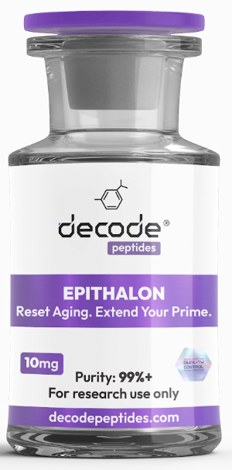

WHAT IT'S FOR
Epithalon is a longevity-focused peptide best known for its potential effects on healthy aging, cellular repair, sleep quality, and telomere support. It is often referred to as one of the most researched anti-aging peptides available. Think of it as a tool for supporting long-term healthspan, recovery, and optimal aging.

HOW IT WORKS
Epithalon is a synthetic version of Epithalamin, a peptide naturally produced by the pineal gland. Research suggests it may help activate telomerase, the enzyme responsible for maintaining telomeres, which protect DNA during cell division. It may also support melatonin production, circadian rhythm regulation, and overall cellular health.

HOW YOU'LL FEEL
Most people do not experience dramatic day-to-day effects from Epithalon. Instead, benefits tend to build gradually over time. Many users report improved sleep quality, more consistent energy levels, enhanced recovery, and an overall feeling of wellbeing after several weeks of use.

WHO IT'S FOR
Ideal for individuals interested in longevity, healthy aging, sleep optimization, recovery, cellular health, and long-term wellness strategies.

WHO IT'S NOT FOR
Not recommended for pregnant or nursing women. Individuals with active cancer or serious medical conditions should consult their healthcare provider before use. Not intended as a replacement for healthy lifestyle habits.

DOSING PROTOCOL
• Epithalon 10MG
1ml (100units) of water into the vial.
0.5ml (50units) injection (5mg) 1x every DAY for 10x days
This means you’ll use 1x vial every 2x days.
5x vials for 10x days treatment (50mg total in that period)
So make up all 5x vials at once.
Repeat this is 6months time

Where to get it:
DecodePeptides.com stocks the highest quality Epithalon. Third-party tested. Comes with a full reconstitution guide and injection tutorial. We can walk you through your first injection if needed.
WhatsApp: +43 681 81917872
For research purposes only. Not for human consumption.
Disclaimer & Usage Guidance: This protocol is provided for educational and informational purposes only. All compounds referenced are intended for research and therapeutic exploration and are not presented as medical advice, diagnosis, or treatment. Dosing guidelines are illustrative and based on commonly reported practices. Individual requirements may vary significantly. All peptides are highly individualised. Factors such as age, metabolism, lifestyle, sleep quality, and overall wellbeing play a significant role in determining response, benefits, and outcomes. Any use of these compounds should be undertaken with appropriate medical oversight where applicable. The author assumes no responsibility or liability for any outcomes resulting from the use or misuse of the information provided.

